HW#1, CSIT311 Assembly Language and Computer Organization
Fall ‘16
State Univ of New York at Fredonia, Fredonia, New York
Maximum Points 100

Assigned: Aug 30th Due: Sep 6th

Justin Kieber-King

- Given the circuit below, fill its truth table.
- Download Logisim, build this circuit with Logisim and then simulate one of the rows and include a screen shot of the simulation result below.
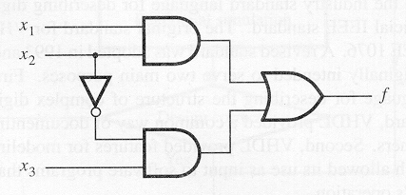

Truth Table of the Given Circuit

x1 | x2 | x3 | f
T | T | T | T
T | T | F | T
T | F | T | T
T | F | F | F
F | T | T | F
F | T | F | F
F | F | T | T
F | F | F | F

Screen shot of simulation of one of the rows:
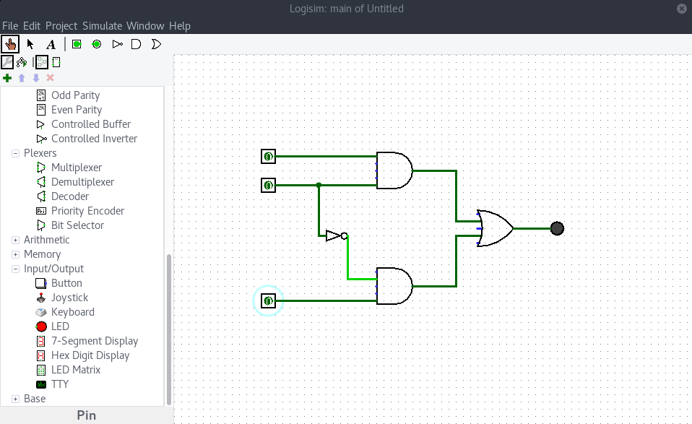
50 points

2.
Carry out the given subtraction by addition using two’s complement binary numbers. Convert the result to decimal number system.
- 127 - 43
127: 01111111
43: 00101011
43:
- 1’s compliment of 43: 11010100
- 2’s compliment of 43: 11010100 + 1 = 11010101
127 + (-43) : 01111111
11010101 +
- - - - - - - - -
01010100

therefore: 127 – 43 = 01010100 = 84 in decimal

- 42 – 121
42: 00101010
121: 01111001
-121:
-1’s compliment of 121: 10000110
-2’s compliment of 121: 10000110 + 1 = 10000111
42 + (-121) : 00101010
10000111 +
-----------------
10110001
therefore: 42 – 121 = 10110001 = -79 in decimal
- points

- Convert the binary number 010110000101000010 into Hexadecimal number system.
010110000101000010 = 16142 in Hex

- Perform the Hexadecimal addition as indicated below and report the correct result in Hexadecimal and decimal formats.

C21
1FF +
E20

C21 + 1FF = E20 in Hex = 3616 in decimal

20 points

