Justin Kieber-King
HW#2, CSIT311 Assembly Language and Computer Organization
Fall ‘16
State Univ of New York at Fredonia, Fredonia, New York
Maximum Points 100
Assigned: Sep 22nd Due: Sep 29th

You can make a group of maximum of two students to solve this assignment. Submit it in Angel Drop Box. You must mention the name of the student who worked with you on this assignment otherwise you will get a zero score. In addition, each student must submit his or her own assignment by the deadline. Make a zip file and add the Logisim circuit files to the zip archive besides this document with screenshots.

1. Implement a binary adder using a 3-to-8 decoder in Logisim. Simulate for A and B inputs as 11 and C_{in} as 1. The output LED’s should show S as 1 and C_{out} as 1.
- points
Screen shot of simulation of adder
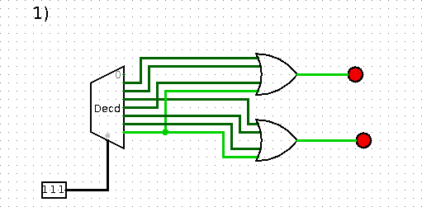

- For the circuit in Q1, modify it so that the inputs are applied from a 3-bit register and outputs go into a 2-bit register instead of LED’s. Apply the same clock to both registers and add the values as shown in Q1.

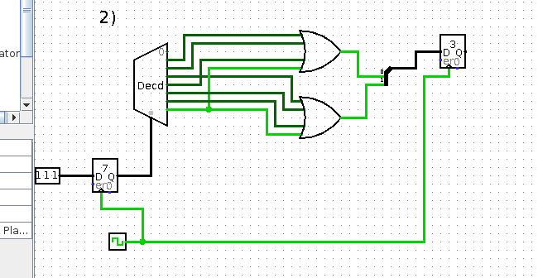
simulation of registers with adder
40 points

3. Use an 8-bit adder from the component library of the Logisim and feed its output to a shifter that would rotate the result by one bit to the left. Perform the following addition and then verify that the circuit produces the correct results.
A= 0011 0111
B= 0100 0001
0111 1000
Rotated Result
= 1111 0000
30 points
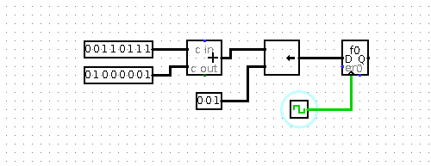
Screen shot of simulation of adder and shifter

