HW#3, CSIT311 Assembly Language and Computer Organization
Fall ‘16
State Univ of New York at Fredonia, Fredonia, New York
Maximum Points 100

Assigned: Oct 4th Due: Oct 11th

You can make a group of maximum of two students to solve this assignment. Submit it in OnCourse Drop Box. You must mention the name of the student who worked with you on this assignment otherwise you will get a zero score. In addition, each student must submit his or her own assignment by the deadline.

Justin Kieber-King
Ruotian Zhang

Use the basic RAM provided in the Logisim components library and use data and address registers to do the following. You must provide the circuit file as well as screenshots of the following two situations: (All numbers are in decimal)
- Write data 23 to location 48
- Read location 48 and store the data to the data register
50 points

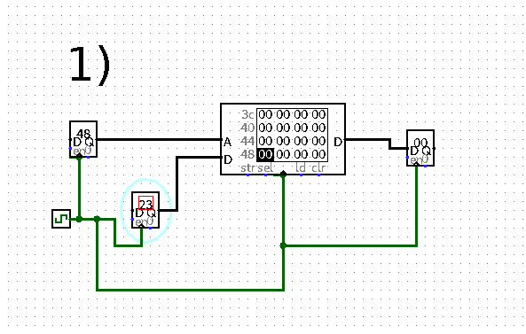
2.
Use LogiSim to design a 3-bit binary counter by using D flip flops.(HINTS: Use the following equations to drive the data inputs of flip flops where D represents input and Q represents output of the flip flop.Q’ would mean inverted output. Use text labels to avoid confusion)
D1 = NOT (Q1)
D2 = XOR (Q1, Q2)
D3 = Q3.(Q1’ + Q2’) + (Q3’.Q2.Q1)
Do not forget to apply the CLOCK to all C inputs of flip flops and wire their outputs to LED’s.) If the counter is not counting correctly, fix the error and let it count correctly.
- Points

