# HW#3 CSIT431 Introduction to Operating Systems

# Fall 2016

SUNY at Fredonia, Fredonia, New York

(Group/Individual Assignment)

Maximum Points 100

**Each student** must submit the assignment indicating the names of all the group members who worked together to solve the problems. Maximum of two students allowed per group. Make sure you have included this file and the program files in the zip archive to be submitted.

**Assigned:** Tue Oct 11th **Due:** Tue Oct 18th

**WORKED WITH:** Nate Braasch

**NOTE:** Only did the 1st question with him, we did the second one separately

Q1:

Write a program in C- - using jBACI IDE to simulate selling the tickets for a Bills game. Deploy four ticket sellers in parallel who would access the last 75 tickets left. Each seller should reduce the number of tickets by 1 after a random delay simulating interactions with the customer. You can use big idle loops to simulate the delay if other options are not available in C- -. Each seller should keep track of the number of tickets sold. Once the tickets are sold out, each seller should report total sales in dollars given the price per ticket is $110. The total amount must add up to $8,250 otherwise the sellers are corrupt and the programmer will be penalized!!

**Deliverables:** Screenshots of the run session and source code.

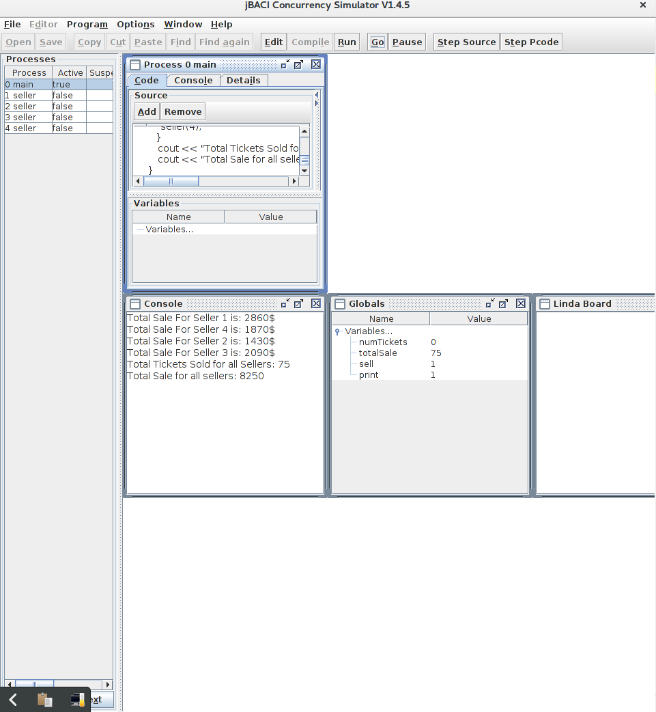**60 Points**

Q2:

Develop a C- - program to simulate a fast food restaurant. You can look at the sample code for the barbershop to get an idea as to how to start. The following persons are involved in a fast food restaurant: Customer, Order-taker, Cook and Cashier. Hire a reasonable number of employees (less than 7) and start at least 15 customers in parallel. Print meaningful messages from each process to show the events such as “order taken” “order ready”, “payment received” “customer done and exits counter”. Following are suggested implementation platforms with bonus points indicated. Bonus points are awarded on successful implementation.

C- - in jBACI with semaphores (bonus 15 extra points for using monitors)

C on Linux with Linux specific concurrency constructs (bonus 15 extra points)

Java with Synchronized methods (bonus 15 extra points)

**Deliverables:** typescript or screenshots of the run session and source code.

**40 Points**

