Pedometer

Custom Project Final Report

Spring 2018

Ji Hwan Kim

Table of Contents

**Introduction** **2**

**Hardware** **2**

Parts List 2

Pinout 3

**Software** **3**

**Complexities** **3**

Completed Complexities: 3

Incomplete complexities: 3

**Youtube Link** **4**

**Known Bugs and Shortcomings** **4**

**Future work** **4**

# 

# Introduction

The pedometer takes in the user’s stride length and counts the user’s steps and distance travelled. The number of steps and the distance travelled is displayed in the LCD.

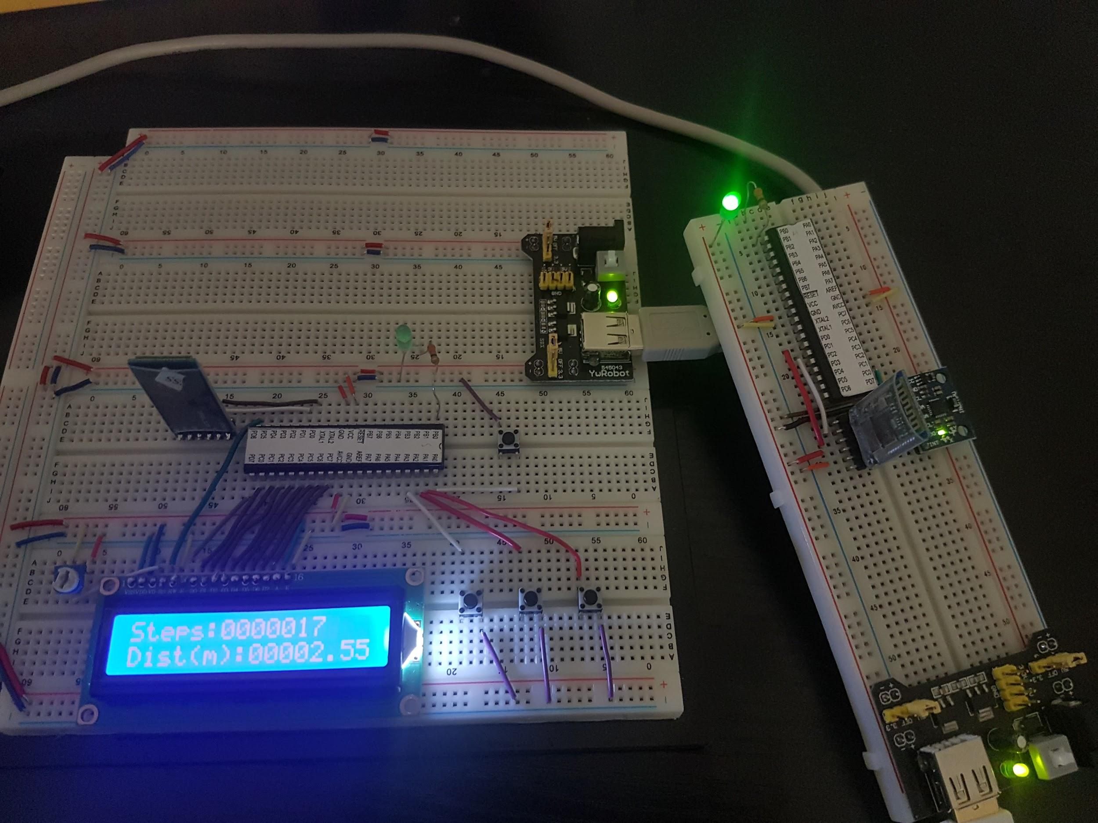

# Hardware

## Parts List

The hardware that was used in this design is listed below. The equipment that was not taught in this course has been bolded.

* 2 ATMega1284 microcontrollers
* LCD Screen
* 2 LEDs
* Buttons
* **2 HC-05 Bluetooth Modules**
* **MPU 6050 Accelerometer**

## Pinouts

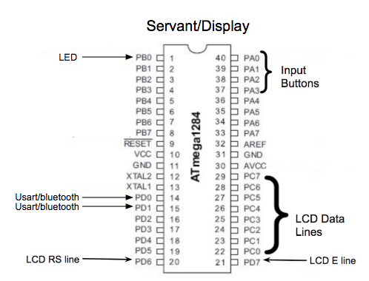

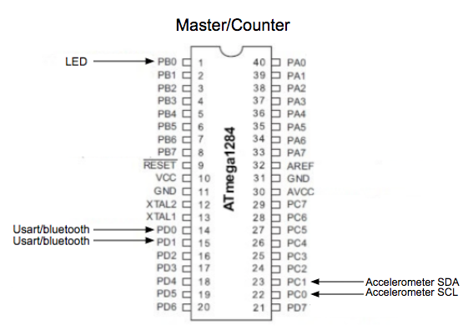

# Software

Master Module

read_tick()

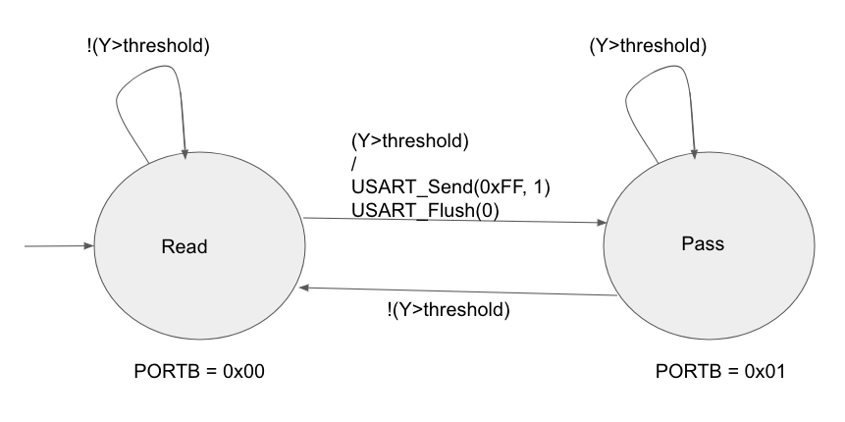

Servant Module

LCD_tick()

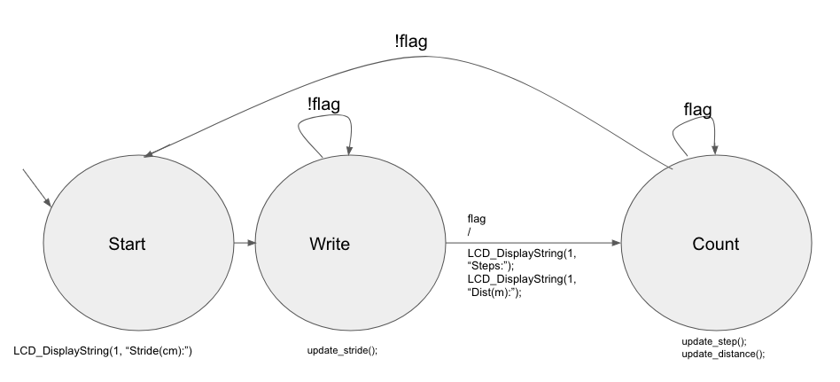

*Flag is set to 1 when enterButton is pressed and set to 0 when resetButton is pressed.

button_tick()

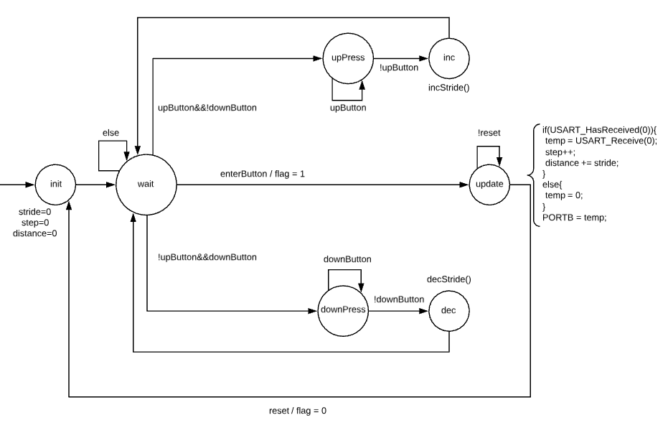

# Complexities

## Completed Complexities:

* Connecting 2 ATMEGA1284 microcontrollers through USART
* Using HC-05 Bluetooth modules for communication between the 2 modules wirelessly
* Using MPU6050 accelerometer to count the steps of the user

## Incomplete complexities:

* None

# Youtube Link

<https://www.youtube.com/watch?v=B79pWX2C-cQ&feature=youtu.be>

# Known Bugs and Shortcomings

* The user may swing his/her arm while standing at the same spot.
  + The counter module can be attached to the user’s leg instead to account for wrong step count via arm swinging.
* Maximum number of steps & distance that can be displayed on the screen is 9,999,999 steps and 99999.99m.
  + I can buy a bigger LCD so that more digits can be displayed.

# Future work

* I will add heartbeat sensor and body temperature sensor as additional features.
* I will also invest in a bigger lcd and display the data as graphs.
* I will incorporate battery into the counter module so as to cut the need for the power line.