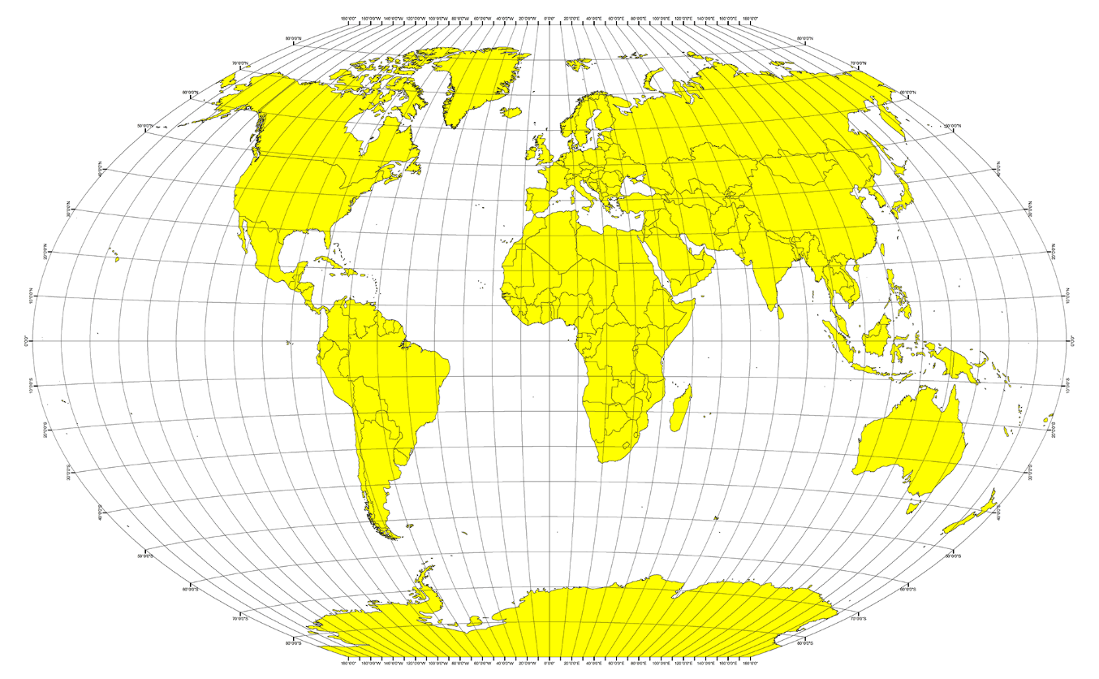

What’s the Weather Like?

Python APi homework

Jeffrey Kim | Rutgers Data Science Bootcamp | 12/01/2019

# Highest Temperature

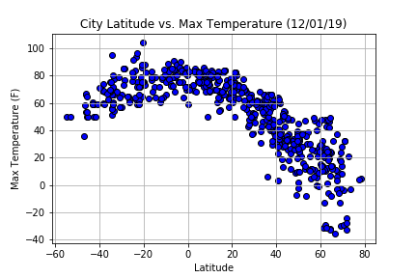

From our research, it can be determined that the latitude range from -40 to 0 has yielded the highest temperatures from our dataset as of 12/01/2019. Although it was previously assumed that the temperatures would be the highest closer to the equator but the current tilt of the earth at this moment can explain why the temperatures reached the highest closest to the latitude 20 degrees of the Southern Hemisphere.

Humidity

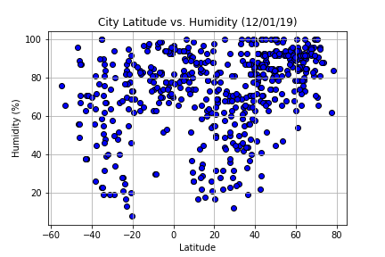

The humidity rate is the highest at the latitude of 55 to 70 degrees of the Northern Hemisphere. The humidity tends to be higher at this time of the year. Contrary to the humidity, the windspeed tends to be lower at this time of year as shown by the graph below.

