**A Simple Authentication and Authorization Framework**

*1. Source Code*

#author: Junbum Kim

from getpass import getpass

#Account List

accounts = []

#Login attempt counter

login_count = 0

#Login success

login_success = False

#username to keep track

username = ""

#---------------------------------------------------------------------#

# Account Object - SETUP FOR ACCOUNT

class account:

def __init__(self, user, pwd):

self.username = user

self.password = pwd

def get_username(self):

return self.username

def get_password(self):

return self.password

# Open user login database

login_db = open("users.txt", "rw+")

login_db_string = login_db.read()

login_db.close()

# STORE ACCOUNTS

# Tokenize newline character

accounts_list = login_db_string.split()

# Tokenize with delimiter : and store into a list of account object

for x in accounts_list:

user_pass_list = x.split(":")

account_to_add = account(user_pass_list[0], user_pass_list[1])

accounts.append(account_to_add)

# LOG IN CHECK

def login_correct(username, password):

result = False

for x in accounts:

if username == x.get_username() and password == x.get_password():

result = True

break

return result

#---------------------------------------------------------------------#

#ATTEMP LOGIN - LOGIN PROCEDURE

print "---------------------"

while login_count < 3 and not login_success:

#prompt user for username and password (echo off)

username = raw_input("User name: ")

password = getpass()

#prompt username again if longer than 8 characters

if len(username) > 8:

print "***User name cannot be longer than 8 alphanumerica characters***"

#username or password does not match

elif login_correct(username, password) == False:

print "***Incorrect username or password.***"

#username and password matches

else:

login_success = True

print "Login Success!"

print "---------------------"

break

#LOGIN FAIL

#increment login count and indicate left login attemps

login_count = login_count + 1

print "---------------------"

print str(3 - login_count) + " login attemp(s) left."

#if no login attempts left and login is unsuccessful, exit program

if login_count == 3 and login_success == False:

print "LOGIN FAIL. EXIT PROGRAM"

print "---------------------"

exit(0)

#---------------------------------------------------------------------#

#LOGGED IN - SETUP FOR AUTH

#Authentication Object

class auth:

def __init__(self, action, user, file_name):

self.action = action

self.user = user

self.file = file_name

def get_action(self):

return self.action

def get_user(self):

return self.user

def get_file(self):

return self.file

#authentication list

auth_list = []

# Open user login database

auth_db = open("auth.txt", "rw+")

auth_db_string = auth_db.read()

auth_db.close()

# STORE ACTIONS

# Tokenize newline character

action_list = auth_db_string.split()

# Tokenize with delimiter : and store into a list of auth object

for x in action_list:

actions_list = x.split(":")

auth_to_add = auth(actions_list[0], actions_list[1], actions_list[2])

auth_list.append(auth_to_add)

#list of files

files = []

for x in auth_list:

if x.get_file() not in files:

files.append(x.get_file())

files.remove("")

files = sorted(files)

#list of files with denied files

global_permit = []

permitted_files = []

permit_all = []

global_deny = []

denied_files = []

deny_all = []

#----------------------------------------------------------------------#

#AUTHENTICATION

print "Authentication Information:"

for x in auth_list:

if x.get_action() == "PERMIT":

if x.get_user() == '':

if x.get_file() == '':

global_permit = files

else:

global_permit.append(x.get_file())

files.remove(x.get_file())

elif x.get_user() == username:

if x.get_file() == "":

permit_all = files

else:

permitted_files.append(x.get_file())

if x.get_action() == "DENY":

if x.get_user() == '':

if x.get_file() == '':

global_deny = files

else:

global_deny.append(x.get_file())

files.remove(x.get_file())

elif x.get_user() == username:

if x.get_file() == "":

deny_all = files

else:

denied_files.append(x.get_file())

#Get Rid of files that are both permitted and denied from the permitted files

for x in denied_files:

for y in permit_all:

if x==y:

permit_all.remove(y)

for y in global_permit:

if x==y:

global_permit.remove(y)

for x in permitted_files:

for y in deny_all:

if x == y:

deny_all.remove(y)

for y in global_deny:

if x==y:

global_deny.remove(y)

#Add files

permitted_files = global_permit + permitted_files + permit_all

denied_files = global_deny + denied_files + deny_all

#sort files and get rid of duplicates

permitted_files = list(set(permitted_files))

denied_files = list(set(denied_files))

permitted_files = sorted(permitted_files)

denied_files = sorted(denied_files)

#echo permitted files

for x in permitted_files:

fo = open(x,"r")

print fo.read()

fo.close()

#print denied files

for x in denied_files:

print "Access to file <" + x + "> denied."

**File1. users.txt:**

userA:1

userB:2

userC:3

userD:4

userE:5

**File2. auth.txt:**

PERMIT::file1

PERMIT:userA:

DENY:userB:file4

PERMIT:userB:file2

PERMIT:userB:file3

DENY:userC:file1

PERMIT:userC:file3

PERMIT:userD:

DENY:userD:file3

DENY:userD:file4

DENY:userE:

**Testing for authentication:**

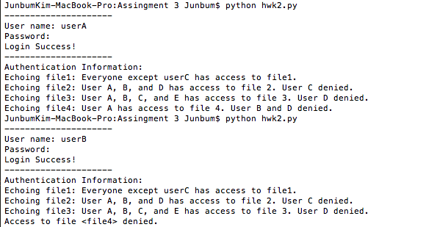

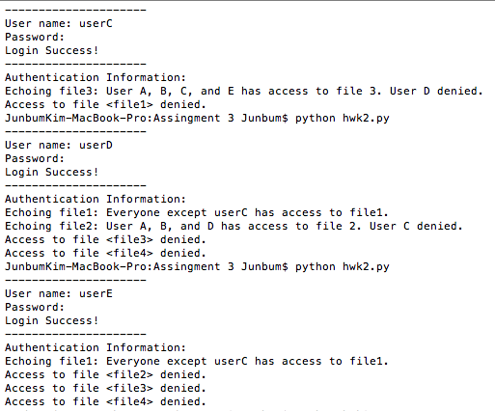

**Testing for Login:**

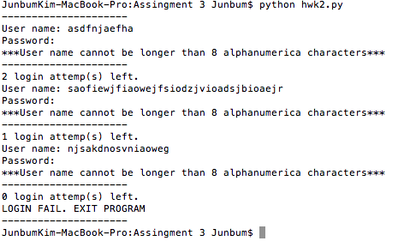

*2. Explain how you would set up the following: “user1 may access file1 or file2. User2 may access file2 only. User3 may access any file.”*

PERMIT:user1:file1

PERMIT:user1:file2

DENY:user2:

PERMIT:user2:file2

PERMIT:user3:

*3. Consider how you would implement the following unusual request: “Authenticated users may have access to ANY files in the directory, except the user eve is forbidden to access the file named adam”*

PERMIT::

DENY:eve:adam

*4. What are the ramifications of the databases being in the same directory as the files?*

If the database is in the same directory as the files, the users will have access to the database, and will be able to edit the access control of files.