Joe Kimpel
CS 601
HW 5
7.21.12
To view this assignment live:
http://jkcs601.zxq.net/hw5.html
Screenshots:

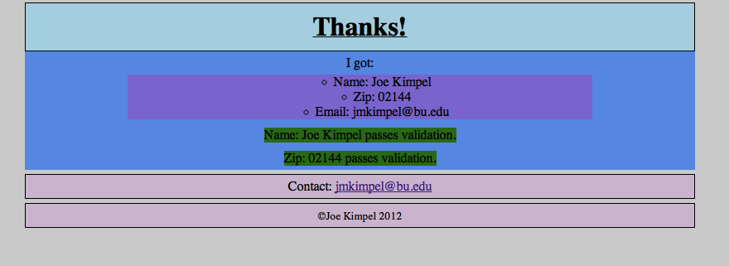

Source Code:
hw5.html:
<!doctype html>
<!--
Joe Kimpel
HW5
CS 601
7.21.2012
-->
<html lang="en">
<head>
<title>Joe K's Homework 5</title>
<meta charset="utf-8"/>
<link href="style.css" type="text/css" rel="stylesheet"/>
<script src="script.js"></script>
</head>
<body>
<h2>Homework 5</h2>
<form name="feedbackForm" id="feedbackForm" action="hw5.php" method="get" onSubmit="return validate(this)">
<div>
Name:
<input name="name" id="name" type="text"/>
</div>
<div>
Zip Code:
<input name="zip" id="zip" type="text"/>
</div>
<div>
Email Address:
<input name="emailAddress" id="emailAddress" type="text"/>
</div>
<div>
<input value="Submit" type="submit"/>
<input value="Clear" type="reset"/>
</div>
</form>

<div class="footer">Contact: <a href="mailto:jmkimpel@bu.edu">jmkimpel@bu.edu</a></div>
<div class="footer"><small>&copy;Joe Kimpel 2012</small></div>
</body>
</html>
hw5.php:
<!doctype html>
<!--
Joe Kimpel
HW5
CS 601
7.21.2012
-->
<html lang="en">
<head>
<title>Joe K's Homework 5 - Response</title>
<meta charset="utf-8"/>
<link href="style.css" type="text/css" rel="stylesheet"/>
</head>
<body>
<?php

function validateName($n){
$pattern = '/^.{5,}$/';
if (preg_match($pattern, $n)){
return True;
} else{
return False;
}
}

function validateZip($z){
$pattern = '/^\d{5}$/';
if (preg_match($pattern, $z)){
return True;
} else{
return False;
}
}

$name = $_GET['name'];
$zip = $_GET['zip'];
$email = $_GET['emailAddress'];
?>
<h1>Thanks!</h1>
<div>I got:
<ul>
<li>Name: <?= $name?></li>
<li>Zip: <?= $zip?></li>
<li>Email: <?= $email?></li>
</ul>
</div>
<div>
<?php
if (validateName($name)){
echo "<span class='pass'>Name: $name passes validation.</span>";
} else{
echo "<span class='fail'>Name: $name fails validation.</span>";
}
?>
</div>
<div>
<?php
if (validateZip($zip)){
echo "<span class='pass'>Zip: $zip passes validation.</span>";
} else{
echo "<span class='fail'>Zip: $zip fails validation.</span>";
}
?>
</div>
<div class="footer">Contact: <a href="mailto:jmkimpel@bu.edu">jmkimpel@bu.edu</a></div>
<div class="footer"><small>&copy;Joe Kimpel 2012</small></div>
</body>
</html>
script.js:
/* Script.js
* Joe Kimpel
* Homework 2
* CS 601
* 6.24.12
*/

function validate(feedbackForm){
//namePattern matches five or more of any characters
var namePattern= /^.{5,}$/g;
if (!namePattern.test(feedbackForm.name.value)) {
alert("Please enter at least a five character name.");
feedbackForm.name.focus();
return false;
}
//zipPattern matches exactly five digit characters
var zipPattern=/^\d{5}$/g;
if (!zipPattern.test(feedbackForm.zip.value)){
alert("Please enter a five-digit, numeric Zip Code.");
feedbackForm.zip.focus();
return false;
}
//emailPattern matches:
// one or more of any character except (/:,;) followed by
// '@' followed by
// one or more of any character except (/:,;) followed by
// '.' followed by
// two or more of any character except (/:,;)
var emailPattern=/^[^\/:,;]{1,}@[^\/:,;]{1,}.[^\/:,;]{2,}$/g;
if (!emailPattern.test(feedbackForm.emailAddress.value)){
alert("Please enter a valid Email Address.");
feedbackForm.emailAddress.focus();
return false;
}
return true;
}
style.css:
/*
* Joe Kimpel
* CS 601
* 6.12.12
* Updated 7.21.12 for HW5
*
*/

body{
background-color: lightgray;
}

h1{
text-align: center;
text-decoration:underline;
font-weight:bold;
padding:10px;
margin-left: 15%;
margin-right: 15%;
margin-top: 5px;
margin-bottom: 0;
border: 1px solid black;
background-color: lightblue;
}

h2{
text-align: center;
font-weight: bold;
padding: 5px;
margin-left: 15%;
margin-right: 15%;
margin-top: 5px;
margin-bottom: 5px;
border: 1px solid black;
background-color: slateblue;
}

p{
text-align:center;
margin-left: 15%;
margin-right: 15%;
padding: 5px;
background-color: aquamarine;
}

div{
text-align:center;
margin-left: 15%;
margin-right: 15%;
padding: 5px;
background-color: cornflowerblue;
}

div.footer{
text-align:center;
margin-left:15%;
margin-right:15%;
padding: 5px;
border: 1px solid black;
background-color: thistle;
margin-top: 5px;
margin-bottom: 0;
}

table{
margin-left:auto;
margin-right:auto;
width:70%;
background-color: lightgreen;
margin-top: 5px;
margin-bottom: 0;
}

ul{
list-style:circle inside;
margin-left: 15%;
margin-right: 15%;
margin-top: 0;
margin-bottom: 0;
background-color: mediumpurple;
margin-top: 5px;
margin-bottom: 0;
}

img{
display:block;
margin-left:auto;
margin-right:auto;
margin-top: 5px;
margin-bottom: 0;
}

table, td{
border: 1px solid black;
}

td{
text-align: center;
}

span.pass{
background-color: green;
}

span.fail{
background-color: red;
}

