**Nutrient fluctuations characteristic of microscale heterogeneity**

**reduce bacterial growth rates**

Jen Nguyen1,2, Vicente Fernandez1 & Roman Stocker1

1 ETH Zürich, Switzerland

2 Microbiology Graduate Program, MIT, USA

Abstract

The characteristic timescale of nutrient fluctuations in many realistic bacterial environments ranges from tens of seconds to several minutes. Bacterial motility, gene expression and rates of translation all respond to nutrient availability within this range. How do nutrient fluctuations affect growth rate? A novel microfluidic device enables us to approach these previously inaccessible questions. We find that seconds- and minute-scale nutrient fluctuations consistently reduce bacterial growth rates. These growth reductions are timescale-dependent, due to an interplay between the nutrient timescale and timescale of growth responses. Intriguingly, we find that unlike cells grown in steady environments, cells that have experienced repeated nutrient shifts put a pause on active adaptations to changing nutrient. This steadiness in growth rate points towards an alternative physiology: one that provides cells with an advantage when growing in highly dynamic environments.

Introduction

***goal****: enough physiology to make results surprising, inspire curiosity!*

From the ocean to soils to wastewater, bacteria are key players in the cycling of all major elements. Underlying these large-scale effects are the growth and activities of individual bacteria, which often unfold in nutrient landscapes that are highly heterogeneous at sub-millimeter scales (Stocker, 2012). This microscopic heterogeneity implies that an individual bacterium can experience frequent fluctuations in nutrient concentration within seconds or minutes. A lysing cell, for instance, is a local hotspot of nutrient orders of magnitude richer than background concentrations, creating a gradient up which chemotactic bacteria can traverse within a minute (Smriga, Fernandez et al., 2016). Diffusion would dissipate such a nutrient patch within 10-20 min. Fluid mixing would stir the patch into thinner sheets and filaments, which would then dissipate on timescales of a few minutes or tens of seconds (Taylor & Stocker, 2012).

The relevance of environmental fluctuations has been an allusion in the literature for decades. It has been repeatedly observed, for example, that bacteria coordinate their growth rate and cell mass with their nutrient environment. Richer nutrient sources result in faster growth rates and larger cells (Schaechter et al., 1958; Godin et al., 2010; Taheri-Araghi et al., 2014), supporting that increased biomass is required for fast growth and that bacteria accordingly prioritize biomass production when nutrient is abundant (Donachie, 1968; Harris & Theriot, 2017). Indeed, higher rates of nutrient influx correspond with higher proteomic proportions of ribosomes and other proteins that facilitate biosynthesis (Scott et al., 2010). Nutrient deplete conditions suppress protein synthesis by reducing intracellular amino acid, increasing the likelihood of stalled translation elongation (REF). Upon binding stalled ribosomes, RelA synthesizes the stress signal (p)ppGpp (Brown et al., 2018; REF on synthesis), which propagates a cascade of stress responses, including further suppression of protein synthesis (Milon et al., 2006), skewed transcription towards stationary phase genes (i.e. σS) (Bougdour et al., 2007), and the arrest of DNA replication (Zyskind and Smith, 1992).

Yet, it is unclear how the behaviors observed in steady-state growth or single nutrient shift conditions – the vast majority of current studies – can apply to realistic environments, which fluctuate repeatedly. Single shift experiments have observed physiological adaptation as a continuous progression from one steady-state to another, characterizing sequences of events as cells transition deeper into a new physiological state (Kjeldgaard et al., 1958; Durfee et al., 2008). But what occurs when the environment fluctuates on timescales faster than complete adaptation? The models from single shift data would suggest that cells continuously change their target physiology, never quite reaching any optimum before re-directing yet again. Thus, frequent environmental fluctuations seem an exhausting challenge, which we expect lowers bacteria growth due to the need to expend energy towards adaptation instead of biomass synthesis.

The current literature, however, largely ignores nutrient environments that fluctuate on sub-adaptation timescales. Instead, there is a persistent implicit assumption that cells grow as if in an averaged nutrient environment.

We propose that fluctuations can considerably affect bacterial growth and aim to address this knowledge gap. We hypothesize that the fine structure of the nutrient landscape, not just the average nutrient concentration, determine bacterial growth. To test this, we developed a novel microfluidic device that enabled us to observe and quantify single cell growth dynamics while precisely delivering automated nutrient signals. With this new approach, we show that fluctuations consistently reduce growth when compared to a steady environment delivering the same total nutrient and suggest that fluctuations induce an unexpectedly stable cell physiology.

Materials & Methods

**Growth media.** All experiments used two types of growth media: (i) 1x MOPS medium supplemented with 0.2% glucose w/v and ___ K2HPO4 (all components purchased from Teknova), and (ii) full Lysogeny Broth (LB) composed of tryptone (10g/L), yeast extract (5 g/L) and NaCl (10g/L). The same stock solution of full LB was used for all experiments. Millipore filtered water was freshly autoclaved – to avoid bubble formation within the microfluidics – and then allowed to cool before preparing the various dilutions of LB, such as the low LB (1/1000) and high LB (1/50) conditions used for the fluctuating environments. The high LB solution was labeled with ___ fluorescein, to visually calibrate switching between mediums. All solutions were adjusted to pH 7. Equal parts of low and high LB were mixed to produce the average LB control. Growth media were loaded into 10 mL syringes (stable environments) or glass vials (fluctuating) and warmed to 37ºC prior to starting experiments.

**Strain.** All experiments were performed with a ∆*motA* strain derived from wild-type *E. coli* K-12 strain NCM3722 (Soupene et al., 2003; Jun lab sequence ref).

**Culture procedure.** Cells for each experiment were prepared in three steps: overnight culture, pre-culture, and microchannel culture. The overnight was inoculated directly from a -80ºC glycerol stock into 3mL MOPS medium with glucose and shaken overnight at 37ºC. The next morning, the pre-culture was seeded with a volume from the overnight to have an initial OD600 well under 0.00, generally a 1:1000 or 1:2000 dilution. The pre-culture was used to inoculate microchannels within an OD600 range of 0.07 – 0.10.

**Microfluidics and experimental set-up.** Microfluidic channels with a depth of ~ 60 um were cast from PDMS and bonded to glass coverslips by plasma treatment. The bonded channels were treated with a 1:10 dilution of poly-L-lysine in milliQ water for 15 min, washed with milliQ, then allowed to air dry for at least 2 hours prior to inoculating the device with cells. Hooking up input and output tubing allowed the cells about 10-15 min to settle and attach to the glass surface within each microchannel before flow was established (20-26 ul/min in MPG, 15 ul/min in stable). Medium switching between high (fluorescein-labeled) and low LB (unlabeled) was calibrated with a 20x objective before finally changing to a 40x objective with 1.5x amplification to image cells with phase microscopy at a total magnification of 60x, or with our Zyla CMOS camera, about 0.1083 um per pixel.

**Image processing**. A custom MATLAB image processing pipeline was developed to: (1) directly read from Nikon Elements image files, (2) identify ellipsoidal particles of within a specified size range, and (3) track individual particles through time. Size criteria, in addition to noise filters, ensured that the vast majority of tracks derive from individual cells growing in isolation. Reducing our analysis to cells without neighbors allowed us to assume no accumulation or depletion of medium components, as well as assume no chemical or physical interactions between cells.

**Growth rate measurements**. From the length and widths measured during particle tracking, the volume of each individual cell was approximated as a cylinder with hemispherical caps (Harris & Theriot, 2016). These calculated volumes were then used to compute instantaneous single cell growth rates, using Vt+1 = Vt • 2µ∆t, where ∆t = (t+1) – t. Specifically, we took the natural logarithm of each volume trajectory and calculated the slope between each point. Dividing the slope by the natural log of 2 changes the base of the exponential from e to 2. Thus, µ represents the exponential rate at which volume doubles.

Results

**Generation of precise and automated nutrient fluctuations.**

Experimental mimicry of a heterogeneous nutrient landscape involves both addition and removal of nutrient. As our timescales of interest required rapid yet precise concentration switches, we engineered a microfluidic device to vary the strength, duration, and frequency of nutrient pulses while simultaneously observing individual *E. coli* cells with time-lapse phase microscopy (**Figure 1A**). In this study, all delivered signals switch between the same two nutrient concentrations: a lower and higher dilution of LB (**Figure IB**). With automated control over the rate at which each LB solution is driven into the device (**Methods I; Supplementary Methods 1**), the cells – attached to the glass surface of the device, downstream of the switching junction – reliably experience sharp switches between high and low LB within 2-3 seconds, with hardly any smoothing (**Figure 1C & 1D**; **Supplementary Methods 2**). Cells from an exponentially growing batch culture of E. coli NCM3722 ∆*motA* attach within the microchannel in greater numbers when the channel is treated with poly-L-lysine, which in our system has no treatment-specific effects on growth rate (**Supplementary Methods 2**). Poly-L-lysine treatment also extends attachment duration, allowing for longer observations of single cells as they grow and divide **(Figure 1E**; **Supplementary Methods 3**).

Each fluctuating environment was performed in parallel with three control conditions: (1 and 2) steady low LB and steady high LB, to measure the expected “boundary” physiologies we could expect to see; and (3) steady averaged LB, the time-averaged nutrient environment, representing a “bulk sampled” environment that may actually be heterogeneous (**Figure 1A**; **Supplementary Methods 4**). From each of these environments, we have tracked thousands of single cell lineages (**Figure 2A**; **Supplementary Methods 5**) with which we ask: how do laboratory-observed behaviors translate to other environments? E.g., can we assume that a growth rate observed in a liter of chemostat culture to apply in a liter of seawater with an equivalent total amount of nutrient? Macroscopically, at the liter-scale, these environments contain identical nutrient concentrations. But microscopically, the chemostat is well mixed whereas seawater is not (**REF 1 & 2**). We hypothesize that the microscopic heterogeneity of seawater, like many microbial environments, would lead to growth rates that differ from those in a well-mixed chemostat, due to temporal fluctuations in nutrient concentration inherent to patchy environmental landscapes.

**Fluctuations reduce growth in a timescale-dependent manner.**

To ask how the timing of nutrient availability influences growth, we first determined a concentration range in which to fluctuate. We experimentally measured steady-state growth rates across a range of fixed nutrient concentrations, spanning five orders of magnitude (**Supplementary Methods 5**). As expected, the cells require about 2-3 hours to adapt to their new microfluidic environment (**Figure 2A, Supplementary Fig X**). Due to the high flow rates used in this study, no nutrient depletion or metabolite excretion is expected to alter the original composition of the nutrient media. (**Supplementary Methods 6**). The steadiness of the nutrient environment is apparent in the saturated growth rates that remain steady for several hours after the initial adaptation (**Figure 2B**). As expected, the average growth rate during this steady phase of the growth curve – i.e. the steady-state growth rate – varies with nutrient concentration, displaying a saturating Monod curve that plateaus at a growth rate of 2 hr-1 at 3% LB or higher (**Figure 3A**). We avoid this saturated regime by designating 2% LB, with a steady-state growth rate (Ghigh) of 1.87 ± 0.10 hr-1, as the “high nutrient” phase of all fluctuating signals (**Figure 3A**). The “low nutrient” phase (0.1% LB; Glow = 0.67 ± 0.15 hr-1) was selected such that the “average nutrient” condition (1.05% LB; Gave = 1.51 ± 0.14 hr-1) would be significantly distinct from the high (**Figure 2B**). Jen to self: red values need to be adjusted for final growth rate metric.

After defining the high and low nutrient phases, we measured average growth rates from E. coli experiencing fluctuating nutrient environments. Complete switching between high and low occurs so quickly that the cells effectively experience an oscillating square wave with equal amounts of time in both phases (**Figure 1B & 1C**; **Supplementary Methods 2**). Across all nutrient signals, growth rates oscillated on the same timescale as nutrient (**Figure 2B**; **Supplementary Methods 7, Supplementary Figure Y**). However, while the nutrient signal amplitude saturates within seconds of a switch, growth rate transitions occurred over minutes and amplitudes often less than matched those observed in steady-state (**Figure 2B**). In fact, time-averaged growth rates from fluctuating environments consistently fell lower than growth rates measured from the equivalent time-averaged steady environment (Gave), reduced by up to 50% (**Figure 4**).

Intriguingly, the average growth rate under fluctuations was dependent on the timescale of nutrient fluctuation (**Figure 3A & 4**). Of the nutrient timescales tested – 30 sec, 5 min, 15 min and 60 min periods – the second-scale fluctuations were less detrimental than minute-scale ones (**Figure 4**). These costs in growth rate, as a percent of Gave from the steady average LB environment, were 15, 30, 40 and 40% respectively (**Figure 4**). We hypothesize that this difference in average growth rate between fluctuating timescales is linked to how each timescale relates to the timing of bacterial responses to shifts in nutrient availability. For example, fluctuations on timescales that are faster than bacterial response times (i.e. milliseconds (**REF 3**)) should lead to cellular averaging of the external nutrient environment and thus growth as if the nutrient environment were steady (**Figure 4**). Similarly, fluctuations on timescales so great that bacterial adaptation times are negligible (i.e. tens of hours, days) should have an average growth rate equal to the average of the two steady-state rates, Ghigh and Glow (**Figure 4**).

Between these two extremes are timescales of many plausible categories, including: first, timescales in which physiological adaptation moves towards that of the steady average and any growth rate deviations are plastic responses of that Gave physiology to brief fluctuations in nutrient concentration (**Figure 4, yellow point**). Second, there may be intermediate timescales at which cells begin to adapt towards the high or low physiology but do not have sufficient time in either phase to fully reach steady-state. Third, some timescales are likely long enough for cells to reach steady-state in both high and low nutrient phases, but short enough for the sub-steady-state adaptation growth rates to manifest as a cost to the overall time-averaged growth rate (**Figure 4, filled gray point**). Finally, there may be timescales that induce bacterial to stabilize around a fluctuation-adapted physiology distinct from the steady-state physiologies of Gave, Ghigh and Glow. Which, if any, of these behavioral classifications apply to the timescales we observe here?

**Single perturbations do not capture dynamics of rapidly fluctuating environments.**

To better understand the growth behaviors observed from our fluctuating environments, we performed a series of single nutrient shift experiments in which *E. coli*, once adapted to one environment, were permitted to fully adapt to another (**Figure 5C**). These data give us the plasticity of growth rate for a given physiology (e.g. steady-state growth at average LB) as well as the expected behavioral trajectory during adaptation between steady-states. Let’s first consider a single upshift from low to high nutrient, where the switch occurs after the cells reach steady-state growth in low LB (**Figure 5C**; **Supplementary Methods 8**). Low-adapted cells transitioned to steady-state growth at high LB over 2-3 hours (**Figure 5C**; **Supplementary Methods 8**). Immediately after the upshift, we observed an initial jump in growth rate (**Figure 5A**), consistent with previous reports (**REF 4 & 5**) that attribute such rapid growth rate responses to unoccupied ribosomes in low nutrient ready to take advantage of increased influxes of nutrient upon upshifts. This initial jump is then followed by a gradual adaptation to the new steady-state growth rate Ghigh (**Figure 5A, 5B & 5C**). Were cells in nutrient fluctuations physiologically adapted to the low, we should expect to see a similar response to the several upshifts delivered in each fluctuating environment – we do not. In all minute-scale fluctuations, growth rates increase rapidly for 2-3 min before saturating instead of the hour needed for low-adapted cells in the single upshift controls to stabilize at Ghigh (**Figure 5A & 5B**). Likewise, single downshifts in nutrient concentration revealed disparate dynamics from environments with rapid repetitive nutrient fluctuations. While adaptation from steady-state Ghigh takes hours (**Figure 5C**), cells experiencing minute-scale fluctuations display a markedly fast transition to a seemingly stable growth rate within a few minutes of nutrient shift (**Figure 5A**). This exceedingly quick response time suggests that cells experiencing repeated nutrients may contain an even greater number of ribosomes (or transporters, *etc.*) than cells adapted to a steady background concentration of nutrient. Overall, single upshifts in nutrient concentration clearly do not capture the growth rate dynamics occurring in rapidly fluctuating environments.

Discussion

**Bulk assessments of nutrient environment substantially overestimate bacterial growth.**

In this study, two environments – steady and fluctuating – represent two perspectives of bacterial habitats: one that measures bulk nutrient at human-scales (e.g. moles of carbon per liter), and one that considers a microscopically heterogeneous nutrient landscape, in which an individual bacterium experiences temporal changes in nutrient concentration on seconds- to minutes- timescales. Nutrient fluctuations on sub-cell cycle timescales consistently reduced time-averaged growth rates by up to 50%, relative to a steady environment delivering the average nutrient concentration (Figure 2). This finding shows that the bacterial biomass produced from a given amount of nutrient – the growth yield – depends on the spatial structure of the nutrients, not just the average concentration, as often implicitly assumed. Thus, averaging over an environment likely overestimates bacterial growth when in reality the environment is heterogeneous or dynamic.

**Repetitive environmental change induces a fluctuation-adapted physiology.**

The growth cost inflicted by nutrient fluctuations is suggestive of a lowered growth yield per available nutrient quantity. One facet of this cost is could be the energy spent attempting to continuously adapt between two steady-state physiologies, which the cells never achieve within the timescales tested (**Figure 4**). Alternatively, the cells could also conceivably adapt to one focused target, steady-state Glow or Ghigh. Normalized growth rate distributions, as described in similar works (Taheri-Araghi et., 2010), reveal that distributions of instantaneous growth rates observed in fluctuating environments aligned with those observed in steady low environments (**Figure 3B**, **Supplementary Figure Z**), particular those from longer timescales (15 min, 60 min).

We observe, however, that *E. coli* perform none of these actions. The cells not are not adapted to Glow nor Ghigh, as evident by the distinct response in growth rate to nutrient shifts from cells growing at Glow nor Ghigh (**Figure 5A & 5B**). Nor are they shifting between states, given the stability in growth rate after a nutrient shift (**Figure 5A**). Instead, this stabilization of growth is suggestive of a stable physiological distinct from the two steady-states presented by the environment.

We propose that this fluctuation-adapted physiology is response to the nutrient stress induced by repeated shifts in nutrient concentration. This behavior is distinct from cells accustomed to life in stable environments, which within minutes of a shift, begin to transition in growth rate towards the new optimum (**Figure 5A**, Kjeldgaard et al., 1958). While jumps and drops in growth rate are apparent, the 2-3 min timescale over which they occur (**Figure 5B**) is more likely derived from the plasticity of the cells’ immediate phenotype as it is faster than the expected timescales of significant physiological adaptation (REF). We hypothesize that when sensing a highly dynamic nutrient environment, perhaps intracellularly through metabolic signals like (p)ppGpp, bacteria recognize that continuous adaptation between environments will be stressful. Thus, they shift to an alternative stable physiology, one that resists see-sawing between two steady-state optimums.

Like a nutrient deplete environment (**Figure 3B**), fluctuating nutrient environments are stressful for bacteria. Bacteria, however, seem to have evolved adaptive mechanisms to cope with such stresses – mechanisms that are not observed when probing growth under steady conditions or environments that shift only once. We have shown that fluctuating environments have significant and unexpected implications on bacterial growth. To form an understanding of bacterial life in the environment, which are often far more complex that standard laboratory conditions, it will be important to further characterize these mechanisms and consider how they functionally affect bacterial behavior in realistic settings.

Acknowledgements

We are enormously grateful to Martin Ackermann, Michael Laub and Katharina Ribbeck for discussions regarding this work. We also thank Suckjoon Jun, Sarah Cox and JT Sauls for the NCM 3722 strains. This work is supported by the Gordon and Betty Moore Foundation ( ) and Swiss National Science Foundation ( ), both to Roman Stocker.

Author Contributions

J.N., V.F. and R.S. designed the study. V.F. designed the microfluidic system and particle tracking software. J.N. performed experiments and analyzed the data. All authors contributed to the writing of this manuscript.

Figures

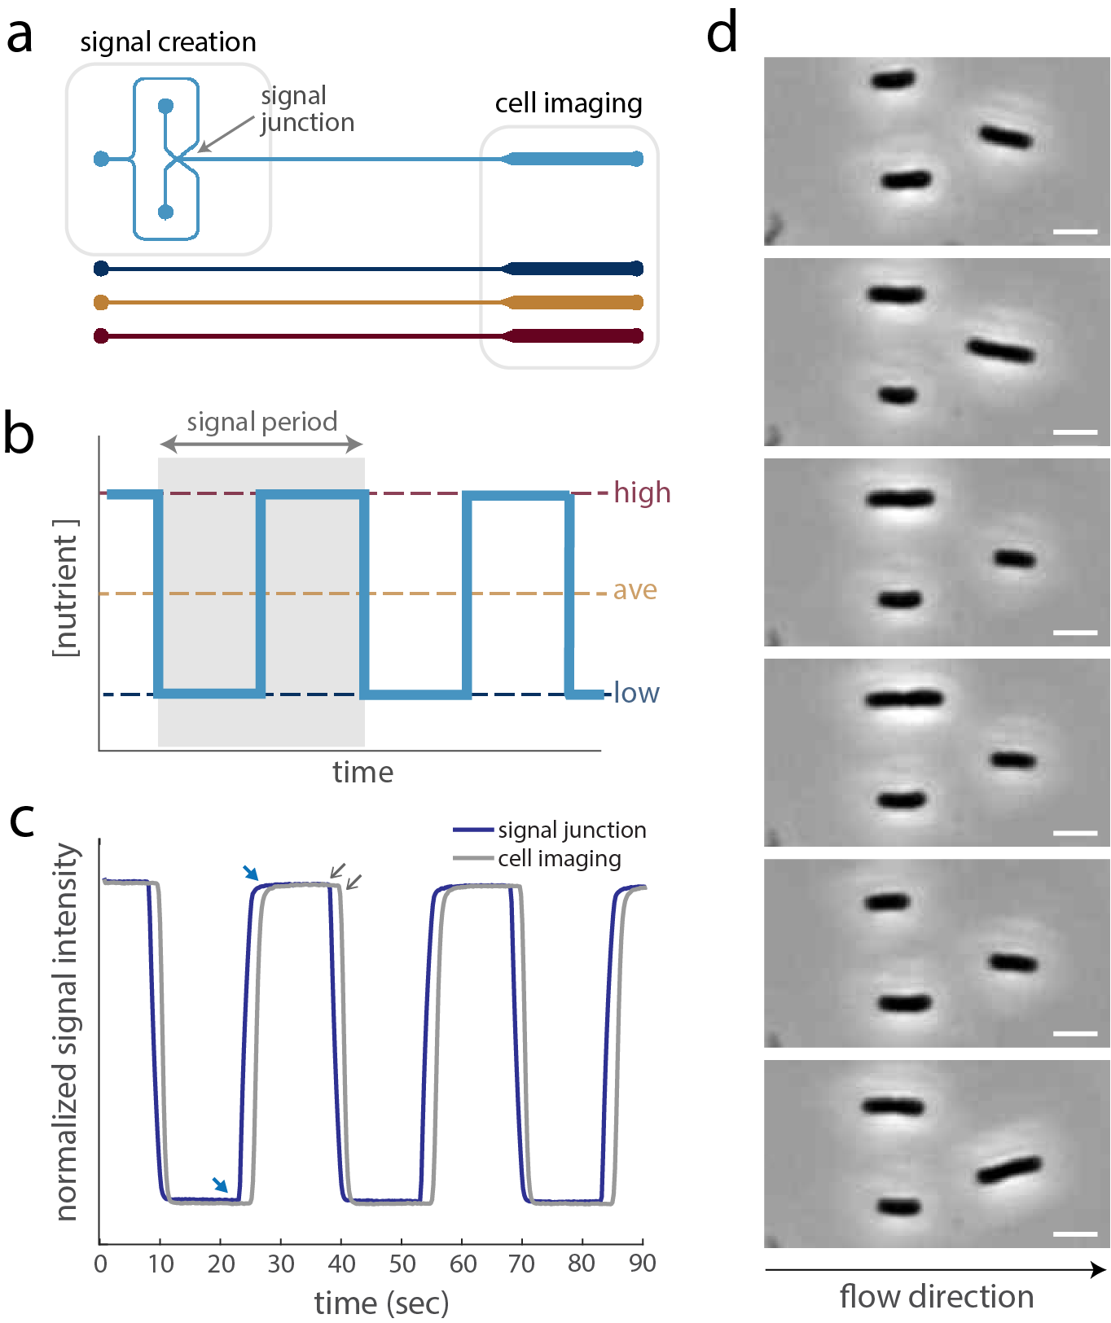

**Figure 1. The Microfluidic Pulse Generator generates automated, precise high-frequency fluctuations while enabling single-cell microscopy.** (**A**) Two channel configurations: the MPG for switching between two mediums (top) and straight channels for steady delivery of a single medium (bottom). The upstream portion of the MPG facilitates switching, and the wider downstream section of both designs fits several (>10) imaging fields of view. (**B**) The fluctuating signals in this study primarily focus on even oscillations between a low and a high LB concentration. The period length, T, ranges between 30 sec to 60 min. For comparison, three control environments – low, average and high LB – run simultaneously with every switching environment. (**C**) Fluorescein intensity over multiple oscillations with 30 sec period in two channel locations: immediately after the switching junction (blue) and further downstream where cell imaging occurs (gray). Transitions between media (blue arrows) are less than 3 sec. Lag time in signal between junction and cell position is about 2 sec. For more detailed characterizations of signal timescales, see Supplementary Information. (**D**) Individual *E. coli* cells, growing and dividing within the MPG. Daughter cells are typically swept away with the flow. Those that adhere are also tracked and analyzed, unless they are in the physical vicinity of another cell. Scale bars indicate 2.5 um.

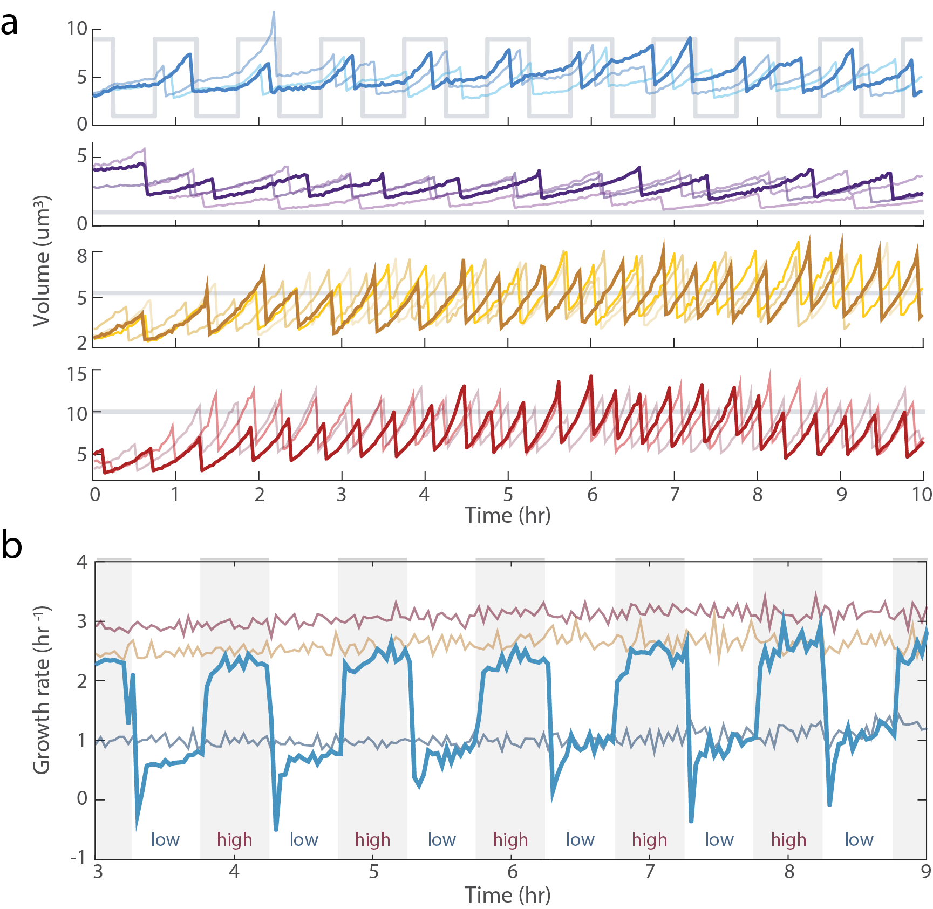

**Figure 2. Rapid adjustments in growth rate following nutrient upshifts and downshifts.** (**A**) Example single-cell size trajectories from a fluctuating (60 min period) environment and corresponding stable controls. Each continuous line marks repeated growth and division events within a single cell lineage. In the stable low (purple), average (yellow) and high (red) LB environments, each growth curve appears exponential, as expected. Growth curves in the fluctuating condition (blue) appear kinked, with greater slopes corresponding to phases of high nutrient. A gray function notes the nutrient signal across time in each condition. (**B**) Time-resolved evolution of population growth rate in steady and fluctuating nutrient environments. The start of image acquisition occurs at t=0, which also coincides with the start of the fluctuating nutrient signal. Parallel to the fluctuating environment (60 min period, blue), three steady environments reach their steady-state growth rates (gray box) in low (purple), average (gold), and high LB (red) around t=2 or 3 hr. Each point time-averages all instantaneous, single-cell growth rates within a 2-min time bin.

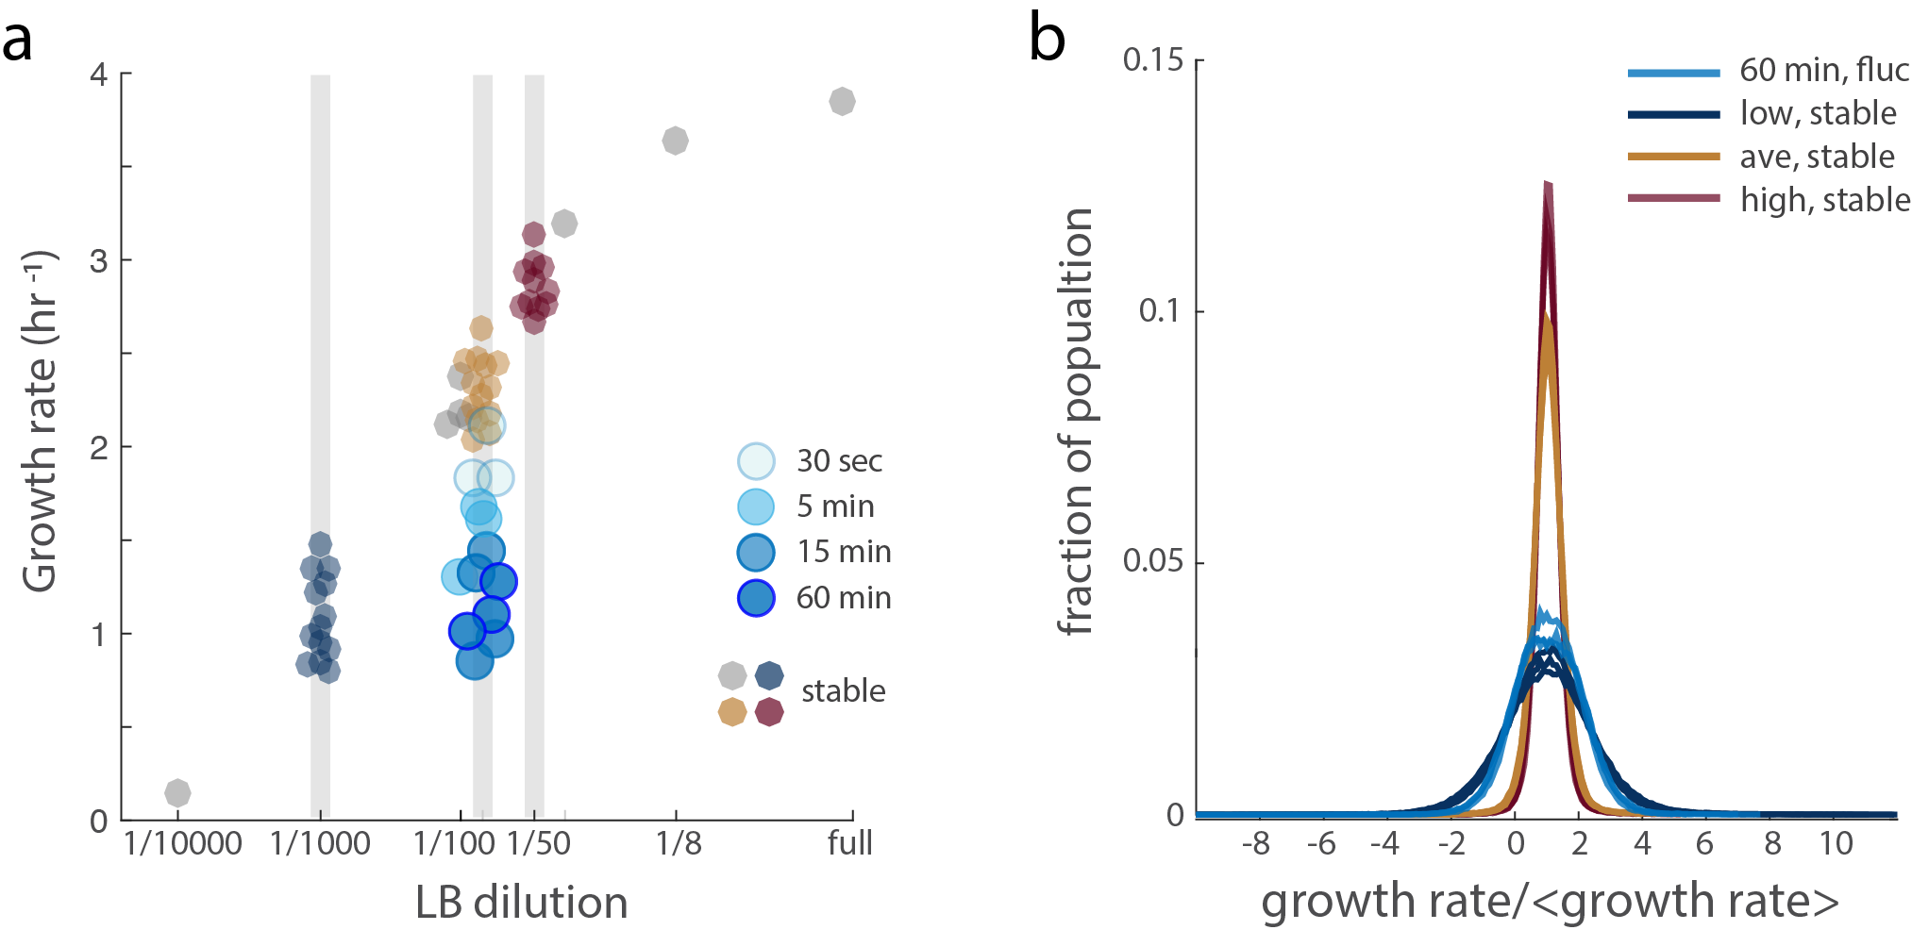

**­**

**Figure 3. Nutrient fluctuations at timescales characteristic of realistic environments reduce growth**. (**A**) Time-averaged growth rate versus time-averaged nutrient concentration. Each point represents the mean growth rate of all individual growth rates measured after 3 hours into each technical replicate. To compare environments of equal time-averaged nutrient concentration, data from steady average LB environments are vertically aligned with data from fluctuating environments with nutrient oscillations of varying period lengths: 30-sec, 5-min, 15-min, and 60-min (lightest to darkest blue, respectively). Error bars report standard error of the mean and are smaller than the points.

(**B**) Probability density functions of instantaneous growth rates from populations experiencing nutrient oscillations of a 60-min period (blue), steady low LB (dark purple), steady average LB (yellow) and steady high LB (red). The three curves of each color represent a unique biological replicate. Normalizing by the mean growth rate population reveals two distinct growth regimes: fast vs. slow.

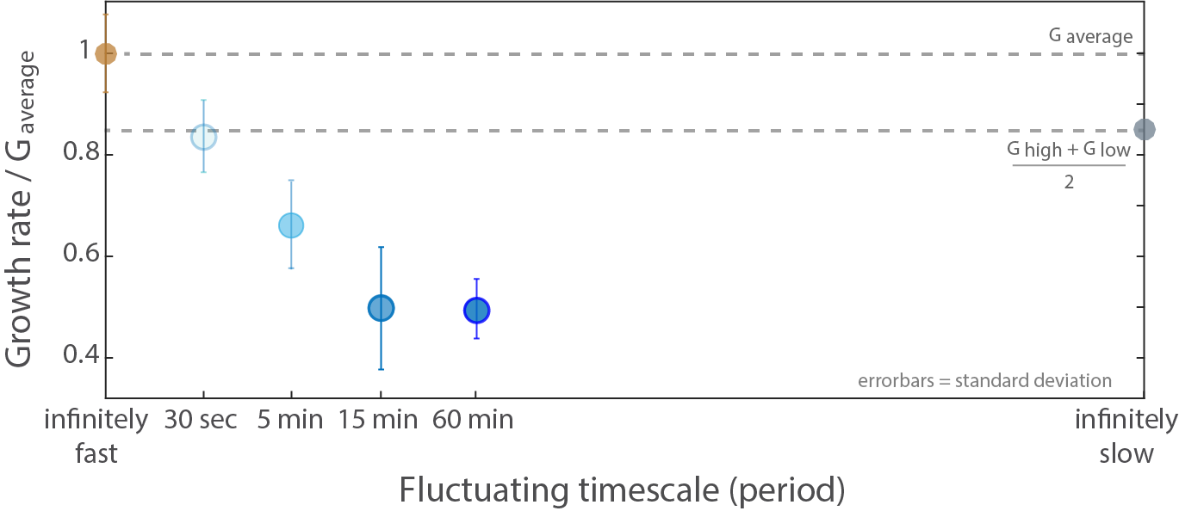

**Figure 4. Nutrient fluctuations can reduce growth rates by 15-50%, depending on the timescale.** Growth rates under fluctuation (blues) as a fraction of measured growth rate in the steady average nutrient environment (yellow). Were adaptation between high and low perfect, a calculated point (filled gray) represents the expected growth reduction from the nonlinear gain in growth rate with increasing nutrient concentration. Additional calculated points (hollow gray) illustrate the hypothetical recovery in growth rate as timescales become increasingly long relative to timescales of adaptation. Each measured data point (colored) represents the average mean growth rate between experimental replicates. Error bars report standard deviation.

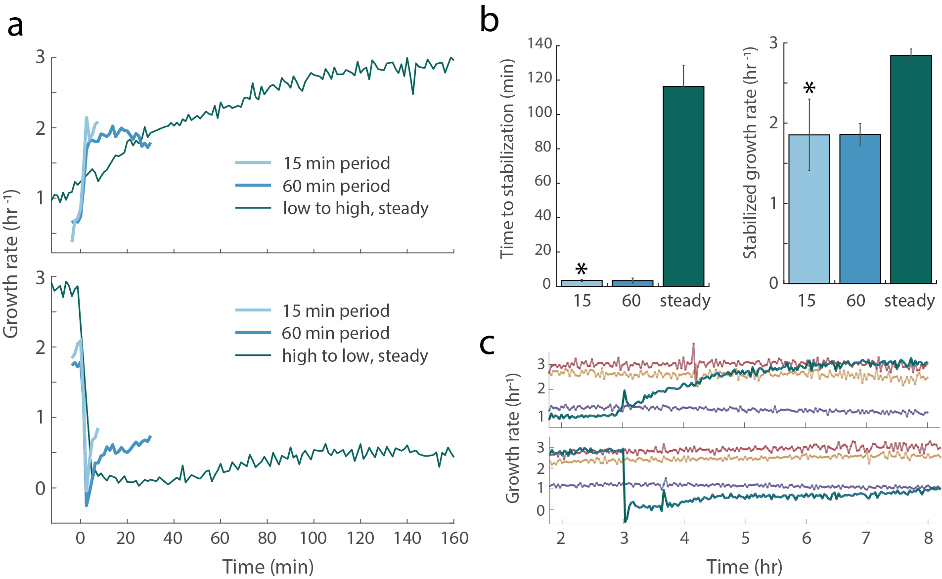

**Figure 5. Evidence of a fluctuation-adapted physiology.** (**A**) Response of growth rate to a nutrient upshift (top) or downshift (bottom), comparing cells exposed to repeated nutrient shifts with cells growing at steady-state prior to the shift (time zero). Data before time zero is the population averaged growth rate preceding the nutrient shift. Post-shift data in fluctuating environments (blues) are plotted up until the point of the next (opposite) shift. Data from steady low shifted to steady high and *vice versa* are plotted in green. (**B**) (**C**)

Bacteria are ubiquitous and are responsible for a broad range of processes in nature, industry and health. Perhaps the most striking contrast between the scale of individual bacteria and the scale at which their effect is realized occurs in the ocean, where these micrometer-sized organisms drive biogeochemical dynamics at scales of hundreds of kilometers (REF 1-3). For example, organic matter tends to sink in the ocean in the form of particles, resulting from the death and coagulation of photosynthetic microorganisms (phytoplankton), removing carbon from the upper ocean and burying it at depth for hundreds of years (REF 4). The magnitude of this vertical flux, also called “the biological pump”, is shaped by bacteria: the more particles they remineralize, the less material reaches the bottom. How microbes access and grow on this organic matter is thus important for the physiology of the bacteria, but also for the biogeochemistry of the oceans.

Our understanding of how bacteria access nutrients in aquatic environments has to-date remained rather simplified, owing to both the technical challenges of replicating key features of the natural nutrient landscape and to a diminishing focus in the field on physiological studies in favor of genomic ones. The realization that the natural environment of aquatic bacteria is rarely the steady, homogenous habitat has not yet translated into systematic experiments to determine how microbial growth is affected by spatially and temporally variable conditions. To date, studies of microbial processes in the ocean still typically examine large-volume water samples (>liters) collected across large spatial scales and at low temporal resolution (REF 8-10). Yet, over the past two decades it has become clear that the nutrient landscape of marine bacterial is characterized by a plethora of microscale sources and hotspots, often sub-millimeter in size, including the lysis of other microorganisms such as phytoplankton cells, excretions by larger organisms such as copepods, marine particles, fecal pellets, and sloppy feeding events (REF 11-15). Further variability is introduced by turbulence, which is nearly always present in aquatic environments ad stirs larger nutrient sources into filaments on the scale of 30-300 micrometers. The nutrient landscape is thus characterized by hotspots of high nutrient concentration amidst an otherwise nutrient poor ocean. From the perspective of individual bacteria, this microscale heterogeneity results in strong temporal fluctuations in nutrient concentration, with characteristic timescales of tens of seconds to several minutes (REF 6). We refer to these fluctuations as “high-frequency fluctuations”, to distinguish them from other slower fluctuations, such as diurnal or seasonal ones. Here, we consider “high-frequency” as any fluctuation occurring on a timescale shorter than the cell doubling time, typically 30-60 min in the laboratory and several hours in the ocean. These scales are currently inaccessible *in situ*.

Beyond this coarse classification, and the recognition that some bacteria can exploit fleeting nutrient concentrations, we still largely ignore how temporal changes in nutrient concentration impact the physiology, growth and ultimately the biogeochemical effects of marine bacteria, compared to the classic picture of growth in steady conditions. In fact, microorganisms have traditionally been studied in steady or quasi-steady environments: in chemostats the environment is imposed to be steady, while changes in batch cultures are slow and gradual. Realization of controlled, high-frequency nutrient fluctuations in the laboratory requires rapid and accurate temporal control of the cells’ environment, which is often beyond traditional culture approaches.

This project also builds upon classic experiments on growth adaptations to single up- or down-shifts in nutrients (REF 25-27). Such studies have identified multiple factors (DNA-binding proteins, metabolic enzymes, transporters, non-coding RNAs) as regulated in response to single nutrient shifts (REF 27), and have characterized the molecular adaptations to such shifts including the timescales over which DNA, RNA, protein and biomass synthesis rates change, and the gene-specific dynamics of transcript and protein abundance (REF 28). Here, instead of single shifts, we will investigate whether bacteria have specific adaptations to repeated changes in nutrient concentration – to fluctuations.

^ End of 2.1 in SNSF research proposal.