Transactions

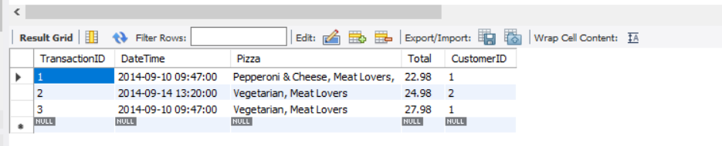

MENU

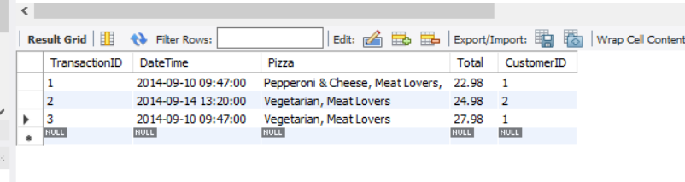

CustomerID

