1. pip install Django (We know you already ran this one. What information do you see returned in terminal after this command?)

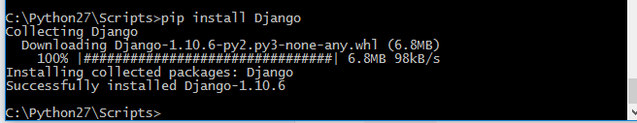

2.

Looks pip freeze pauses the program running? In this case Djanjo.

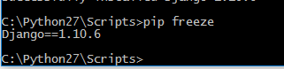

Pip list deprecates. It will switch default formatto columns in the future.



3. 