Excess Mortality in the Age of COVID-19

Data Mining for Insights into Death

Julie Kirkpatrick  
 University of Colorado Boulder  
 Boulder Colorado USA  
 juki9272@colorado.edu

Alex Melnick  
 University of Colorado Boulder  
 Boulder Colorado USA  
 alme9138@colorado.edu

Kyle Tomlinson  
University of Colorado Boulder  
 Boulder Colorado USA  
 kyto3309@colorado.edu

ABSTRACT

One of the main challenges of understanding the COVID-19 pandemic is the lack of quality inputs for the number of cases and deaths experienced in a given population. At times, particularly early in the pandemic, testing resources were limited and many cases went unconfirmed. As the pandemic progressed, testing was not conducted universally, leaving an unknown number of COVID infections undiagnosed. At the same time, while deaths due to COVID are reported more reliably, this count fails to account for the second-order effects of the pandemic. Measuring excess mortality and using that as the basis for investigating the consequences and actions taken in response to the pandemic held promise for better illuminating some of the unknowns.

Some questions we investigated:

* Were excess mortality rates higher during the pandemic at a statistically significant level?
* Could relative excess mortality rates be used to rank the success of various countries at controlling the pandemic?
* How closely did reported COVID deaths match overall excess mortality?
* Are stringent public health measures related to excess mortality rates?
* In the absence of testing, can the number of cases be predicted based on other, more easily measured predictors?

We generated normalized excess mortality rates based on a publicly available mortality database using linear regression and normalization by population. Using these quantities in concert with information from COVID datasets, we were able to visualize a significant increase in excessive mortality in the majority of countries in the period from 2020 to 2022. Some countries, such as Taiwan and South Korea, outperformed other countries overall as they were able to keep their excess mortality within two standard deviations of normal levels. Total excess mortality globally outstripped reported COVID deaths, indicating that second-order mortality increased along with COVID or that deaths attributed to COVID did not fully account for all COVID deaths. Finally, we found a positive correlation between excess mortality and the stringency of public health measures. This correlation diminished in the weeks following the implementation of such measures, possibly indicating effectiveness over time. Attempts to correlate vaccination rates to overall mortality rates and attempts to predict cases based on other factors were inconclusive.

CCS CONCEPTS

• Applied computing~Life and medical sciences~Health care information systems

KEYWORDS

COVD-19, Mortality, Data Mining, Excess Mortality, Coronavirus, Pandemic, Data Collection

ACM Reference format:

Julie Kirkpatrick, Alex Melnick and Kyle Tomlinson. Excess Mortality in the Age of COVID-19: Data Mining for Insights into Death.

1  Introduction

When a global pandemic hits, there are many questions to answer and few clear answers. At the most basic level, there is debate in society over a question as simple as “Have people died as a result of the COVID-19 Pandemic?” The pandemic has disrupted society on myriad levels as governments and people make attempts to control the fallout from the pandemic. Using COVID datasets and a derivation of excess mortality, we have attempted to answer five key questions:

*Were excess mortality rates higher during the pandemic at a statistically significant level?*

Frustration at lockdowns, mask mandates, and other public health measures has some people questioning whether attempting to control the pandemic is even necessary. The ability to clearly show that overall mortality has risen significantly during the pandemic will provide a foundational reason for modifying personal behavior and implementing public health controls and counteract the claim that deaths attributed to COVID are merely relabeled deaths from other causes. A clear increase in overall mortality will indicate that the pandemic does, in fact, cause more deaths than the null hypothesis.

*Could relative excess mortality rates be used to rank the success of various countries at controlling the pandemic?*

Different countries approached the pandemic in different ways, such as the strict quarantine of New Zealand or the relative non-intervention of Sweden. Normalizing and comparing excess mortality may provide a method of measuring which national approaches and circumstances enjoyed the most success.

*How closely did reported COVID deaths match overall excess mortality?*

There are both challenges and incentives/disincentives to accurately reporting COVID deaths and measuring the toll of the pandemic. Assessing how closely the reporting of the world and individual countries matched the overall excess mortality will provide insight into where the deltas exist.

*Are stringent public health measures related to excess mortality rates?*

This question seeks to determine if public health measures do, in fact, lead to a reduction in mortality during the pandemic. If so, this will provide motivation for public health controls in future pandemics and insight into the calculus of weighing public health against competing interests.

*In the absence of testing, can the number of cases be predicted based on other, more easily measured predictors?*

Without testing the population regularly, it is difficult to gain a true understanding of the number of COVID cases during the pandemic, which in turn makes it difficult to assess the efficacy of public health measures or conditions that are correlated to pandemic outcomes. Being able to reliably reverse engineer case counts based on excess mortality or other factors might provide a more complete picture of the true case count.

**2 Related Work**

A substantial amount of research has been done in regards to the pandemic’s effects on mortality rates. Unfortunately, factors such as availability of testing supplies and political influences on public health messaging result in substantial differences between countries and subregions in reporting deaths as attributable to COVID-19 [2, 3, 6]. As a result of these differences public health research has often focused on a different metric: excess mortality, which refers to the number of deaths occurring over and above predicted mortality rates for a population [4]. The variation between reported COVID-19 mortality and excess mortality rates can be staggering: one example country reported 300,000 COVID-19 deaths but had over one million projected deaths over and above expected baseline mortality rates [6]. The majority of prior work focuses on either total excess mortality, a value that is relatively easier to state with confidence, or excess mortality directly attributable to COVID-19.

Predicted mortality rates establish a baseline upon which to compare mortality rates during the pandemic. The four-year period between 2015-2019 is commonly used to create these predicted rates[6, 4, 9], though some models opt to use different periods for a variety of reasons[2, 4, 5]. One of the primary challenges in creating an accurate baseline is the presence of non-pandemic-related factors that affect mortality rates. Changes in population demographics such as age can exhibit a powerful effect on actual mortality[1].

One article in particular, What has happened to non-COVID mortality during the pandemic?[8], does seek to address the same basic question that our project is focused on. While the scope of said article is restricted solely to the United Kingdom, it does provide a possible roadmap for our own inquiries. Another (admittedly pre-print) article presents a possibility for teasing out changes in specific non-COVID-19 mortality types by projecting current mortality rate subtype units in lieu of local units [7].

**3 Data Set**

We will be utilizing 3 data sets:

Human Mortality Database (HMD), which contains mortality data by week and age group for 38 countries Accessed at: <https://www.mortality.org/>, COVID-19 Dataset (COVID) which contains Global COVID Statistics by country and date Accessed at: <https://ourworldindata.org/explorers/coronavirus-data-explorer> , and COVID-19 Stringency Index which contains time series information on countries and the stringency of their policies regarding the pandemic. They also housed a separate dataset detailing the vaccination rates of various countries. Accessed at: <https://ourworldindata.org/covid-stringency-index>

List of 36 Countries investigated

|  |  |
| --- | --- |
| **Country** | **Code** |
| Australia | AUS |
| Austria | AUT |
| Belgium | BEL |
| Bulgaria | BGR |
| Croatia | HRV |
| Chile | CHL |
| Czechia | CZE |
| Denmark | DNK |
| Estonia | EST |
| Finland | FIN |
| France | FRA |
| Germany | DEU |
| Greece | GRC |
| Hungary | HUN |
| Iceland | ISL |
| Israel | ISR |
| Italy | ITA |
| Latvia | LVA |
| Lithuania | LTU |
| Luxembourg | LUX |
| Netherlands | NLD |
| New Zealand | NZL |
| Norway | NOR |
| Poland | POL |
| Portugal | PRT |
| South Korea | KOR |
| Russia | RUS |
| Slovakia | SVK |
| Slovenia | SVN |
| Spain | ESP |
| Switzerland | CHE |
| Sweden | SWE |
| Taiwan | TWN |
| United Kingdom | GBR |
| United States | USA |

Human Mortality Database

|  |  |  |
| --- | --- | --- |
| Name | Type | Description |
| CountryCode | Nominal String | Identifies country |
| Year | Ordinal Integer | Year in 1-year increments |
| Week | Ordinal Integer | Week from 1-52 from 1st full week of year |
| Sex | Nominal String | male, female, and combined |
| D0_14 | Ordinal float | # of deaths age 0 to 14 (float due to transforming input data) |
| D15_64 | Ordinal float | # of deaths age 15 to 64 (float due to transforming input data) |
| D65_74 | Ordinal float | # of deaths age 65 to 74 (float due to transforming input data) |
| D75_84 | Ordinal float | # of deaths age 75 to 84 (float due to transforming input data) |
| D85p | Ordinal float | # of deaths age 85+ |
| DTotal | Ordinal integer | Total # of deaths for all age groups |

COVID-19 Dataset

|  |  |  |
| --- | --- | --- |
| Name | Type | Description |
| iso_code | Nominal String | Identifies country |
| Date | Ordinal String | Date in MM/DD/YYYY format |
| total_cases | Ordinal Integer | Daily total of COVID cases; does not decrease with recovery or death |
| new_cases | Ordinal Integer | Daily new cases reported |
| total_deaths | Ordinal Integer | Daily total of COVID cases |
| new_deaths | Ordinal Integer | Daily new deaths reported |
| total_cases_per_million | Ordinal float | total_cases per million |
| new_cases_per_million | Ordinal float | New_cases per million |
| hops_patients | Ordinal Integer | Daily total of COVID cases hospitalized; does decrease with recovery or death |
| population | Ordinal integer | Population of country; does not change |

COVID-19 Stringency Index

|  |  |  |
| --- | --- | --- |
| Name | Type | Description |
| Entity | Nominal String | Identifies country full name |
| Code | Nominal String | Identifies country code |
| Day | Ordinal String | Date in MM/DD/YYYY format |
| stringency_index | Ordinal Float | The index on any given day is calculated as the mean score of the nine metrics, 0 -100, with 100 being the strictest |

The stringency index includes the following metrics: school closures; workplace closures; cancellation of public events; restrictions on public gatherings; closures of public transport; stay-at-home requirements; public information campaigns; restrictions on internal movements; and international travel controls.

COVID-19 Vaccination Dataset

|  |  |  |
| --- | --- | --- |
| Name | Type | Description |
| location | Nominal String | Identifies country full name |
| iso_code | Nominal String | Identifies country code |
| date | Ordinal String | Date in MM/DD/YYYY format |
| People_fully_  vaccinated | Ordinal integer | Total number of people who have received 2+ vaccination shots |

**5 Main Techniques Applied**

**5.1 Data Cleaning and Preprocessing**

Tools used: Python with Pandas and numpy libraries

COVID

* Retained only the following attributes: country, date, total_cases, new_cases, total_deaths, new_deaths, total_cases_per_million, hosp_patients, and population
* Dataset was resampled from daily to weekly data. “New” columns were summed and “Total” columns were retained as the first value in each week.
* “year” and “week” columns were extracted from the date column

HMD

* The individual “male” and “female” categories were dropped while the combined category was retained
* Retained only the following attributes: country, week, year, DTotal
* Country codes that differed from the COVID dataset were transformed to match
* Great Britain data, split into England and Wales, Scotland, and Northern Ireland categories, was combined, summing the DTotal. Years prior to 2015 were eliminated due to missing information for Scotland and Northern Ireland in those ranges.
* “week” and “year” were transformed into a “date” column to assist in merging and visualizations

COVID Stringency Index

* Because we only have stringency index data from the beginning of the pandemic, another dataframe was made from the previously merged and cleaned datasets.
* Filtered first by the countries that we have excess mortality data on by excluding country codes that are not present in the cleaned, merged dataset.
* Day column converted to a datetime datatype, in order to pull the week number and year.
* Grouped and averaged indices by country code, week number, and year.

**5.2 Data Warehouse Techniques**

Though no formal data warehouse was established, two techniques were borrowed from the data warehouse scheme. First, aggregating the COVID datasets from daily data to weekly data was a form of drill-up. This allowed us to combine rows into a less granular form in order to match the HMD dataset. In addition, the aggregation had the effect of smoothing the data without a loss of fidelity. Secondly, use of Tableau as a tool allowed a much more efficient method of manipulating and filtering data from the datasets than could be accomplished by hand or through python, our principle tool for queries and manipulations. A good example of this was the initial plot of normalized excess mortality by country.

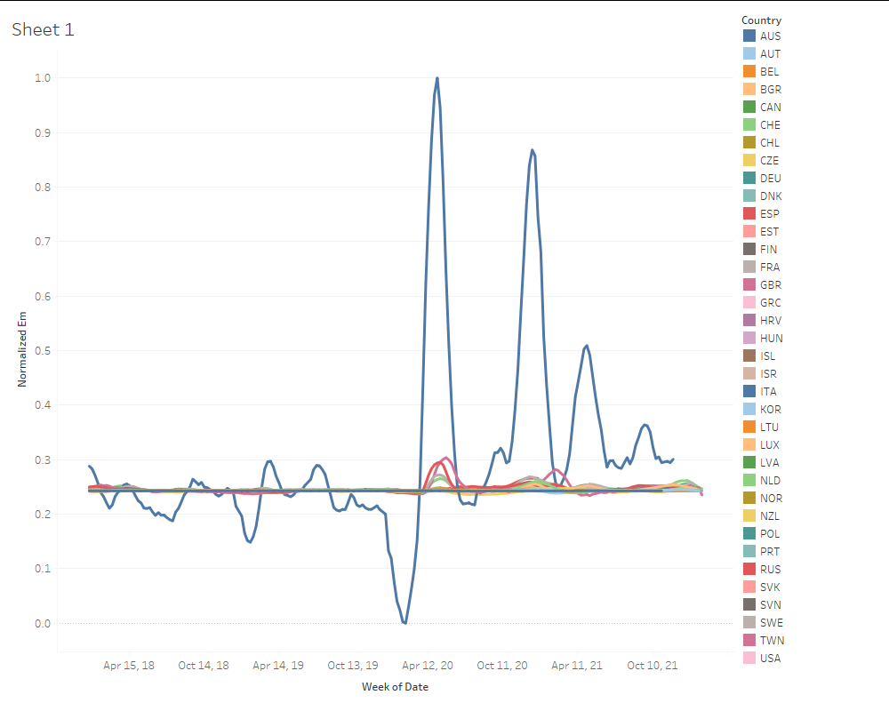

Figure 1: Excess Mortality over Time with Errors

At a glance (see figure 1), Italy was such an outlier that it indicated some mistakes were made in the data processing. In fact, some population values had been misassigned while merging datasets, causing the false outliers. The efficiency of Tableau as a tool for interrogating the data allowed us to recognize and rectify this before drawing any erroneous conclusions.

**5.3 Data Mining**

Once both datasets were preprocessed and cleaned, we merged them into a single dataset. We then derived some additional attributes:

For both weekly deaths and weekly new cases, a moving average was computed by taking the mean of the nearest seven weeks in order to smooth the data and reduce the effects of random variation. Using the smoothed weekly death average for each individual week (e.g., week 1 of all years, week 2 of all years, etc.) we made a linear regression model based on ordinary least squares for each country to predict the number of expected deaths for each combination of week number and year. This was performed by week number to account for cyclical mortality rates that tend to rise and fall based on time of the year.

A linear regression was deemed appropriate as it would account for many unknown factors that make up the normal mortality rate for any given country, such as changes in healthcare standards, large disasters, or widespread external factors.

Subtracting the predicted weekly deaths from the actual deaths gave us an excess mortality number for each country/date combination.

To normalize for population and better compare between countries, we divided excess mortality by population to create the em_per_capita attribute. We further normalized this measure by performing a min-max normalization across all countries.

To check these results, we placed the per capita excess mortality rates for all years prior to 2020 into a normal distribution using the statsmodel library. This allowed us to compute the standard deviation in order to evaluate the null hypothesis against the hypothesis that excess mortality rates had increased from 2020 to 2022 during the pandemic.

Visualizations were a powerful tool as we evaluated the significance of our work and interrogated the correlation between our data parameters. Comparisons were made quickly and efficiently between countries, between reported COVID deaths and overall excess mortality, and between predictors to assess the correlation between various inputs.

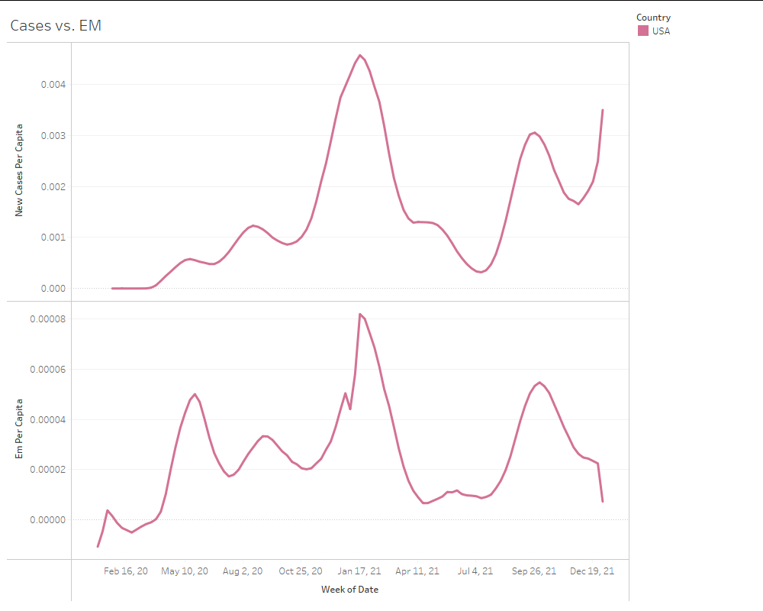

Figure 2: Reported Cases (top) vs. Excess Mortality (USA)

“A picture tells a thousand words” is apt during the data exploration process. The line graph in figure 2, for example, compares reported cases (aggregated from daily to weekly) from one dataset with excess mortality from another dataset (derived from multiple attributes). The result shows a clear correlation between rising cases and excess mortality, indicating a successful data clean, merge, and mining process. In addition, it provokes potential lines of investigation, such as the lack of testing early in the pandemic indicating low case numbers but resulting in high mortality or relatively high case numbers correlated to lower mortality later in the pandemic, potentially indicating the change in virus variants or the success of vaccination campaigns.

**6 Key Results**

*Were excess mortality rates higher during the pandemic at a statistically significant level?*

To answer this question, we fit the weekly mortality rates by capita for each country in the years before 2020 into a normal distribution with a mean of essentially 0 () and a standard deviation of 8.616 excess deaths per million people. Computing the 95% confidence interval yielded a lower critical value of -14.172 excess deaths per million and a higher critical value of 14.172 excess deaths per million people.

Using this distribution, we normalized all of the excess mortality rates, giving each a z-score. Plotting these normalized excess mortality rates over time and the 95% confidence interval, a clear delineation is visible between the pre-COVID years and the years since 2020.

Figure 3: Z-Score Normalized Excess Mortality

The dark band in Figure 3 denotes the 95% confidence interval. A marked period of excess mortality beyond the limits of that confidence interval is visible beginning in 2020.

Figure 4: Median Excess Mortality Z-Score (Global)

While there are a number of countries that momentarily exceeded the confidence interval in non-pandemic years, looking at the median score in figure 4, this is an outlier restricted to February 2017 overall. Further investigation could be warranted into what is causing the spike in excess mortality at that time.

Overall, however, both charts show unequivocally that the pandemic years were host to a significant increase in excess mortality rates.

*Could relative excess mortality rates be used to rank the success of various countries at controlling the pandemic?*

To answer this question, we interrogate the excess mortality rates during the 2020-2022 period and counted the number of weeks in which a country experienced a statistically significant increase in excess mortality rate at the 95% confidence level. These values were divided by the number of weeks during the period to produce an overall percentage of time spent experiencing excess mortality. There are myriad ways one could approach ranking the countries; we settled on this method as it is interpretable and shows long-term success (or lack thereof) at responding to excess mortality due to COVID-19.

Figure 5: Countries Ranked by Percentage of Time Spent Experiencing Excess Mortality

At the far left of this comparison depicted in Figure 5, Estonia spent 89% of the pandemic with an elevated excess mortality rate. This may be partially due to the effects of a relatively small population (1.3 million) where small changes in mortality rate will have an outsize effect.

Four countries have significant excess mortality more than 60% of the time: United States, Portugal, Latvia, and Bulgaria (See figure 6). At the other end of the scale, four countries experienced statistically significant excess mortality during zero weeks: Australia, Iceland, Korea, New Zealand, and Taiwan (See figure 7).

Figure 6: Excess Mortality 2020-2022 (USA, Portugal, Latvia, Bulgaria)

Figure 7: Excess Mortality 2020-2022 (Australia, Iceland, Korea, New Zealand, Taiwan)

This measure will be useful in determining which features of a country or its public health response will lead to a lower or higher excess mortality rate and can inform predictions and public health policy choices. A quick takeaway from these results shows that countries that lack open land borders can successfully limit excess deaths due to COVID.

*How closely did reported COVID deaths match overall excess mortality?*

To investigate this question, we visualized weekly reported COVID deaths against total excess mortality.

Figure 8: Global COVID Death Reports and Excess Mortality

This lead to two interesting conclusions. First, there is a noticeable lead on number of reported COVID deaths compared to excess mortality. This lead disappeared as the pandemic advanced and excess mortality eclipsed reported COVID deaths and never relinquished the lead. This leads us to believe that the response to the pandemic in the early weeks had the effect of reducing non-COVID mortality rates and leaving a net negative increase in mortality during that period. Second, reported COVID deaths as a sole measure of the mortal impact of the pandemic are insufficient.

Separating the investigation by country had other interesting takeaways:

Figure 9: Russia COVID Death Reports and Excess Mortality

Excess mortality for Russia far outstrips reported COVID deaths. One may suspect the government of Russia is interested in showing an overly-optimistic report of their success during the pandemic.

Figure 10: COVID Death Reports and Excess Mortality AUT, ISL, NZL, and TWN

For four of the five best-performing countries (Australia, Iceland, New Zealand, and Taiwan) the periods of the most reported COVID deaths corresponded to negative periods of negative mortality.

Figure 11: Korea COVID Death Reports and Excess Mortality

Korea, the other best-performing country, followed a similar pattern until the end of 2021, when excess mortality outstripped COVID.

*Are stringent public health measures related to excess mortality rates?*

In reference to stringency, we can see that higher rates of stringency might be associated with higher excess mortality. This goes against what we might believe, as higher stringency should result in less cases, thus less death and a smaller excess mortality.

However, it is possible that the stringent regulations were put in place due to the high excess mortality, and need time to be in effect to show a result in the excess mortality. To explore this, we set an offset of days (in 1 week increments) on the stringency index to see if having some implementation time allowed for a stronger pattern to emerge.

Figure 12: Correlation of Stringency Index with Excess Mortality; Increasing 1 Week offsets

From this we can see there is some effect on offsetting the date, even if it looks like there is no correlation between stringency index and excess mortality per capita from a single chart, the fact that the data shifts backwards shows that there was some effect of stringency on the excess mortality, although perhaps not as strong or statistically significant as initially hypothesized.

Figure 13: Vaccinate Rate vs. New Cases (USA)

Just looking at the data from the USA, we find a slight negative correlation between percent vaccinated and cases. Stringency has been overlayed as a hue to show that vaccinations in addition to more stringent policies are correlated to lower cases. This linear regression has a score of 0.262746.

*In the absence of testing, can the number of cases be predicted based on other, more easily measured predictors?*

We ran multivariate linear regressions as well to try to figure out which attributes caused case numbers to increase or decrease.

Figure 14: Predictive Power of Excess Mortality, Percent Vaccinated, and Stringency Index

Figure 15: Predictive Power of Excess Mortality

Figure 16: Predictive Power of Percent Vaccinated

Figure 17: Predictive Power of Stringency Index

Clearly, excess mortality is the best predictor of case number, although that association might be backwards. However, adding other attributes made the model more predictive. We must be aware of overfitting.

In addition to just isolating the USA, we also did analysis of this type on all other countries. Interestingly, there were more positively correlated cases (21) than negative (12). We suspect this is from the massive spike in cases due to the Omicron variant this past winter, in which is when countries has highest vaccination rates.

Excess mortality does show promise as a predictor that could be used to reconstruct case totals. It is clear, however, that this is a complex environment for a regression model with a target variable that changes over time and where high quality training and test sets will be elusive.

**7 Applications**

On a broad level, the knowledge we have generated in this investigation has underscored the importance and utility of the excess mortality metric. At its most basic level, this shows that the COVID-19 pandemic had a significant and undeniable impact on mortality rates worldwide. This provides an entering motivation for public health policy and provides an interpretable counter-argument to pandemic deniers.

Comparing and contrasting the results of various countries and their circumstances and public health measures can use excess mortality as an equalizing gauge to evaluate the risk factors of a given country and the likely effectiveness of proposed measures. Further analysis that cluster similar countries can illuminate differences in policy that lead to different outcomes.

Our answers to the latter two questions investigating the effect of stringent health measures, though largely inconclusive on specifics, do show the difficulty of isolating correlation and causation in the rapidly-changing and imprecise domain of COVID research and policy. The biggest takeaway is that investigations in this domain should take great care before coming to conclusions. Excess mortality, however, does show promise as an equalizing and dependable measurement of outcome.

REFERENCES

1. David Adam. 2021. The Effort to Count the Pandemic’s Death Toll. In *Nature 601, 312-315 (2022)*. <https://doi.org/10.1038/d41586-022-00104-8>
2. Abhishek Anand, Justin Sandefur, and Arvind Subramanian. 2021. Three New Estimates of India’s All-Cause Excess Mortality during the COVID-19 Pandemic. In *Center for Global Development, Working Paper 589, July 2021, Washington, DC*. <https://www.cgdev.org/publication/three-new-estimates-indias-all-cause-excess-mortality-during-covid-19-pandemic>
3. Héctor Pifarré i Arolas, Enrique Acosta, Guillem López-Casasnovas, Adeline Lo, Catia Nicodemo, Tim Riffe, and Mikko Myrskylä. 2021. Years of life lost to COVID-19 in 81 countries. In *Scientific Reports 11, 3504 (2021).* <https://doi.org/10.1038/s41598-021-83040-3>
4. Thomas Beaney, Jonathan M Clarke, Vageesh Jain, Amelia Kataria Golestaneh, Gemma Lyons, David Salman, and Azeem Majeed. 2020. Excess mortality: the gold standard in measuring the impact of COVID-19 worldwide? In *Journal of the Royal Society of Medicine. 2020;113(9):329-334*. <https://doi.org/10.1177/0141076820956802>
5. Nazrul Islam, Vladimir M Shkolnikov, Rolando J Acosta, Ilya Klimkin, Ichiro Kawachi, Rafael A Irizarry, Gianfranco Alicandro, Kamlesh Khunti, Tom Yates, Dmitri A Jdanov, Martin White, Sarah Lewington, and Ben Lacey. 2021. Excess deaths associated with covid-19 pandemic in 2020: age and sex disaggregated time series analysis in 29 high income countries. In *BMJ 2021;373:n1137*. <https://www.bmj.com/content/373/bmj.n1137>
6. Ariel Karlinsky and Dmitry Kobak. 2021. Tracking excess mortality across countries during the COVID-19 pandemic with the World Mortality Dataset. In *eLife 2021;10:e69336*. <https://doi.org/10.7554/eLife.69336>
7. Ariel Karlinsky. 2021. National Excess Mortality from Sub-National data: Method and Application for Argentina. Preprint in *medRxiv*. <https://doi.org/10.1101/2021.08.30.21262814>
8. Holly Krelle and Charles Tallack. 2021. *What has happened to non-COVID mortality during the pandemic?* The Health Foundation. <https://www.health.org.uk/publications/long-reads/what-has-happened-to-non-covid-mortality-during-the-pandemic>
9. Francesco Sanmarchi, Davide Golinelli, Jacopo Lenzi, Francesco Esposito, Angelo Capodici, Chiara Reno, and Dino Gibertoni. Exploring the Gap Between Excess Mortality and COVID-19 Deaths in 67 Countries. In *JAMA Network Open. 2021;4(7):e2117359*. <https://doi.org/10.1001/jamanetworkopen.2021.17359>

Conference Name:ACM Woodstock conference

Conference Short Name:WOODSTOCK’18

Conference Location:El Paso, Texas USA

ISBN:978-1-4503-0000-0/18/06

Year:2018

Date:June

Copyright Year:2018

Copyright Statement:rightsretained

DOI:10.1145/1234567890

RRH: F. Surname et al.

Price:$15.00