Identification of sulfur tolerant bimetallic surfaces using DFT parameterized models and atomistic thermodynamics
Nilay İnoğlu¹, John R. Kitchin^{1,2}*
1 .Department of Chemical Engineering, Carnegie Mellon University, Pittsburgh PA, 15213, USA.
2. National Energy Technology Laboratory, Pittsburgh, PA 15236, USA.
Corresponding Author
*E-mail: jkitchin@andrew.cmu.edu
ABSTRACT

The identification of sulfur tolerant alloys for catalytic applications is difficult due to the combinatorially large number of alloy compositions and surface structures that may be considered. Density functional theory calculations (DFT) are not fast enough to enumerate all the possible structures and their sulfur tolerance. In this work a DFT parameterized algebraic model that accounts for structure and composition was used to estimate the d-band properties and sulfur adsorption energies of 400 transition metal-based bimetallic alloy surfaces. The estimated properties were validated by DFT calculations for 110 of the surface structures. We then utilized an atomistic thermodynamic framework that includes surface segregation, the presence of adsorbates and effects of environmental conditions to identify alloy compositions and structures with enhanced sulfur tolerance that are likely to be stable under the environmental conditions. As a case study, we show how this database can be used to identify sulfur-tolerant Cu-based catalysts and compare the results to what is known about these catalysts experimentally.

Keywords: Sulfur tolerance; Bimetallic surface structures; Electronic structure modification; d-band width formalism; Solid-state table; Segregation; Atomistic thermodynamics.

INTRODUCTION
Transition metal catalysts are frequently employed in chemical processes. Sulfur (S) containing molecules are common impurities in fossil fuel derived feedstocks and one of the major problems associated with the use of these metal-based catalysts is sulfur poisoning. Studies have demonstrated that sulfur poisoning has a very negative impact on the performance of the catalysts used in industrial applications. The identification of sulfur tolerant catalysts remains an important and outstanding problem in catalysis.
Sulfur poisoning is a complicated phenomenon. The performance reduction induced by sulfur poisoning results from combinations of the formation of new chemical compounds on the catalyst surface such as sulfide films, modifications in the crystal morphology, blockage of active sites by adsorbed S atoms, and changes in the electronic characteristics of the metal catalysts.^{3,4} One way to improve the sulfur tolerance of metal catalysts may be to modify their electronic properties by alloying.^{3,5} Therefore, understanding the interactions of S with alloy surfaces is necessary to achieve a better understanding of sulfur tolerance and to be able to identify and design sulfur tolerant catalysts. These facts have motivated many computational and experimental studies of sulfur adsorption on many different surfaces.^{1,6}
Pt-Pd bimetallic catalysts have shown better performance towards hydrogenation, paraffin hydroisomerization/hydrocracking and naphtha reforming than either of the monometallic catalysts in terms of selectivity and resistance to S poisoning as well as increased activity. ⁵ The higher sulfur tolerance of these systems was attributed to structural and electronic effects due to alloying. The reactivity of Pd surfaces is strongly modified even by small amounts of S, and Pd alloyed with Cu and Ag appears to be the most promising materials for the commercial hydrogen separation process when S-poisoning is a problem.⁷ It has also been reported that S-Pt bonds modify the structure of the surface Pt d-band causing a decrease in the density of states near the Fermi level of the system and finally resulting in a reduction in the activity of the catalyst based on these electronic perturbations.^{1,6} Rodriguez et al. suggested that a Pt/Sn alloy is a better option than Cu or Ag alloys for reducing the sensitivity of the Pt reforming catalyst towards S poisoning.³ Similarly, it has been shown that SO₂ adsorption on Cu/Ag(111) surfaces differs significantly from that of pure Ag systems; the more Cu atoms there are in the alloy surface the stronger the SO₂ binding energies are.⁸
S poisoning of alloy systems is more difficult to understand than S poisoning of monometallic systems due to the nature of the metal-metal and sulfur-metal interactions that could lead to the occurrence of different phenomena in the alloy system than in the monometallic system. Depending on the chemical potential of S, the formation of bimetallic sulfides that exhibit very different chemical properties from those of the pure metals has been observed.⁹ In some systems, S poisoning could result in surface segregation due to the stronger interaction between S and one of the metal atoms.^{10,11} It is also possible to observe some alloy systems in which alloy formation causes a decrease in the affinity of S towards both metals.³ In some systems, the presence of a specific type of atom promotes the reactivity of the other metal towards S. This effect can actually be beneficial for hydrodesulfurization catalysis.¹²
Even though it has been shown that S tolerance could be enhanced by the utilization of alloys, choosing which metals to use is still a demanding task due to the large number of combinations of metals and surface structures that could be considered. Experimental evaluation of the S tolerance requires the synthesis and characterization of a large number of alloys which is time-consuming and expensive. These experiments need to be rationally guided to reduce the amount of work required and to accelerate the discovery of new materials.
One approach to identifying new materials uses computational tools such as density functional theory (DFT) to compute the properties of a large database of structures, and then to apply screening methodologies to identify promising candidates.¹³⁻¹⁵ At large scales, e.g. more than thousands of calculations, even DFT calculations can become prohibitively time consuming, and simpler, more efficient models are needed. For example, Greeley showed that the adsorption energy of oxygen on a multicomponent metal site can be efficiently and reasonably approximated by a composition weighted average of the pure component adsorption energies.¹⁵ Alternatively, one can compute a simple descriptor that is related to the catalytic property of interest through models.
One of the simple models that has been widely used to explain trends in the reactivity of transition metals using a descriptor is the d-band model. The basic trends in the reactivity of many different transition metal based systems involving pure metals, surface alloys, surfaces with strain,²⁰ poisons, promoters ²¹ and electron deficient sites ²⁰ are captured by the model. There are some reports in the literature showing the limitations of the d-band model in capturing the reactivity of some systems especially those involving noble metals,²²⁻²⁴ but overall the model allows one to estimate alloy reactivity efficiently and with moderate accuracy in many cases.
The utility of the d-band model is that very often there is a good correlation between the d-band centers (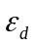) and/or the d-band widths (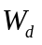) of a metal surface and the surface reactivity. This significantly reduces the computational expense because computing d-band properties is much cheaper than computing adsorption energies. However, this still requires a DFT calculation for each surface considered and that can still be prohibitively expensive for large numbers of calculations. We have developed a simple, algebraic d-band width model (the DFT parameterized Solid State Table) with predictive capabilities of the d-band characteristics of many different surface structures. This model utilizes the correlation between the width of the surface d-band and the interatomic matrix element (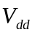) between neighboring atoms.²⁷ The d-band width of transition metals is directly proportional to the d-band center due to band-filling constraints. Consequently, we can very efficiently compute the d-band widths and then estimate the reactivity of alloy surfaces. The presence of adsorbates can also be taken into account by the model through the coupling matrix elements of the metal and the adsorbed atom. Thus, the model is capable of estimating the coverage dependence of the surface electronic structure as well. The development of this simple model having predictive capabilities of d-band characteristics can be used as the basis of a screening tool for the identification of surface structures with desirable properties.
In this work we examine the sulfur tolerance of binary combinations of 10 different late transition metal atoms (Fe, Ni, Cu, Ru, Rh, Pd, Ag, Ir, Pt and Au) in four different surface structures (Figure 1). This requires evaluating the S tolerance of 400 surfaces. This is too many structures to directly evaluate using DFT. We computed the S adsorption energies and d-band widths of a subset (110) of these structures to establish a correlation between the surface electronic structure and S adsorption properties. We then used the DFT parameterized Solid State Table to rapidly estimate the d-band widths of all 400 structure and predicted the S adsorption energies from the DFT derived correlation. To evaluate the stability of each structure we utilized an atomistic thermodynamic framework that includes the effects of surface segregation, adsorption and the environmental conditions (pressure and temperature) to determine which structures were thermodynamically stable and more sulfur tolerant than pure metals.
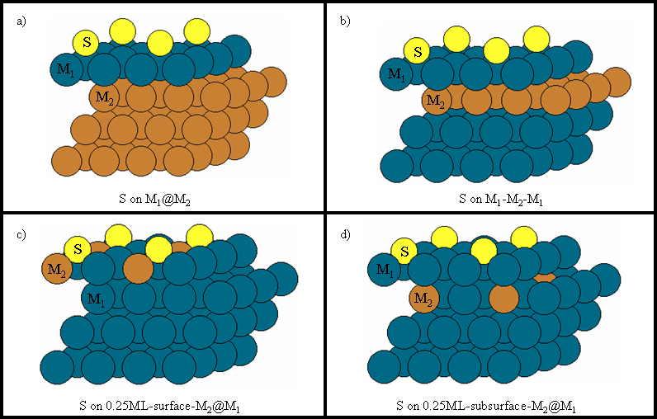
Figure 1. The binary alloy and adsorption structures considered in this work: a) Heteroepitaxial overlayer, b) heteroepitaxial subsurface underlayer, c) 0.25ML surface dopant, and d) 0.25ML subsurface dopant. The labeling scheme used in the manuscript is indicated in each figure. The adsorption site and the configurations of the considered alloys are shown.
METHODS
In this study we utilized the DACAPO code for all DFT calculations.²⁸ Both pure and alloy surface structures were modeled as slabs that were repeated periodically in a cell geometry with 10 Å of vacuum space in between any two successive slabs. For each different surface structure, we utilized the fcc crystal structure with lattice constants optimized for the host metal. Spin-polarized calculations were used where needed for slabs containing magnetic atoms. The slabs were modeled in a 2×2 unit cell consisting of 4-layers. The upper two layers were relaxed until the root mean squared forces were less than 0.05eV/Å, keeping the other layers at the frozen bulk coordinates. Sulfur adsorption was performed by placing a single atom on one side of the slab corresponding to a surface coverage of 0.25ML at its most stable fcc adsorption site. At low coverages this is reasonable; at higher coverages reconstructions may occur, as well as S-S bond formation. We are interested in identifying the onset of S-poisoning, thus the use of low coverages is appropriate. Ionic cores were described by Vanderbilt ultrasoft pseudopotentials and the one electron valence eigenstates were expanded in a plane wave basis set with a cutoff energy of 340 eV. The exchange correlation functional used was the generalized gradient approximation (GGA) due to Perdew-Wang (PW91). Brillouin-zone integrations were performed using a 6×6×1 Monkhorst-Pack grid for the 2×2 surface unit cell. In our experience, these calculation parameters lead to convergence in the S adsorption energies of less than 50 meV/adsorbate. The atom-projected d-bands were calculated by projecting the computed wave functions onto atomic orbitals localized on each atom. The d-band width is calculated as the square root of the second moment of the d-band with respect to the Fermi level as 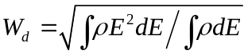.
For each heteroepitaxial overlayer alloy structure, we utilized three substrate layers and one surface layer. The lattice constants of the bimetallic structures were dictated by the lattice constant of the substrate (host) atom. In total, we considered binary combinations of 10 different late transition metal atoms (Fe, Ni, Cu, Ru, Rh, Pd, Ag, Ir, Pt and Au) in four different surface structures (Figure 1).
The stability of alloy systems can be evaluated by comparing the surface free energies to reference systems. The most stable surface structure is the one that minimizes the surface free energy, , which is a function of temperature, pressure and composition. We express the surface free energy as,
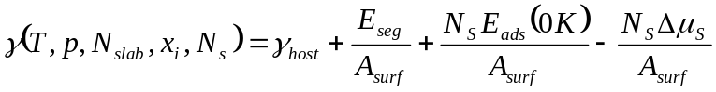 (1).
In the above surface free energy expression,  is the surface free energy for the clean surface of the host metal. 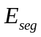corresponds to the segregation of an impurity atom from the bulk to the surface. A negative value for indicates favorable segregation to the surface. We have assumed in this work that the segregation energy contribution is not alloy concentration dependent. We define the S adsorption energy at 0K (in the approximation where 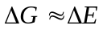) as,
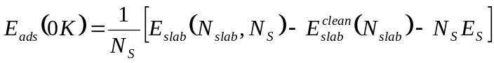 (2)
Negative S adsorption energies are exothermic.
The S chemical potential 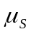 is expressed in terms of the difference in chemical potentials of gas phase H₂S and H₂. For S adsorption, if the S chemical potential becomes equal to or greater than that of bulk S (S-rich conditions) then S will begin to condense on the surface and form the bulk S phase (in addition to possibly forming bulk metal-sulfides) leading to a total deactivation of the surface. There is no lower limit for the S chemical potential; a chemical potential of -∞ corresponds to a gas-phase environment with no sulfur in it. We define 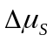 as 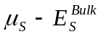. We used the phase of S for 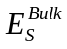 and shifted the limits to have the S-rich chemical potential at zero so that the range for the S chemical potential is expressed from -∞ to zero. The surface energy equation shows that at a fixed S chemical potential, more stable surface structures (with lower surface energies) can either be achieved by an exothermic S adsorption or by energetically favorable surface segregation, or by some favorable combination of adsorption and segregation. For example, an unfavorable segregation energy can be compensated by a very favorable adsorption energy. The surface energy equation can be used to compute the chemical potential of S that will result in sulfur poisoning. In this context, a more sulfur tolerant surface will require a higher chemical potential of sulfur before poisoning occurs.
RESULTS AND DISCUSSION
d-band Characteristics and Adsorption Properties
Adsorption energies are often correlated with the surface d-band center (). We observed linear correlations between the calculated sulfur adsorption energies on Pd and Pt (111) surfaces and the surface d-band center (Figure 2.a). The surface d-band center is linearly correlated with the surface d-band width based on the rectangular d-band model (Figure 2.b). These results show that one can estimate changes in the adsorption energy from changes in the surface d-band width.
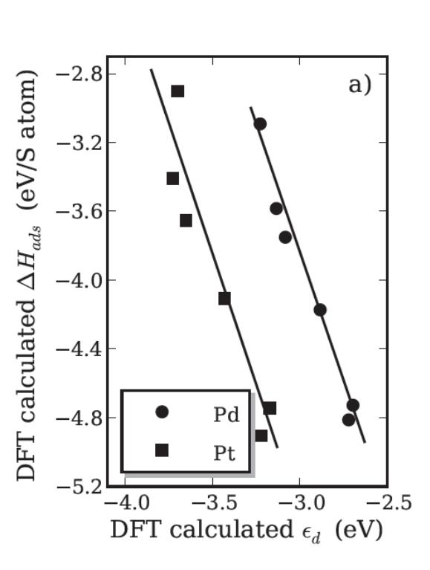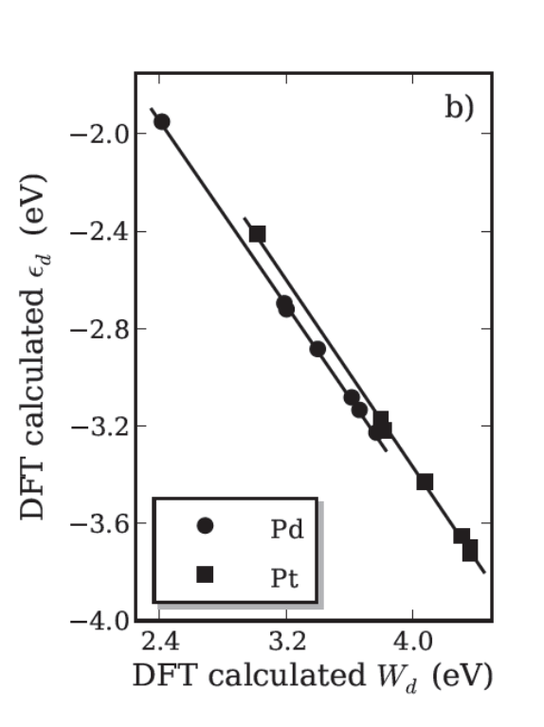
Figure 2. a) Sulfur adsorption energies at different coverages from 0.25 to 1ML on Pd and Pt metal (111) facets as a function of the d-band center. b) d-band centers of the configurations in Figure 2a as a function of the d-band widths.
Moreover, it has been well established that the estimation of the adsorption properties could be achieved from clean surface properties, particularly from the surface d-band center. For instance, oxygen binding energies over transition metal alloys have been estimated by incorporating the changes in ligand, strain effects and chemical composition into the surface d-band center. Since the shifts in d-band characteristics and adsorption properties are correlated, the reactivities of alloy surfaces towards S can be estimated if the d-band characteristics of the surface structures are known. Our previous studies demonstrated that the surface d-band width can readily be estimated using the DFT parameterized Solid State Table.
Estimating d-band widths
Interatomic matrix elements describe the bonding interactions between the d states of atoms in terms of their corresponding characteristic orbital sizes (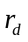) and the spacing between the metals (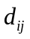). The matrix elements can be expressed as 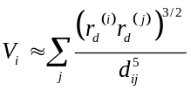.²⁷ Based on the tight binding theory, these interatomic matrix elements are correlated with d-band widths. We developed a model that accounts for the sharpening/broadening of the d-band due to the interaction of all neighboring atoms through their characteristic orbital sizes and their corresponding atomic separation. For surfaces we account for a facet-specific redistribution of electron density near the surface due to the loss of bulk symmetry. These contributions lead 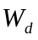 to take the following form,
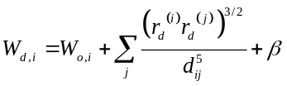 (3)
where W_{o,i} is the non-zero band width of an atom i at infinite separation which is an artifact of the d-band width being defined as the square root of the second moment of the d-band about the Fermi level. is a facet specific constant that accounts for effects of surface relaxation on the d-band width. The details of the model and the values for each parameter (the Solid State Table) can be found elsewhere. The model works for monometallic and bimetallic surfaces in a variety of surface structures (e.g. (111), (100), (110) surfaces, etc…).
We considered different combinations of heteroepitaxial overlayers and estimated their corresponding surface d-band widths by utilizing the Solid State Table. The agreement between the estimated and the DFT calculated surface d-band widths of 110 heteroepitaxial overlayer combinations is excellent (Figure 3). The mean absolute error in the estimation is less than 4.5%. The outliers generally correspond to the binary systems involving Ag or Au as the overlayer. This can be attributed to the large relaxations caused by the large differences between the lattice constants of these atoms and the other late transitions metals. In the estimation of the d-band widths, the unrelaxed distances between the atoms are determined by the lattice constant of the host atoms. This simplification works well for systems with similar lattice constants because relaxation effects are small.
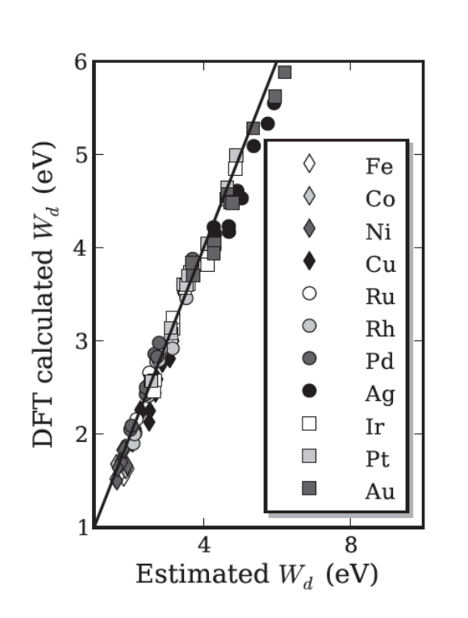
Figure 3. Parity plot of d-band widths for clean heteroepitaxial overlayer combinations of late transition metals (Fe, Co, Ni, Cu, Ru, Rh, Pd, Ag, Ir, Pt, and Au). The legend identifies the composition of the overlayer.
Estimation of Sulfur Adsorption Properties
We computed the adsorption energies of S on the sites shown in Figure 1 for the heteroepitaxial overlayer structures. The correlations between the DFT calculated S adsorption energies and the d-band widths for the 110 heteroepitaxial overlayer combinations are shown in Figure 4.a. Each structure has its own correlation. The correlations for Au and Ag containing structures were very poor. The poor correlation is not due to poor estimates of the d-band widths for Ag and Au based systems (Figure 3). In these systems the discrepancy can be attributed to the completely filled d-band states of these noble metals resulting in additional types of interactions with sulfur (e.g. Pauli repulsion, or inter-adsorbate bonding) that are not accounted for in the simple d-band model or in our tight-binding model. For these outliers the d-band characteristics do not fully the capture the reactivity of the surfaces towards S. Excluding the Ag and Au based systems the system specific correlations between S adsorption energies and surface d-band widths collapse to 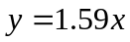 line if shifts in adsorption characteristics 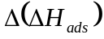 and shifts in d-band widths 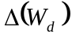 are considered (Figure 4.b).
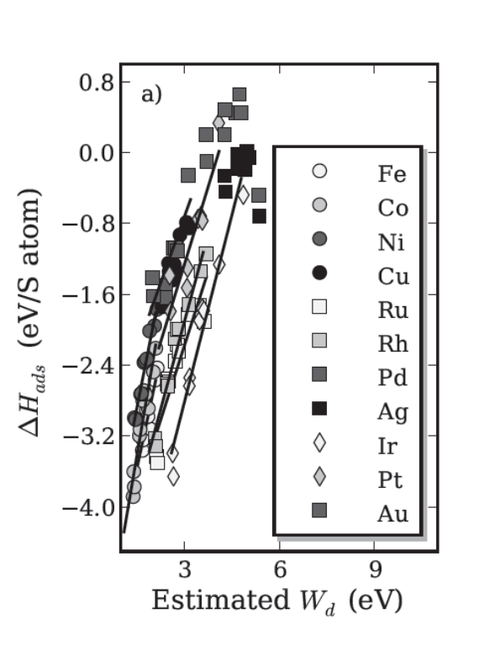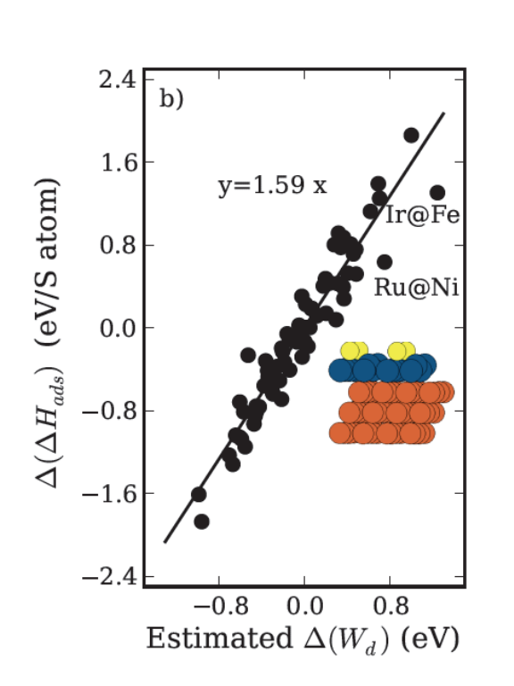
Figure 4. a) Correlation between DFT calculated S adsorption energies and estimated d-band widths for different heteroepitaxial overlayer combinations. The legend identifies the composition of the overlayer. b) Correlation between shifts in DFT calculated S adsorption energies and shifts in estimated d-band widths structures. The shifts are calculated with respect to the pure metallic systems.
The most outlying data correspond to structures with reconstructions. Some examples of reconstructions observed in this work are Ir@Fe and Ru@Ni heteroepitaxial overlayer combinations where the surface Ir (Ru) atoms not bonded directly to the S adatom show rumpling (inset in Figure 4.b). For these systems the clean surface d-band properties are insufficient to capture the surface reactivity due to the structure changes and corresponding changes in bonding that occur. This is one of the main limitations of the Solid State Table; we estimate the d-band widths of the surface atoms from unrelaxed bond lengths determined by the host. If significant relaxation or reconconstruction occurs, the estimated d-band widths deviate more significantly from the DFT values, and the bonding contributions to the adsorption deviate from the simple d-band model more significantly. Better agreement with the DFT results can be obtained using the actual relaxed metal distances, but this requires that one know the geometry in advance. Even with these problematic systems, the good linearity of the correlation between and suggests that we can utilize the linear relationships associated with the estimated d-band widths to predict S adsorption energies over the investigated transition metal alloy structures. We show the agreement between the DFT calculated and estimated adsorption energies over the (111) facets of the heteroepitaxial overlayer alloy surfaces in Figure 5.
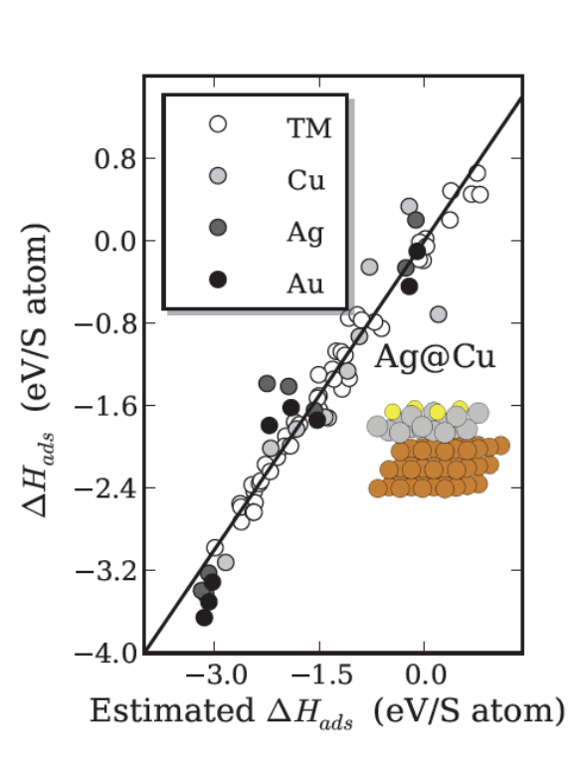
Figure 5. Parity plot of S adsorption energies over heteroepitaxial overlayer combinations. The legend corresponds to the same host (Cu, Ag and Au, TM stands for the other transition metals) with different types of overlayer atoms.
The outliers correspond to the binary structures involving Cu, Ag or Au metals. Excluding the systems where d-band model fails to capture the reactivity of the systems, the mean absolute error in estimating S adsorption properties is less than 6% which demonstrates the feasibility of using the simple algebraic Solid State Table model to estimate reactivity.
The approach outlined here could be more broadly useful than simply predicting sulfur adsorption energies. There exist scaling relationships in the literature that relate the adsorption energies of CH, CH₂ and CH₃ to the adsorption energy of C, of NH and NH₂ to the adsorption energy of N, of OH to the adsorption energy of O, and of SH to the adsorption energy of S. Thus, provided correlations exist between the electronic structure properties that are easy to compute and reactivity properties that are desired it may be possible to construct sophisticated screening methods to identify materials with desired reactive properties.
The determination of S tolerant surface structures cannot be achieved only by looking at the S adsorption energy. Reactive environmental conditions and surface segregation energies play an important role in determining the stability of the investigated systems. For example, it is easy to put an Au monolayer on Cu to make it more S-tolerant because S bonds more weakly to Au. However, S bonds more strongly to Cu, and an adsorbate-induced segregation of Cu is possible depending on the environmental conditions. Furthermore, the Au monolayer would be under substantial compressive strain, and would not be likely to be stable. Thus, the Au monolayer is not a stable, S-tolerant structure. An atomistic thermodynamic approach is needed to account for the effects of segregation and environment. We do not consider the effect of strain on stability in this work.
Atomistic Thermodynamics Approach to Sulfur Tolerant Surface Structures
We used an atomistic thermodynamic formalism to compute the sulfur tolerance of each structure in the database of 400 structures considered. The results are tabulated in Table 1 for all the structures that are determined to be thermodynamically stable with respect to segregation. The values given in bold designate the S chemical potential where the monometallic surface in its normal structure starts to become S poisoned, i.e., the onset of S adsorption at 0.25 ML. The empty entries correspond to the structures with unfavorable segregation properties. The red entries indicate systems with less S tolerance; whereas the blue ones designate the surface structures with enhanced S tolerance. The darker the blue the more S tolerant the structures are. The values given in white indicate the most S tolerant binary alloy configuration for that combination.
Table 1. S chemical potentials where the corresponding binary alloy structure starts to become S poisoned due to adsorption. The values in bold correspond the S chemical potential where monometallic surfaces start to get S poisoned. The red cells designate alloys with less S tolerance than the parent metal whereas the blue cells correspond to the structures with enhanced S tolerance. Empty cells with a dash in them do not have thermodynamically favorable segregation energies. The columns represents the metals at the surface; whereas the rows designate the substrate or the host metals.
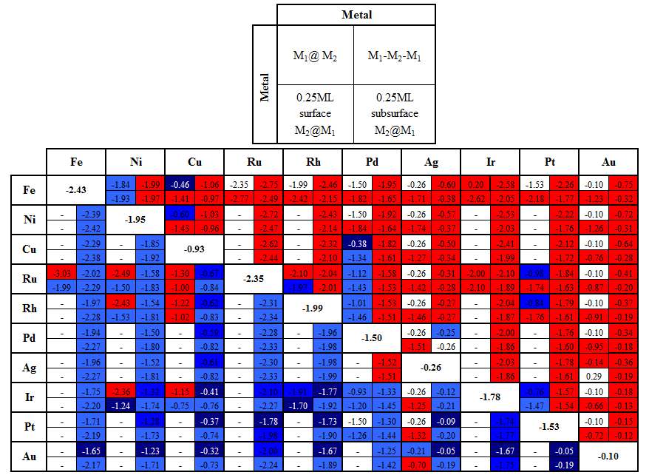
In general, S tolerance of the alloys increases when the metals are alloyed with metals having a smaller lattice parameter. This is due to an increase in the overlap of the d-orbitals of the corresponding metal atoms. The increased overlap results in a broadening of the d-band and in a lowering of d-band centers in energy, with a corresponding reduction in the S adsorption energy. The same phenomenon of enhanced S tolerance also applies for M₁-M₂-M₁ type of alloys when lattice constant of M₂ is greater than M₁. The presence of the type of metal atoms with larger characteristic length causes an increase in the overlap of the d-orbitals that would results in the broadening of d-band widths. This leads to weaker S adsorption properties of the surface structures. To observe higher S tolerant structures with 0.25ML surface (subsurface) M₂@M₁ alloys, the dopant should have a much larger lattice parameter than the substrate atoms. This can be attributed to the low coverage of dopant in the structures; only the metals with very large lattice parameters could show the effect in terms of increased overlap and could result in weaker S adsorption properties.
Application to S-tolerance for a specific metal
S poisoning is a great issue over Cu-based systems. Even the presence of small amounts of S in the feed streams can cause the deactivation of the catalyst due to the formation of a strong bond between the adsorbate and the surface metal atoms.³⁷⁻³⁹ To illustrate how our approach may be used to identify sulfur-tolerant catalysts, we apply the method to Cu-based systems which are known to be the best pure metal for the low temperature water gas shift reaction used in hydrogen generation from fossil fuels.⁴⁰ Under normal operating conditions in the water gas shift reaction there are S impurities which can adsorb on Cu surfaces and block the active sites of the catalyst for the desired reaction and can result in catalyst deactivation. The estimated S adsorption energies on the Cu based alloy structures and the results are shown in Figure 6. 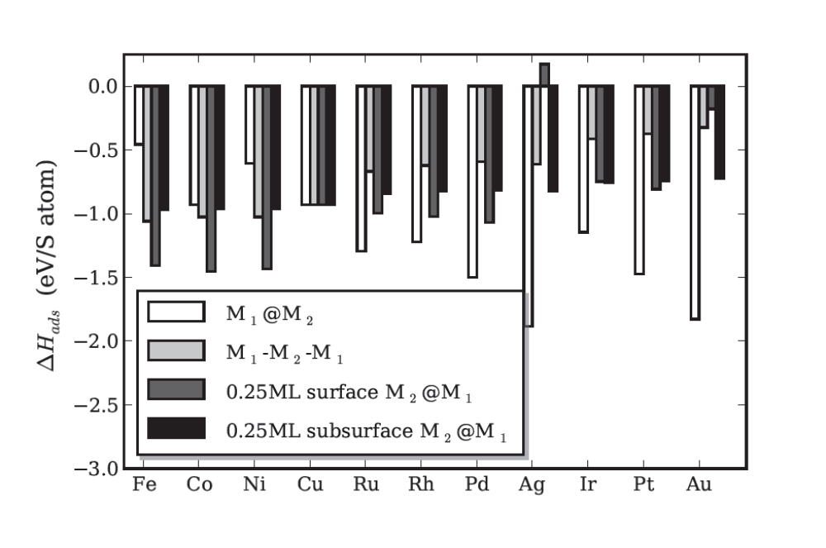
Figure 6. Estimated S adsorption energies over Cu based catalyst with different binary alloy structures; heteroepitaxial overlayer, heteroepitaxial subsurface underlayer, 0.25ML surface dopant, and 0.25ML subsurface dopant. The x- axis designates the second metal in the binary alloys. For the pure metallic case, the estimated S adsorption energies are the same for each different surface structure considered.
Weaker S adsorption energies are obtained when Cu is alloyed with Fe or Ni to form M₁@M₂ type of alloys; or with 4d and 5d metals to form M₁-M₂-M₁; or with Ag, Ir, Pt, Au to form 0.25ML surface and subsurface M₂@M₁ alloys. For Cu@Fe and Cu@Ni systems, the lattice constants are dictated by Fe and Ni substrates which are smaller than the lattice constant of monometallic Cu. Smaller lattice constants result in compressive strain leading to an increase in the overlap of the d-orbitals of neighboring metal atoms. The increased overlap results in a broadening of the d-band. The broader bands have lower surface d-band centers in energy, and consequently interact more weakly with adsorbates leading to weaker S adsorption properties. When Cu is alloyed with 4d or 5d metals to form M₁-M₂-M₁ and 0.25ML subsurface M₂@M₁ types of alloys, the increase on the overlap of the d-orbitals due to the larger characteristic orbital sizes of these 4d and 5d metals also results in the broadening of d-band width and lowering of the surface d-band. The same phenomenon holds for 0.25ML surface M₂@M₁ alloys with large characteristic orbital sizes of the dopants. Since the dopant is at 0.25ML, only the metals with very large r_{d} could show the effect in terms of increased overlap and thus could results in weaker S adsorption properties.
To illustrate how S-tolerance is enhanced we have calculated the surface free energies of clean (horizontal lines) and S poisoned (corresponding lines with negative slopes) binary alloy combinations for selected Cu based systems. Below we have considered only two of the stable structures for the purpose of illustrating sulfur tolerance; one with less and one with more S tolerant characteristics than monometallic Cu system (Figure 7).
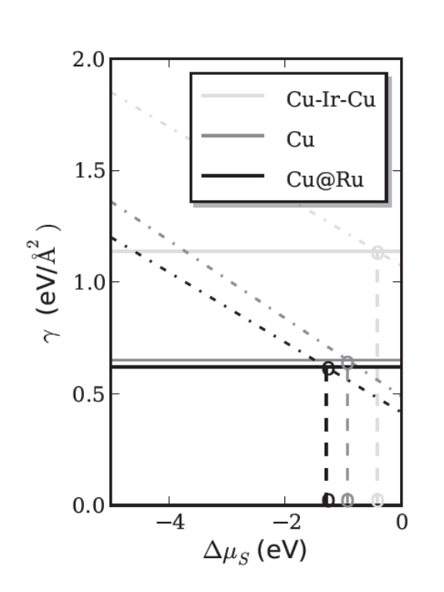
Figure 7. Surface free energies of Cu based catalyst surface structures as a function of S chemical potential. The columns correspond to the interested metal catalyst whereas the rows designate the substrates/dopants. Horizontal lines designate the surface free energies of the clean structures; whereas their corresponding lines with negative slopes refer to the S poisoned cases of the same structures. The ‘o’ corresponds to S chemical potentials where S poisoned structures would become thermodynamically more favorable than their corresponding clean surfaces. Vertical dashed lines are for the eye guidance.
The S poisoned monometallic Cu system starts to form at a S chemical potential of -1eV (the intersection of the solid and dashed lines for Cu). The partial pressures of gas phase H₂S to H₂ at different temperatures that correspond to this S chemical potential could be looked up in the Janaf Thermochemical Tables⁴¹ similar to our previous work.⁴ For a surface to have a higher S tolerance the initial S adsorption needs to occur at chemical potential more positive than -1 eV. For example, enhanced S tolerance can be obtained when Cu is alloyed with Ir to form M₁-M₂-M₁ type of alloys. In contrast, Cu@Ru shows less S tolerance; S poisoned surfaces become thermodynamically more favorable than a clean surface at a S chemical potential of -1.30eV which is lower than the value of -1eV for monometallic Cu system. In other words, the Cu@Ru system is poisoned at a lower concentration of sulfur in the environment than a pure Cu surface. This is due larger lattice constant of Ru that leads to tensile strain in the Cu overlayer causing a narrower d-band width and higher d-band center with increased activity towards S poisoning.
Our findings suggest that Pd alloyed with Cu (Pd@Cu) is the most S tolerant structure in our database. This alloy has been used as the catalyst membrane in hydrogen separation and is known to be sulfur tolerant. Moreover, our simple model combined with atomistic thermodynamic approach captures the enhanced S characteristics of Pt based systems when alloyed with Ag to form 0.25ML subsurface Ag@Pt and Pt-Ag-Pt surface structures.⁶ The reason for S resistivity is attributed to the increase in the overlap of d-orbitals due to the presence of Ag atoms in the structures. Conversely, S interacts more strongly with Cu-Ag alloys than that of pure Ag systems due to the smaller characteristic radius of the Cu d-orbitals that results in a reduced orbital overlap of the d-states compared to pure Ag. This causes a narrowing of the d-band width and higher d-band center in energy and finally with increased interaction with S, similar results have been reported previously.⁸ Our findings suggests that Rh based systems become more S tolerant when alloyed with Au which lies good agreement with the study by Rodriguez et al.⁴² The demonstration of the predictive capability of our proposed approach is not limited to only to the above mentioned examples. In this work, Pd@Rh, 0.25ML subsurface Rh@Pd and Rh-Pd-Rh, 0.25ML surface Pd@Rh show better S characteristics than that of their pure metallic systems. This may be one reason for the use of Pd/Rh based system for the automotive exhaust catalyst in catalytic converters; the bimetallic Pd-Rh catalyst may have a higher sulfur tolerance than pure Pt.
This approach presented here is a coarse grained way to screen a very large number of alloy structures for S-tolerance. Pools of potentially S-tolerant compositions must be chosen judiciously because several simplifications are made in the process to make the computations very fast. For example, the segregation energies are approximated as the impurity segregation energies from pure bulk metals. In real alloy systems the segregation energy depends on the bulk structure and composition,³² as well as on the surface and temperature. As promising candidates are identified one would naturally choose to investigate them more deeply with more accurate models. The approach presented here could be part of the motivation for deeper investigations of promising candidates.
CONCLUSIONS
We utilized a DFT parameterized Solid State Table to estimate the d-band characteristics of transition metal based binary alloys and their corresponding reactivities towards S poisoning. The results were validated on a subset of 110 DFT calculations. We considered a total of 400 different surface alloy configurations and assessed their sulfur tolerance using an atomistic thermodynamic framework. It is in general possible to increase or decrease the S tolerance of a metal by alloying, and to identify alloys that are likely to be stable under reaction conditions. The approach presented here should be viewed as a first step in identifying sulfur-tolerant alloys where one seeks to focus from a very large number of catalyst composition possibilities to a smaller, reasonable number of possibilities.
ACKNOWLEDGMENT
J.R.K. gratefully acknowledges partial support of this work by the Ofﬁce of Basic Energy Science of the U.S. Department of Energy (Grant No. DOE-BES DEFG0207ER15919).
DESCRIPTION OF SUPPLEMENTAL INFORMATION
A pdf containing summary of the atomic geometry and calculation parameters for each calculation in this work is available.
REFERENCES
(1) Bartholomew, C. H.; Agrawal, P. K.; Katzer, J. R. Advances in Catalysis 1982, 31, 135.
(2) Rodriguez, J. A.; Hrbek, J. Acc. Chem. Res. 1999, 32, 719.
(3) Rodriguez, J. A.; Hrbek, J.; Kuhn, M.; Jirsak, T.; Chaturvedi, S.; Maiti, A. J. Chem. Phys. 2000, 113, 11284.
(4) İnoğlu, N.; Kitchin, J. R. J. Cat. 2009, 261, 188.
(5) Jiang, H.; Yang, H.; Hawkins, R.; Ring, Z. Catal. Today 2007, 125, 282.
(6) Rodriguez, J. A.; Kuhn, M.; Hrbek, J. Chem. Phys. Lett. 1996, 251, 13.
(7) Alfonso, D. R.; Cugini, A. V.; Sholl, D. S. Surf. Sci. 2003, 546, 12.
(8) Zhao, X. Y.; Liu, P.; Hrbek, J.; Rodriguez, J. A.; Perez, M. Surf. Sci. 2005, 592, 25.
(9) Rodriguez, J. A.; Kuhn, M. J. Phys. Chem. 1995, 99, 9567.
(10) Kuhn, M.; Rodriguez, J. A. J. Phys. Chem. 1994, 98, 12059.
(11) Kuhn, M.; Rodriguez, J. A. Chem. Phys. Lett. 1994, 231, 199.
(12) Kuhn, M.; Rodriguez, J. A. Surf. Sci. 1996, 355, 85.
(13) Greeley, J.; Nørskov, J. K. Surf. Sci. 2007, 601, 1590.
(14) Greeley, J.; Jaramillo, T. F.; Bonde, J.; Chorkendorff, I. B.; Nørskov, J. K. Nature Materials 2006, 5, 909.
(15) Greeley, J.; Nørskov, J. K. Surf. Sci. 2005, 592, 104.
(16) Hammer, B.; Nørskov, J. K. Nature 1995, 376, 238.
(17) Hammer, B.; Nørskov, J. K. Surf. Sci. 1995, 343, 211.
(18) Kitchin, J. R.; Nørskov, J. K.; Barteau, M. A.; Chen, J. G. J. Chem. Phys. 2004, 120, 10240.
(19) Greeley, J.; Mavrikakis, M. J. Phys. Chem. B 2005, 109, 3460.
(20) Mavrikakis, M.; Hammer, B.; Nørskov, J. K. Phys. Rev. Lett. 1998, 81, 2819.
(21) Mortensen, J. J.; Hammer, B.; Nørskov, J. K. Phys. Rev. Lett. 1998, 80, 4333.
(22) İnoğlu, N.; Kitchin, J. R. Mol. Sim. 2009, 35, 936.
(23) Hyman, M. P.; Loveless, B. T.; Medlin, J. W. Surf. Sci. 2007, 601, 5382.
(24) Xin, H.; Linic, S. J. Chem. Phys. 2010, 132, 221101.
(25) İnoğlu, N.; Kitchin, J. R. Phys. Rev. B 2010, 82, 045414.
(26) İnoğlu, N.; Kitchin, J. R. Mol. Sim. 2010, 36, 633.
(27) Harrison, W. A. Electronic Structure and the Properties of Solids; Dover Publication, Inc., New York, 1989.
(28) DACAPO https://wiki.fysik.dtu.dk/dacapo.
(29) Vanderbilt, D. Phys. Rev. B 1993, 41, 7892.
(30) Laasonen, K., A. Pasquarello, R. Car, C. Lee, D. Vanderbilt Phys. Rev. B 1993, 47, 10142.
(31) Perdew, J. P.; Wang, Y. Phys. Rev. B 1992, 45, 13244.
(32) Kitchin, J. R.; Reuter, K.; Scheffler, M. Phys. Rev. B 2008, 77, 075437.
(33) Christensen, A.; Ruban, A. V.; Stoltze, P.; Jacobsen, K. W.; Skriver, H. L.; Nørskov, J. K.; Besenbacher, F. Phys. Rev. B 1997, 56, 5822.
(34) Kitchin, J. R.; Nørskov, J. K.; Barteau, M. A.; Chen, J. G. Phys. Rev. Lett. 2004, 93, 156801.
(35) Abild-Pedersen, F.; Greeley, J.; Studt, F.; Rossmeisl, J.; Munter, T. R.; Moses, P. G.; Skulason, E.; Bligaard, T.; Nørskov, J. K. Phys. Rev. Lett. 2007, 99, 016105.
(36) Jones, G.; Bligaard, T.; Abild-Pedersen, F.; Nørskov, J. K. J. Phys. Cond. Matt. 2008, 20, 064239.
(37) Rodriguez, J. A.; Chaturvedi, S.; Jirsak, T. Chem. Phys. Lett. 1998, 296, 421.
(38) Gravil, P. A.; Toulhoat, H. Surf. Sci. 1999, 430, 176.
(39) Feibelman, P. J.; Hamann, D. R. Surf. Sci. 1985, 149, 48.
(40) Schumacher, N.; Boisen, A.; Dahl, S.; Kandoi, S.; Grabow, L. C.; Dumesic, J. A.; Mavrikakis, M.; Chorkendorff, I. J. Cat. 2005, 229, 265.
(41) Stull, D. R.; Prophet, H. Janaf Thermochemical Tables, 2nd Edition, Nat. Stand. Ref. Data Ser., Nat. Bur. Stand., Washington D.C., 1971.
(42) Rodriguez, J. A.; Kuhn, M.; Hrbek, J. J. Phys. Chem. 1996, 100, 3799

Graphical abstract
