Results and Input Data
Measuring the Indic Tokenizer Tax: A Comparative Study of Sarvam AI's Tokenizers and Akshara-Aware Subword Segmentation for Indian Languages
Name | Nikhileshwar Jakka
Reg. No. | 23FE10CII00213
Course | Natural Language Processing (NLP)
Guide | Heena Kalim
Programme | B.Tech CSE (IoT & Intelligent Systems), Manipal University Jaipur
GitHub repository: https://github.com/jkknikhil-git/indic-tokenizer-study

1. Input data links
Item | Description | Link
Evaluation data | FLORES-200 devtest (12 languages x 1,012 parallel sentences) | https://dl.fbaipublicfiles.com/nllb/flores200_dataset.tar.gz
Training data | AI4Bharat Sangraha, verified split (50,000 sentences per language, streamed) | https://huggingface.co/datasets/ai4bharat/sangraha
Corpus statistics | Sentence counts, filtering and overlap removal per language | https://github.com/jkknikhil-git/indic-tokenizer-study/blob/main/results/corpus_stats.json
Run metadata | Library versions, seeds, dataset sources, tokenizer revisions | https://github.com/jkknikhil-git/indic-tokenizer-study/blob/main/results/run_metadata.json
Code and results | Full repository (one-command reproduction) | https://github.com/jkknikhil-git/indic-tokenizer-study

Tokenizers evaluated (tokenizer files only; no model weights were downloaded):
Tokenizer | Source
Sarvam-1 | https://huggingface.co/sarvamai/sarvam-1
Sarvam-M | https://huggingface.co/sarvamai/sarvam-m
Sarvam-30B | https://huggingface.co/sarvamai/sarvam-30b
Sarvam-105B | https://huggingface.co/sarvamai/sarvam-105b
GPT-4o / GPT-4 (tiktoken o200k_base, cl100k_base) | https://github.com/openai/tiktoken
Llama-3.1 (public mirror) | https://huggingface.co/unsloth/Llama-3.1-8B
Gemma-3 (public mirror) | https://huggingface.co/unsloth/gemma-3-1b-it
Qwen2.5 | https://huggingface.co/Qwen/Qwen2.5-7B
MuRIL | https://huggingface.co/google/muril-base-cased
IndicBERTv2 | https://huggingface.co/ai4bharat/IndicBERTv2-MLM-only
XLM-R | https://huggingface.co/FacebookAI/xlm-roberta-base
mBERT | https://huggingface.co/google-bert/bert-base-multilingual-cased

2. Result outcome screenshots
Each screenshot is the captured output of running the command shown at its top in the project folder (regenerate with: python scripts/make_screenshots.py).
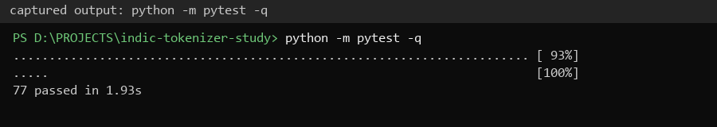
Screenshot 1: Automated tests: all 77 pass (akshara segmentation, metrics, round-trip).
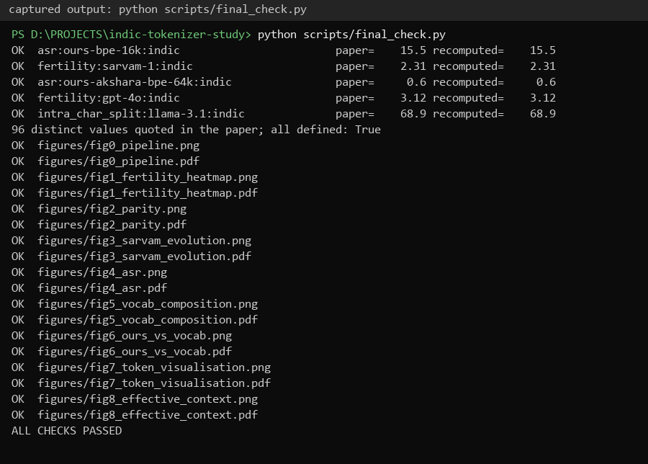
Screenshot 2: Consistency check: random numbers quoted in the paper recomputed from raw data; all figures current.
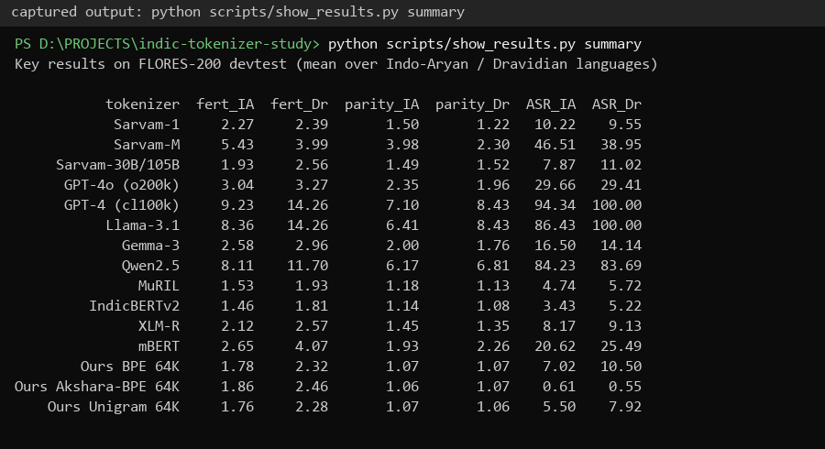
Screenshot 3: Key results on FLORES-200: fertility, parity and Akshara Split Rate for every tokenizer.
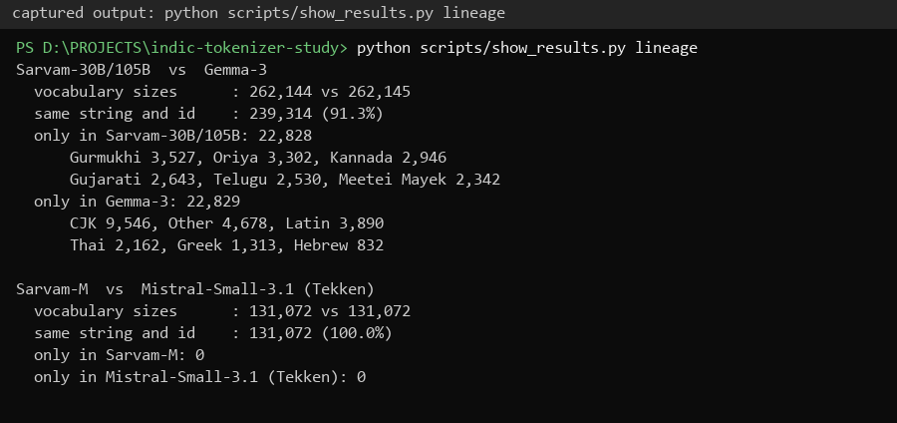
Screenshot 4: Vocabulary lineage: Sarvam-30B vs Gemma-3 and Sarvam-M vs Mistral-Small-3.1.
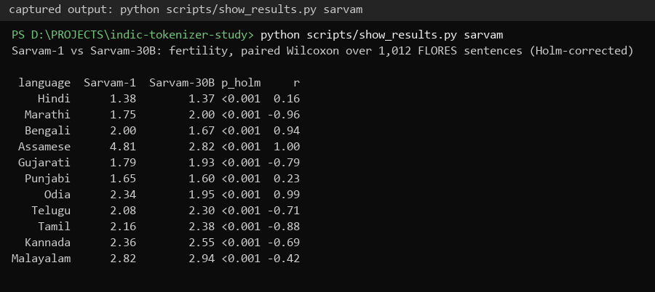
Screenshot 5: Sarvam-1 vs Sarvam-30B fertility per language (paired Wilcoxon, Holm-corrected).
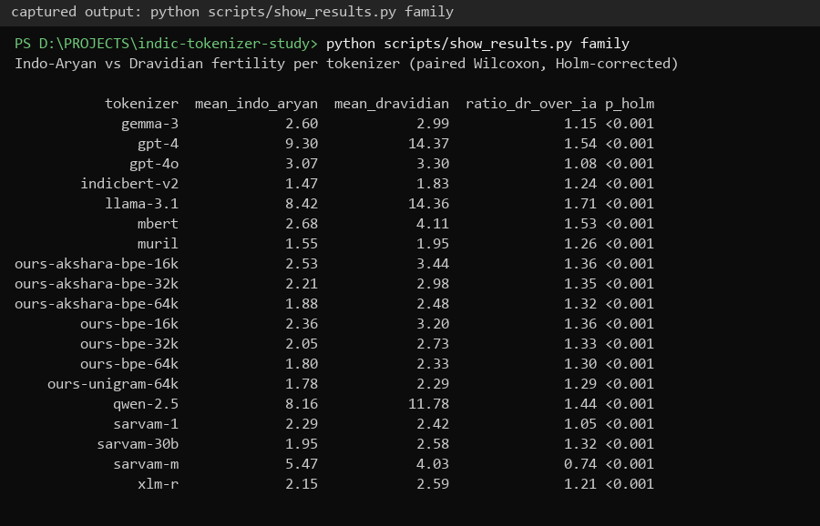
Screenshot 6: Indo-Aryan vs Dravidian fertility per tokenizer (paired Wilcoxon).
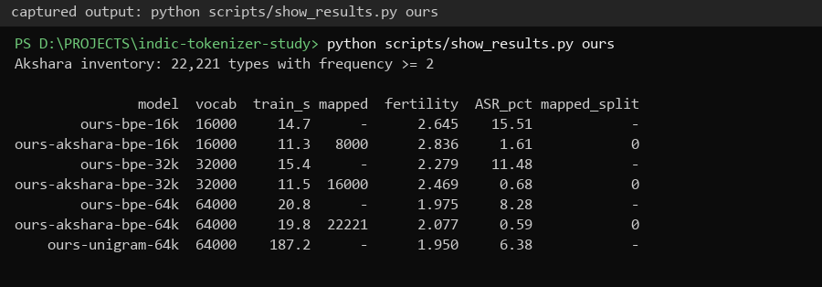
Screenshot 7: Our tokenizers: training time, mapped aksharas, fertility and Akshara Split Rate.

3. Result figures
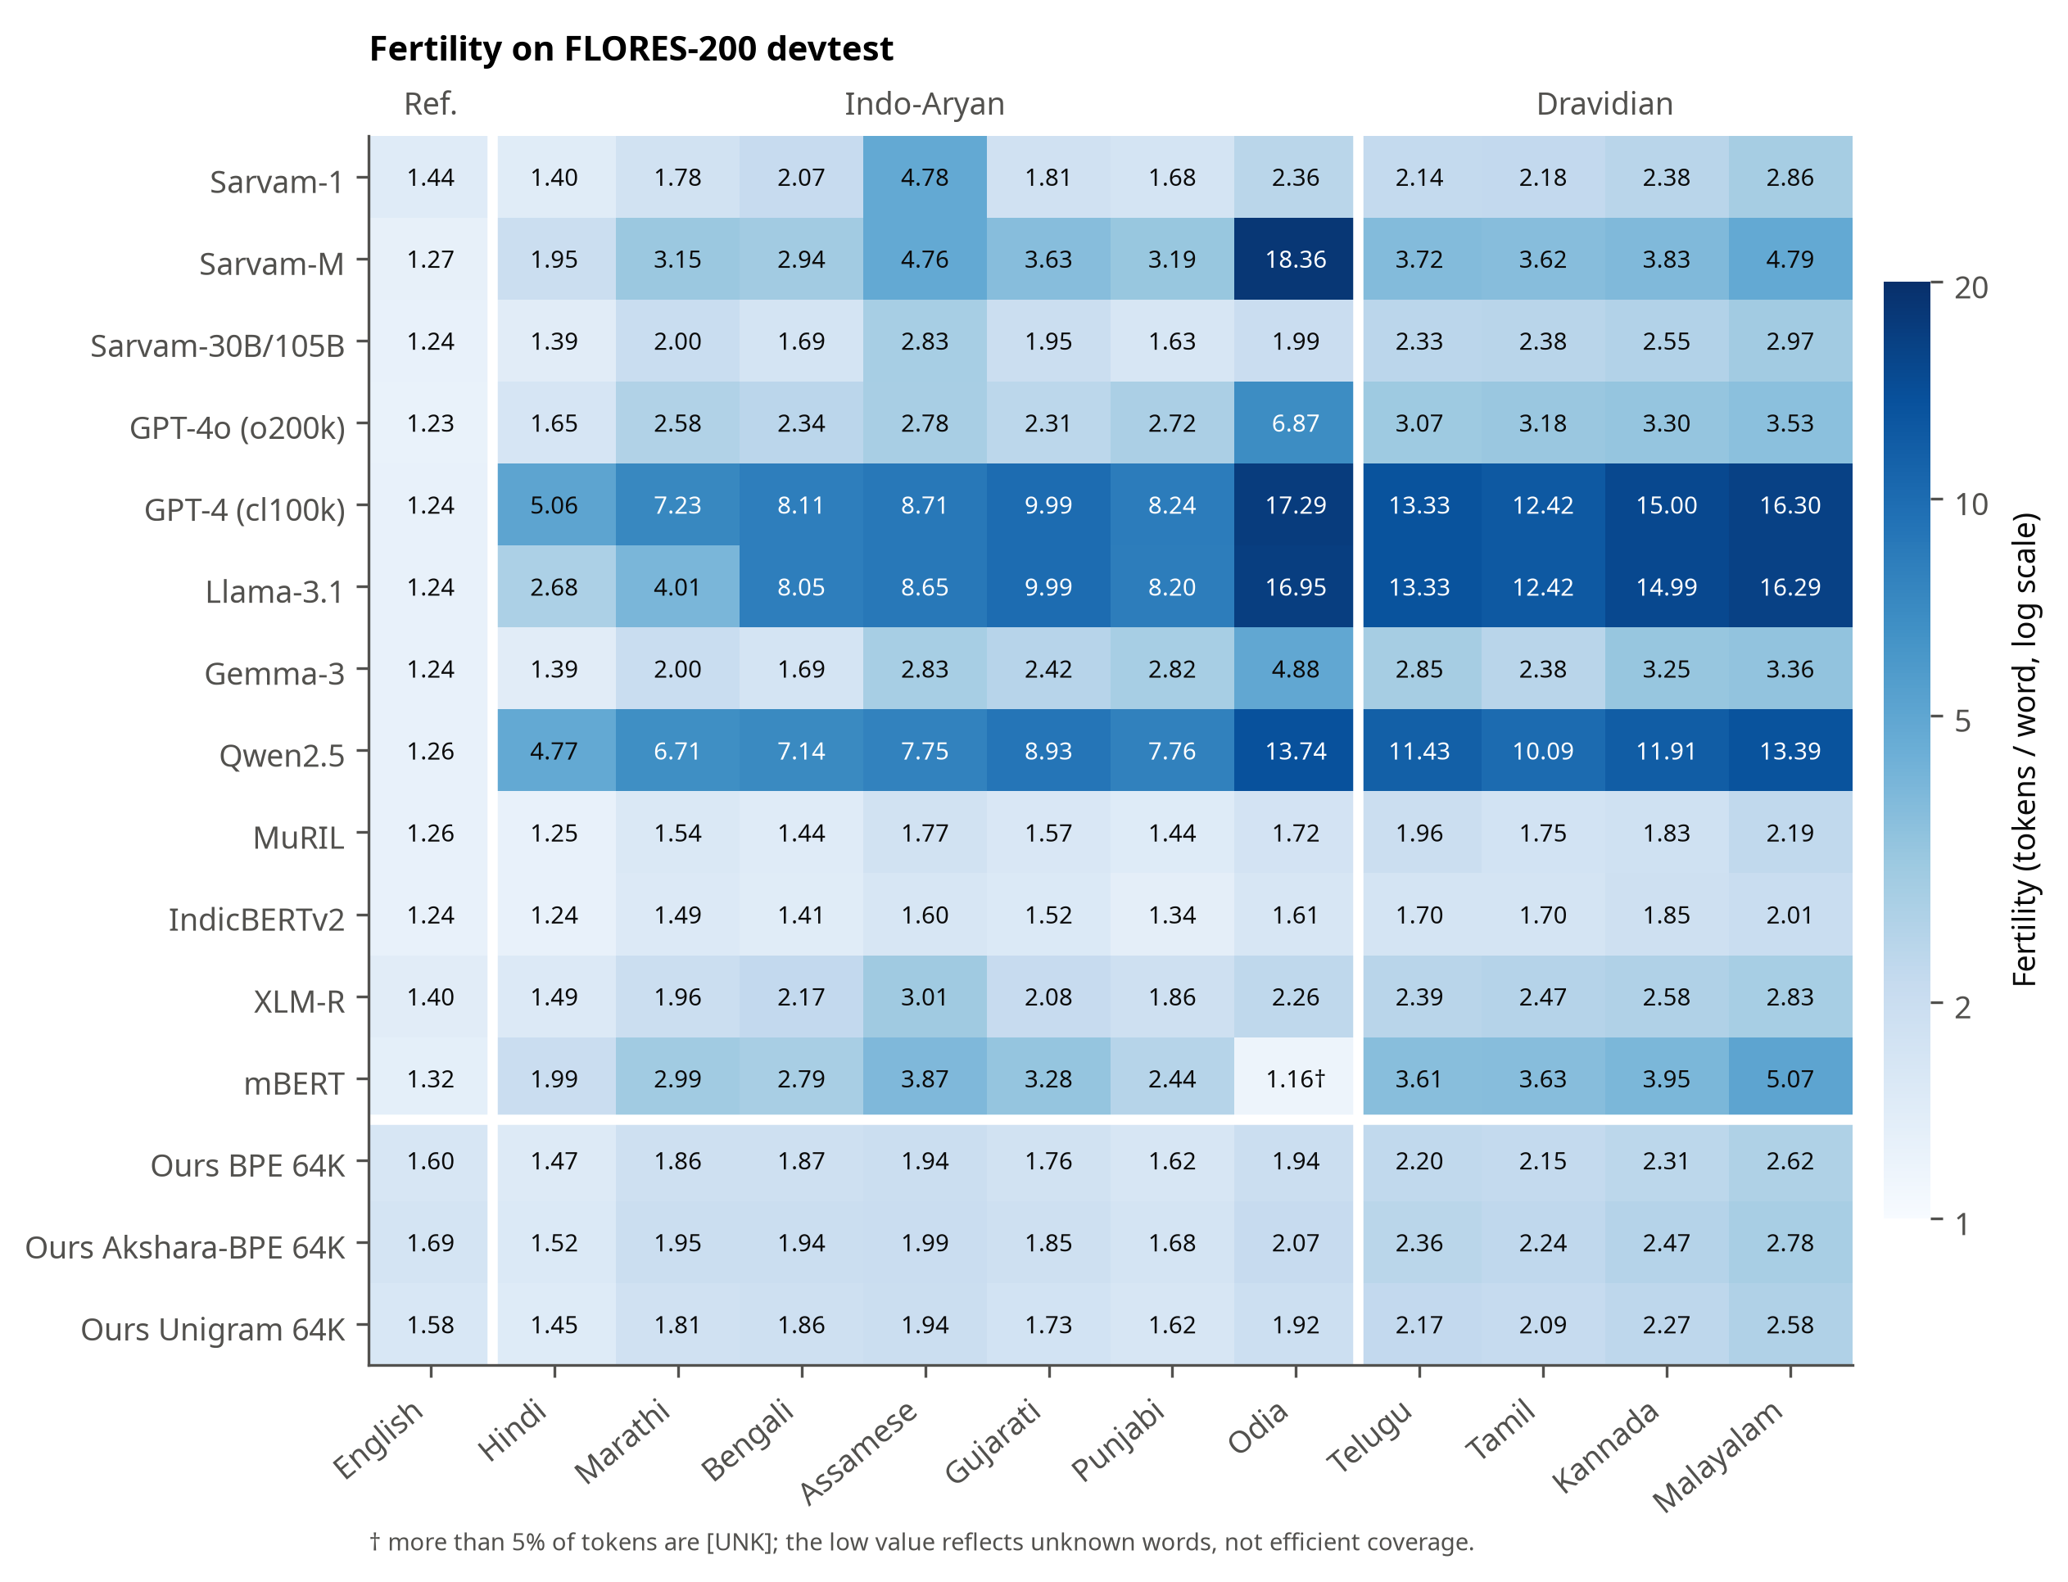
Figure 1: Fertility (tokens per word) for every tokenizer and language.
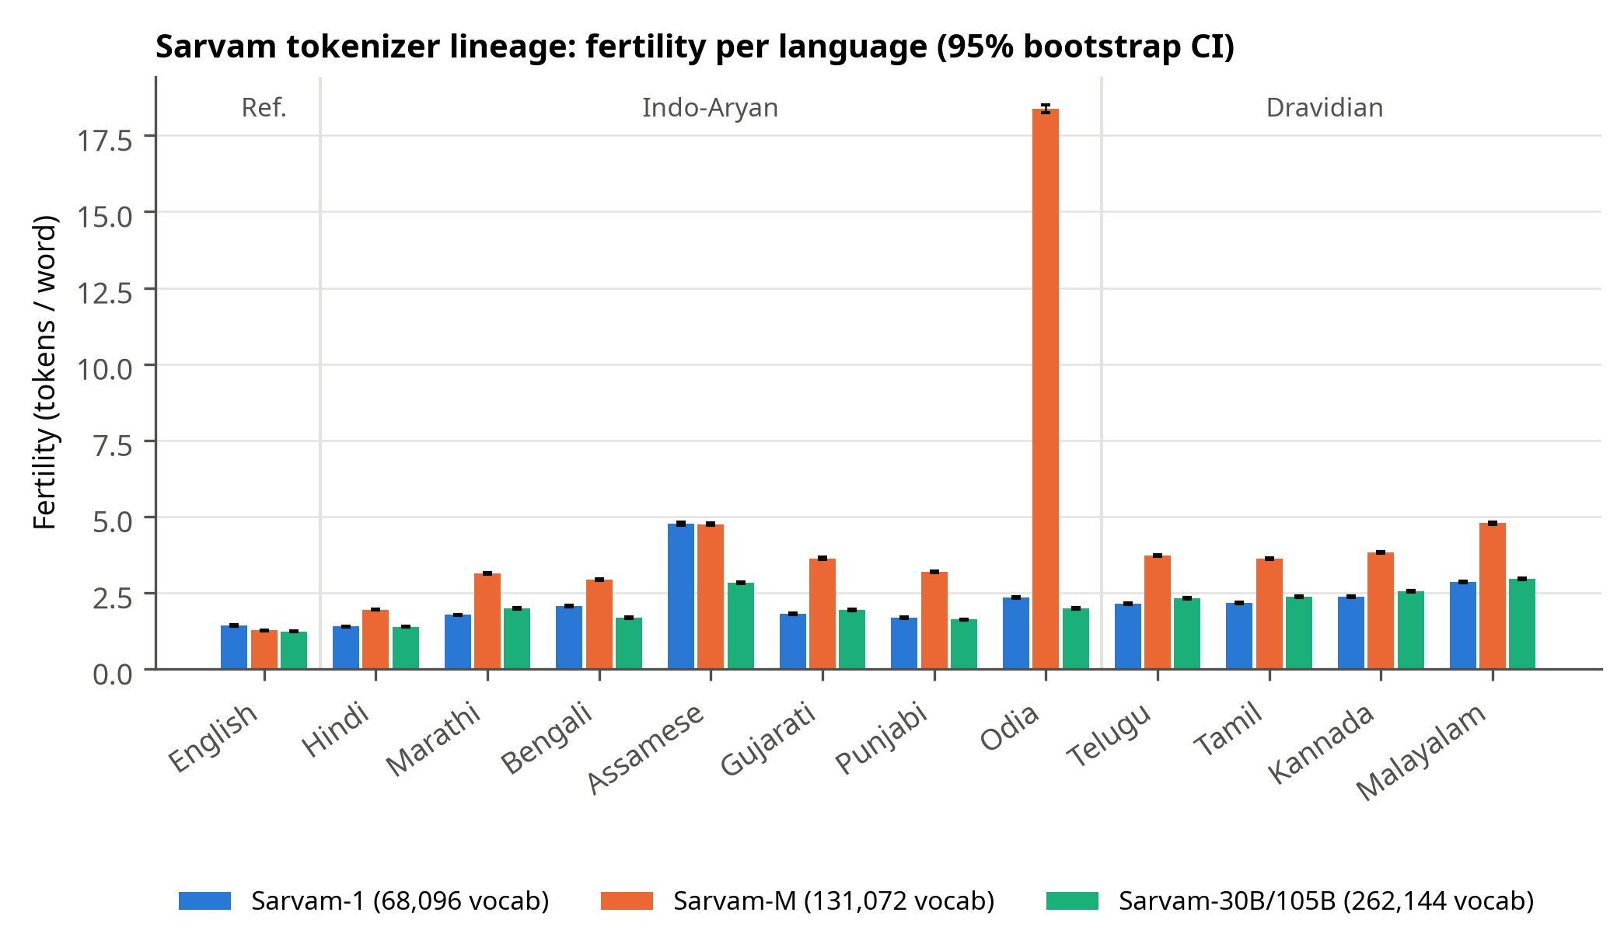
Figure 2: Fertility of the three Sarvam tokenizers with 95% bootstrap CIs.
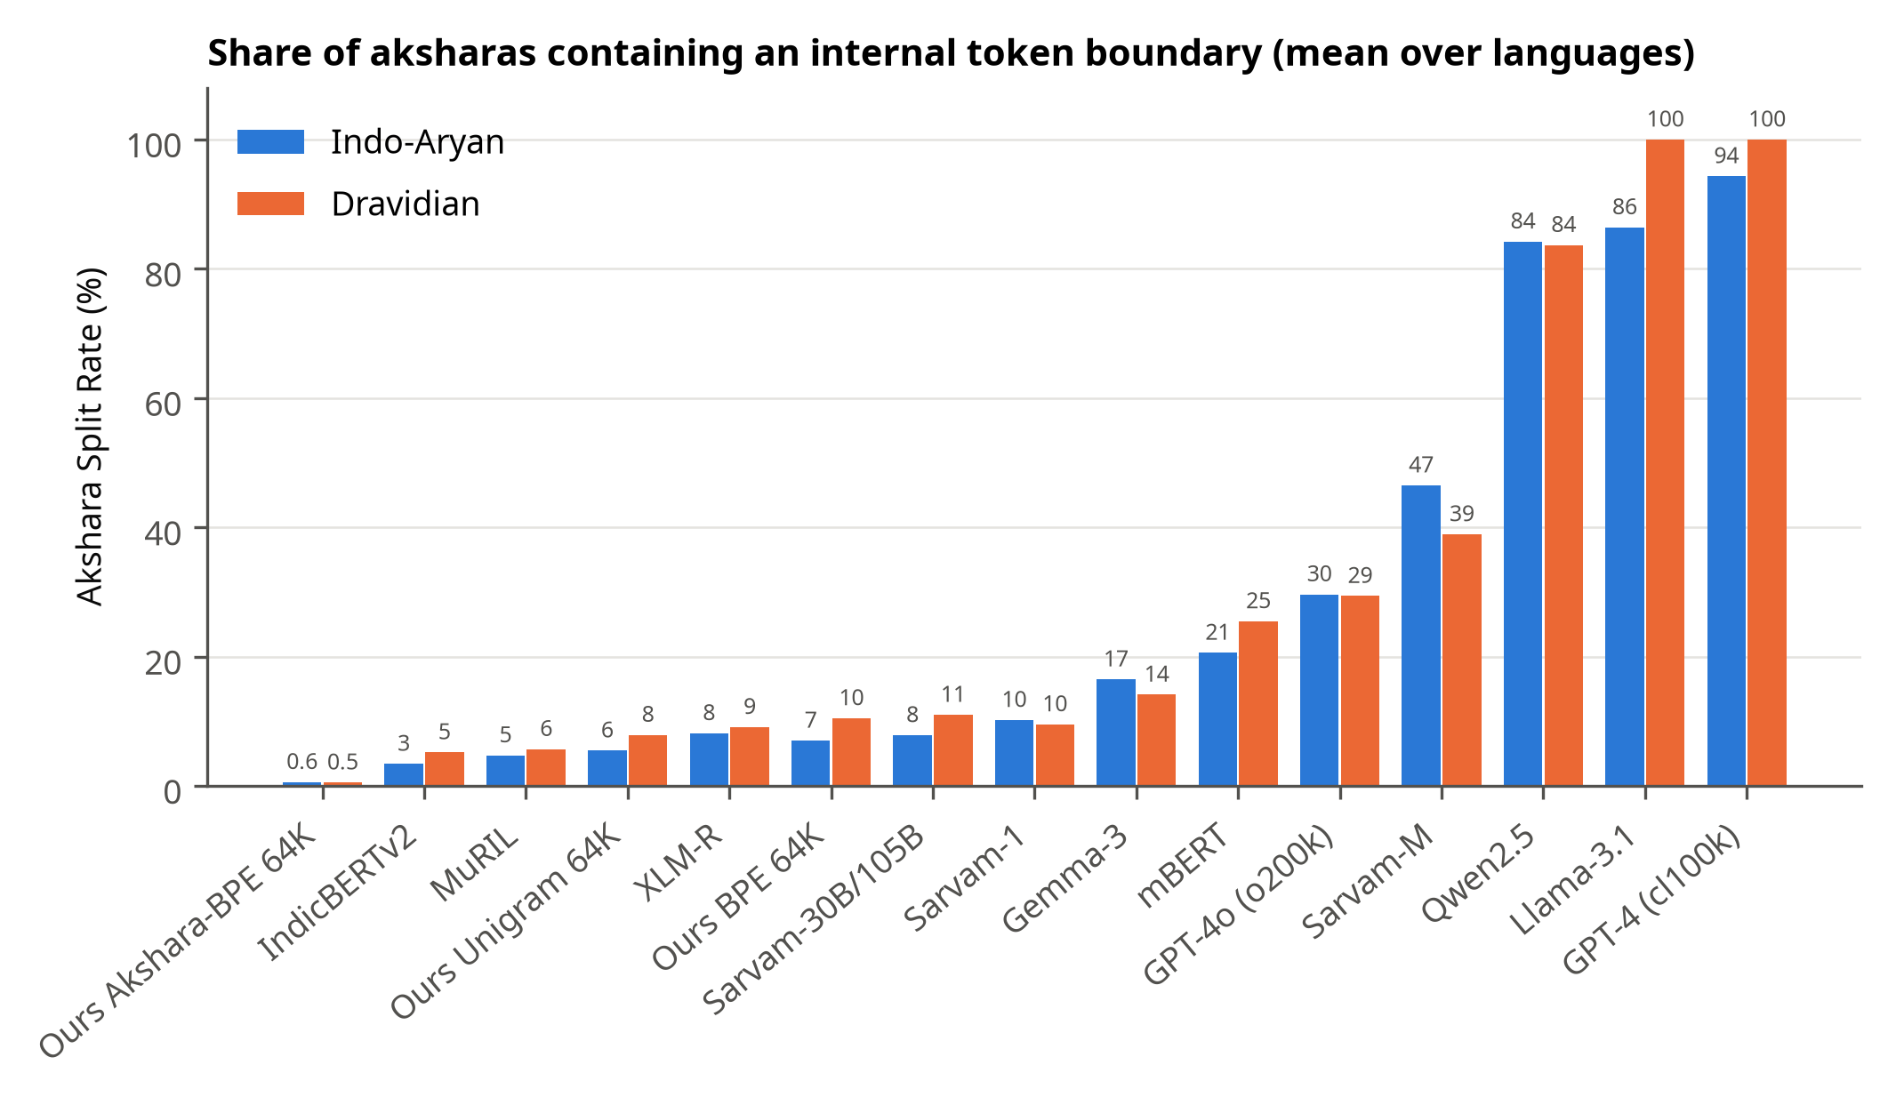
Figure 3: Akshara Split Rate by tokenizer, Indo-Aryan vs Dravidian.
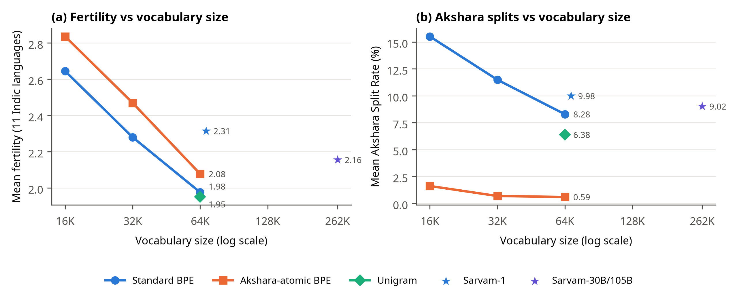
Figure 4: Akshara-atomic BPE vs standard BPE across vocabulary sizes.
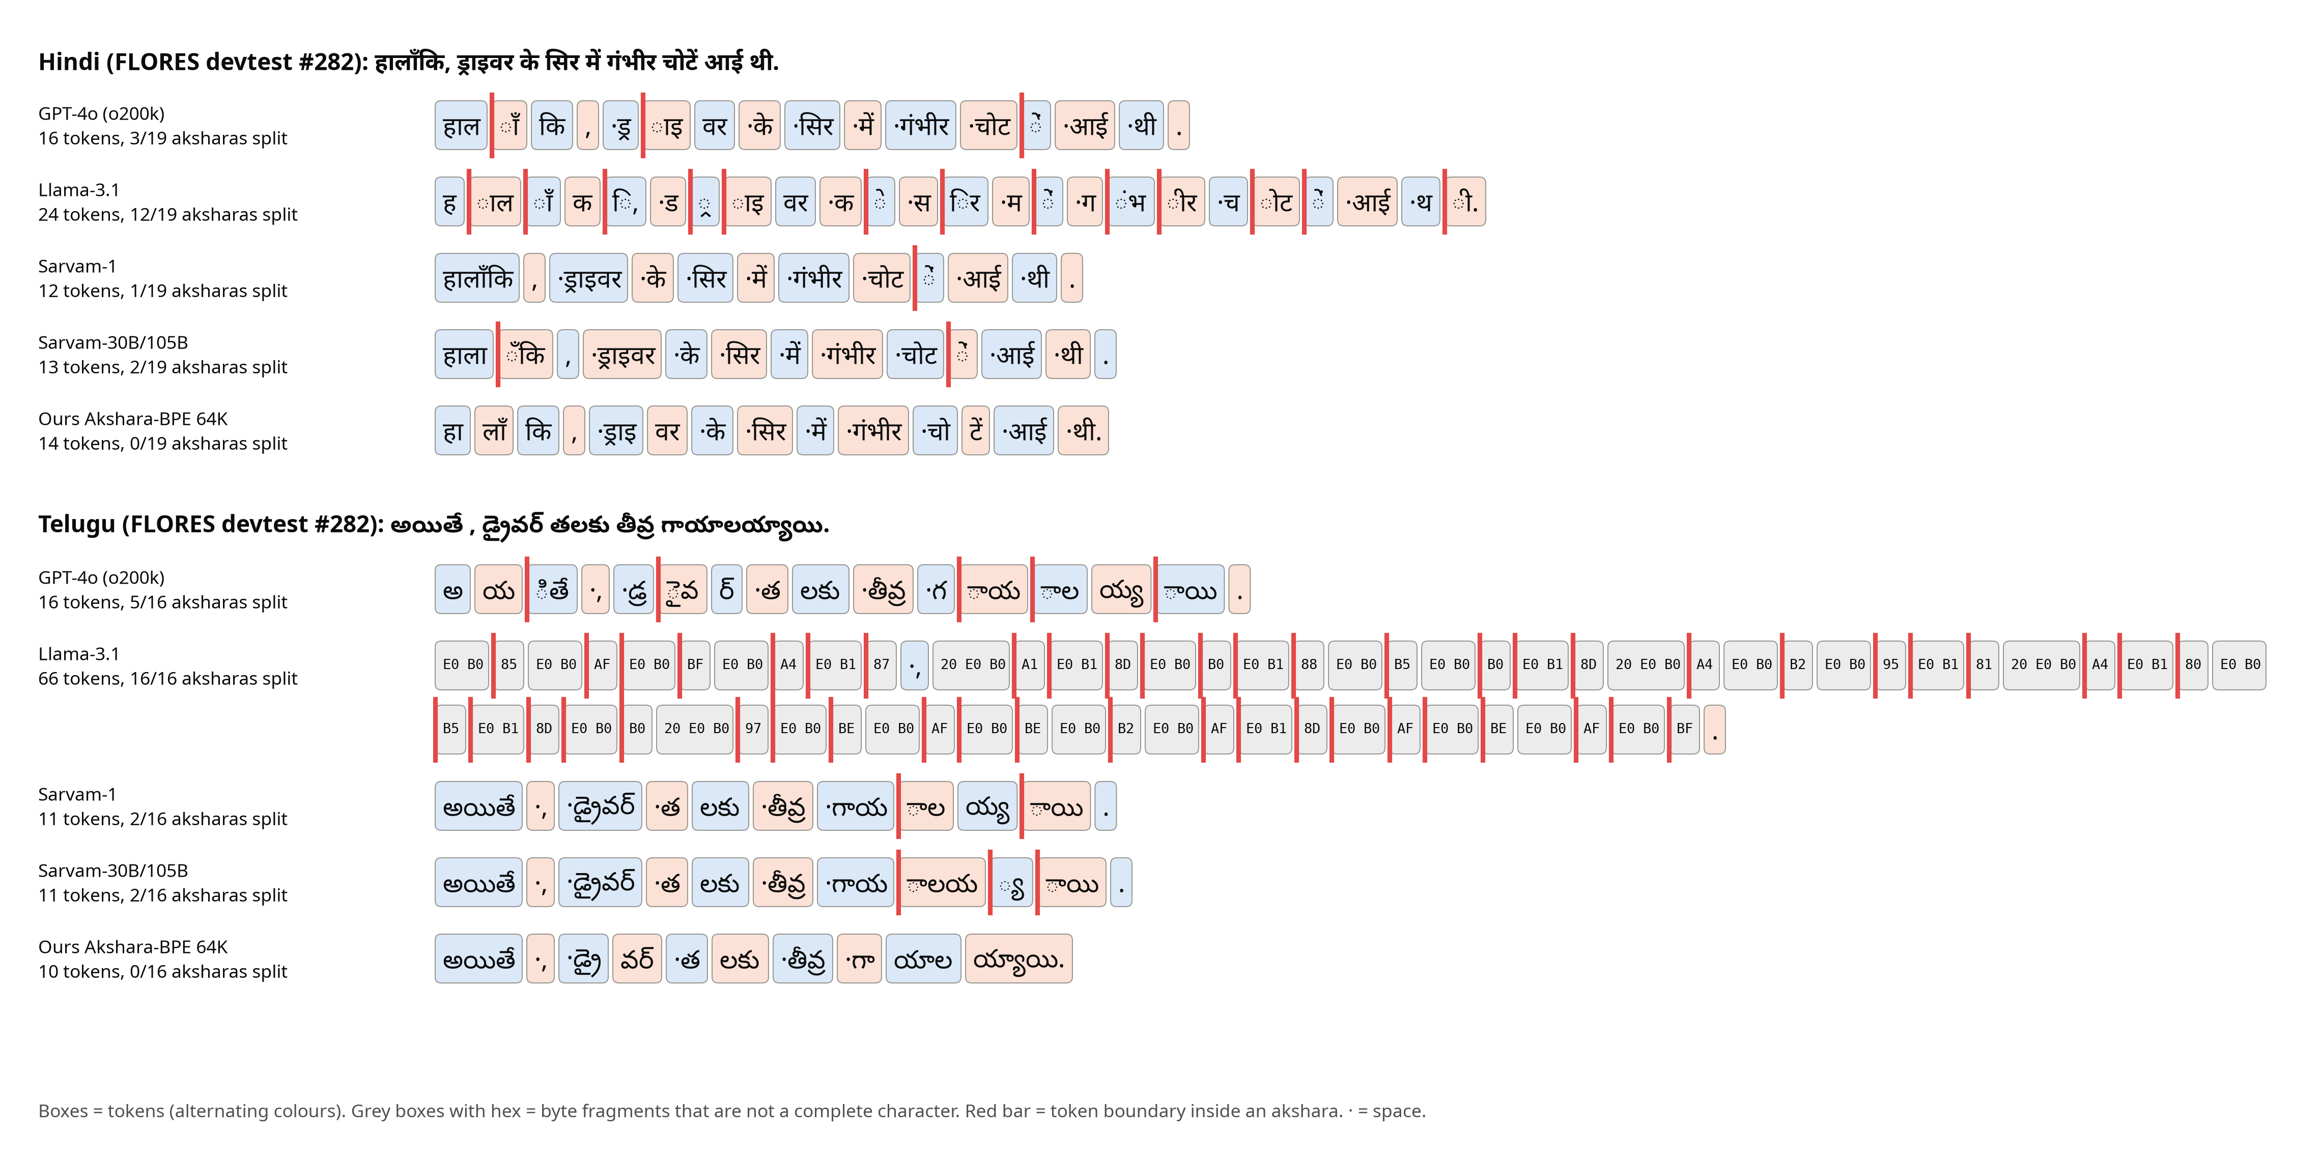
Figure 5: How five tokenizers split the same Hindi and Telugu sentence.

