Programming Questions. Run main.m to reproduce Q1 result. Run main.py to reproduce Q2 results.

Q1)

Does each error in the binary Huffman code symbols give you one error in the source symbols?

The MATLAB code shows it gives at least one error, but if one codeword is detected as another then there may be more than one error because the error will compound now that the next codeword is not the same. Eventually there usually is another error because all the other codewords are offset by 1. So there can be more than one error caused by one error in the binary Huffman code symbol.

An example of this is the output:

number of errors in huffman code

223

number of errors in huffman code

225

Since I am generating a random sequence, this shows that sometimes the same number of errors will create more errors in the source symbols.

Q2)

a)

for num_phrases=4 length of codewords per average number of symbols = 0.738007

for num_phrases=8 length of codewords per average number of symbols = 0.575040

for num_phrases=16 length of codewords per average number of symbols = 0.503709

for num_phrases=32 length of codewords per average number of symbols = 0.509939

for num_phrases=64 length of codewords per average number of symbols = 0.513482

for num_phrases=128 length of codewords per average number of symbols = 0.502555

for num_phrases=256 length of codewords per average number of symbols = 0.491719

for num_phrases=512 length of codewords per average number of symbols = 0.490866

for num_phrases=1024 length of codewords per average number of symbols = 0.491279

b)

Tunstall encoding

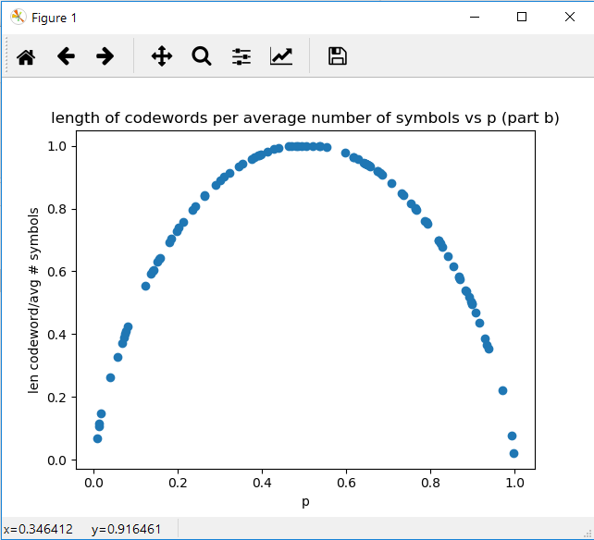

c)

Tunstall then Huffman encoding

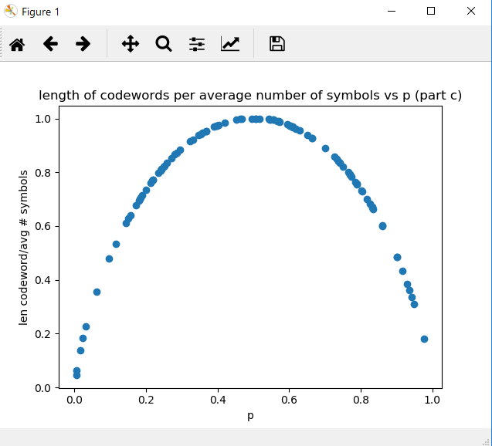

d) In HW 1, I had the following plot:

Huffman encoding

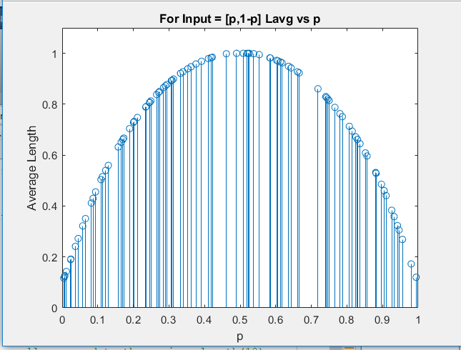

Note that this plot is better than the Tunstall (part b), and the same performance as the Tunstall and Huffman code (part c). This is good to know since it confirms the fact that the Huffman code is the optimal encoding, and also shows that the Tunstall encoding does not stop a code from being optimal.