Creative Mode Plus
Author: Caleb Waggoner
Organization: MyPace
© 2012 Caleb Waggoner

I. Purpose
This document's purpose is to explain how to use the Creative Mode Plus (CMP) application. It will briefly detail what the different items in the interface do to help you build structures in your Minecraft world.

II. Bug Reporting
In order to help the developer quickly fix any bugs you may find (which he dearly hopes you do not find any), please reproduce the bug you've found several times before submitting a report to him. Then report exactly how to reproduce the bug in an email to bug.report.creativemodeplus@gmail.com.

III. The Interface
Below and to the left is the main window of the CMP application. The first things to notice about it are, the “63” and “100%” labels in the menu area. These are the indicators for Y-level usage, and zoom factor respectively. These values can be changed using the Scroll bar above the black area for the Y-level, and the mouse wheel for the zoom. Above the Scroll bar are the block and brush size selectors. These will be explained in more detail later. The black area that makes up the majority of the opening screen is the editing area, an image of the terrain you wish to edit will appear here when you open a Minecraft level. At the bottom of the editing area is the Tool Window, it will follow the main window until it is moved. The tools available area Selection, Move, Paint brush, Fill, and Pencil. These will be explained later. On the bottom of the main window are, from left to right, the Loading bar, Load indicator, Block indicator, and Cursor location. The Loading bar and indicator show completion percentage of a background process and what that process is doing. The Block indicator and Cursor location show what block the cursor is over, and where it is in the window.

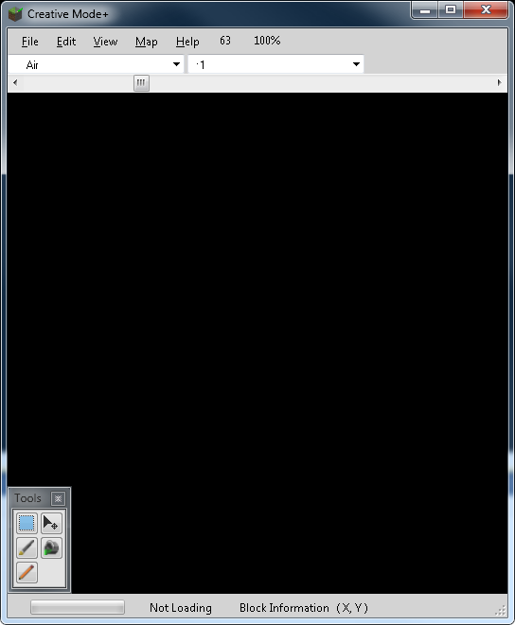
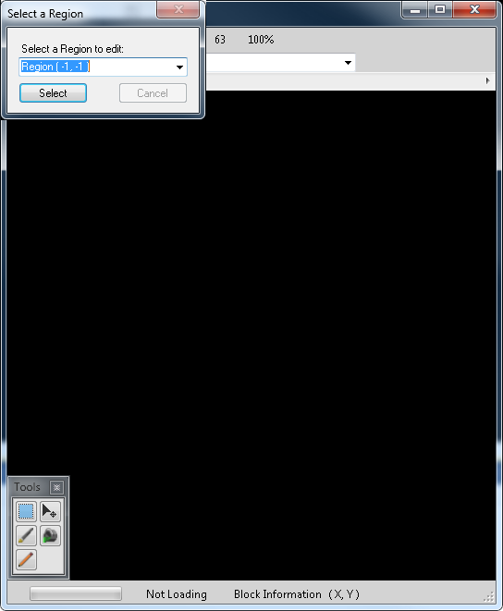
The image to the right of the main window shows the Region selection window. For the purposes of memory conservation and speed, only one level of region is loaded at a time. This may seem inconvenient but there are features to help ease this. This window is opened automatically when world data is loaded, and can be also accessed via the main menu in “Map” > “Select Region” or with the keyboard using the Ctrl+R shortcut.

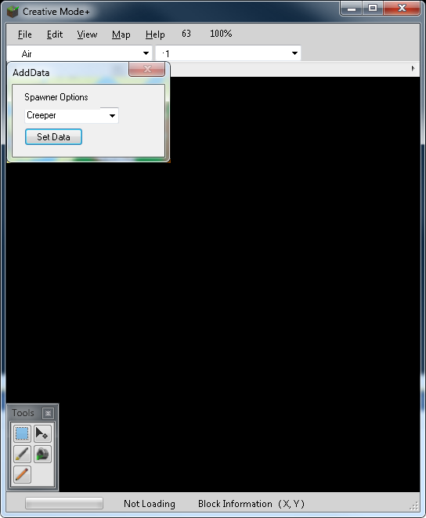
The final window in the interface involves Block data. As you should be aware not all blocks placed are made equal, some involve other data, such as directions, some use entities to be fully usable. This window will open automatically when you select a block type that requires additional data.

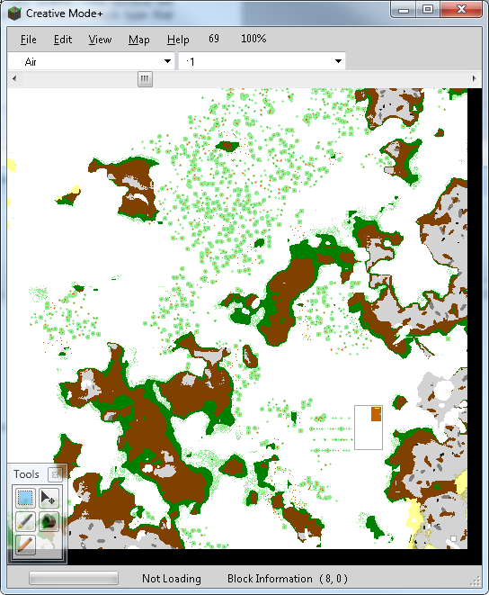

IV. Editing a Map
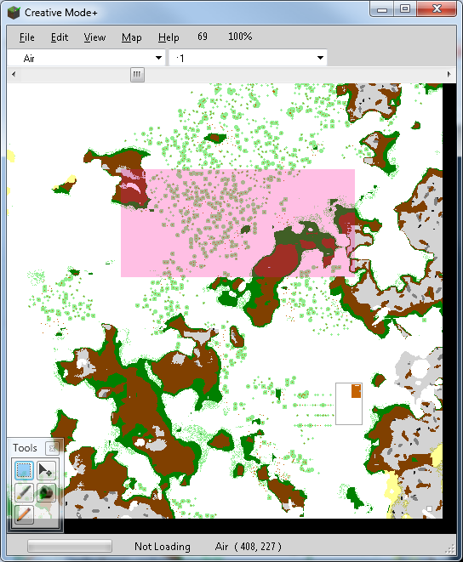
The most important thing that must be said about the ability to edit Minecraft levels is that this program allows building structures that would otherwise be tedious to build. To facilitate this, Air blocks (which normally are transparent) have been rendered as visible blocks. This may make building from the ground up slightly harder, but makes building in-air structures much easier.

A. Tools
Starting with the Selection tool, this operates much like any image editor available. To make a selection, simply hold the left mouse button down, drag the cursor over the area you wish to select, and release when you have what you want selected. If you want to clear the selection, quickly click anywhere in the edit window while the Selection tool is active. Please note, unless you have the Selection tool active, the only other way to clear the selection is to use the Cut and Paste functions (Ctrl+X and Ctrl+V or “Edit” > “Cut” and “Edit” > “Paste”) to remove or change the selections with other side effects.

That said, selected areas will remain even when the Y-level is changed. This is to provide a way to keep track of the boundaries of structures when building them.
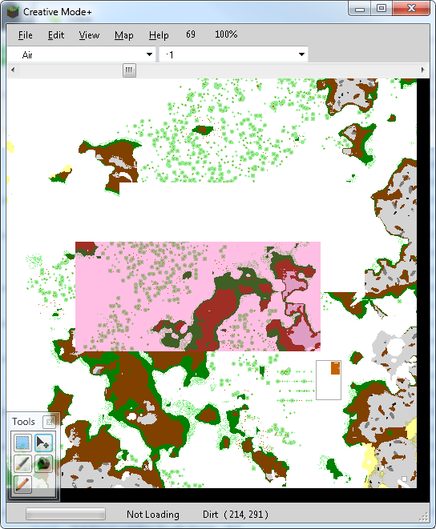
The Move tool also works the much the same as you would expect of the same tool in an image editor. There is one exception to this, it will only operate on selected areas, if there is nothing selected it will do nothing. When moving data around, press and hold the left mouse button down, drag the area from one place to another, and release when it is in the right place. The original area will be filled with Air blocks as replacement information.

When you Paste data that you have Copied or Cut from the level the Move tool will be automatically activated to move the data around, this is the only instance where the original data will not be destroyed by what is covered.

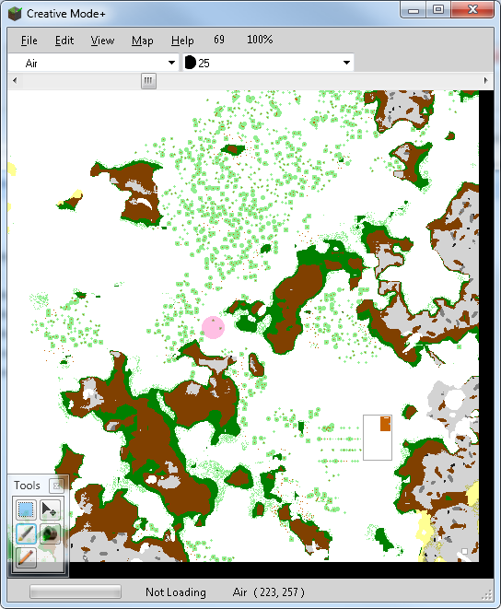
The Paint brush tool, unlike normal paint brush tools available in image editors, there is not ability to anti-alias, so all that separates the Paint brush from the Pencil tool is the fact that brushes can be a 32 pixel diameter circle instead of being stuck as only 1 pixel. To select a brush size, simply use the brush size selector drop down and select the size that fits your needs. Additionally, you can choose what block to place using the block selector located to the left of the brush size selector.

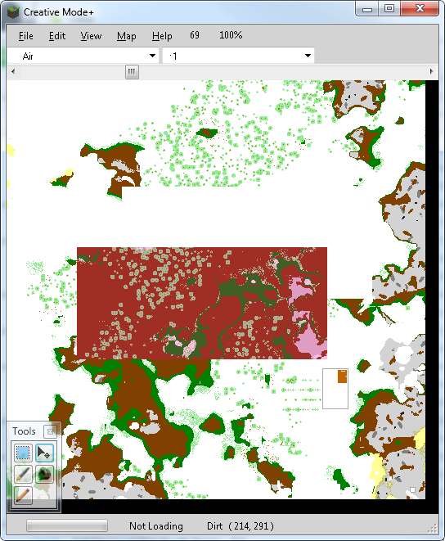
The Fill tool has the same settings as a fill would in an image editor. When you click it replaces all the blocks around with IDs that match the original block that was clicked and stops upon discovering a block with different ID. Then the Shift key is pressed in conjunction with the tool, all the blocks with matching IDs in the region or selection area are replaced.

The Copy, Cut, Paste, Undo, and Redo functions do as the would do in any other application, and can be activated by using the “Edit” menu or by Ctrl+C, Ctrl+X, Ctrl+V, Ctrl+Z, and Ctrl+Y respectively. The Undo and Redo are slightly special in that when sets of changes are made with the same tool, Undo will revert all the changes made with that tool, up to the point where a different tool was used. Redo will, likewise, restore the set of changes.

V. Edits
As of 0.9.7.0, the height bar and indicator have been replaced by a drop down box for ease of height selection.

