電通二乙微處理器實驗 實驗結報

實驗名稱 | 類比輸入
組別 | 31 | 組員 | 03050991 張詠喻

- 實驗目的
使用 USB-Serial 做為輸入輸出 * 讀取類比輸入之數值
1. 量測 5V 及 3.3V 之電壓值
2. 量測可變電阻之數值
3. 量測光敏電阻之數值
- 實驗步驟
1. 由 Arduino 傳送訊息給PC * Arduino 傳送一訊息 “Hello, World!” 至 PC
2. PC 經由 Serial Monitor 接收 * 打開 Arduino IDE 的 Serial Monitor, 確認有收到訊息
3. 由 PC 傳送指令至 Arduino * 傳送命令 1 及 0 至 Arduino * Arduino 收到 ‘1’ 後, LED 13 亮 * Arduino 收到 ‘0’ 後, LED 13 滅

- 程式碼
Checkpoint01
void setup() {
pinMode(13,OUTPUT);
Serial.begin(9600);
Serial.println("Hello");
Serial.print("\tLED PIN IS : 13");

Serial.print("\nBYE!");

}
void loop()
{
char val;
if(Serial.available())
{
val = Serial.read();
switch(val)
{

case'0':
digitalWrite(13,LOW);
Serial.println("LED OFF");
break;
case'1':
digitalWrite(13,HIGH);
Serial.println("LED ON");
}
}
}
Checkpoint02
float Analogin = 0;
float X = 0;
void setup() {
pinMode(14,INPUT);
Serial.begin(9600);

}
void loop()
{

for (int i=0;i<=5;i++)
Analogin = 0.7* Analogin + 0.3* analogRead(A0);
Analogin = Analogin * 2.5 / 4095;
Serial.println(Analogin);
Serial.println(X);
delay(500);
}
Checkpoint03
int Vin = 5;
const int analogInPin = A3;
const int analogInPin1 = A2;
double sensorValue = 0;
double sensorValue1 = 0;
double sensorVoltage = 0;
double sensorVoltage1 = 0;
double ResisterValue = 1000;
double ResisterValue1 = 981300;
double R2,R1; void setup() {
Serial.begin(9600);
for(int i=1;i<=5;i++) {
sensorValue += analogRead(analogInPin);
}
sensorValue = sensorValue/5;
}
void loop()
{
for(int i=1;i<=20;i++)
{
for(int i=1;i<=5;i++)
{
sensorValue = 0.7* sensorValue + 0.3 * analogRead(analogInPin);
sensorValue1 = 0.7* sensorValue1 + 0.3 * analogRead(analogInPin1);
}
sensorVoltage = sensorValue * 5 / 1024;
sensorVoltage1 = sensorValue1 * 5 / 1024;
R2 = (sensorVoltage * ResisterValue)/(Vin-sensorVoltage);
R1 = 981300 - (sensorVoltage1 * ResisterValue1)/Vin; Serial.print("sensorValue = ");
Serial.println(sensorValue1); Serial.print("sensorVoltage = ");
Serial.println(sensorVoltage1); Serial.print("Potentiometer = ");
Serial.println(R1);
Serial.println("--------------");
Serial.print("LDR = "); Serial.println(R2);
Serial.println("**************");
delay(500);
}
delay(1000);
}
Checkpoint04
void setup()
{
Serial.begin(9600);
}
float sensorValue ;
float sensorVoltage;
float R1=0,R2=1083000,Vin=5;
int i;
void loop()
{
for (i=0;i<=5;i++)
{
sensorValue = 0.7* sensorValue + 0.3* analogRead(A2);
}
sensorVoltage = sensorValue * 5 / 1024 ;// sensorVoltage= Vin * R1 / (R1+R2)

delay(100);
Serial.print("sensorVoltage=");
Serial.print(sensorVoltage);
Serial.print("\n");

}
- 實驗結果及分析
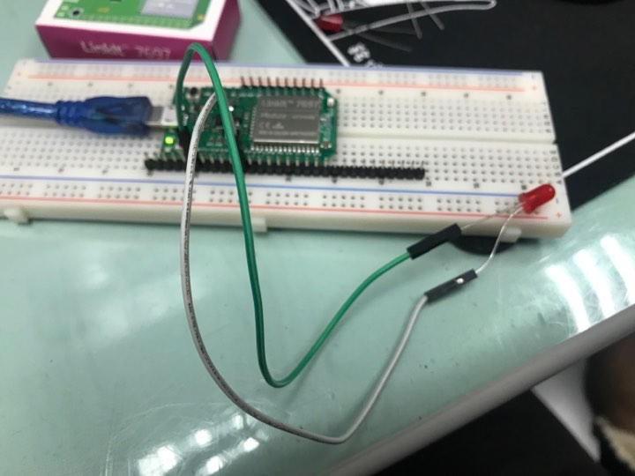
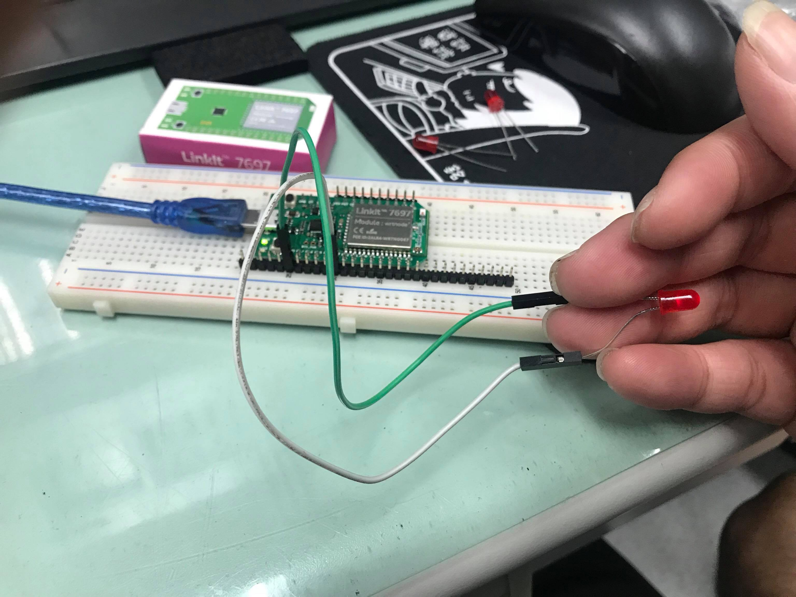
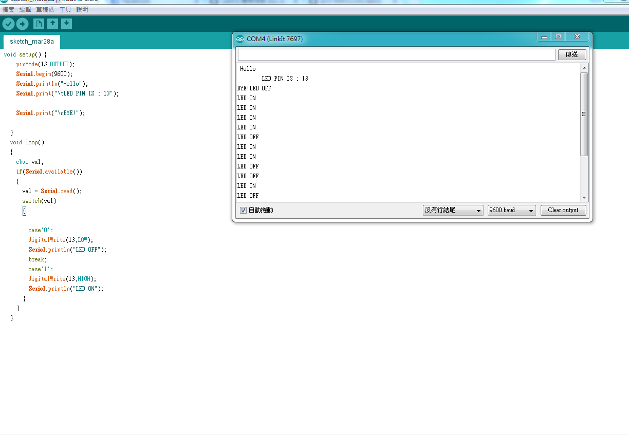
Checkpoint02
實際電壓 | Analogread讀值 | 推測電壓
0 | 12.71 | 0.01
0.5 | 837 | 0.5
1 | 1652 | 1
1.5 | 2497 | 1.5
2 | 3276 | 2
2.5 | 4095 | 2.5

Checkpoint03
可變電阻量測值 | Analogread讀值 | 推測電壓 | 推測電阻值 | SerialMonitor輸出

- 心得討論
這次實驗非常難,需要做多次一點,才做得出來!
- 修正電路圖
- 修正程式碼

