電通二乙微處理器實驗 實驗結報

實驗名稱 | Lab08-中段控制與超音波測距
組別 | 31 | 組員 | 張詠喻

- 實驗目的
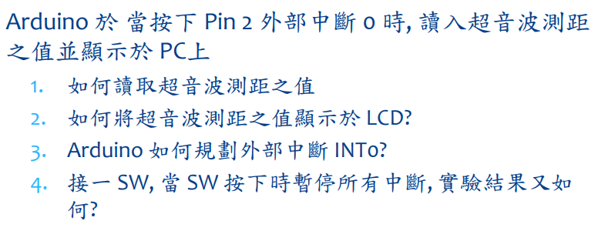
- 實驗步驟
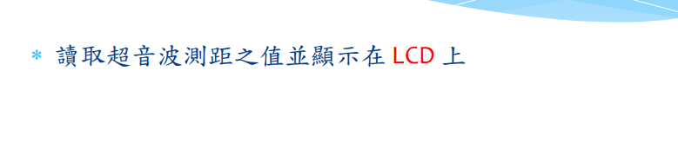
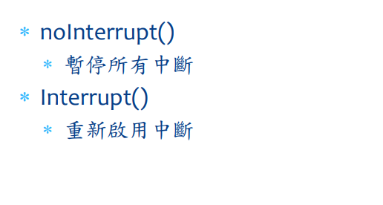
- 程式碼
#include <LiquidCrystal.h>
const int trig = 13;
const int echo = 12;
int time = 0;
LiquidCrystal lcd(11, 10, 5, 4, 3, 2);
void setup() {
Serial.begin(9600);
pinMode (trig, OUTPUT);
pinMode (echo, INPUT);
lcd.begin(16, 2); // set up the LCD's number of columns and rows:
}

void loop() {
lcd.setCursor(0, 1);
float duration, distance;
digitalWrite(trig, HIGH);
delayMicroseconds(1000);
digitalWrite(trig, LOW);
duration = pulseIn (echo, HIGH);
distance = (duration/2)/29;
lcd.print(" cm = ");
lcd.print(distance);
delay(1000);
}

#include <LiquidCrystal.h>
const int trig = 13;
const int echo = 12;
const int inter_time = 1000;
int time = 0;
LiquidCrystal lcd(11, 10, 5, 4, 3, 2);
void setup() {
Serial.begin(9600);
pinMode (trig, OUTPUT);
pinMode (echo, INPUT);
lcd.begin(16, 2); // set up the LCD's number of columns and rows:
attachInterrupt(6, int0, HIGH);
}

void loop() {

}
void int0() {
lcd.setCursor(0, 1);
float duration, distance;
digitalWrite(trig, HIGH);
delayMicroseconds(1000);
digitalWrite(trig, LOW);
duration = pulseIn (echo, HIGH);
distance = (duration/2)/29;
//lcd.print("Data:");
//lcd.print (time/1000);
lcd.print(" cm = ");
lcd.print(distance);
time = time + inter_time;
delay(inter_time);
}

4.實驗結果及分析
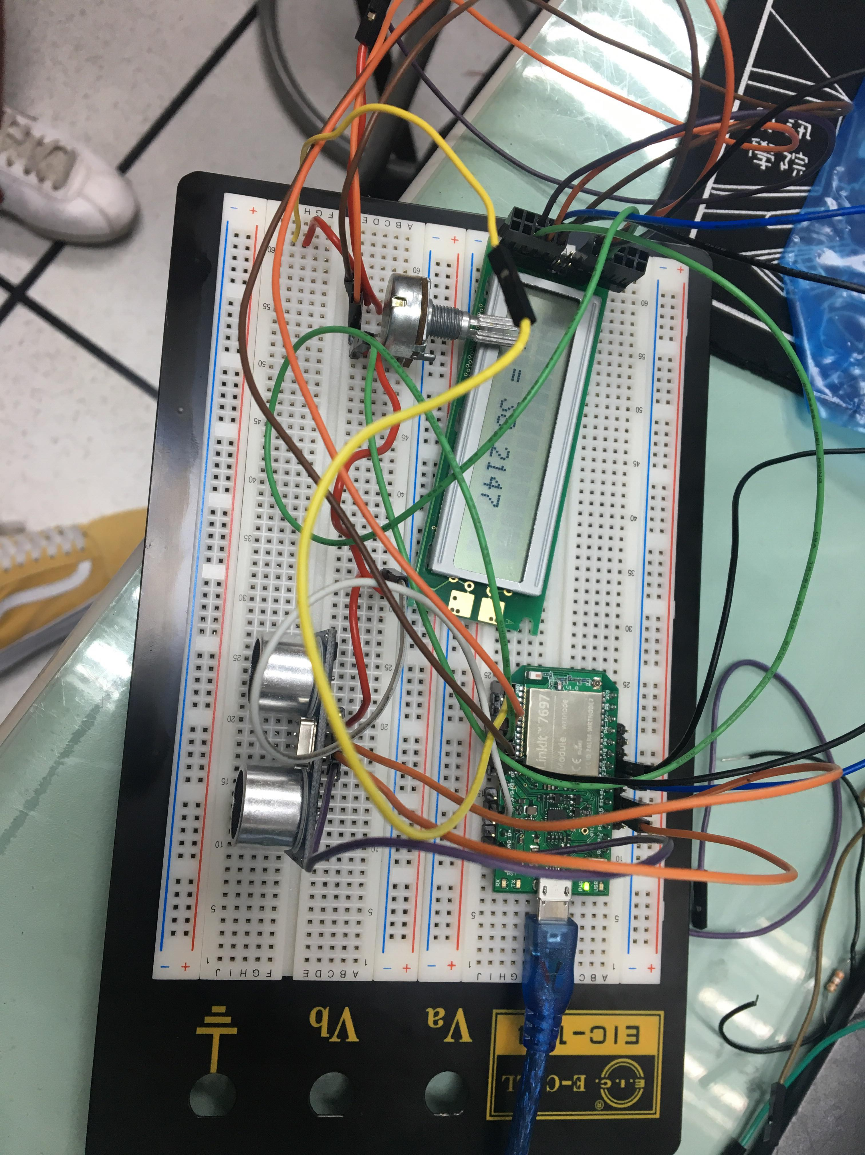

5.心得討論
這次實驗的接線分常麻煩非常容易接錯

