電通二乙微處理器實驗 實驗結報

實驗名稱 | Lab02-跑馬燈
組別 | 31 | 組員 | 張詠喻

- 實驗目的
Arduino UNO D1 – D8 分別接到 LED，實作跑馬燈展 示。
- 實驗步驟
1. LED 向左及向右執行花色展示
2. 執行自定花色展示: 所有LED亮滅兩次 -> 左移八次 -> 所有LED亮滅兩
次 -> 右移八次
- 程式碼
Checkpoint 01
const byte NUM=8;
const byte
led[]={3,4,5,8,9,10,11,12};
const int delaytime=50;
int ii;
void setup() {
for (ii=0;ii<NUM;ii++)
{ pinMode(led[ii],OUTPUT);
digitalWrite(led[ii],LOW);
}
}

void loop()
{

for(ii=0;ii<NUM;ii++)

{ digitalWrite(led[ii],HIGH);
delay(delaytime);
digitalWrite(led[ii],LOW);
}
for (ii=0;ii<NUM;ii++)
{
digitalWrite(led[ii],LOW);
}
delay(delaytime);

for(ii=NUM-1;ii>=0;ii--)

{ digitalWrite(led[ii],HIGH);
delay(delaytime);
digitalWrite(led[ii],LOW);
}
for (ii=0;ii<NUM;ii++)
{
digitalWrite(led[ii],LOW);
}
delay(delaytime);
}

Checkpoint 02

const byte NUM=8;
const byte
led[]={3,4,5,8,9,10,11,12};
const int delaytime=50;
int ii;
void setup() {
for (ii=0;ii<NUM;ii++)
{ pinMode(led[ii],OUTPUT);
digitalWrite(led[ii],LOW);
}
}

void loop()
/*左移*/
{

delay(delaytime);
delay(delaytime);
digitalWrite(led[0],HIGH);
digitalWrite(led[1],HIGH);
digitalWrite(led[2],HIGH);
digitalWrite(led[3],HIGH);
digitalWrite(led[4],HIGH);
digitalWrite(led[5],HIGH);
digitalWrite(led[6],HIGH);
digitalWrite(led[7],HIGH);
delay(delaytime);
delay(delaytime);
digitalWrite(led[0],LOW);
digitalWrite(led[1],LOW);
digitalWrite(led[2],LOW);
digitalWrite(led[3],LOW);
digitalWrite(led[4],LOW);
digitalWrite(led[5],LOW);
digitalWrite(led[6],LOW);
digitalWrite(led[7],LOW);
delay(delaytime);
delay(delaytime);
delay(delaytime);
digitalWrite(led[0],HIGH);
digitalWrite(led[1],HIGH);
digitalWrite(led[2],HIGH);
digitalWrite(led[3],HIGH);
digitalWrite(led[4],HIGH);
digitalWrite(led[5],HIGH);
digitalWrite(led[6],HIGH);
digitalWrite(led[7],HIGH);
delay(delaytime);
delay(delaytime);
digitalWrite(led[0],LOW);
digitalWrite(led[1],LOW);
digitalWrite(led[2],LOW);
digitalWrite(led[3],LOW);
digitalWrite(led[4],LOW);
digitalWrite(led[5],LOW);
digitalWrite(led[6],LOW);
digitalWrite(led[7],LOW);
delay(delaytime);

for(ii=0;ii<NUM;ii++)

{ digitalWrite(led[ii],HIGH);
delay(delaytime);
digitalWrite(led[ii],LOW);
}
delay(delaytime);
delay(delaytime);
for (ii=0;ii<NUM;ii++)
{
digitalWrite(led[ii],LOW);
}
delay(delaytime);
delay(delaytime);
digitalWrite(led[0],HIGH);
digitalWrite(led[1],HIGH);
digitalWrite(led[2],HIGH);
digitalWrite(led[3],HIGH);
digitalWrite(led[4],HIGH);
digitalWrite(led[5],HIGH);
digitalWrite(led[6],HIGH);
digitalWrite(led[7],HIGH);
delay(delaytime);
delay(delaytime);
digitalWrite(led[0],LOW);
digitalWrite(led[1],LOW);
digitalWrite(led[2],LOW);
digitalWrite(led[3],LOW);
digitalWrite(led[4],LOW);
digitalWrite(led[5],LOW);
digitalWrite(led[6],LOW);
digitalWrite(led[7],LOW);
delay(delaytime);
delay(delaytime);
delay(delaytime);
digitalWrite(led[0],HIGH);
digitalWrite(led[1],HIGH);
digitalWrite(led[2],HIGH);
digitalWrite(led[3],HIGH);
digitalWrite(led[4],HIGH);
digitalWrite(led[5],HIGH);
digitalWrite(led[6],HIGH);
digitalWrite(led[7],HIGH);
delay(delaytime);
delay(delaytime);
digitalWrite(led[0],LOW);
digitalWrite(led[1],LOW);
digitalWrite(led[2],LOW);
digitalWrite(led[3],LOW);
digitalWrite(led[4],LOW);
digitalWrite(led[5],LOW);
digitalWrite(led[6],LOW);
digitalWrite(led[7],LOW);
delay(delaytime);

/*右移*/
for(ii=NUM-1;ii>=0;ii--)

{ digitalWrite(led[ii],HIGH);
delay(delaytime);

digitalWrite(led[ii],LOW);
}
delay(delaytime);

for (ii=0;ii<NUM;ii++)
{
digitalWrite(led[ii],LOW);
}
delay(delaytime);

}

- 實驗結果及分析
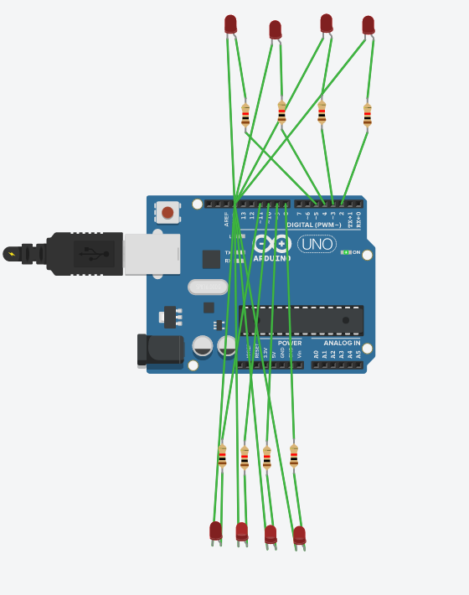

- 心得討論

程式碼非常複雜須認真看才能完成
- 修正電路圖

- 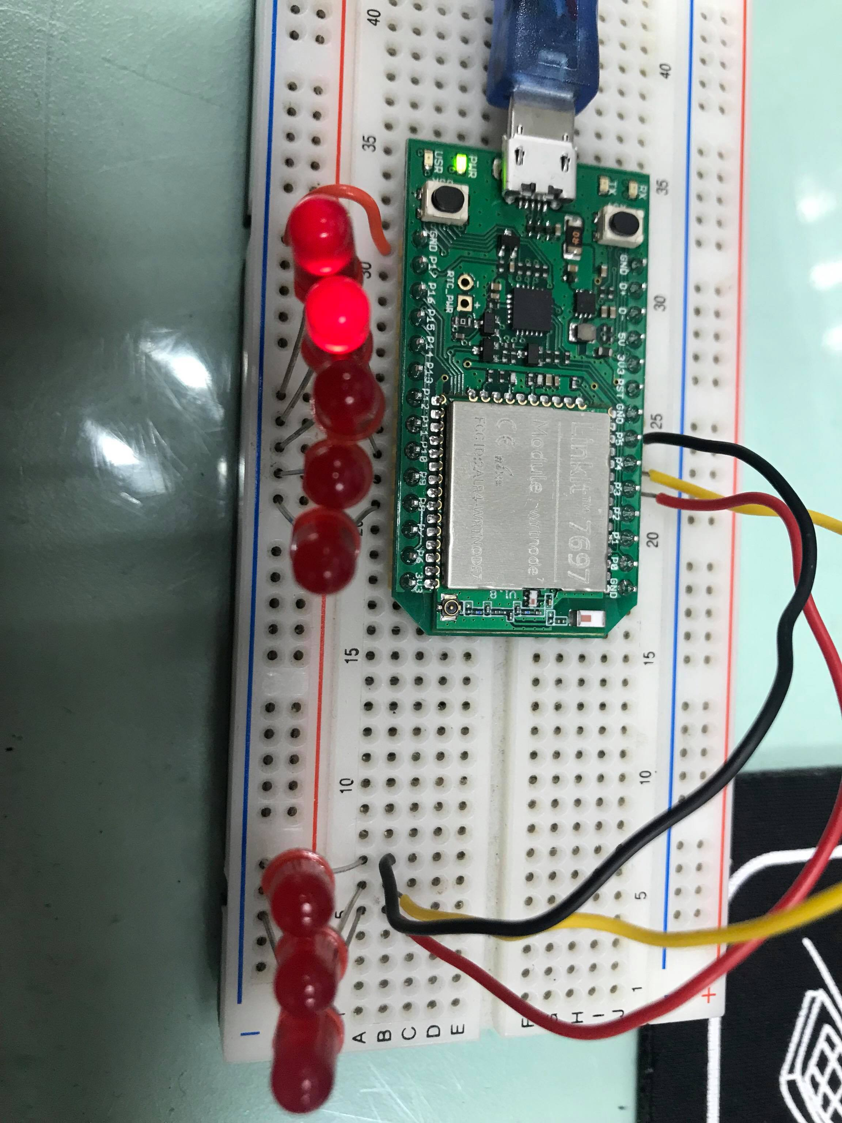
修正程式碼

