* Using blogger.com
* Blog Link:
  + [Airline Travel with Southwest - Safe as Always! (dsc640blogpost4-3jakemeyer.blogspot.com)](https://dsc640blogpost4-3jakemeyer.blogspot.com/)
  + <https://dsc640blogpost4-3jakemeyer.blogspot.com/2023/02/dsc-640-project-task-3-blog-post.html>
* Methodology Followed:
  + Beginning, Middle, End
  + Narrative Flow: Order of the story (Chronologically) to establish credibility with the audience.
  + Bingo, Bango, Bongo – Tell the audience what you are going to tell them (introduction paragraph), tell it to them (content), and then summarize what you just told them.
  + Reverse Storyboarding
  + Topic, Audience Purpose: TAP
  + Inkscape 1.2.2 for visualization edits.
* Beginning
  + Why should the audience pay attention?
  + Setup the plot.
  + Elaborate on the setting, main character, imbalance, balance, and solution.
* Middle
  + Retain audiences’ attention by addressing how they can solve the problem you introduced.
  + Work to convince them why they should accept the solution you are proposing or act in the way you want them to.
  + Incorporate external context or comparison points.
  + Include data that demonstrates the problem.
  + Discuss potential options for addressing the problem.
  + Make it clear to your audience why they are in a unique position to make a decision or drive action.
* End
  + End with a call to action: make it totally clear to your audience what you want them to do with the new understanding or knowledge that you’ve imparted to them.
* Narrative Flow
  + Chronologically – identify a problem, gather data to better understand the situation, we analyze the data (look at it one way, look at it another way), tie in other things to see if they had an impact), we emerge with a finding or solution, and based on this we have a recommended action.
* Topic – Southwest Airline Travel remains safe for the public.
* Audience – The General Public. Travelers. Enthusiasts.
* Purpose- To persuade the public to continue using southwest airlines.
* Introduction
  + Hook – The media has recently portrayed airline travel as an unsafe mode of transportation.
  + Airline Industry - Comparatively to other modes of transportation.
  + Chronologically – Airline accident trends over time.
  + Within Industry – Southwest had no recordable fatal incidents between 2000-2014.
  + Successes – Number of passengers for both domestic and international flights over the last ten years.
  + Thesis Statement: Through a breakdown of the true facts surrounding the airline industry, it will become clear that Southwest Airlines remains a great option for travel.
* Middle
  + Transportation Mode Comparison
  + Chronologically
  + Within Industry
  + Successes
* Conclusion
  + When compared to land, water, rail, air has the least number of fatalities over the last x number of years.
  + It is clear that the airline industry is at an all-time low in terms of number of accidents per year.
  + Southwest Airlines has not had a fatal accident between 2000-2014. Strive to continue improving and reducing the number of incidents.
  + People trust Southwest with increasing number of passengers for both domestic and international flights over the last 10 years.
  + Call to Action: When booking travel options, continue with a safe trusted choice in Southwest Airlines.

Airline Travel with Southwest – Safe As Always! Blog Post.

The media has recently portrayed airline travel as an unsafe mode of transportation. It is only fair that you, the public, are presented with the true facts surrounding airline travel. There are many obvious benefits of flying to a destination such as speed, comfort, and cost. However, the main benefit to focus on for this discussion is safety. On behalf of Southwest Airlines, this post will overview safety in several different aspects. First, it is essential to understand how airline travel compares to other modes of transportation in terms of fatalities. Second, the accident trends for airlines need to be understood over time. Third, let’s review how Southwest Airlines stacks up amongst other airlines in terms of accidents and fatalities. Fourth, let’s determine if there is a difference in the number of passengers that choose Southwest Airlines every year. Through a deeper analysis of the true facts, it will become clear that Southwest Airlines remains a great option for travel.

**How does the number of fatalities compare across different modes of transportation?** Since 1960, transportation fatality data has been collected by the Bureau of Transportation Statistics. The modes of transportation include Highway (busses, cars, motorcycles, etc.…), Railroad (train), Water (boat), and Air (airplane). The Highway mode of transportation resulted in the most fatalities by far. In fact, there were more fatalities when traveling via Highway compared to Railroad, Water, and Air combined. Travel by Air only accounted for 1.8% of total fatalities which is the lowest compared to each mode. The visualization below shows the drastic difference.

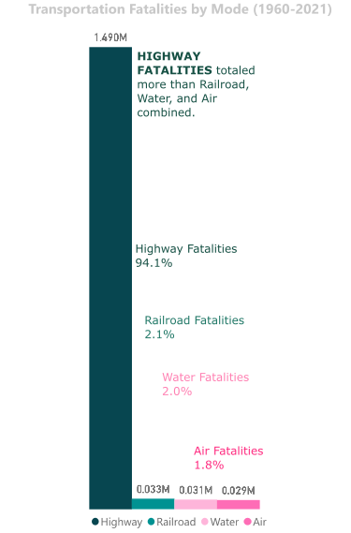

**How have accident trends via airline travel trended through time?** One of the best indicators whether something is improving or getting worse is through a trend over time. The Aviation Safety Network collects data on the number of accidents for airlines each year. Since 1946, the number of annual accidents has generally declined and is lower than ever before. The accident trend will continue to decrease over future years as technology continues to improve along with increased safety precautions. As seen in the below visualization, the airline accidents per year have decreased and are currently at an all-time low.

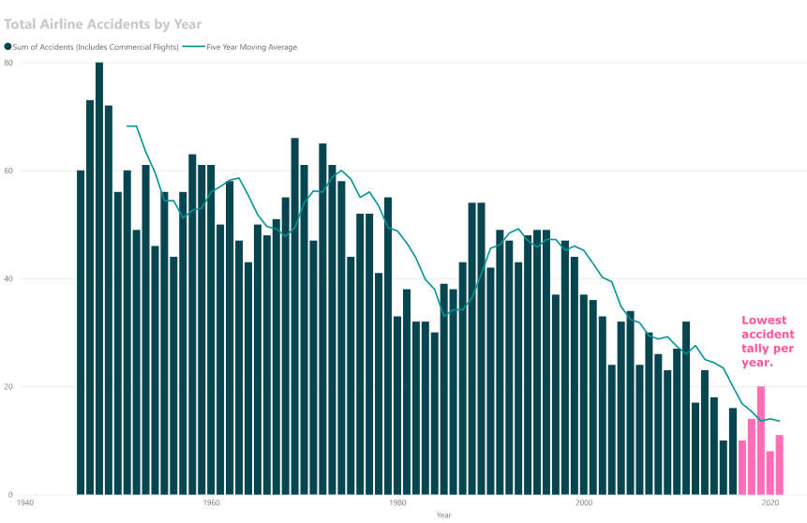

**How does Southwest Airlines compare to other airlines in terms of accidents and fatalities?** There is a difference between a fatal airline accident and a general airline accident. A fatal accident is defined as an accident in which one of the passengers died. A general accident can range across a variety of things, but did not result in any fatalities. Obviously, airlines strive to avoid both situations, however the fatal airline accidents are the worst-case scenario. Data was collected between the Years 2000-2014 and consolidated by fivethirtyeight. Southwest had eight accidents during this timeframe, however no accidents were fatal. Southwest plans to implement safety improvement projects to reduce the number of accidents moving forward. The visualization helps show where Southwest ranks.

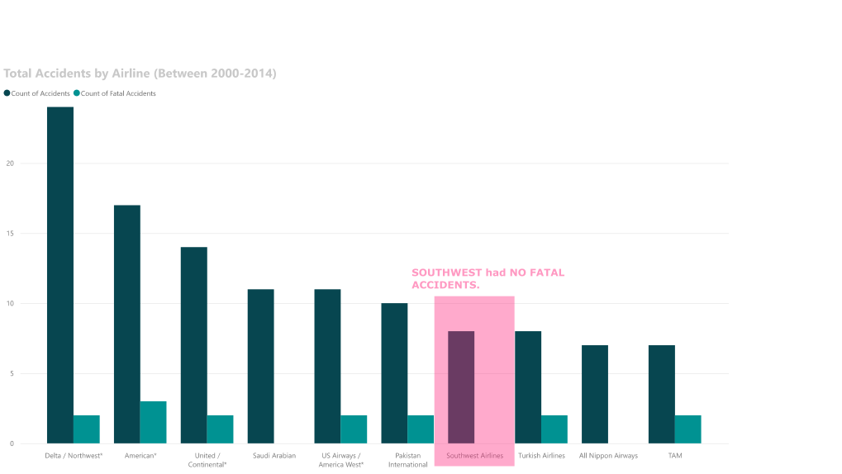

**Do passengers still trust Southwest Airlines?** Millions of passengers put their trust in Southwest each year. In fact, the annual number of passengers increased each year up until the COVID-19 Pandemic in 2020. Since then, passenger numbers are starting to increase again for each year. Whether it is a domestic or international flight, Southwest can get you to where you want to go safely. The visualization below helps show the annual trends.

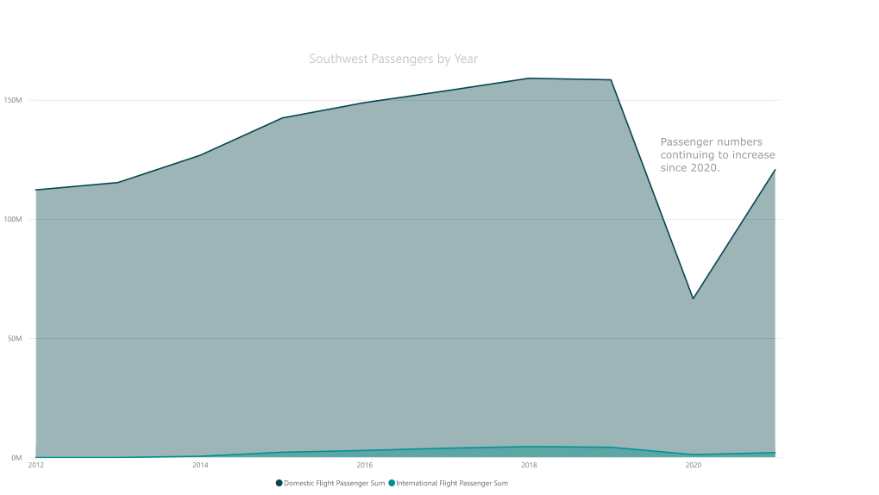

References

Bureau of Aircraft Accidents Archives. (2023). *Accidents Rate Per Year*. Statistics. [Accidents Rate per Year | Bureau of Aircraft Accidents Archives (baaa-acro.com)](http://www.baaa-acro.com/statistics/crashs-rate-per-year?page=0)

Bureau of Transportation Statistics. (2023). *Transportation Fatalities by Mode*. United States Department of Transportation. [Transportation Fatalities by Mode | Bureau of Transportation Statistics (bts.gov)](https://www.bts.gov/content/transportation-fatalities-mode)

David, Isaiah. (2023). *Advantages of Air Travel*. USA Today. [Advantages of Air Travel (usatoday.com)](https://traveltips.usatoday.com/advantages-air-travel-12486.html)

Escobar, Francisco. (2019). *The Statistics of Airplane Accidents* [Data]. Kaggle. [The Statistics of Airplane Accidents | Kaggle](https://www.kaggle.com/code/franciscoescobar/the-statistics-of-airplane-accidents/data)

Fivethirtyeight. (2023). *Airline Safety* [Data]. Github. [data/airline-safety at master · fivethirtyeight/data · GitHub](https://github.com/fivethirtyeight/data/tree/master/airline-safety)

McMahon, Conor. (2022). *20 Southwest Airlines Statistics [2023]: Passengers, Revenue, and Facts*. Zippia. [20 Southwest Airlines Statistics [2023]: Passengers, Revenue, And Facts – Zippia](https://www.zippia.com/advice/southwest-airlines-statistics/)

Nussbaumer, Cole (2015). Storytelling with Data. John Wiley & Sons, Inc.

Ranter, Harro. (2021). *Aviation Safety Network* [Data]. Aviation Safety Network Database. [Accidents and fatalities per year - Google Sheets](https://docs.google.com/spreadsheets/d/1SDp7p1y6m7N5xD5_fpOkYOrJvd68V7iy6etXy2cetb8/edit)

Yau, Nathan. (2011). Visualize This. (1st ed). John Wiley & Sons, Inc.