# Assignment 06 Code and Outputs

For Assignment 6, I executed the code locally and had the following outputs with the example code. The chapter code for the CNN assignment was referenced through the Deep Learning with Python Github Link: [deep-learning-with-python-notebooks/first_edition at master · fchollet/deep-learning-with-python-notebooks (github.com)](https://github.com/fchollet/deep-learning-with-python-notebooks/tree/master/first_edition).

## Assignment 6.1 Code and Outputs:

## Assignment 6-1

### DSC 650

### Jake Meyer

### 04/22/2023

Using section 5.1 in Deep Learning with Python as a guide (listing 5.3 in particular), create a ConvNet model that classifies images in the MNIST digit dataset. Save the model, predictions, metrics, and validation plots in the dsc650/assignments/assignment06/results directory. If you are using JupyterHub, you can include those plots in your Jupyter notebook.

Using code from [deep-learning-with-python-notebooks](https://github.com/fchollet/deep-learning-with-python-notebooks)

In [1]:

*## Import the necessary modules for the assignment above.*

**import** csv

**import** pandas **as** pd

**import** numpy **as** np

**import** matplotlib.pyplot **as** plt

**import** tensorflow **as** tf

**import** keras

**import** sklearn

**from** sklearn.model_selection **import** train_test_split

**import** itertools

**from** pathlib **import** Path

**import** time

**import** os

*## Import the necessary keras components for the data and CNN*

**from** keras **import** layers, models

**from** keras.datasets **import** mnist

**from** keras.utils **import** to_categorical, np_utils

**from** keras.models **import** Sequential, load_model

**from** keras.layers.core **import** Dense, Dropout, Activation

**import** tensorflow.compat.v1 **as** tf

tf**.**disable_v2_behavior()

WARNING:tensorflow:From C:\Users\jkmey\anaconda3\envs\dsc650\lib\site-packages\tensorflow\python\compat\v2_compat.py:107: disable_resource_variables (from tensorflow.python.ops.variable_scope) is deprecated and will be removed in a future version.

Instructions for updating:

non-resource variables are not supported in the long term

In [2]:

*## Print versions of essential packages*

print("keras version: {}"**.**format(keras**.**__version__))

print("tensorflow version: {}"**.**format(tf**.**__version__))

print("pandas version: {}"**.**format(pd**.**__version__))

print("numpy version: {}"**.**format(np**.**__version__))

keras version: 2.11.0

tensorflow version: 2.11.0

pandas version: 1.5.3

numpy version: 1.24.2

In [3]:

*## Try to setup tensorflow to run on GPU using ConfigProto()*

*## config = tf.compat.v1.ConfigProto*

*## devices = tf.config.experimental.list_physical_devices("GPU")*

*## tf.config.experimental.set_memory_growth(devices, True)*

In [4]:

*## Setup the directories for the assignment*

current_dir **=** Path('C:/Users/jkmey/Documents/Github/DSC650_Course_Assignments/dsc650/dsc650/assignments/assignment06')

results_dir **=** Path('C:/Users/jkmey/Documents/Github/DSC650_Course_Assignments/dsc650/dsc650/assignments/assignment06/')**.**joinpath('results')

results_dir**.**mkdir(parents **=** **True**, exist_ok **=** **True**)

### Import the MSNT Dataset

In [5]:

*## Load the data from mnist as specified from Deep Learning with Python Textbook.*

(train_images, train_labels), (test_images, test_labels) **=** mnist**.**load_data()

In [6]:

*## Understand the shape of the train and test datasets.*

print('train_images: {}'**.**format(train_images**.**shape))

print('test_images: {}'**.**format(test_images**.**shape))

print('train_labels: {}'**.**format(train_labels**.**shape))

print('test_labels: {}'**.**format(test_labels**.**shape))

train_images: (60000, 28, 28)

test_images: (10000, 28, 28)

train_labels: (60000,)

test_labels: (10000,)

### Show Training Images and Labels

In [7]:

*## Show the first 16 training images and labels for better understanding of the data.*

fig **=** plt**.**figure()

**for** i **in** range(16):

plt**.**subplot(4,4,i**+**1)

plt**.**tight_layout()

plt**.**imshow(train_images[i], cmap **=** 'gray', interpolation**=**'none')

plt**.**title("Digit: {}"**.**format(train_labels[i]))

plt**.**xticks([])

plt**.**yticks([])

img_file **=** results_dir**.**joinpath('assignment06-1_Sample_Digits_QTY_16.png')

plt**.**savefig(img_file)

print("First 16 Training Images and Labels")

plt**.**show()

First 16 Training Images and Labels

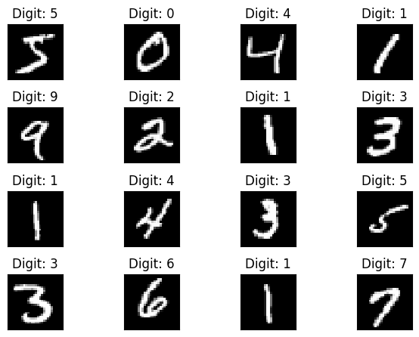

### Pixel Value Histogram

In [8]:

*## Code to check the digit in the train image with the label shown from 0-9.*

fig **=** plt**.**figure()

plt**.**subplot(2,1,1)

plt**.**imshow(train_images[4], cmap **=** 'gray', interpolation **=** 'none')

plt**.**title('Digit: {}'**.**format(train_labels[4]))

plt**.**xticks([])

plt**.**yticks([])

img_file **=** results_dir**.**joinpath('assignment06-1_Digit_Overview.png')

plt**.**savefig(img_file)

plt**.**show()

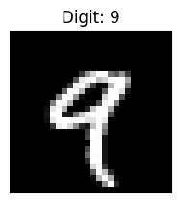

In [9]:

*## Pixel distribution shown in the plot below for the image chosen in the previous cell.*

plt**.**subplot(2,1,2)

plt**.**hist(train_images[4]**.**reshape(784)) *# Value needs to be 784 for reshape, otherwise error*

plt**.**title("Pixel Value Histogram")

img_file **=** results_dir**.**joinpath('assignment06-1_Pixel_Value_Histogram.png')

plt**.**savefig(img_file)

plt**.**show()

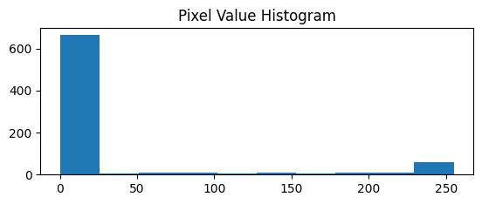

### Prepare the Data

In [10]:

*## Reshape the training images and normalize.*

train_images **=** train_images**.**reshape((60000, 28, 28, 1))

train_images **=** train_images**.**astype('float32') **/** 255

*## Reshape the testing images and normalize.*

test_images **=** test_images**.**reshape((10000, 28, 28, 1))

test_images **=** test_images**.**astype('float32') **/** 255

*## Convert the training and test labels to numbers.*

train_labels **=** to_categorical(train_labels)

test_labels **=** to_categorical(test_labels)

In [11]:

*## Split train_images and train_labels into train and validation subsets.*

train_images_val **=** train_images[:10000]

train_images **=** train_images[10000:]

train_labels_val **=** train_labels[:10000]

train_labels **=** train_labels[10000:]

### Create the CNN Model

In [12]:

*## From the textbook repository, Instantiate the CNN Model*

model **=** models**.**Sequential()

model**.**add(layers**.**Conv2D(32, (3, 3), activation**=**'relu', input_shape**=**(28, 28, 1)))

model**.**add(layers**.**MaxPooling2D((2, 2)))

model**.**add(layers**.**Conv2D(64, (3, 3), activation**=**'relu'))

model**.**add(layers**.**MaxPooling2D((2, 2)))

model**.**add(layers**.**Conv2D(64, (3, 3), activation**=**'relu'))

*## Add a classifier on top of the CNN (also from the textbook repository)*

model**.**add(layers**.**Flatten())

model**.**add(layers**.**Dense(64, activation**=**'relu'))

model**.**add(layers**.**Dense(10, activation**=**'softmax'))

model**.**compile(optimizer**=**'rmsprop',

loss**=**'categorical_crossentropy',

metrics**=**['accuracy'])

In [13]:

*## Show a summary of the model that was just created.*

model**.**summary()

Model: "sequential"

_________________________________________________________________

Layer (type) Output Shape Param #

=================================================================

conv2d (Conv2D) (None, 26, 26, 32) 320

max_pooling2d (MaxPooling2D (None, 13, 13, 32) 0

)

conv2d_1 (Conv2D) (None, 11, 11, 64) 18496

max_pooling2d_1 (MaxPooling (None, 5, 5, 64) 0

2D)

conv2d_2 (Conv2D) (None, 3, 3, 64) 36928

flatten (Flatten) (None, 576) 0

dense (Dense) (None, 64) 36928

dense_1 (Dense) (None, 10) 650

=================================================================

Total params: 93,322

Trainable params: 93,322

Non-trainable params: 0

_________________________________________________________________

### Train the Model

In [14]:

*## Train the model and store the results in the variable history.*

history **=** model**.**fit(train_images, train_labels, epochs**=**20, batch_size**=**128, verbose **=** 2,

validation_data **=** (train_images_val, train_labels_val))

Train on 50000 samples, validate on 10000 samples

WARNING:tensorflow:OMP_NUM_THREADS is no longer used by the default Keras config. To configure the number of threads, use tf.config.threading APIs.

Epoch 1/20

C:\Users\jkmey\anaconda3\envs\dsc650\lib\site-packages\keras\engine\training_v1.py:2333: UserWarning: `Model.state_updates` will be removed in a future version. This property should not be used in TensorFlow 2.0, as `updates` are applied automatically.

updates = self.state_updates

50000/50000 - 11s - loss: 0.2669 - acc: 0.9162 - val_loss: 0.1013 - val_acc: 0.9692 - 11s/epoch - 222us/sample

Epoch 2/20

50000/50000 - 12s - loss: 0.0605 - acc: 0.9811 - val_loss: 0.0536 - val_acc: 0.9853 - 12s/epoch - 234us/sample

Epoch 3/20

50000/50000 - 12s - loss: 0.0402 - acc: 0.9872 - val_loss: 0.0525 - val_acc: 0.9834 - 12s/epoch - 235us/sample

Epoch 4/20

50000/50000 - 11s - loss: 0.0302 - acc: 0.9905 - val_loss: 0.0403 - val_acc: 0.9888 - 11s/epoch - 216us/sample

Epoch 5/20

50000/50000 - 11s - loss: 0.0235 - acc: 0.9923 - val_loss: 0.0360 - val_acc: 0.9900 - 11s/epoch - 227us/sample

Epoch 6/20

50000/50000 - 11s - loss: 0.0182 - acc: 0.9943 - val_loss: 0.0367 - val_acc: 0.9904 - 11s/epoch - 216us/sample

Epoch 7/20

50000/50000 - 11s - loss: 0.0158 - acc: 0.9951 - val_loss: 0.0360 - val_acc: 0.9903 - 11s/epoch - 216us/sample

Epoch 8/20

50000/50000 - 11s - loss: 0.0125 - acc: 0.9964 - val_loss: 0.0430 - val_acc: 0.9889 - 11s/epoch - 216us/sample

Epoch 9/20

50000/50000 - 11s - loss: 0.0099 - acc: 0.9970 - val_loss: 0.0359 - val_acc: 0.9908 - 11s/epoch - 221us/sample

Epoch 10/20

50000/50000 - 11s - loss: 0.0084 - acc: 0.9974 - val_loss: 0.0498 - val_acc: 0.9890 - 11s/epoch - 217us/sample

Epoch 11/20

50000/50000 - 11s - loss: 0.0068 - acc: 0.9977 - val_loss: 0.0442 - val_acc: 0.9906 - 11s/epoch - 215us/sample

Epoch 12/20

50000/50000 - 11s - loss: 0.0060 - acc: 0.9979 - val_loss: 0.0400 - val_acc: 0.9920 - 11s/epoch - 214us/sample

Epoch 13/20

50000/50000 - 11s - loss: 0.0055 - acc: 0.9980 - val_loss: 0.0472 - val_acc: 0.9906 - 11s/epoch - 215us/sample

Epoch 14/20

50000/50000 - 11s - loss: 0.0044 - acc: 0.9987 - val_loss: 0.0524 - val_acc: 0.9911 - 11s/epoch - 214us/sample

Epoch 15/20

50000/50000 - 11s - loss: 0.0041 - acc: 0.9987 - val_loss: 0.0559 - val_acc: 0.9902 - 11s/epoch - 215us/sample

Epoch 16/20

50000/50000 - 11s - loss: 0.0042 - acc: 0.9987 - val_loss: 0.0518 - val_acc: 0.9916 - 11s/epoch - 215us/sample

Epoch 17/20

50000/50000 - 11s - loss: 0.0033 - acc: 0.9989 - val_loss: 0.0490 - val_acc: 0.9929 - 11s/epoch - 215us/sample

Epoch 18/20

50000/50000 - 11s - loss: 0.0028 - acc: 0.9990 - val_loss: 0.0674 - val_acc: 0.9909 - 11s/epoch - 214us/sample

Epoch 19/20

50000/50000 - 11s - loss: 0.0028 - acc: 0.9992 - val_loss: 0.0488 - val_acc: 0.9922 - 11s/epoch - 216us/sample

Epoch 20/20

50000/50000 - 11s - loss: 0.0030 - acc: 0.9990 - val_loss: 0.0537 - val_acc: 0.9923 - 11s/epoch - 216us/sample

In [16]:

*## Save the result model file to the results directory.*

result_model_file **=** results_dir**.**joinpath('assignment06-1_Model.h5')

model**.**save(result_model_file)

print("Saved the Trained model at %s " **%** result_model_file)

Saved the Trained model at C:\Users\jkmey\Documents\Github\DSC650_Course_Assignments\dsc650\dsc650\assignments\assignment06\results\assignment06-1_Model.h5

In [22]:

*## Generate and Save Plot of Training and Validation Accuracy from Model.*

accuracy **=** history**.**history["acc"]

val_accuracy **=** history**.**history["val_acc"]

epochs **=** range(1, len(accuracy) **+** 1)

plt**.**plot(epochs, accuracy, "bo", label**=**"Training accuracy")

plt**.**plot(epochs, val_accuracy, "b", label**=**"Validation accuracy")

plt**.**title("Training and Validation Accuracy")

plt**.**legend()

img_file **=** results_dir**.**joinpath('assignment06-1_Training_and_Validation_Accuracy_Plot.png')

plt**.**savefig(img_file)

plt**.**show()

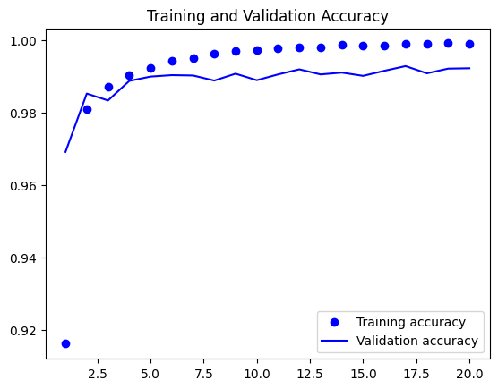

In [18]:

*## Generate and Save Plot of Training and Validation Loss from Model.*

loss **=** history**.**history["loss"]

val_loss **=** history**.**history["val_loss"]

epochs **=** range(1, len(accuracy) **+** 1)

plt**.**plot(epochs, loss, "bo", label**=**"Training loss")

plt**.**plot(epochs, val_loss, "b", label**=**"Validation loss")

plt**.**title("Training and Validation Loss")

plt**.**legend()

img_file **=** results_dir**.**joinpath('assignment06-1_Training_and_Validation_Loss_Plot.png')

plt**.**savefig(img_file)

plt**.**show()

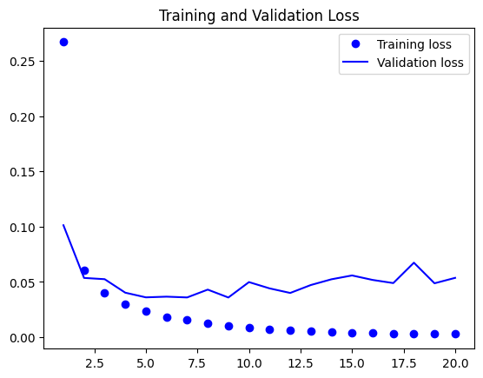

### CNN Model Results on Test Data

In [19]:

*## Evaluate the model on the test subsets. Code from the textbook repository.*

test_loss, test_acc **=** model**.**evaluate(test_images, test_labels)

In [20]:

*## Show the Test Accuracy and Loss from the cell above.*

print("Test Accuracy: {}%"**.**format((test_acc)**\***100))

print("Test Loss: {}"**.**format(test_loss))

Test Accuracy: 99.18000102043152%

Test Loss: 0.054932919396300336

In [24]:

*## Write the Test Accuracy and Loss to the results folder.*

csv_test **=** results_dir**.**joinpath('assignment06-1_Test_Accuracy_Loss_Results.csv')

test_dict **=** {'Test Accuracy': test_acc,

'Test Loss': test_loss}

**with** open(csv_test, 'w') **as** csv_file:

writer **=** csv**.**writer(csv_file)

**for** key, value **in** test_dict**.**items():

writer**.**writerow([key,value])

### Model Predictions

In [25]:

*## Setup predictions from the model.*

predict_test_labels **=** model**.**predict(test_images)

predict_classes **=** np**.**argmax(predict_test_labels, axis **=** 1)

predict_prob **=** np**.**max(predict_test_labels, axis **=** 1)

C:\Users\jkmey\anaconda3\envs\dsc650\lib\site-packages\keras\engine\training_v1.py:2357: UserWarning: `Model.state_updates` will be removed in a future version. This property should not be used in TensorFlow 2.0, as `updates` are applied automatically.

updates=self.state_updates,

In [26]:

*## Show an example predictions for the model.*

fig **=** plt**.**figure()

**for** i **in** range(16):

plt**.**subplot(4,4,i**+**1)

plt**.**tight_layout()

plt**.**imshow(test_images[i], cmap **=** 'gray', interpolation**=**'none')

plt**.**title("Prediction: {}"**.**format(predict_classes[i]))

plt**.**xticks([])

plt**.**yticks([])

img_file **=** results_dir**.**joinpath('assignment06-1_Prediction_Images_QTY_16.png')

plt**.**savefig(img_file)

print("16 Prediction Images and Labels")

plt**.**show()

16 Prediction Images and Labels

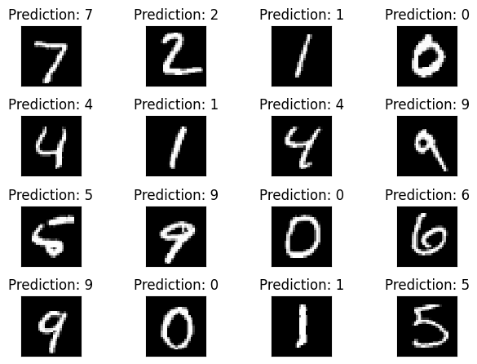

## Assignment 6.2a Code and Outputs:

## Assignment 6-2a

### DSC 650

### Jake Meyer

### 04/22/2023

Using section 5.2 in Deep Learning with Python as a guide, create a ConvNet model that classifies images CIFAR10 small images classification dataset. Do not use dropout or data-augmentation in this part. Save the model, predictions, metrics, and validation plots in the dsc650/assignments/assignment06/results directory. If you are using JupyterHub, you can include those plots in your Jupyter notebook.

Using code from [deep-learning-with-python-notebooks](https://github.com/fchollet/deep-learning-with-python-notebooks)  
Using code from [CIFAR-10 Photo Classification Dataset](https://machinelearningmastery.com/how-to-develop-a-cnn-from-scratch-for-cifar-10-photo-classification/)

In [3]:

*## Import the necessary modules for the assignment above.*

**import** csv

**import** pandas **as** pd

**import** numpy **as** np

**import** matplotlib.pyplot **as** plt

**import** tensorflow **as** tf

**import** keras

**import** sklearn

**from** sklearn.model_selection **import** train_test_split

**import** itertools

**from** pathlib **import** Path

**import** time

**import** os**,** shutil

*## Import the necessary keras components for the data and CNN*

**from** keras **import** layers, models

**from** keras.datasets **import** cifar10

**from** keras.utils **import** to_categorical, np_utils

**from** keras.models **import** Sequential, load_model

**from** keras.layers.core **import** Dense, Dropout, Activation

**from** keras.layers **import** Conv2D, MaxPooling2D, Dense, Flatten

**from** keras.optimizers **import** SGD

**import** tensorflow.compat.v1 **as** tf

tf**.**disable_v2_behavior()

WARNING:tensorflow:From C:\Users\jkmey\anaconda3\envs\dsc650\lib\site-packages\tensorflow\python\compat\v2_compat.py:107: disable_resource_variables (from tensorflow.python.ops.variable_scope) is deprecated and will be removed in a future version.

Instructions for updating:

non-resource variables are not supported in the long term

In [4]:

*## Print versions of essential packages*

print("keras version: {}"**.**format(keras**.**__version__))

print("tensorflow version: {}"**.**format(tf**.**__version__))

print("pandas version: {}"**.**format(pd**.**__version__))

print("numpy version: {}"**.**format(np**.**__version__))

keras version: 2.11.0

tensorflow version: 2.11.0

pandas version: 1.5.3

numpy version: 1.24.2

In [5]:

*## Setup the directories for the assignment*

current_dir **=** Path('C:/Users/jkmey/Documents/Github/DSC650_Course_Assignments/dsc650/dsc650/assignments/assignment06')

results_dir **=** Path('C:/Users/jkmey/Documents/Github/DSC650_Course_Assignments/dsc650/dsc650/assignments/assignment06/')**.**joinpath('results')

results_dir**.**mkdir(parents **=** **True**, exist_ok **=** **True**)

### Import the CIFAR10 Dataset

In [6]:

*## Load the dataset*

(trainX, trainy), (testX, testy) **=** cifar10**.**load_data()

In [7]:

*## Understand the shape of the train and test datasets.*

print('trainX: {}'**.**format(trainX**.**shape))

print('testX: {}'**.**format(testX**.**shape))

print('trainy: {}'**.**format(trainy**.**shape))

print('testy: {}'**.**format(testy**.**shape))

trainX: (50000, 32, 32, 3)

testX: (10000, 32, 32, 3)

trainy: (50000, 1)

testy: (10000, 1)

### Show Training Images and Labels

In [8]:

*## Show the first 16 training images and labels for better understanding of the data.*

fig **=** plt**.**figure()

**for** i **in** range(16):

plt**.**subplot(4,4,i**+**1)

plt**.**tight_layout()

plt**.**imshow(trainX[i], cmap **=** 'gray', interpolation**=**'none')

plt**.**title("Classify: {}"**.**format(trainy[i]))

plt**.**xticks([])

plt**.**yticks([])

img_file **=** results_dir**.**joinpath('assignment06-2a_Sample_Images_QTY_16.png')

plt**.**savefig(img_file)

print("First 16 Training Images and Labels")

plt**.**show()

First 16 Training Images and Labels

Referenced [CIFAR10](https://keras.io/api/datasets/cifar10/) for available classes.

In [9]:

*## Define the classes for images within a list for the image dataset.*

image_classes **=** ['airplane', 'automobile', 'bird', 'cat', 'cat', 'deer', 'dog', 'frog', 'horse', 'ship', 'truck']

### Pixel Value Histogram

In [10]:

*## Code to check the digit in the train image with the label shown from 0-9.*

fig **=** plt**.**figure()

plt**.**subplot(2,1,1)

plt**.**imshow(trainX[4], cmap **=** 'gray', interpolation **=** 'none')

plt**.**title('Category: {}'**.**format(trainy[4]))

plt**.**xticks([])

plt**.**yticks([])

img_file **=** results_dir**.**joinpath('assignment06-2a_Digit_Overview.png')

plt**.**savefig(img_file)

plt**.**show()

In [11]:

*## Pixel distribution shown in the plot below for the image chosen in the previous cell.*

plt**.**subplot(2,1,2)

plt**.**hist(trainX[4]**.**reshape(3072)) *# Value needs to be 3072 for reshape, otherwise error*

plt**.**title("Pixel Value Histogram")

img_file **=** results_dir**.**joinpath('assignment06-2a_Pixel_Value_Histogram.png')

plt**.**savefig(img_file)

plt**.**show()

### Prepare the Data

In [12]:

*## Normalize the training and test images.*

train_images **=** trainX**.**astype('float32') **/** 255

test_images **=** testX**.**astype('float32') **/** 255

*## Convert the training and test labels to numbers.*

train_labels **=** to_categorical(trainy)

test_labels **=** to_categorical(testy)

In [13]:

*## Split train_images and train_labels into train and validation subsets.*

train_images_val **=** train_images[:10000]

train_images **=** train_images[10000:]

train_labels_val **=** train_labels[:10000]

train_labels **=** train_labels[10000:]

### Create the ConvNet Model

In [14]:

*## Use the code from the textbook Github repository for section 5.2. Also, remember the shape input shape (32,32,3)*

model **=** Sequential()

model**.**add(Conv2D(32, (3, 3), activation**=**'relu', kernel_initializer**=**'he_uniform', padding**=**'same', input_shape**=**(32, 32, 3)))

model**.**add(Conv2D(32, (3, 3), activation**=**'relu', kernel_initializer**=**'he_uniform', padding**=**'same'))

model**.**add(MaxPooling2D((2, 2)))

model**.**add(Conv2D(64, (3, 3), activation**=**'relu', kernel_initializer**=**'he_uniform', padding**=**'same'))

model**.**add(Conv2D(64, (3, 3), activation**=**'relu', kernel_initializer**=**'he_uniform', padding**=**'same'))

model**.**add(MaxPooling2D((2, 2)))

model**.**add(Conv2D(128, (3, 3), activation**=**'relu', kernel_initializer**=**'he_uniform', padding**=**'same'))

model**.**add(Conv2D(128, (3, 3), activation**=**'relu', kernel_initializer**=**'he_uniform', padding**=**'same'))

model**.**add(MaxPooling2D((2, 2)))

model**.**add(Flatten())

model**.**add(Dense(128, activation**=**'relu', kernel_initializer**=**'he_uniform'))

model**.**add(Dense(10, activation**=**'softmax'))

*## Compile the Model. Choosing categorical crossentropy as loss and accuracy as metric.*

*## Also, define an optimizer with a learning rate of 0.001 and momentum of 0.9.*

opt **=** SGD(learning_rate**=**0.001, momentum**=**0.9)

model**.**compile(optimizer**=**opt, loss**=**'categorical_crossentropy', metrics**=**['accuracy'])

In [15]:

*## Show a summary of the model.*

model**.**summary()

Model: "sequential"

_________________________________________________________________

Layer (type) Output Shape Param #

=================================================================

conv2d (Conv2D) (None, 32, 32, 32) 896

conv2d_1 (Conv2D) (None, 32, 32, 32) 9248

max_pooling2d (MaxPooling2D (None, 16, 16, 32) 0

)

conv2d_2 (Conv2D) (None, 16, 16, 64) 18496

conv2d_3 (Conv2D) (None, 16, 16, 64) 36928

max_pooling2d_1 (MaxPooling (None, 8, 8, 64) 0

2D)

conv2d_4 (Conv2D) (None, 8, 8, 128) 73856

conv2d_5 (Conv2D) (None, 8, 8, 128) 147584

max_pooling2d_2 (MaxPooling (None, 4, 4, 128) 0

2D)

flatten (Flatten) (None, 2048) 0

dense (Dense) (None, 128) 262272

dense_1 (Dense) (None, 10) 1290

=================================================================

Total params: 550,570

Trainable params: 550,570

Non-trainable params: 0

_________________________________________________________________

### Train the Model

In [16]:

*## Train the model and store the results in the variable history.*

history **=** model**.**fit(train_images, train_labels, epochs**=**20, batch_size**=**32, verbose **=** 1,

validation_data **=** (train_images_val, train_labels_val))

Train on 40000 samples, validate on 10000 samples

WARNING:tensorflow:OMP_NUM_THREADS is no longer used by the default Keras config. To configure the number of threads, use tf.config.threading APIs.

Epoch 1/20

40000/40000 [==============================] - ETA: 0s - loss: 1.6764 - acc: 0.3981

C:\Users\jkmey\anaconda3\envs\dsc650\lib\site-packages\keras\engine\training_v1.py:2333: UserWarning: `Model.state_updates` will be removed in a future version. This property should not be used in TensorFlow 2.0, as `updates` are applied automatically.

updates = self.state_updates

40000/40000 [==============================] - 75s 2ms/sample - loss: 1.6764 - acc: 0.3981 - val_loss: 1.4222 - val_acc: 0.4860

Epoch 2/20

40000/40000 [==============================] - 74s 2ms/sample - loss: 1.2945 - acc: 0.5376 - val_loss: 1.1595 - val_acc: 0.5926

Epoch 3/20

40000/40000 [==============================] - 75s 2ms/sample - loss: 1.1051 - acc: 0.6096 - val_loss: 1.0206 - val_acc: 0.6448

Epoch 4/20

40000/40000 [==============================] - 75s 2ms/sample - loss: 0.9723 - acc: 0.6598 - val_loss: 0.9429 - val_acc: 0.6678

Epoch 5/20

40000/40000 [==============================] - 73s 2ms/sample - loss: 0.8608 - acc: 0.6981 - val_loss: 0.9123 - val_acc: 0.6813

Epoch 6/20

40000/40000 [==============================] - 69s 2ms/sample - loss: 0.7757 - acc: 0.7319 - val_loss: 0.8571 - val_acc: 0.6960

Epoch 7/20

40000/40000 [==============================] - 70s 2ms/sample - loss: 0.6954 - acc: 0.7597 - val_loss: 0.8162 - val_acc: 0.7134

Epoch 8/20

40000/40000 [==============================] - 76s 2ms/sample - loss: 0.6233 - acc: 0.7838 - val_loss: 0.8270 - val_acc: 0.7147

Epoch 9/20

40000/40000 [==============================] - 75s 2ms/sample - loss: 0.5516 - acc: 0.8061 - val_loss: 0.8151 - val_acc: 0.7261

Epoch 10/20

40000/40000 [==============================] - 70s 2ms/sample - loss: 0.4909 - acc: 0.8275 - val_loss: 0.8760 - val_acc: 0.7085

Epoch 11/20

40000/40000 [==============================] - 72s 2ms/sample - loss: 0.4224 - acc: 0.8512 - val_loss: 0.8633 - val_acc: 0.7323

Epoch 12/20

40000/40000 [==============================] - 70s 2ms/sample - loss: 0.3670 - acc: 0.8707 - val_loss: 0.8991 - val_acc: 0.7184

Epoch 13/20

40000/40000 [==============================] - 72s 2ms/sample - loss: 0.3093 - acc: 0.8911 - val_loss: 1.0054 - val_acc: 0.7067

Epoch 14/20

40000/40000 [==============================] - 73s 2ms/sample - loss: 0.2593 - acc: 0.9099 - val_loss: 0.9878 - val_acc: 0.7169

Epoch 15/20

40000/40000 [==============================] - 78s 2ms/sample - loss: 0.2159 - acc: 0.9231 - val_loss: 1.1270 - val_acc: 0.7107

Epoch 16/20

40000/40000 [==============================] - 79s 2ms/sample - loss: 0.1790 - acc: 0.9366 - val_loss: 1.1179 - val_acc: 0.7231

Epoch 17/20

40000/40000 [==============================] - 74s 2ms/sample - loss: 0.1497 - acc: 0.9484 - val_loss: 1.2099 - val_acc: 0.7205

Epoch 18/20

40000/40000 [==============================] - 78s 2ms/sample - loss: 0.1279 - acc: 0.9551 - val_loss: 1.3091 - val_acc: 0.7018

Epoch 19/20

40000/40000 [==============================] - 73s 2ms/sample - loss: 0.1105 - acc: 0.9610 - val_loss: 1.2970 - val_acc: 0.7260

Epoch 20/20

40000/40000 [==============================] - 79s 2ms/sample - loss: 0.1050 - acc: 0.9634 - val_loss: 1.4012 - val_acc: 0.7208

In [17]:

*## Save the result model file to the results directory.*

result_model_file **=** results_dir**.**joinpath('assignment06-2a_Model.h5')

model**.**save(result_model_file)

print("Saved the Trained model at %s " **%** result_model_file)

Saved the Trained model at C:\Users\jkmey\Documents\Github\DSC650_Course_Assignments\dsc650\dsc650\assignments\assignment06\results\assignment06-2a_Model.h5

In [18]:

*## Generate and Save Plot of Training and Validation Accuracy from Model.*

accuracy **=** history**.**history["acc"]

val_accuracy **=** history**.**history["val_acc"]

epochs **=** range(1, len(accuracy) **+** 1)

plt**.**plot(epochs, accuracy, "bo", label**=**"Training accuracy")

plt**.**plot(epochs, val_accuracy, "b", label**=**"Validation accuracy")

plt**.**title("Training and Validation Accuracy")

plt**.**legend()

img_file **=** results_dir**.**joinpath('assignment06-2a_Training_and_Validation_Accuracy_Plot.png')

plt**.**savefig(img_file)

plt**.**show()

In [19]:

*## Generate and Save Plot of Training and Validation Loss from Model.*

loss **=** history**.**history["loss"]

val_loss **=** history**.**history["val_loss"]

epochs **=** range(1, len(accuracy) **+** 1)

plt**.**plot(epochs, loss, "bo", label**=**"Training loss")

plt**.**plot(epochs, val_loss, "b", label**=**"Validation loss")

plt**.**title("Training and Validation Loss")

plt**.**legend()

img_file **=** results_dir**.**joinpath('assignment06-2a_Training_and_Validation_Loss_Plot.png')

plt**.**savefig(img_file)

plt**.**show()

### CNN Results on Test Data

In [20]:

*## Evaluate the model on the test subsets. Code from the textbook repository.*

test_loss, test_acc **=** model**.**evaluate(test_images, test_labels)

In [21]:

*## Show the Test Accuracy and Loss from the cell above.*

print("Test Accuracy: {}%"**.**format((test_acc)**\***100))

print("Test Loss: {}"**.**format(test_loss))

Test Accuracy: 71.10999822616577%

Test Loss: 1.493364258670807

In [22]:

*## Write the Test Accuracy and Loss to the results folder.*

csv_test **=** results_dir**.**joinpath('assignment06-2a_Test_Accuracy_Loss_Results.csv')

test_dict **=** {'Test Accuracy': test_acc,

'Test Loss': test_loss}

**with** open(csv_test, 'w') **as** csv_file:

writer **=** csv**.**writer(csv_file)

**for** key, value **in** test_dict**.**items():

writer**.**writerow([key,value])

### Model Predictions

In [23]:

*## Setup predictions from the model.*

predict_test_labels **=** model**.**predict(test_images)

predict_classes **=** np**.**argmax(predict_test_labels, axis **=** 1)

predict_prob **=** np**.**max(predict_test_labels, axis **=** 1)

C:\Users\jkmey\anaconda3\envs\dsc650\lib\site-packages\keras\engine\training_v1.py:2357: UserWarning: `Model.state_updates` will be removed in a future version. This property should not be used in TensorFlow 2.0, as `updates` are applied automatically.

updates=self.state_updates,

In [24]:

*## Show an example predictions for the model.*

fig **=** plt**.**figure()

**for** i **in** range(16):

plt**.**subplot(4,4,i**+**1)

plt**.**tight_layout()

plt**.**imshow(test_images[i], cmap **=** 'gray', interpolation**=**'none')

plt**.**title("Prediction: {}"**.**format(predict_classes[i]))

plt**.**xticks([])

plt**.**yticks([])

img_file **=** results_dir**.**joinpath('assignment06-2a_Prediction_Images_QTY_16.png')

plt**.**savefig(img_file)

print("16 Prediction Images and Labels")

plt**.**show()

16 Prediction Images and Labels

## Assignment 6.2b Code and Output:

## Assignment 6-2b

### DSC 650

### Jake Meyer

### 04/22/2023

Using section 5.2 in Deep Learning with Python as a guide, create a ConvNet model that classifies images CIFAR10 small images classification dataset. This time includes dropout and data-augmentation. Save the model, predictions, metrics, and validation plots in the dsc650/assignments/assignment06/results directory. If you are using JupyterHub, you can include those plots in your Jupyter notebook.

Using code from [deep-learning-with-python-notebooks](https://github.com/fchollet/deep-learning-with-python-notebooks)  
Using code from [CIFAR-10 Photo Classification Dataset](https://machinelearningmastery.com/how-to-develop-a-cnn-from-scratch-for-cifar-10-photo-classification/)

In [1]:

*## Import the necessary modules for the assignment above.*

**import** csv

**import** pandas **as** pd

**import** numpy **as** np

**import** matplotlib.pyplot **as** plt

**import** tensorflow **as** tf

**import** keras

**import** sklearn

**from** sklearn.model_selection **import** train_test_split

**import** itertools

**from** pathlib **import** Path

**import** time

**import** os**,** shutil

*## Import the necessary keras components for the data and CNN*

**from** keras **import** layers, models

**from** keras.datasets **import** cifar10

**from** keras.utils **import** to_categorical, np_utils

**from** keras.models **import** Sequential, load_model

**from** keras.layers.core **import** Dense, Dropout, Activation

**from** keras.layers **import** Conv2D, MaxPooling2D, Dense, Flatten

**from** keras.optimizers **import** SGD

**import** tensorflow.compat.v1 **as** tf

tf**.**disable_v2_behavior()

WARNING:tensorflow:From C:\Users\jkmey\anaconda3\envs\dsc650\lib\site-packages\tensorflow\python\compat\v2_compat.py:107: disable_resource_variables (from tensorflow.python.ops.variable_scope) is deprecated and will be removed in a future version.

Instructions for updating:

non-resource variables are not supported in the long term

In [2]:

*## Print versions of essential packages*

print("keras version: {}"**.**format(keras**.**__version__))

print("tensorflow version: {}"**.**format(tf**.**__version__))

print("pandas version: {}"**.**format(pd**.**__version__))

print("numpy version: {}"**.**format(np**.**__version__))

keras version: 2.11.0

tensorflow version: 2.11.0

pandas version: 1.5.3

numpy version: 1.24.2

In [3]:

*## Setup the directories for the assignment*

current_dir **=** Path('C:/Users/jkmey/Documents/Github/DSC650_Course_Assignments/dsc650/dsc650/assignments/assignment06')

results_dir **=** Path('C:/Users/jkmey/Documents/Github/DSC650_Course_Assignments/dsc650/dsc650/assignments/assignment06/')**.**joinpath('results')

results_dir**.**mkdir(parents **=** **True**, exist_ok **=** **True**)

### Import the CIFAR10 Dataset

In [4]:

*## Load the dataset*

(trainX, trainy), (testX, testy) **=** cifar10**.**load_data()

In [5]:

*## Understand the shape of the train and test datasets.*

print('trainX: {}'**.**format(trainX**.**shape))

print('testX: {}'**.**format(testX**.**shape))

print('trainy: {}'**.**format(trainy**.**shape))

print('testy: {}'**.**format(testy**.**shape))

trainX: (50000, 32, 32, 3)

testX: (10000, 32, 32, 3)

trainy: (50000, 1)

testy: (10000, 1)

### Show Training Images and Labels

In [6]:

*## Show the first 16 training images and labels for better understanding of the data.*

fig **=** plt**.**figure()

**for** i **in** range(16):

plt**.**subplot(4,4,i**+**1)

plt**.**tight_layout()

plt**.**imshow(trainX[i], cmap **=** 'gray', interpolation**=**'none')

plt**.**title("Classify: {}"**.**format(trainy[i]))

plt**.**xticks([])

plt**.**yticks([])

img_file **=** results_dir**.**joinpath('assignment06-2b_Sample_Images_QTY_16.png')

plt**.**savefig(img_file)

print("First 16 Training Images and Labels")

plt**.**show()

First 16 Training Images and Labels

Referenced [CIFAR10](https://keras.io/api/datasets/cifar10/) for available classes.

In [7]:

*## Define the classes for images within a list for the image dataset.*

image_classes **=** ['airplane', 'automobile', 'bird', 'cat', 'cat', 'deer', 'dog', 'frog', 'horse', 'ship', 'truck']

### Pixel Value Histogram

In [12]:

*## Code to check the digit in the train image with the label shown from 0-9.*

fig **=** plt**.**figure()

plt**.**subplot(2,1,1)

plt**.**imshow(trainX[0], cmap **=** 'gray', interpolation **=** 'none')

plt**.**title('Category: {}'**.**format(trainy[0]))

plt**.**xticks([])

plt**.**yticks([])

img_file **=** results_dir**.**joinpath('assignment06-2b_Digit_Overview.png')

plt**.**savefig(img_file)

plt**.**show()

In [13]:

*## Pixel distribution shown in the plot below for the image chosen in the previous cell.*

plt**.**subplot(2,1,2)

plt**.**hist(trainX[0]**.**reshape(3072)) *# Value needs to be 3072 for reshape, otherwise error*

plt**.**title("Pixel Value Histogram")

img_file **=** results_dir**.**joinpath('assignment06-2b_Pixel_Value_Histogram.png')

plt**.**savefig(img_file)

plt**.**show()

### Prepare the Data

In [14]:

*## Normalize the training and test images.*

train_images **=** trainX**.**astype('float32') **/** 255

test_images **=** testX**.**astype('float32') **/** 255

*## Convert the training and test labels to numbers.*

train_labels **=** to_categorical(trainy)

test_labels **=** to_categorical(testy)

In [15]:

*## Split train_images and train_labels into train and validation subsets.*

train_images_val **=** train_images[:10000]

train_images **=** train_images[10000:]

train_labels_val **=** train_labels[:10000]

train_labels **=** train_labels[10000:]

### Create the ConvNet Model

In [16]:

*## Use the code from the textbook Github repository for section 5.2. Also, remember the shape input shape (32,32,3)*

model **=** Sequential()

model**.**add(Conv2D(32, (3, 3), activation**=**'relu', kernel_initializer**=**'he_uniform', padding**=**'same', input_shape**=**(32, 32, 3)))

model**.**add(Conv2D(32, (3, 3), activation**=**'relu', kernel_initializer**=**'he_uniform', padding**=**'same'))

model**.**add(MaxPooling2D((2, 2)))

model**.**add(Conv2D(64, (3, 3), activation**=**'relu', kernel_initializer**=**'he_uniform', padding**=**'same'))

model**.**add(Conv2D(64, (3, 3), activation**=**'relu', kernel_initializer**=**'he_uniform', padding**=**'same'))

model**.**add(MaxPooling2D((2, 2)))

model**.**add(Conv2D(128, (3, 3), activation**=**'relu', kernel_initializer**=**'he_uniform', padding**=**'same'))

model**.**add(Conv2D(128, (3, 3), activation**=**'relu', kernel_initializer**=**'he_uniform', padding**=**'same'))

model**.**add(MaxPooling2D((2, 2)))

model**.**add(Flatten())

model**.**add(Dense(128, activation**=**'relu', kernel_initializer**=**'he_uniform'))

*## Per the assignment add model.add(Dropout(0.2, input_shape=(60,)))*

model**.**add(Dropout(0.1))

model**.**add(Dense(10, activation**=**'softmax'))

*## Compile the Model. Choosing categorical crossentropy as loss and accuracy as metric.*

*## Also, define an optimizer with a learning rate of 0.001 and momentum of 0.9.*

opt **=** SGD(learning_rate**=**0.001, momentum**=**0.9)

model**.**compile(optimizer**=**opt, loss**=**'categorical_crossentropy', metrics**=**['accuracy'])

In [17]:

*## Show a summary of the model.*

model**.**summary()

Model: "sequential"

_________________________________________________________________

Layer (type) Output Shape Param #

=================================================================

conv2d (Conv2D) (None, 32, 32, 32) 896

conv2d_1 (Conv2D) (None, 32, 32, 32) 9248

max_pooling2d (MaxPooling2D (None, 16, 16, 32) 0

)

conv2d_2 (Conv2D) (None, 16, 16, 64) 18496

conv2d_3 (Conv2D) (None, 16, 16, 64) 36928

max_pooling2d_1 (MaxPooling (None, 8, 8, 64) 0

2D)

conv2d_4 (Conv2D) (None, 8, 8, 128) 73856

conv2d_5 (Conv2D) (None, 8, 8, 128) 147584

max_pooling2d_2 (MaxPooling (None, 4, 4, 128) 0

2D)

flatten (Flatten) (None, 2048) 0

dense (Dense) (None, 128) 262272

dropout (Dropout) (None, 128) 0

dense_1 (Dense) (None, 10) 1290

=================================================================

Total params: 550,570

Trainable params: 550,570

Non-trainable params: 0

_________________________________________________________________

In [19]:

*## Create data generator. Code help from machine learning mastery site listed in introduction section.*

datagen **=** keras**.**preprocessing**.**image**.**ImageDataGenerator(width_shift_range**=**0.1, height_shift_range**=**0.1, horizontal_flip **=** **True**)

In [22]:

*## Prepare the Iterator. Code help from machine learning mastery site listed in introduction section.*

it_train **=** datagen**.**flow(train_images, train_labels, batch_size **=** 64)

*## Number of epoxh steps to fit the model for training.*

steps **=** int(train_images**.**shape[0]**/**64)

### Train the Model

In [29]:

*## Train the model and store the results in the variable history. Code help from machine learning mastery site.*

history **=** model**.**fit(it_train, steps_per_epoch **=** steps, epochs**=**75, verbose **=** 1,

validation_data **=** (train_images_val, train_labels_val))

625/625 [==============================] - 721s 1s/step - batch: 312.0000 - size: 64.0000 - loss: 0.5463 - acc: 0.8087 - val_loss: 0.5884 - val_acc: 0.7969

Epoch 36/75

625/625 [==============================] - 64s 102ms/step - batch: 312.0000 - size: 64.0000 - loss: 0.5467 - acc: 0.8069 - val_loss: 0.5994 - val_acc: 0.7997

Epoch 37/75

625/625 [==============================] - 64s 102ms/step - batch: 312.0000 - size: 64.0000 - loss: 0.5311 - acc: 0.8146 - val_loss: 0.5992 - val_acc: 0.7961

Epoch 38/75

625/625 [==============================] - 63s 101ms/step - batch: 312.0000 - size: 64.0000 - loss: 0.5272 - acc: 0.8134 - val_loss: 0.5694 - val_acc: 0.8073

Epoch 39/75

625/625 [==============================] - 63s 101ms/step - batch: 312.0000 - size: 64.0000 - loss: 0.5220 - acc: 0.8157 - val_loss: 0.5693 - val_acc: 0.8050

Epoch 40/75

625/625 [==============================] - 63s 100ms/step - batch: 312.0000 - size: 64.0000 - loss: 0.5152 - acc: 0.8194 - val_loss: 0.6214 - val_acc: 0.7910

Epoch 41/75

625/625 [==============================] - 63s 101ms/step - batch: 312.0000 - size: 64.0000 - loss: 0.5091 - acc: 0.8213 - val_loss: 0.6015 - val_acc: 0.7981

Epoch 42/75

625/625 [==============================] - 62s 100ms/step - batch: 312.0000 - size: 64.0000 - loss: 0.5077 - acc: 0.8205 - val_loss: 0.5915 - val_acc: 0.8019

Epoch 43/75

625/625 [==============================] - 62s 100ms/step - batch: 312.0000 - size: 64.0000 - loss: 0.5023 - acc: 0.8253 - val_loss: 0.6099 - val_acc: 0.7984

Epoch 44/75

625/625 [==============================] - 62s 100ms/step - batch: 312.0000 - size: 64.0000 - loss: 0.4948 - acc: 0.8263 - val_loss: 0.5717 - val_acc: 0.8071

Epoch 45/75

625/625 [==============================] - 62s 100ms/step - batch: 312.0000 - size: 64.0000 - loss: 0.4832 - acc: 0.8288 - val_loss: 0.5675 - val_acc: 0.8134

Epoch 46/75

625/625 [==============================] - 63s 100ms/step - batch: 312.0000 - size: 64.0000 - loss: 0.4893 - acc: 0.8277 - val_loss: 0.5518 - val_acc: 0.8142

Epoch 47/75

625/625 [==============================] - 62s 100ms/step - batch: 312.0000 - size: 64.0000 - loss: 0.4771 - acc: 0.8337 - val_loss: 0.5690 - val_acc: 0.8140

Epoch 48/75

625/625 [==============================] - 64s 103ms/step - batch: 312.0000 - size: 64.0000 - loss: 0.4742 - acc: 0.8345 - val_loss: 0.5654 - val_acc: 0.8133

Epoch 49/75

625/625 [==============================] - 64s 102ms/step - batch: 312.0000 - size: 64.0000 - loss: 0.4657 - acc: 0.8367 - val_loss: 0.5506 - val_acc: 0.8149

Epoch 50/75

625/625 [==============================] - 62s 99ms/step - batch: 312.0000 - size: 64.0000 - loss: 0.4605 - acc: 0.8392 - val_loss: 0.5661 - val_acc: 0.8113

Epoch 51/75

625/625 [==============================] - 62s 99ms/step - batch: 312.0000 - size: 64.0000 - loss: 0.4640 - acc: 0.8358 - val_loss: 0.5540 - val_acc: 0.8199

Epoch 52/75

625/625 [==============================] - 63s 102ms/step - batch: 312.0000 - size: 64.0000 - loss: 0.4502 - acc: 0.8436 - val_loss: 0.5723 - val_acc: 0.8140

Epoch 53/75

625/625 [==============================] - 62s 99ms/step - batch: 312.0000 - size: 64.0000 - loss: 0.4460 - acc: 0.8433 - val_loss: 0.5547 - val_acc: 0.8146

Epoch 54/75

625/625 [==============================] - 62s 99ms/step - batch: 312.0000 - size: 64.0000 - loss: 0.4390 - acc: 0.8456 - val_loss: 0.5592 - val_acc: 0.8129

Epoch 55/75

625/625 [==============================] - 62s 99ms/step - batch: 312.0000 - size: 64.0000 - loss: 0.4306 - acc: 0.8476 - val_loss: 0.5541 - val_acc: 0.8199

Epoch 56/75

625/625 [==============================] - 62s 99ms/step - batch: 312.0000 - size: 64.0000 - loss: 0.4303 - acc: 0.8501 - val_loss: 0.5674 - val_acc: 0.8162

Epoch 57/75

625/625 [==============================] - 62s 99ms/step - batch: 312.0000 - size: 64.0000 - loss: 0.4262 - acc: 0.8526 - val_loss: 0.5604 - val_acc: 0.8146

Epoch 58/75

625/625 [==============================] - 62s 100ms/step - batch: 312.0000 - size: 64.0000 - loss: 0.4212 - acc: 0.8534 - val_loss: 0.5343 - val_acc: 0.8256

Epoch 59/75

625/625 [==============================] - 61s 98ms/step - batch: 312.0000 - size: 64.0000 - loss: 0.4173 - acc: 0.8524 - val_loss: 0.5392 - val_acc: 0.8264

Epoch 60/75

625/625 [==============================] - 61s 98ms/step - batch: 312.0000 - size: 64.0000 - loss: 0.4155 - acc: 0.8517 - val_loss: 0.5835 - val_acc: 0.8122

Epoch 61/75

625/625 [==============================] - 64s 102ms/step - batch: 312.0000 - size: 64.0000 - loss: 0.4118 - acc: 0.8536 - val_loss: 0.5482 - val_acc: 0.8222

Epoch 62/75

625/625 [==============================] - 61s 98ms/step - batch: 312.0000 - size: 64.0000 - loss: 0.3990 - acc: 0.8600 - val_loss: 0.5332 - val_acc: 0.8247

Epoch 63/75

131/625 [=====>........................] - ETA: 45s - batch: 65.0000 - size: 64.0000 - loss: 0.3913 - acc: 0.8646

In [33]:

*## Save the result model file to the results directory.*

result_model_file **=** results_dir**.**joinpath('assignment06-2b_Model.h5')

model**.**save(result_model_file)

print("Saved the Trained model at %s " **%** result_model_file)

Saved the Trained model at C:\Users\jkmey\Documents\Github\DSC650_Course_Assignments\dsc650\dsc650\assignments\assignment06\results\assignment06-2b_Model.h5

In [34]:

*## Generate and Save Plot of Training and Validation Accuracy from Model.*

accuracy **=** history**.**history["acc"]

val_accuracy **=** history**.**history["val_acc"]

epochs **=** range(1, len(accuracy) **+** 1)

plt**.**plot(epochs, accuracy, "bo", label**=**"Training accuracy")

plt**.**plot(epochs, val_accuracy, "b", label**=**"Validation accuracy")

plt**.**title("Training and Validation Accuracy")

plt**.**legend()

img_file **=** results_dir**.**joinpath('assignment06-2b_Training_and_Validation_Accuracy_Plot.png')

plt**.**savefig(img_file)

plt**.**show()

In [35]:

*## Generate and Save Plot of Training and Validation Loss from Model.*

loss **=** history**.**history["loss"]

val_loss **=** history**.**history["val_loss"]

epochs **=** range(1, len(accuracy) **+** 1)

plt**.**plot(epochs, loss, "bo", label**=**"Training loss")

plt**.**plot(epochs, val_loss, "b", label**=**"Validation loss")

plt**.**title("Training and Validation Loss")

plt**.**legend()

img_file **=** results_dir**.**joinpath('assignment06-2b_Training_and_Validation_Loss_Plot.png')

plt**.**savefig(img_file)

plt**.**show()

### CNN Results on Test Data

In [36]:

*## Evaluate the model on the test subsets. Code from the textbook repository.*

test_loss, test_acc **=** model**.**evaluate(test_images, test_labels)

In [37]:

*## Show the Test Accuracy and Loss from the cell above.*

print("Test Accuracy: {}%"**.**format((test_acc)**\***100))

print("Test Loss: {}"**.**format(test_loss))

Test Accuracy: 82.05000162124634%

Test Loss: 0.5744333950042725

In [41]:

*## Write the Test Accuracy and Loss to the results folder.*

csv_test **=** results_dir**.**joinpath('assignment06-2b_Test_Accuracy_Loss_Results.csv')

test_dict **=** {'Test Accuracy': test_acc,

'Test Loss': test_loss}

**with** open(csv_test, 'w') **as** csv_file:

writer **=** csv**.**writer(csv_file)

**for** key, value **in** test_dict**.**items():

writer**.**writerow([key,value])

### Model Predictions

In [42]:

*## Setup predictions from the model.*

predict_test_labels **=** model**.**predict(test_images)

predict_classes **=** np**.**argmax(predict_test_labels, axis **=** 1)

predict_prob **=** np**.**max(predict_test_labels, axis **=** 1)

In [43]:

*## Show an example predictions for the model.*

fig **=** plt**.**figure()

**for** i **in** range(16):

plt**.**subplot(4,4,i**+**1)

plt**.**tight_layout()

plt**.**imshow(test_images[i], cmap **=** 'gray', interpolation**=**'none')

plt**.**title("Prediction: {}"**.**format(predict_classes[i]))

plt**.**xticks([])

plt**.**yticks([])

img_file **=** results_dir**.**joinpath('assignment06-2b_Prediction_Images_QTY_16.png')

plt**.**savefig(img_file)

print("16 Prediction Images and Labels")

plt**.**show()

16 Prediction Images and Labels

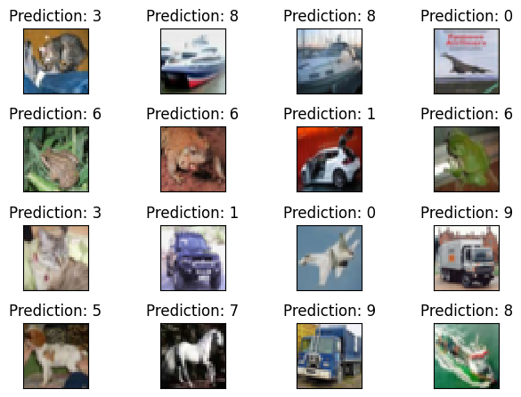

## Assignment 6.3 Code and Output:

## Assignment 6-3

### DSC 650

### Jake Meyer

### 04/23/2023

Load the ResNet50 model. Perform image classification on five to ten images of your choice. They can be personal images or publically available images. Include the images in dsc650/assignments/assignment06/images/. Save the predictions dsc650/assignments/assignment06/results/predictions/resnet50 directory. If you are using JupyterHub, you can include those plots in your Jupyter notebook.

Using code from [deep-learning-with-python-notebooks](https://github.com/fchollet/deep-learning-with-python-notebooks)  
Using [ResNet50 function api site](https://keras.io/api/applications/resnet/#resnet50-function)

In [1]:

*## Import the necessary modules for the assignment above.*

**import** csv

**import** cv2

**import** pandas **as** pd

**import** numpy **as** np

**import** matplotlib.pyplot **as** plt

**import** tensorflow **as** tf

**import** keras

**import** sklearn

**from** pathlib **import** Path

**import** time

**import** os

*## Import the necessary keras components for the data and CNN*

**from** tensorflow.keras.preprocessing.image **import** load_img

**from** tensorflow.keras.preprocessing.image **import** img_to_array

**from** tensorflow.keras.preprocessing **import** image

**from** tensorflow.keras.applications.imagenet_utils **import** decode_predictions

**from** tensorflow.keras.applications.imagenet_utils **import** preprocess_input

**from** tensorflow.keras.applications.resnet50 **import** ResNet50

**from** tensorflow.keras.applications **import** resnet50

**import** tensorflow.compat.v1 **as** tf

tf**.**disable_v2_behavior()

WARNING:tensorflow:From C:\Users\jkmey\anaconda3\envs\dsc650\lib\site-packages\tensorflow\python\compat\v2_compat.py:107: disable_resource_variables (from tensorflow.python.ops.variable_scope) is deprecated and will be removed in a future version.

Instructions for updating:

non-resource variables are not supported in the long term

In [2]:

*## Print versions of essential packages*

print("keras version: {}"**.**format(keras**.**__version__))

print("tensorflow version: {}"**.**format(tf**.**__version__))

print("pandas version: {}"**.**format(pd**.**__version__))

print("numpy version: {}"**.**format(np**.**__version__))

keras version: 2.11.0

tensorflow version: 2.11.0

pandas version: 1.5.3

numpy version: 1.24.2

In [3]:

*## Setup the directories for the assignment*

current_dir **=** Path('C:/Users/jkmey/Documents/Github/DSC650_Course_Assignments/dsc650/dsc650/assignments/assignment06')

image_dir **=** Path('C:/Users/jkmey/Documents/Github/DSC650_Course_Assignments/dsc650/dsc650/assignments/assignment06/images')

results_dir **=** Path('C:/Users/jkmey/Documents/Github/DSC650_Course_Assignments/dsc650/dsc650/assignments/assignment06/')**.**joinpath('results')

predictions_dir **=** Path('C:/Users/jkmey/Documents/Github/DSC650_Course_Assignments/dsc650/dsc650/assignments/assignment06/results')**.**joinpath('predictions')

resnet_dir **=** Path('C:/Users/jkmey/Documents/Github/DSC650_Course_Assignments/dsc650/dsc650/assignments/assignment06/results/predictions')**.**joinpath('resnet50')

resnet_dir**.**mkdir(parents **=** **True**, exist_ok **=** **True**)

### Load the ResNet50 Model

In [4]:

*## Load the ResNet50 model as shown in the ResNet50 site listed above.*

model **=** ResNet50(weights **=** 'imagenet')

WARNING:tensorflow:From C:\Users\jkmey\anaconda3\envs\dsc650\lib\site-packages\keras\layers\normalization\batch_normalization.py:561: _colocate_with (from tensorflow.python.framework.ops) is deprecated and will be removed in a future version.

Instructions for updating:

Colocations handled automatically by placer.

WARNING:tensorflow:OMP_NUM_THREADS is no longer used by the default Keras config. To configure the number of threads, use tf.config.threading APIs.

Pulled 10 random images from the internet of various animals. Per the assignment, will write code to classify these images with ResNet50.

### Using ResNet50 Model for Predictions on 10 Images

In [5]:

*## Load and resize (224x224 per the ResNet50 site) for the 10 images.*

img1 **=** image**.**load_img('images/bear.png', target_size **=** (224, 224))

img2 **=** image**.**load_img('images/cat.png', target_size **=** (224, 224))

img3 **=** image**.**load_img('images/dog.png', target_size **=** (224, 224))

img4 **=** image**.**load_img('images/elephant.png', target_size **=** (224, 224))

img5 **=** image**.**load_img('images/giraffe.png', target_size **=** (224, 224))

img6 **=** image**.**load_img('images/gorilla.png', target_size **=** (224, 224))

img7 **=** image**.**load_img('images/hippo.png', target_size **=** (224, 224))

img8 **=** image**.**load_img('images/leapord.png', target_size **=** (224, 224))

img9 **=** image**.**load_img('images/penguin.png', target_size **=** (224, 224))

img10 **=** image**.**load_img('images/tiger.png', target_size **=** (224, 224))

In [6]:

*## Show the 10 images (after resizing) for reference prior to classifying.*

image_list **=** [img1, img2, img3, img4, img5, img6, img7, img8, img9, img10]

**for** animal **in** image_list:

plt**.**imshow(animal)

plt**.**show()

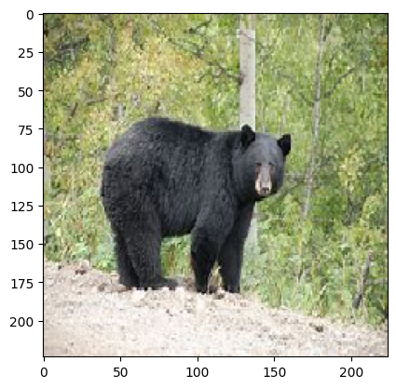

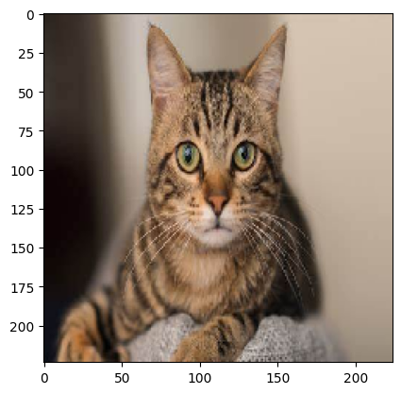

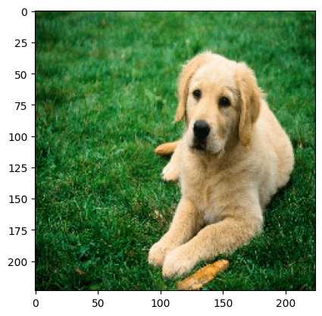

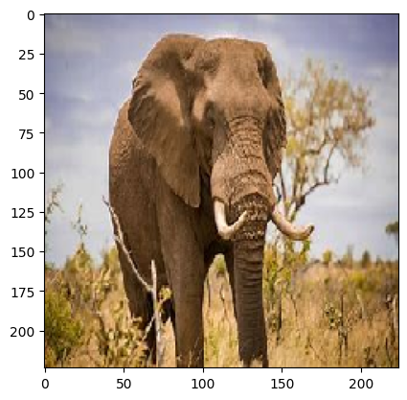

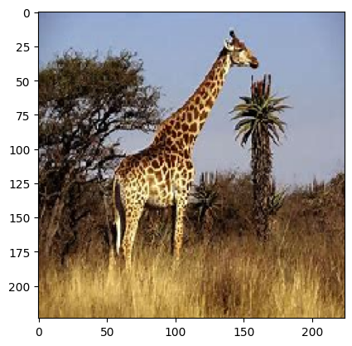

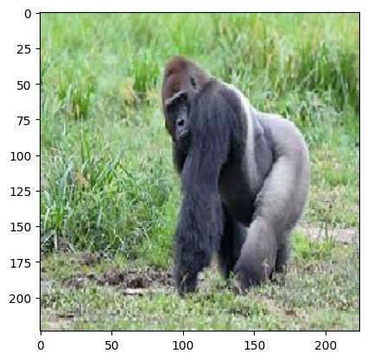

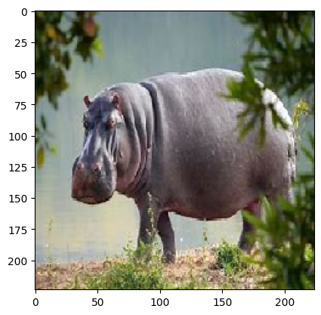

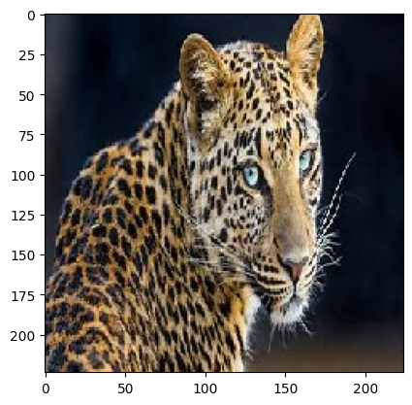

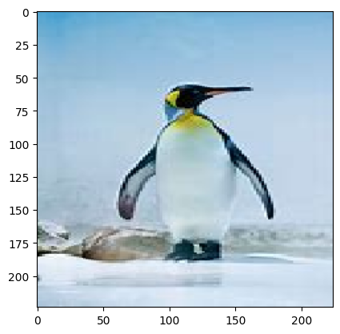

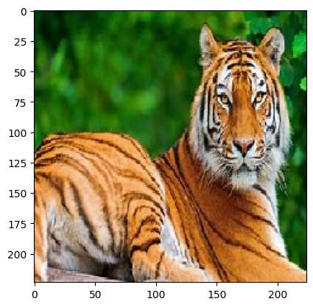

### Create the predictions for each image using the ResNet50 model.

In [16]:

*## Adjust the image. Convert to numpy array, add batch dimension, and preprocess.*

image_array1 **=** image**.**img_to_array(img1)

image_array1 **=** np**.**expand_dims(image_array1, axis **=**0)

image_array1 **=** preprocess_input(image_array1)

prediction1 **=** model**.**predict(image_array1)

*## Print the image and prediction here in the Jupyter Notebook.*

print("Prediction: {}"**.**format(decode_predictions(prediction1, top **=** 1)[0]))

plt**.**imshow(img1)

plt**.**show()

*## Export the prediction to a prediction file as specified in the document.*

resnet50_predictions **=** resnet_dir**.**joinpath('assignment06-3_resnet50_predictions.csv')

test_dict1 **=** {'Image 1': str(decode_predictions(prediction1, top **=** 1)[0])}

**with** open(resnet50_predictions, 'w') **as** csv_file:

writer **=** csv**.**writer(csv_file)

**for** key, value **in** test_dict1**.**items():

writer**.**writerow([key,value])

Prediction: [('n02133161', 'American_black_bear', 0.99549896)]



In [17]:

*## Adjust the image. Convert to numpy array, add batch dimension, and preprocess.*

image_array2 **=** image**.**img_to_array(img2)

image_array2 **=** np**.**expand_dims(image_array2, axis **=**0)

image_array2 **=** preprocess_input(image_array2)

prediction2 **=** model**.**predict(image_array2)

*## Print the image and prediction here in the Jupyter Notebook.*

print("Prediction: {}"**.**format(decode_predictions(prediction2, top **=** 1)[0]))

plt**.**imshow(img2)

plt**.**show()

*## Export the prediction to a prediction file as specified in the document.*

resnet50_predictions **=** resnet_dir**.**joinpath('assignment06-3_resnet50_predictions.csv')

test_dict2 **=** {'Image 2': str(decode_predictions(prediction2, top **=** 1)[0])}

**with** open(resnet50_predictions, 'a') **as** csv_file:

writer **=** csv**.**writer(csv_file)

**for** key, value **in** test_dict2**.**items():

writer**.**writerow([key,value])

Prediction: [('n02123045', 'tabby', 0.64965636)]



In [18]:

*## Adjust the image. Convert to numpy array, add batch dimension, and preprocess.*

image_array3 **=** image**.**img_to_array(img3)

image_array3 **=** np**.**expand_dims(image_array3, axis **=**0)

image_array3 **=** preprocess_input(image_array3)

prediction3 **=** model**.**predict(image_array3)

*## Print the image and prediction here in the Jupyter Notebook.*

print("Prediction: {}"**.**format(decode_predictions(prediction3, top **=** 1)[0]))

plt**.**imshow(img3)

plt**.**show()

*## Export the prediction to a prediction file as specified in the document.*

resnet50_predictions **=** resnet_dir**.**joinpath('assignment06-3_resnet50_predictions.csv')

test_dict3 **=** {'Image 3': str(decode_predictions(prediction3, top **=** 1)[0])}

**with** open(resnet50_predictions, 'a') **as** csv_file:

writer **=** csv**.**writer(csv_file)

**for** key, value **in** test_dict3**.**items():

writer**.**writerow([key,value])

Prediction: [('n02099601', 'golden_retriever', 0.9001567)]



In [19]:

*## Adjust the image. Convert to numpy array, add batch dimension, and preprocess.*

image_array4 **=** image**.**img_to_array(img4)

image_array4 **=** np**.**expand_dims(image_array4, axis **=**0)

image_array4 **=** preprocess_input(image_array4)

prediction4 **=** model**.**predict(image_array4)

*## Print the image and prediction here in the Jupyter Notebook.*

print("Prediction: {}"**.**format(decode_predictions(prediction4, top **=** 1)[0]))

plt**.**imshow(img4)

plt**.**show()

*## Export the prediction to a prediction file as specified in the document.*

resnet50_predictions **=** resnet_dir**.**joinpath('assignment06-3_resnet50_predictions.csv')

test_dict4 **=** {'Image 4': str(decode_predictions(prediction4, top **=** 1)[0])}

**with** open(resnet50_predictions, 'a') **as** csv_file:

writer **=** csv**.**writer(csv_file)

**for** key, value **in** test_dict4**.**items():

writer**.**writerow([key,value])

Prediction: [('n01871265', 'tusker', 0.6794936)]



In [20]:

*## Adjust the image. Convert to numpy array, add batch dimension, and preprocess.*

image_array5 **=** image**.**img_to_array(img5)

image_array5 **=** np**.**expand_dims(image_array5, axis **=**0)

image_array5 **=** preprocess_input(image_array5)

prediction5 **=** model**.**predict(image_array5)

*## Print the image and prediction here in the Jupyter Notebook.*

print("Prediction: {}"**.**format(decode_predictions(prediction5, top **=** 1)[0]))

plt**.**imshow(img5)

plt**.**show()

*## Export the prediction to a prediction file as specified in the document.*

resnet50_predictions **=** resnet_dir**.**joinpath('assignment06-3_resnet50_predictions.csv')

test_dict5 **=** {'Image 5': str(decode_predictions(prediction5, top **=** 1)[0])}

**with** open(resnet50_predictions, 'a') **as** csv_file:

writer **=** csv**.**writer(csv_file)

**for** key, value **in** test_dict5**.**items():

writer**.**writerow([key,value])

Prediction: [('n02130308', 'cheetah', 0.98081505)]



In [21]:

*## Adjust the image. Convert to numpy array, add batch dimension, and preprocess.*

image_array6 **=** image**.**img_to_array(img6)

image_array6 **=** np**.**expand_dims(image_array6, axis **=**0)

image_array6 **=** preprocess_input(image_array6)

prediction6 **=** model**.**predict(image_array6)

*## Print the image and prediction here in the Jupyter Notebook.*

print("Prediction: {}"**.**format(decode_predictions(prediction6, top **=** 1)[0]))

plt**.**imshow(img6)

plt**.**show()

*## Export the prediction to a prediction file as specified in the document.*

resnet50_predictions **=** resnet_dir**.**joinpath('assignment06-3_resnet50_predictions.csv')

test_dict6 **=** {'Image 6': str(decode_predictions(prediction6, top **=** 1)[0])}

**with** open(resnet50_predictions, 'a') **as** csv_file:

writer **=** csv**.**writer(csv_file)

**for** key, value **in** test_dict6**.**items():

writer**.**writerow([key,value])

Prediction: [('n02480855', 'gorilla', 0.9995832)]



In [22]:

*## Adjust the image. Convert to numpy array, add batch dimension, and preprocess.*

image_array7 **=** image**.**img_to_array(img7)

image_array7 **=** np**.**expand_dims(image_array7, axis **=**0)

image_array7 **=** preprocess_input(image_array7)

prediction7 **=** model**.**predict(image_array7)

*## Print the image and prediction here in the Jupyter Notebook.*

print("Prediction: {}"**.**format(decode_predictions(prediction7, top **=** 1)[0]))

plt**.**imshow(img7)

plt**.**show()

*## Export the prediction to a prediction file as specified in the document.*

resnet50_predictions **=** resnet_dir**.**joinpath('assignment06-3_resnet50_predictions.csv')

test_dict7 **=** {'Image 7': str(decode_predictions(prediction7, top **=** 1)[0])}

**with** open(resnet50_predictions, 'a') **as** csv_file:

writer **=** csv**.**writer(csv_file)

**for** key, value **in** test_dict7**.**items():

writer**.**writerow([key,value])

Prediction: [('n02398521', 'hippopotamus', 0.9997882)]



In [23]:

*## Adjust the image. Convert to numpy array, add batch dimension, and preprocess.*

image_array8 **=** image**.**img_to_array(img8)

image_array8 **=** np**.**expand_dims(image_array8, axis **=**0)

image_array8 **=** preprocess_input(image_array8)

prediction8 **=** model**.**predict(image_array8)

*## Print the image and prediction here in the Jupyter Notebook.*

print("Prediction: {}"**.**format(decode_predictions(prediction8, top **=** 1)[0]))

plt**.**imshow(img8)

plt**.**show()

*## Export the prediction to a prediction file as specified in the document.*

resnet50_predictions **=** resnet_dir**.**joinpath('assignment06-3_resnet50_predictions.csv')

test_dict8 **=** {'Image 8': str(decode_predictions(prediction8, top **=** 1)[0])}

**with** open(resnet50_predictions, 'a') **as** csv_file:

writer **=** csv**.**writer(csv_file)

**for** key, value **in** test_dict8**.**items():

writer**.**writerow([key,value])

Prediction: [('n02128385', 'leopard', 0.91118056)]



In [24]:

*## Adjust the image. Convert to numpy array, add batch dimension, and preprocess.*

image_array9 **=** image**.**img_to_array(img9)

image_array9 **=** np**.**expand_dims(image_array9, axis **=**0)

image_array9 **=** preprocess_input(image_array9)

prediction9 **=** model**.**predict(image_array9)

*## Print the image and prediction here in the Jupyter Notebook.*

print("Prediction: {}"**.**format(decode_predictions(prediction9, top **=** 1)[0]))

plt**.**imshow(img9)

plt**.**show()

*## Export the prediction to a prediction file as specified in the document.*

resnet50_predictions **=** resnet_dir**.**joinpath('assignment06-3_resnet50_predictions.csv')

test_dict9 **=** {'Image 9': str(decode_predictions(prediction9, top **=** 1)[0])}

**with** open(resnet50_predictions, 'a') **as** csv_file:

writer **=** csv**.**writer(csv_file)

**for** key, value **in** test_dict9**.**items():

writer**.**writerow([key,value])

Prediction: [('n02056570', 'king_penguin', 0.99983263)]



In [25]:

*## Adjust the image. Convert to numpy array, add batch dimension, and preprocess.*

image_array10 **=** image**.**img_to_array(img10)

image_array10 **=** np**.**expand_dims(image_array10, axis **=**0)

image_array10 **=** preprocess_input(image_array10)

prediction10 **=** model**.**predict(image_array10)

*## Print the image and prediction here in the Jupyter Notebook.*

print("Prediction: {}"**.**format(decode_predictions(prediction10, top **=** 1)[0]))

plt**.**imshow(img10)

plt**.**show()

*## Export the prediction to a prediction file as specified in the document.*

resnet50_predictions **=** resnet_dir**.**joinpath('assignment06-3_resnet50_predictions.csv')

test_dict10 **=** {'Image 10': str(decode_predictions(prediction10, top **=** 1)[0])}

**with** open(resnet50_predictions, 'a') **as** csv_file:

writer **=** csv**.**writer(csv_file)

**for** key, value **in** test_dict10**.**items():

writer**.**writerow([key,value])

Prediction: [('n02129604', 'tiger', 0.85221666)]

