Linux Project: User Account Management

# Objective

The objective of this project is to practice Linux user and group management tasks. The project covers creating users, groups, assigning users to groups, setting up shared directories with permissions, and verifying ownerships and access rights.

# Implementation Steps

1. Created three new user accounts: dev_user, test_user, and admin_user
2. Created two groups: developers and testers
3. Added users to appropriate groups: dev_user → developers, test_user → testers
4. Created shared directories with specific permissions:   
    • /shared/development → read/write for developers   
    • /shared/testing → read/write for testers   
    • /shared/readonly → read-only for all users
5. Changed group ownership of directories (chgrp)
6. Applied correct permissions using chmod
7. Verified permissions and ownership using ls -la
8. Redirected permissions report into a file: ls -la /shared/ > ~/permissions_report.txt

# Screenshots of Execution

Figure 1: Creation of users and groups.  
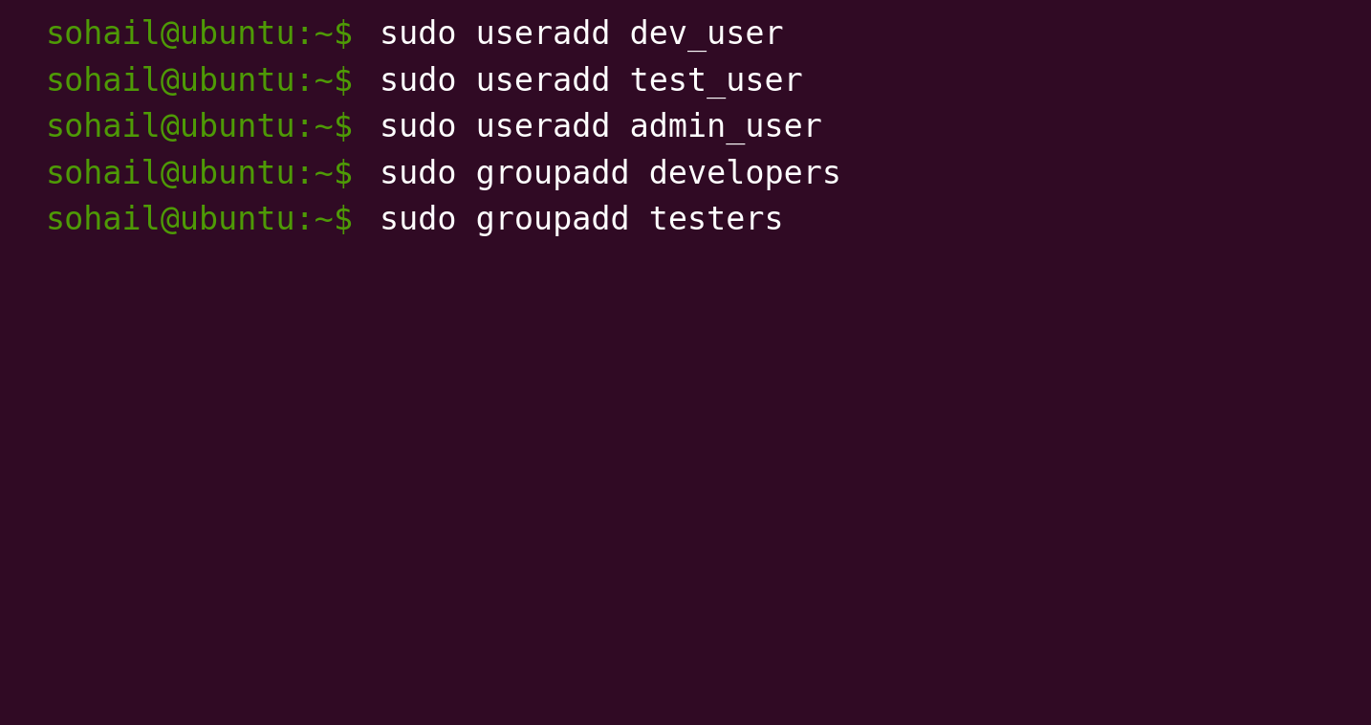

Figure 2: Adding users to groups and directory setup.  
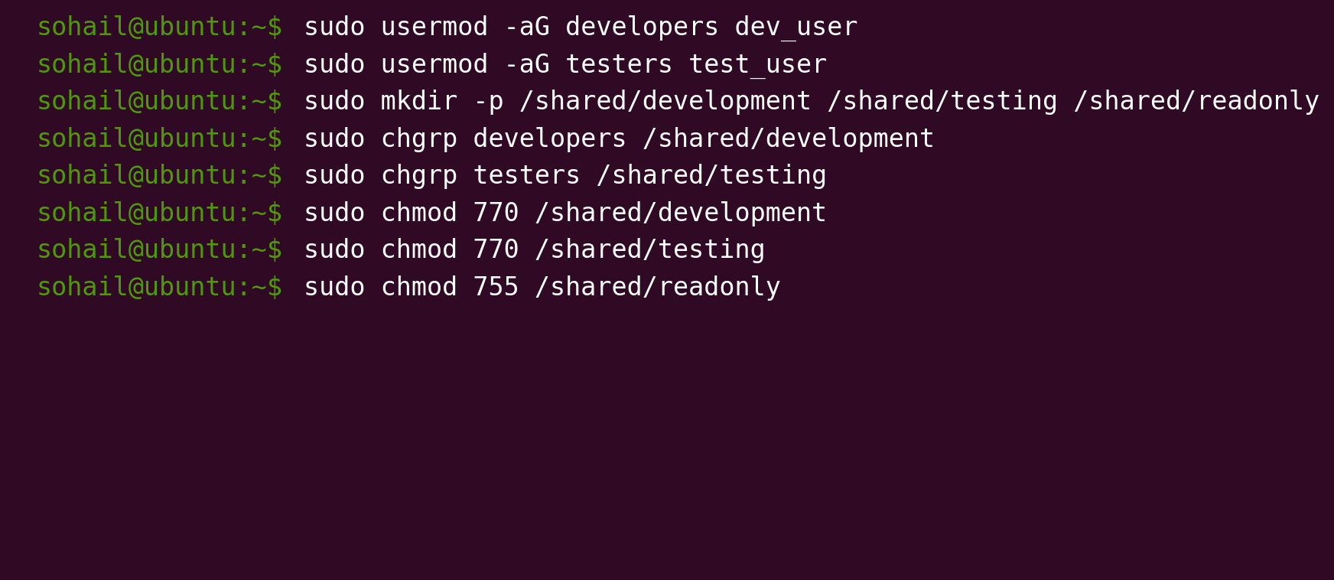

Figure 3: Verification of permissions and ownership.  
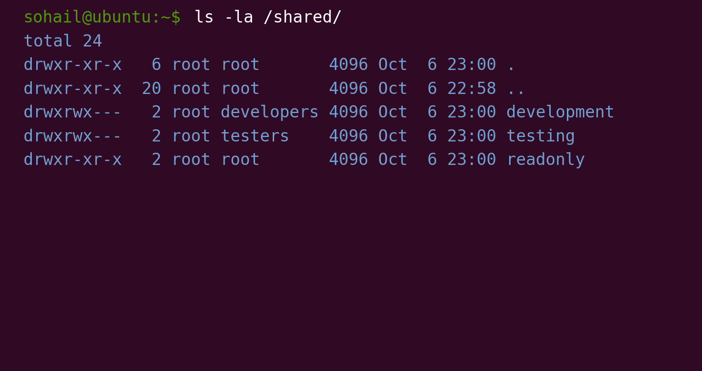

# Troubleshooting and Resolution

• Issue: Error when using chgrp before creating the directory.  
 Resolution: Ensure that directories are created with mkdir before running chgrp.

• Issue: Permissions not reflecting correctly.  
 Resolution: Re-applied correct permissions with chmod and verified using ls -la.

# Conclusion

This project demonstrated how to manage Linux users, groups, and shared directories with proper permissions. Such user and group management tasks are essential for system administrators to organize team access, maintain security, and ensure collaborative environments function correctly.

# Command Explanations

► Command: sudo useradd dev_user

Scope: User Management

Explanation: Creates a new user account named dev_user.

Output: A user account entry in /etc/passwd.

► Command: sudo groupadd developers

Scope: Group Management

Explanation: Creates a new group called developers.

Output: Entry added in /etc/group.

► Command: sudo usermod -aG developers dev_user

Scope: User & Group Association

Explanation: Adds dev_user to the developers group without removing them from existing groups (-aG).

Output: User now belongs to the developers group.

► Command: sudo mkdir -p /shared/development

Scope: Filesystem / Directory Management

Explanation: Creates the /shared/development directory. The -p option creates parent directories if they don’t exist.

Output: A new directory under /shared/.

► Command: sudo chgrp developers /shared/development

Scope: Ownership Management

Explanation: Changes the group ownership of the directory to developers.

Output: Directory now owned by the developers group.

► Command: sudo chmod 770 /shared/development

Scope: Permissions Management

Explanation: Grants read, write, and execute permissions to the owner and group, while restricting access for others.

Output: Only users in developers group can access and modify the directory.

► Command: sudo chmod 770 /shared/testing

Scope: Permissions Management

Explanation: Grants read, write, and execute permissions to the owner and group for the testing directory.

Output: Only users in testers group can access and modify the directory.

► Command: sudo chmod 755 /shared/readonly

Scope: Permissions Management

Explanation: Provides read and execute permissions to all users, but only the owner can write.

Output: All users can view contents, but only owner can modify.

► Command: ls -la /shared/ > ~/permissions_report.txt

Scope: Verification

Explanation: Lists details (permissions, ownership, size, date) of /shared/ contents and saves them into a report file.

Output: permissions_report.txt with directory details.