EET125
Professor Wu
SUM 9-30-2004
Brad Foran
Justin Knox

Software Project Lab

Chapter 17 Excercises 5 , 6 , 14

Exercise no 5.a

a = 4.0000 + 6.0000i 0 - 6.0000i
0 - 6.0000i 0 - 2.0000i

b = 10.0000
-20.0000 -34.6400i

c = a^-1 * b

i1 = 4.6859 - 2.1357i
i2 = 3.2622 - 3.5930i

Polar Conversion Yields
i1 = 5.15 ∠ -24.5
i2 = 4.853 ∠ -47.76

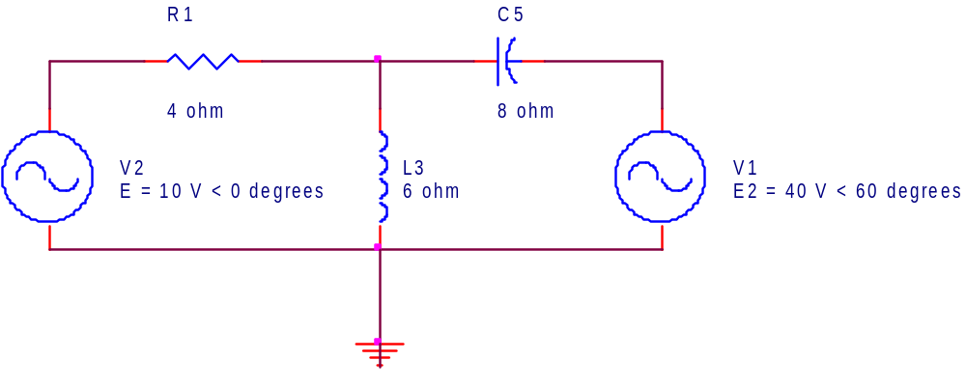

Exercise no 5.b

a = [ 50+20i , -20i ; -20i , -40i]

50.0000 +20.0000i 0 -20.0000i
0 -20.0000i 0 -40.0000i

b= [ -15.6699 + 2.5i ; 20 ]

-15.6699 + 2.5000i
20.0000

c = a^-1 * b

-0.3554 + 0.2633i
0.1777 + 0.3684i

Polar Conversion Yields
I1 = .4423 ∠ 143.467
I2 = .409 ∠ 62.249

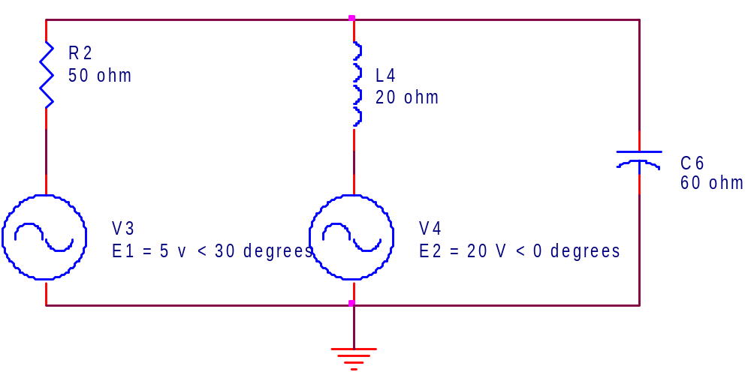

Exercise no 6.a

a = [ 15+12i , -3 ; -3 , 3-1i]

15.0000 +12.0000i -3.0000
-3.0000 3.0000 - 1.0000i

b = [-7.66546 - 41.0607i ; -19.4788 + 56.3816i]

-7.6655 -41.0607i
-19.4788 +56.3816i

c = a^-1 * b

-1.7317 + 1.8749i
-13.6028 +16.1345i

Polar Conversion Yields
I1 = 2.5523 ∠ 132.726
I2 = 21.103 ∠ 130.134

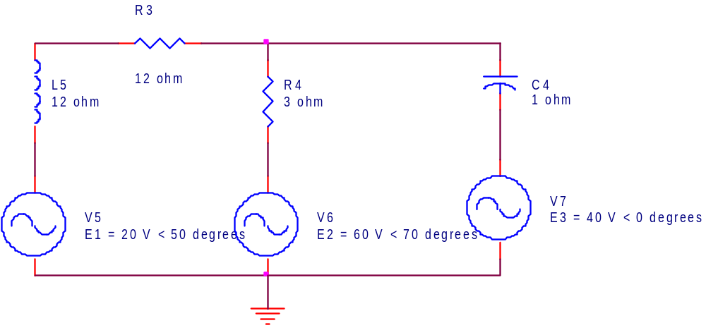

Exercise no 6.b

a = [2 + 20 + 10i , -10i ; -10i , 10 - 10i ]

22.0000 +10.0000i 0 -10.0000i
0 -10.0000i 10.0000 -10.0000i

b = [12 ; -30]

12
-30

c = a^-1 * b

0.5283 - 0.8491i
-1.3396 - 0.8113i

Polar Conversion Yields
i1 = 1 ∠ -58.107
i2 = 1.566 ∠ -148.8

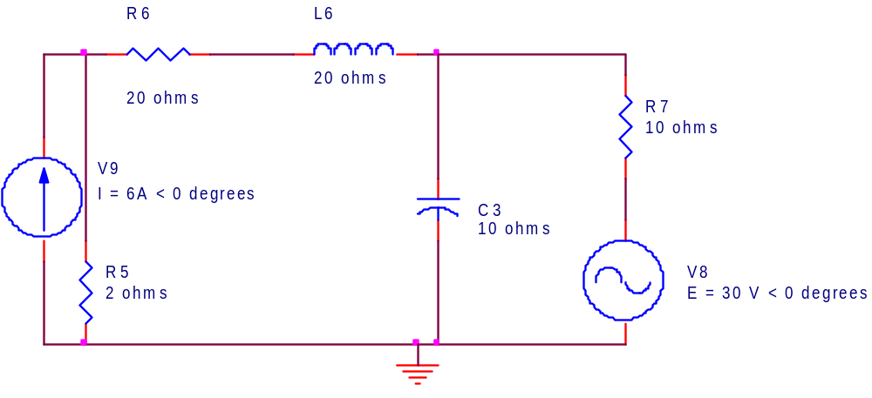

Exercise no 14.a

a = [.25 + -.2i, -.2i ; -.2i , .5i - .2i ]

0.2500 - 0.2000i 0 - 0.2000i
0 - 0.2000i 0 + 0.3000i

b = [ 3 ; -4.33 + -2.5i]

3.0000
-4.3300 - 2.5000i

c = a^-1 * b

3.3632 - 2.1824i
-6.0912 +12.9784i

Polar Conversion Yields

v1 = 4.0087 ∠ -32.98
v2 = 14.333 ∠ 115.142

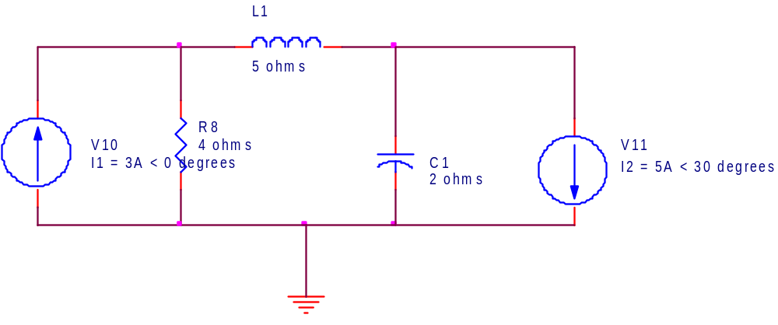

Exercise no 14.b

a = [.62-.16i , -.5 ; -.5 , .16667+.125i]

0.6200 - 0.1600i -0.5000
-0.5000 0.6667 + 0.1250i

b = [-1.26 - 4.1444i ; .6945 + 3.939i]

-1.2600 - 4.1444i
0.6945 + 3.9390i

c = a^-1 * b

0.9393 - 5.0376i
2.0726 + 1.7416i

POLAR
V1 = 5.1244 ∠ -79.438
V2 = 2.0726 ∠ 40.0402

