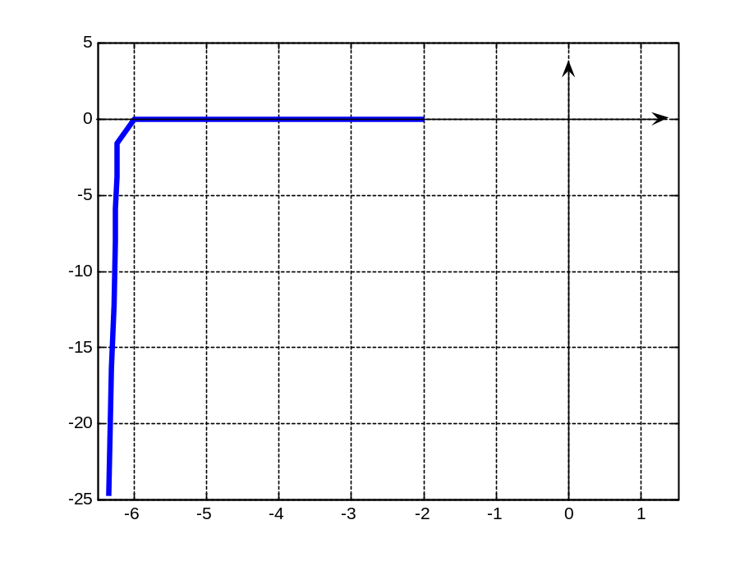
Figure 1. The Zener diode characteristics in break-down region
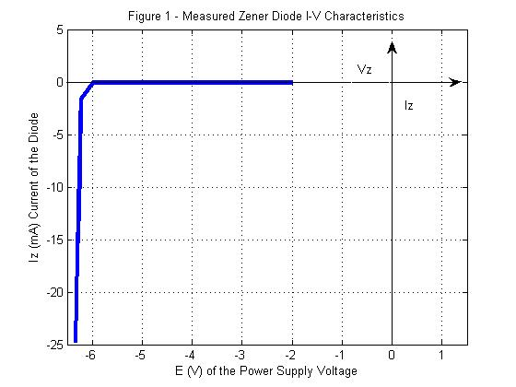
Warning: Could not get change notification handle for remote Z:\MATLAB7\work.
This file server does not appear to support change notification.
Cannot determine whether this server supports directory timestamp updates.
Type 'help changeNotification' for more info.

To get started, select MATLAB Help or Demos from the Help menu.

>> Ev = [2 ,4,5,6,7,8,9,10,12,14,16,18];
>> Vz = [1.9987,3.9982,4.9982,5.9922,6.2242,6.2337,6.2564,6.2735,6.3016,6.3201,6.3368];
>> Iz = [.000000213,.000000426,.000003.000016,1.6,3.8,5.9,8.0,12.2,16.4,20.6,24.8];
??? Iz = [.000000213,.000000426,.000003.000016,1.6,3.8,5.9,8.0,12.2,16.4,20.6,24.8];
|
Error: Missing MATLAB operator.

>> Iz = [.000000213,.000000426,.000003,.000016,1.6,3.8,5.9,8.0,12.2,16.4,20.6,24.8];
>> plot(vz,iz)
??? Undefined function or variable 'vz'.

>> plot(Vz,Iz)
??? Error using ==> plot
Vectors must be the same lengths.

>> Vz = [1.9987,3.9982,4.9982,5.9922,6.2242,6.2337,6.2445,6.2564,6.2735,6.3016,6.3201,6.3368];
>> plot(Vz,Iz)
>> axis([0 18 0 25])
>> Vz=-Vz

Vz =

Columns 1 through 7

-1.9987 -3.9982 -4.9982 -5.9922 -6.2242 -6.2337 -6.2445

Columns 8 through 12

-6.2564 -6.2735 -6.3016 -6.3201 -6.3368

>> Iz=-Iz

Iz =

Columns 1 through 7

-0.0000 -0.0000 -0.0000 -0.0000 -1.6000 -3.8000 -5.9000

Columns 8 through 12

-8.0000 -12.2000 -16.4000 -20.6000 -24.8000

>> plot(Vz,Iz)
>> grid
>> axis([0 18 0 25])axis([-6.5 1.5 -25 5])
??? axis([0 18 0 25])axis([-6.5 1.5 -25 5])
|
Error: Missing MATLAB operator.

>> axis([-6.5 1.5 -25 5])
>> Vl[2.719,4.0807,5.4393,6.2236,6.247,6.261,6.283,6.298,6.323,6.339,6.366];
??? Vl[2.719,4.0807,5.4393,6.2236,6.247,6.261,6.283,6.298,6.323,6.339,6.366];
|
Error: Unbalanced or misused parentheses or brackets.

>> Vl=[2.719,4.0807,5.4393,6.2236,6.247,6.261,6.283,6.298,6.323,6.339,6.366];
>> Is=[2.74,4.109,5.479,8.016,12.241,16.472,20.723,24.99,29.32,33.783,38.184];
>> Iz=[.000006, .000008, .000009 , .00178, .00597 , .010163,.014372 ,.018618,.072872,.027913,.031550];
>> Il=[.00273,.004106,]

Il =

0.0027 0.0041

>>

