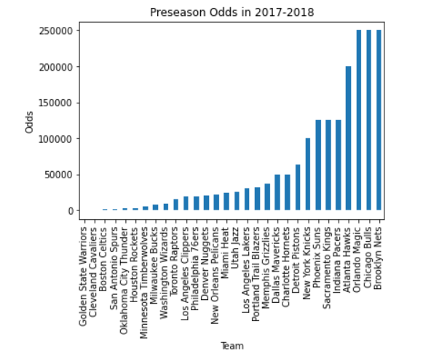

The Warriors beat the Cavaliers for the 2017-2018 NBA championship.

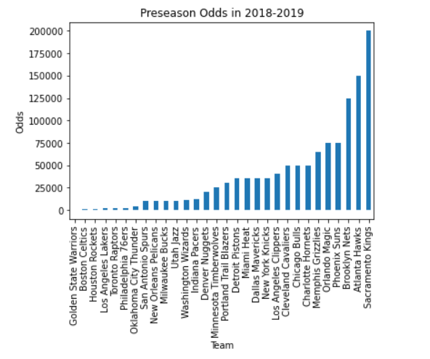

The Raptors beat the Warriors for the 2018-2019 NBA championship.

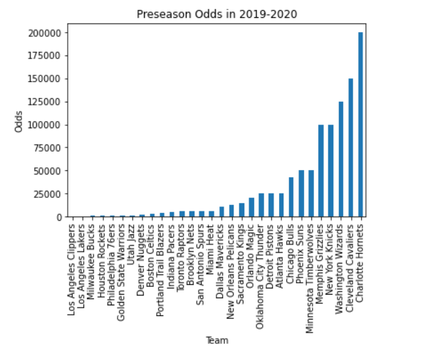

The Lakers beat the Heat for the 2019-2020 NBA championship.

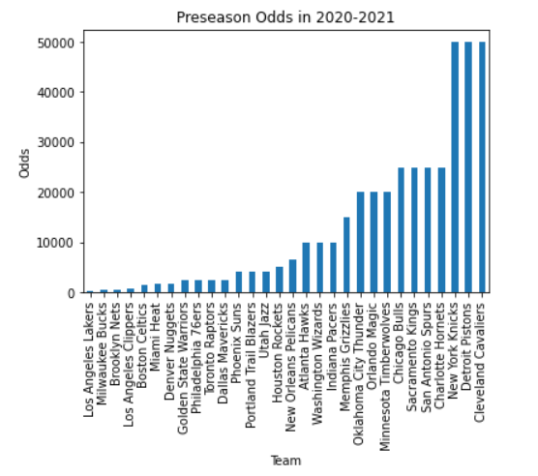

The Bucks beat the Suns for the 2020-2021 NBA championship.

Looking at the past 4 NBA championships, we can see that the winner of the NBA championship was in the top-5 preseason odds for every year. This gives us an indication that the sport of basketball is quite predictable and that a predictive model should give reasonable results.

To better understand whether or not the preseason W/L O/U values would be a good predictor of the team’s season success, we decided to find the difference between the actual wins and the predicted wins to see how close the values were. On average, the differences were relatively small, as can be seen below.

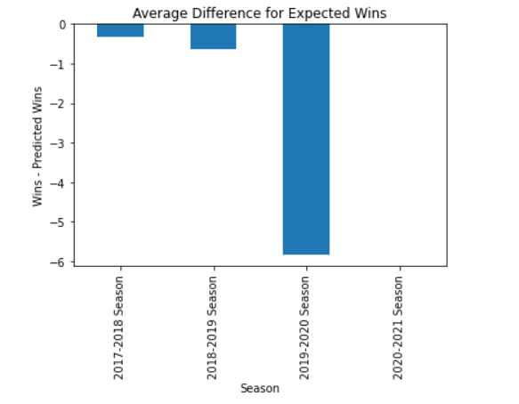

The only anomaly in the data is for the 2019-2020 season where the difference between wins and predicted wins is less than -5. The reason behind this is that it was a shortened season and teams were not able to play their full 82-game schedule. The most dramatic difference could be seen in the Warriors, who were more than 30 games below their projected win total. Due to the shortened season, we decided that it would be unwise to use the 2019-2020 season predictions in our model.

