Measure execution time using Fody  
(MethodTimer.Fody)[development only]

Using Fody to measure execution time of a function and logging it*.* ***Fody is a powerful library that facilitates IL (Intermediate Language) rewriting.*** It can remove the boilerplate code for stopwatch functions, to keep the code cleaner and easier to add and remove for testing.

## Guide Topics:

1. Installing the packages
2. Put the [Time] decorator on the function
3. Additional controls

### Installing the packages

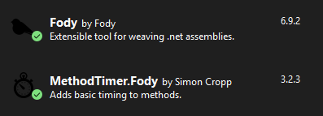

### Basic Usage

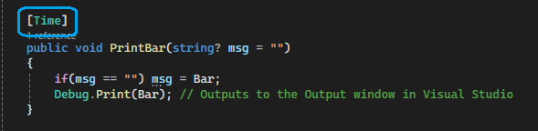

### Additional Controls

Fody [Time] default method can be overridden. Make sure the intercept class is **static** and the name should be MethodTimeLogger

There are 2 options for the functions to override the Log with. One usings **TimeSpan** the other uses **long**.

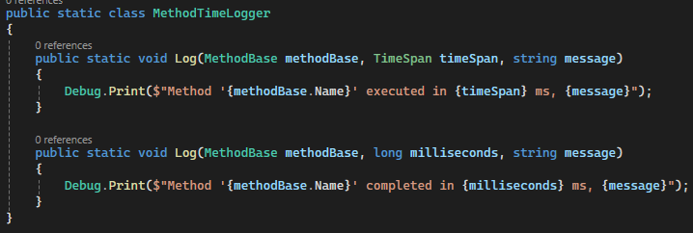

Passing Parameters, the logs can show function variables values if passed into [Time] decorator

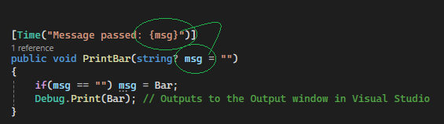

Sources:

<https://github.com/Fody/MethodTimer>

<https://www.youtube.com/watch?v=xlqcT4NSrZw>