Business Use Case Requirement Document

SME Engagement Platform Business   
Use Case Requirement Document

Date: 29.01.2025  
Credits/Details: Ulrike Domanig  
Department: Business Unit Enterprise, Digital Process Transformation  
Version: 1.0



Table of Contents 

**1.** **Introduction and Overview 5**

*1.1* *Purpose of this document 5*

*1.2* *Scope of this document and the RFI 5*

*1.3* *Reason why of capabilities in scope 5*

**2.** **Product Catalog Management 7**

*2.1* *Overall Description 7*

2.1.1 Commercial Product Modelling 7

2.1.2 Discount Modelling 11

*2.2* *Use Case: Configuration of Product (Soft) Bundles und and Product Offerings 13*

*2.3* *Use Case: Discount configuration 13*

*2.4* *Use Case: Configuration of Offering Rules 13*

*2.5* *Use Case: Configuration and import of A1 internal product modules 14*

*2.6* *Use Case: Configuration and import of 3rd party (i.e. partner) product modules 14*

**3.** **Product Offering (CPQ) 15**

*3.1* *Overall Description 15*

*3.2* *Use Case: Generate cross category offers and bundles 16*

3.2.1 Personalization 16

3.2.2 Roles and Rights 16

3.2.3 Location Management 16

3.2.4 Product Selection 16

*3.3* *Use Case: Standardized Discounting 18*

3.3.1 Discounting Based on Existing Products 19

*3.4* *New Provide and MACD 20*

3.4.1 Use Case: Cross- & Up-Selling 20

3.4.2 Product Replacements 20

3.4.3 Alternative Products 21

**4.** **Commerce (Ordering Platform) 22**

*4.1* *Overall Description 22*

*4.2* *Use Case: Clean Order 22*

*4.3* *Use Case: Order Enrichment 25*

*4.4* *Use Case: Shopping cart 28*

**5.** **Omnichannel Sales Portal 32**

*5.1* *Overall Description 32*

*5.2* *Components of the Platform 32*

*5.3* *End-to-End Salesflow on the Omnichannel Plattform 33*

*5.4* *Customer journey represented on the Omnichannel Platform 38*

*5.5* *Use Case: Unified Sales frontend 39*

*5.6* *Use Case: Digital Proposal / Offer creation and acceptance 39*

*5.7* *Use Case: Display of customer and business transaction data from the Sales CRM (quotes / orders / contracts) 40*

*5.8* *Guided Sales journey 40*

**6.** **Sales CRM / Funnel Management 41**

*6.1* *Overall Description 41*

*6.2* *Use Case: Data Entity Management 42*

*6.3* *Funnel Management 46*

6.3.1 Lead Management 46

6.3.2 Opportunity Management 47

6.3.3 Order Tracking 48

*6.4* *Use Case: Communication Hub 48*

*6.5* *Customer Interaction Management 49*

6.5.1 Use Case: Clarity and Transparency 51

6.5.2 Use Case: Securing the case closing 51

**7.** **Authentication & Authorization 52**

*7.1* *Overall Description 52*

*7.2* *Use Case: Hierarchical and multi-client authorization concept ensured by login & dynamic content structure 52*

*7.3* *Use Case: Online registration of new users & role assignment by administration user 53*

*7.4* *Use Case: Multi-factor authorization and Single Sign-On 53*

**8.** **Commercial Inventory (CPI, EI) 54**

*8.1* *Overall Description 54*

*8.2* *Use Case: Building and maintaining CPI and contract data in one central system and ensuring CPI contains all data from A1 and partner products purchased by customers 54*

*8.3* *Use Case: Providing CPI and contract data to ensure the product compatibility with existing products and services and to reduce fulfillment errors within a new order. 54*

**9.** **Content Management 55**

*9.1* *Overall Description 55*

9.1.1 Types of Content to be processed in the Platform CMS 55

9.1.2 Integration Points with other Interfaces 56

*9.2* *Use Case: Asset Management 58*

*9.3* *Use Case: Product / Offer / Solution Overview 59*

9.3.1 Content Creation and Editing 59

9.3.2 Multichannel Content Delivery 59

9.3.3 Workflow and Approval Processes 60

9.3.4 Search Engine Optimization (SEO) 60

**10.** **Customer Order Management 61**

*10.1* *Overall Description 61*

*10.2* *Use Case: Automatic Order Capture and creation of E2E Order-ID 62*

*10.3* *Use Case: Customer Order Orchestration & Order Workflow Management 63*

*10.4* *Use Case: Manage and coordinate installation date and involved Departments / Service Partners 64*

*10.5* *Use Case: Customer Order Tracking & Management (Track & Trace) 65*

*10.6* *Use Case: Manual Changes and Identified Change Requests 67*

*10.7* *Use Case: Exception Handling 68*

*10.8* *Use Case: Error Monitoring and Alarming 69*

**11.** **Partner management for Sales, Service and Solution Partner 70**

*11.1* *Overall Description 70*

*11.2* *Objectives & Scope: 70*

*11.3* *Use Case: Partner Onboarding 72*

*11.4* *Use Case: Partner lifecycle management / Admin 74*

*11.5* *Use Case: Partner lifecycle management / Commissioning and Monitoring 75*

# Introduction and Overview

## Purpose of this document

This document is intended to give additional information and context to the Use Case & User Story file provided in XLS-Format. The purpose is to illustrate the use cases and provided underlying assumptions and a frame of reference from a business side. It is a RFI that include all A1 operating companies.

## Scope of this document and the RFI

The scope for this RFI is based on the capabilities (these are based on TMF capabilities) shown in the chart below. The core scope to be covered in the RFI response is covered by the upper eight capabilities (please refer to the legend in the chart below).

The optional cope parts that are those in lighter blue color. In addition, the scope of the RFI response includes a generative AI component that shall be implemented across multiple capabilities as indicated in the chart.

The capabilities colored in red are those capabilities that need to be integrated into the solution. These capabilities are currently available in the countries legacy systems or in one case (Campaign Management) covered by an A1 Group wide solution that is already present.

For the RFI response it is important to have the first three capabilities (Sales Portals, API Management, CMS & IAM & Document Management) offered in two versions: 1. Integrated in the overall solution proposal, 2. Considered to be self-development based on open-source frameworks.

The following capabilities

* Product Catalog Management
* Product Offering (CPQ)
* Commerce (Ordering Platform)
* Omnichannel Sales Portal
* Sales CRM / Funnel Management
* Authentication & Authorization
* Commercial Inventory (CPI, EI)
* Content Management
* Capability Customer Order Management

are illustrated within this document and these illustrations refer to the user Use Cases & User Stories in the XLS-File 20_b_RFI_SME_Engagement_Platform_Business_Use_Case_Requirements_Document - User Story.

## Reason why of capabilities in scope

The capabilities we see as a group priority to address our SME strategy focus on our goal to bring our sales performance to a new, digital level, including partners to accelerate our revenue growth. As this is not only a question of frontends, it includes key backend capabilities, such as Product Catalogue, Product Offering and a few more. Campaigning is not in scope, as the group system is already chosen. Nevertheless, is hast to be integrated into sales and offering.

Additional to optimize sales, a transparent, fast efficient journey from lead to activation/installation of products is key. Therefore, sales funnel management, including leads and opportunities, as well as order management and orchestration are crucial capabilities.

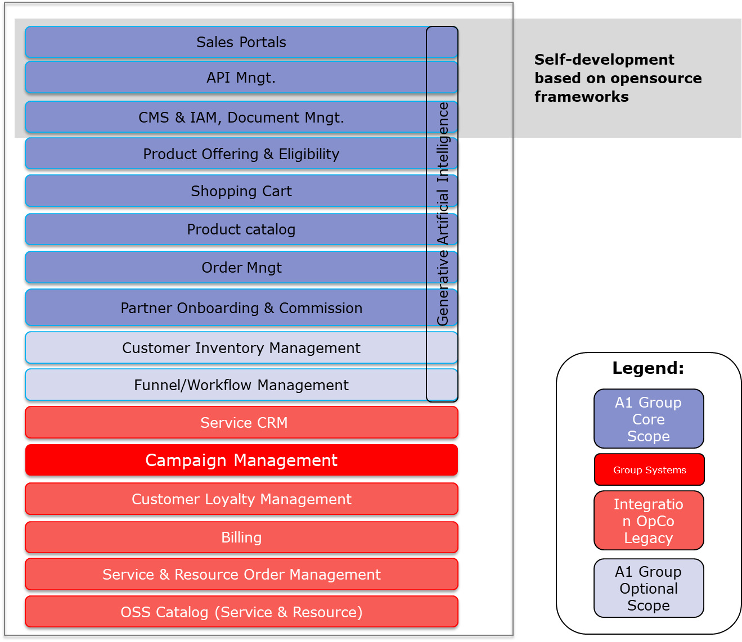

# Product Catalog Management

## Overall Description

This section gives a broader context in which the use cases for Product Catalog (PC) Management are embedded.

### Commercial Product Modelling

The commercial product catalogue shall contain all products a customer can buy via the SME engagement platform.

#### Logical Levels of the PC

There shall be three logical levels in the catalogue. These are:

* Bundle Product Offerings (BPO)
* Simple Product Offerings (SPO)
* Product Specifications (PS)

**Bundle Product Offerings (BPO):** These shall be created of various Product Offerings that form a useful bundle for customers and address customer needs.

**Simple Product Offerings (SPO)**: These shall be created from Product Specifications defining concrete variants of services that can be created based on the underlying Product Specifications. The Product offering defines the specific product parameters that form the promise to the customer in terms of the product performance (e.g. bandwidth, included data volume, storage space, number of voice channels etc.)

**Product Specifications (PS):** These define all possible characteristics (e.g. bandwidth) and values (e.g. 1 Mbit, 10 Mbit, 100 Mbit, etc.) a product manager can choose from to create Product offerings. The product specifications will also be the link to technical/service catalogues required to order and fulfil the Product Offering. It is assumed that all required logic to do a correct order fulfilment is encapsulated in the technical catalogues and feasibility checks (where applicable) integrate with the technical catalogues.

The product specifications are needed for products that are provided by A1 internal systems/infrastructure (e.g. Fixed Data Access, Mobile Access, etc.) as well as those provided by our partners or vendors (e.g. Microsoft 365, Azure, Zscaler, etc.)

**Remark:** The terms used here are taken from the TM Forum definitions and they can be named differently as long as the general modelling is similar and the flexibility to define product offerings does not suffer from a different implementation.

#### Additional PC content (logical view)

In addition to the products the catalogue shall hold the following information that is related to the defined product offerings:

* **Prices:** allprice types such as recurring charges (monthly product base price, annual service charge, service fees, etc.), one-time charges(e.g. installation fee, product change fee, activation fees, retail price, etc.)  
    
  **Indexation:** The product catalogue needs to provide a function that allows to update product prices based on the indexation (e.g. consumer price index) that applies for the products.
* **Cost:** this is used to support contribution margin calculation in the offing process, cost can be either a simple value or a value that may be a function of the number of times the product is bought (e.g. 1 license costs € 5,00, 5-9 licenses cost € 4,30 each, 10+ licenses cost 3,90 each)
* **Discounts** shall be defined as a separate logical entity and linked to (bundles) product offerings.
* **Discount rules** shall be possible to define so that the application of discounts on a shopping cart level does not exceed commercially sensible amounts.
* **Bundling rules** shall define in what way product offerings can be bundled on a shopping cart level (soft bundling).
* **Compatibility Rules** shall define what products can be combined.
* **Exclusion rules** shall define what products logically or technically exclude each other.
* **Eligibility Rules** shall define for each (bundled) product offering, whether the offering is offered in/on a customer segment, touchpoint, region and whether it is eligible for loyalty programs and indexation of prices.
* **Product lifecycle status.** All (bundled) product offerings need to have life cycle information assigned so that it is clear at any given time whether a product offering is in sale, in service or out of service.
* **Alternative Products.** The catalogue needs to have a function that allows to maintain relations between products so that similar products can be linked together, and an alternative can be suggested in the offer process on all omnichannel touchpoints.

The overall structure is also illustrated in the diagram below.

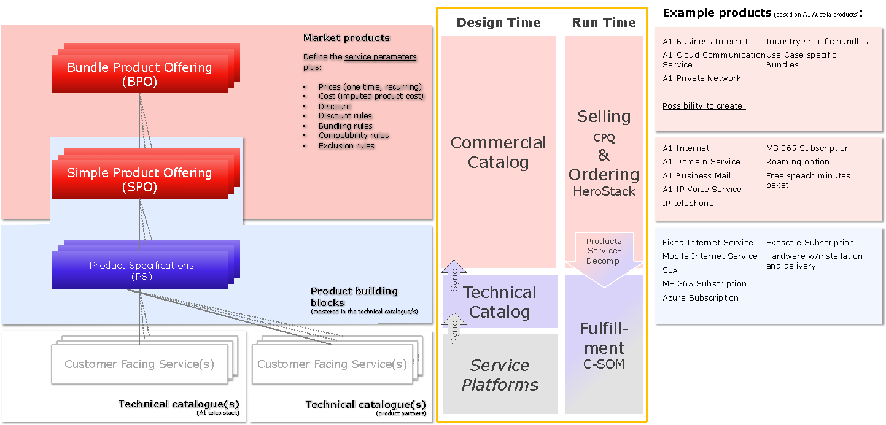

The catalogue shall have an interface that can be easily used by a trained business user to define all commercial products based on predefined product specifications. It shall also allow to define prices, cost and relational data in a way that a trained business user can do it without involvement from technology departments or even developers.

The illustration also shows that there is a design-time view and a run-time view that neds to be considered. It also lists a few sample products based on the current A1 Austria product portfolio. These are linked to the future logical levels of the product – this is for illustration only and is not a comprehensive view on the future product portfolio.

#### Standardization & Modularization

The reason behind this logical model is to enable in product development a high level of standardization and modularization.

Standardization allows to model all products in all A1 countries in a similar way and include similar product components to allow common product “mechanics” across all A1 markets. The key driver behind this is to allow harmonized sales and ordering processes.

Modularization is needed to allow the definition of product components in a way that to reuse these components across different markets. This allows for example to define a product once and reuse is in another market (e.g. cloud services like MS 365 or endpoint security solutions) by potentially just adopting the price. In addition, modularization allows easier exchange of product components and more efficient creation of product offerings reusing the same product components over and over.

#### Example product modelling

The following structure shows a product in the way it shall be modelled in the future. It is essentially a bundle with components that are always part of the bundle “Fixed Data 80” and “Fixed IP Address Basic”. All other product offerings in this illustration are independent product offerings that are loosely linked to the product offering via compatibility rules. Some of them can even be ordered without any prerequisite product offering like Mailbox or Webspace. Others need a prerequisite product to be ordered like Dual Power, which requires the A1 Business Internet product as a prerequisite (either in the same order or already in the customer product inventory as an active product.

The prices indicated are those that are offered and it can be seen, that these may vary with the minimum contract term the customer chooses.

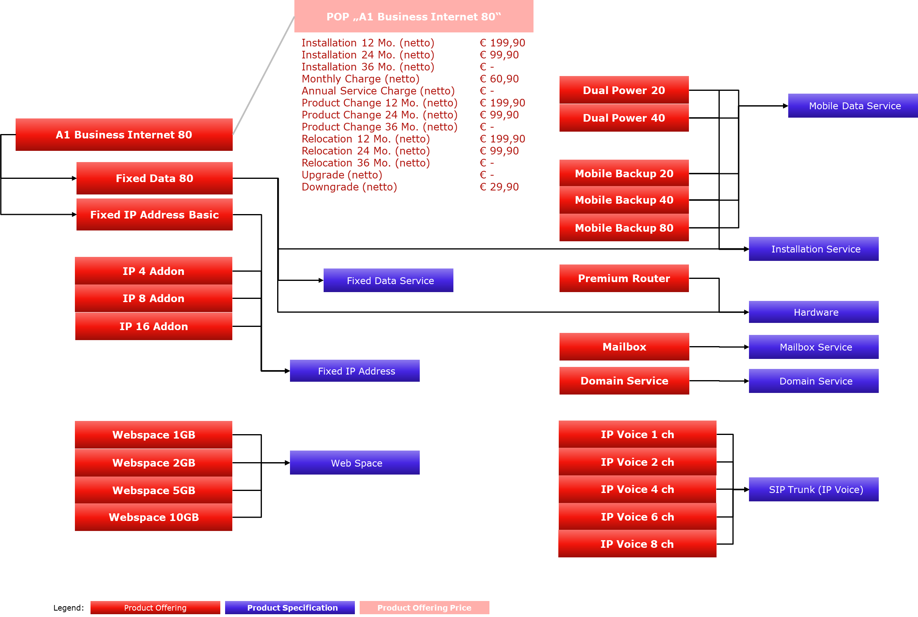

To illustrate the structure of product specifications here are three of those broken down into the characteristics and values. Remark: This is not a comprehensive modelling and is intended only give an overview of the logical model that needs to be supported.

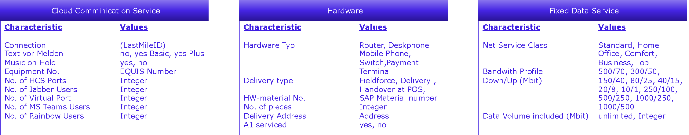

### Discount Modelling

The product catalogue shall be able to define discounts in a way that these can be described the way it is illustrated in the picture below.

There shall be two sections to define the discount:

* **Eligibility Rules:** This section defines where the discount can be used. This includes the Product Group(s), the sales channels, target customer (groups), the business use case (e.g. new provide, product change, relocation, etc.), time limits (start, end), and conditions that may apply on a shopping cart and/or customer inventory level.
* **Target Price Element / Credit:** In this section the price types are defined that the discount takes effect on. This can be each defined price element / charge type of the product offerings or simply a credit that is booked on the customer’s account. For each of the elements a percentage or value shall be definable, and a duration shall also be definable for wish the respective discount is granted.

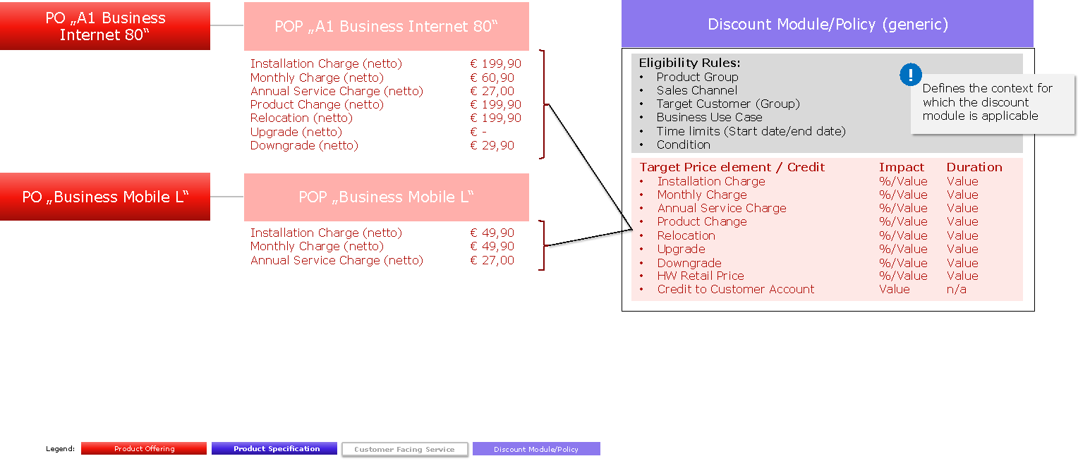

The following discount variants need to be supported:

* Monthly credit: e.g. a credit to the monthly invoice of € 100,- for 3, 6, or 12 months)
* Discount to the monthly charge: x% discount to the monthly charge (e.g. -10% for the first 6 months)
* One-off discount, fixed amount (e.g. € 150 discount when an order is placed)
* Add’l benefits for free: e.g. static IP, more bandwidth for x months, no charge for product change
* Discounted Equipment: Router/Option free of charge or at a discounted price
* Satisfaction guarantee: Money back within the first three months
* Bundle discount; discount if an additional product is ordered (e.g. mobile access or telephony service)
* Volume discount: given based on the number of locations the customer ordered with A1 or the level of bandwidth ordered
* One-off upgrades: e.g. bandwidth boost for x months (e.g. 300 to 500 Mbit)
* Runtime of promotions: limited promotions such as “12 months for the price of 10”, for new customers or when a contract is renewed
* Free of charge months: e.g. first 6 months free of charge if minimum contract duration is 36 months
* Partner promotions: cooperations with third-party vendors (e.g. BDS, Microsoft to offer credits for M 365 or Azure)

For further illustration here are a few examples of how selected discounts are envisioned to be modelled.

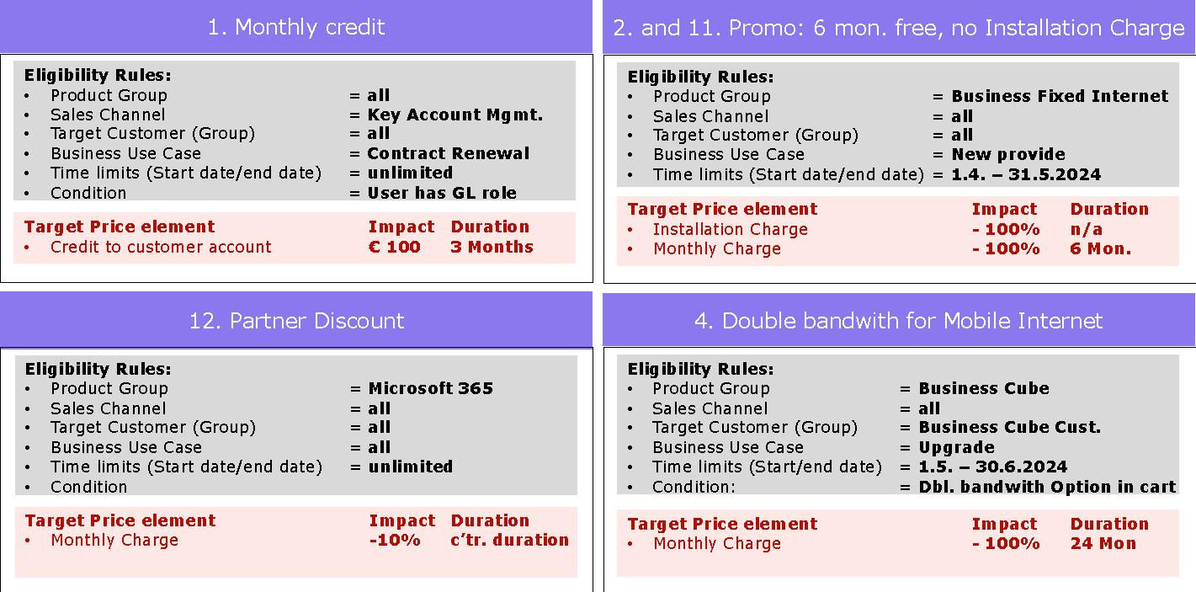

For discounts like the number 4 in the list above we assume that there is an option (separate product offering) that needs to be put into the shopping cart to allow the ordering of the additional benefit (in this example doubled bandwidth). This option is then discounted to a zero charge (in this example for 24 months).

#### Versioning and Audit Trail

All product offerings, product specifications and discounts and relational information (e.g. compatibility rules) in the catalogue need versioned so that product life cycle management processes are enabled, and all historic versions are kept for future reference.

## Use Case: Configuration of Product (Soft) Bundles und and Product Offerings

All product offerings need to be configurable by a business user (i.e. an offering manager or product manager who) based on predefined product specifications. This includes the definition which values of the respective characteristics apply for the product offering, prices and cost that is base for the calculation of the contribution margin of a customer offer in the Offering capability.

Additionally, the catalog needs to allow to update all prices of eligible product offerings based on indexation (e.g. consumer price index, or any other index that is base for the price change) in an automated way. The price history needs to be kept in place for future reference.

The configuration shall be possible based on the logical entities described in chapter 2.1.1. (Commercial Product Modelling).

## Use Case: Discount configuration

The catalogue needs to have possibilities to define discounts that can be used in the offering capability described below as well to define of policies that limit the use on the sales touchpoints (based on touchpoint specific discounts and policies). Also, a mechanism needs to be in place that allows the ranking of discounts in the offering process.

The modelling of discounts needs to be similar to the modelling described in chapter 2.1.2 (Discount Modelling).

## Use Case: Configuration of Offering Rules

The catalogue needs to allow to define relation between product offerings that describe their compatibility or incompatibility so that in the offering process the information can be used to create meaningful offers for the customer

In addition, a possibility needs to be in place to allow a business user (i.e. an offering manager or product manager who) to define the prioritization of product offerings and/or discounts to assist the customer and/or sales representative (internal or partner) in the offering process.

Lastly, a mechanism needs to be in place that allows to describe then a product change is an upgrade, or a downgrade and the effect it has on charges (e.g. upgrade charge, downgrade charge).

## Use Case: Configuration and import of A1 internal product modules

The catalogue needs to be able to integrate with various internal systems to allow the import of product specifications and their respective characteristics and values.

This requires also a mechanism for versioning of the product specification to support the product life cycle process operationally.

## Use Case: Configuration and import of 3rd party (i.e. partner) product modules

The catalogue needs to be able to integrate with various technical catalogues to allow the import of product specifications and their respective characteristics and values from these catalogues. This shall be possible either for the partner himself or an A1 internal user in case the partner can or will not do it himself.

In case the 3rd party/partner does not have a technical catalogue, the overall solution needs to take this into considerations to allow a seamless offer and order flow with the partner integrated in the processes.

For this an approval mechanism needs to be in place so that changes are taking effect in controlled way.

This requires also a mechanism for versioning of the product specification to support the product life cycle process operationally.

# Product Offering (CPQ)

## Overall Description

The current process for offer configuration and submission is facing several challenges that hinder efficiency and customer satisfaction. In terms of offer creation, a unified process/system to configure SME products is needed. Today systems are country specific, touchpoint specific, product group specific (fixed line vs mobile vs ICT) and pricing calculation specific (standardized discounts vs. individual pricing, vs. promotions/campaigns).

Product offerings and bundles need to be configurable, based on product offering modules (SPOs). Bundling across product groups shall be possible, based on a centralized product catalogue structure. Offers shall be generated in 2 ways:

* Pre-configuration of offers and bundles by the offer manager, that are displayed to sales channels/TP
* On-spot individual configuration of offers, based on available product modules, for a specific customer, by the sales touchpoints themselves (including external sales partners)

In terms of pricing, there shall be a unified view on standard price points (base prices) and the calculation logic. Additionally, the discount logic shall be standardized and predefined discount modules need to be available as well as Promotions/Campaigning offers.

Ein Bild, das Text, Screenshot, Schrift, Software enthält.

For offer submission, creation of proposal documents varies due to the different approaches to configure offers. Partly it must be created manually right now, as an automated generation out of the configured offer is not available. As a result of these issues, customers experience long wait times for their price calculations, which are often inconsistent due to the reliance on multiple systems. This creates a complicated and complex pricing experience for the customer. Therefore, there shall be a functionality to generate a legally valid contract document out of the finalized configured offer that is summarized in the shopping cart.

The objective is to implement a solution that enables simple and fast offer configuration for both customers and A1 touchpoints (internal and external), based on a clear set of standardized rules. The system should provide all sales touchpoints with a uniform offering template and structure across all digital omnichannel channels, ensuring consistency for every type of offer. The offer will be based on standardized and modularized product components. Promotions and general discounts shall be automatically displayed or suggested, depending on the level of configuration effort. Automated pricing logic will be applied to bundles, ensuring that customers are informed about the effects of their product or bundle choices, such as limited product additions, longer production times, or compatibility with existing products. Indexation of standard price price points (base prices) will be applied automatically. The validity of offer prices will be governed by clear rules, with automatic updates or terminations as necessary.

## Use Case: Generate cross category offers and bundles

### Personalization

The system must support personalized offer configurations to enhance the customer experience. It should use available customer data to tailor offerings**,** displaying framework agreements, individual campaigns, and promotions.

Unauthenticated customers should be prompted to log in, enabling them to access preferential prices and save their sales workflow. Whereas logged-in customers should receive personalized offers and promotions tailored to their preferences, ensuring they are presented with the best options. The offer configuration process must incorporate suitable promotions/campaigns and individual prices based on framework agreements as well as product preferences to personalize the experience effectively.

### Roles and Rights

The system must facilitate the identification and assignment of roles and authorizations for data entry during the offer creation process. Customers should be able to see an overview of the required data and the stages of the process in which it is needed. This functionality will allow users to plan and organize data entry internally for complex offerings. Specific roles, such as purchasers or technical staff, should have distinct permissions to enter or authorize data relevant to their responsibilities in different phases of the offering process.

### Location Management

The system must integrate to capabilities for selecting and managing customer locations to streamline product availability and compatibility. Customers should be able to select an existing location from a preloaded list or add a new location, which will ensure that the system displays only the products available for that specific location. Existing customers and employees must be able to access previously registered locations easily, enabling quick selection and accurate product recommendations. For fixed products, the system should request precise details about the location, such as the floor or door level, to assess technical feasibility. Additionally, the system must display products already associated with a chosen location. For customers with an existing inventory, products should only appear if they are available at the specified location.

### Product Selection

The system must allow for the creation, configuration, and ordering of product bundles to enhance the sales process and improve customer satisfaction. Customers should be able to view both Simple Product Offerings (SPOs) and Bundled Product Offerings (BPOs) in the product catalog and within their framework agreements. Customers should also be able to order bundles that include products already in their subscription, with the pricing reflecting the bundle’s benefits. The system must support the inclusion of hardware and supplementary products in bundles, ensuring a smooth purchasing experience. Additionally, A1 must have the ability to configure business rules to control compatibility, delivery conditions, and other critical parameters of product bundles.

The system must present the product catalog in an optimized and context-sensitive manner to simplify the selection process for customers. Using Next Best Offer (NBO) logic and prioritization rules, the system should suggest relevant products based on customer needs and priorities. It should display only products that are technically and commercially feasible or that can become feasible with defined modifications. The system must clearly inform customers of any additional requirements needed to make selected products compatible with their existing inventory. Upselling opportunities should be highlighted, providing customers with clear paths to enhance their current setups or services.

The system must enable customers to access and order offerings across different segments, production lines, and catalogs. It should support the creation and management of combined offers, such as mobile, fixed network, and ICT services, ensuring that customers can address their diverse needs in a unified ordering process. The system must also display relevant upgrades, options, and production-relevant services to simplify decision-making for customers.

The system must be supplier-agnostic, allowing customers to view and order both A1 and partner products. It should enable seamless switching between A1 and partner offerings, allowing customers to optimize their portfolio choices. Customers must be able to place mixed orders containing both A1 and partner products in a single shopping cart. Discounts for quantity or bundle purchases should be applied where applicable. The purchasing experience must remain consistent across all product providers to maintain a seamless buyer journey.

**Offer Configuration**

Customers need the ability to select, configure and price products in a guided and structured manner. For smaller customers, predefined configurations should simplify the process, including guiding workflows to add optional services. Pre-discounted promotions and deal closer discount modules shall support to suggest competitive prices.

To improve usability, the platform must provide robust support for configuring products, whether by customers directly or through A1 sales touchpoints. Customers should benefit from pre-filled configuration attributes to speed up the ordering process. Additionally, tools should offer real-time feedback on how changes in product configurations impact costs, dependencies, and production timelines, enabling informed decision-making.

The platform should also allow users to compare multiple configurations and pricing scenarios side-by-side. Internal users must have the capability to adjust configurations on behalf of customers and save these solutions as shareable links for review and further action.

Existing customer contracts and commitments should be transparently displayed, enabling decisions based on active agreements.

**Visibility of Production and Delivery Dates**

For finalized offers and - in the end - clean orders, validated and reliable delivery dates must be shown, giving customers the confidence to plan effectively.Additionally, potential delivery options and timelines regarding hardware should be visible, allowing customer-specific selection, e.g. pick-up or shipping.

**Real-Time Stock Visibility**

A1 internal users require up-to-date information on stock levels and material availability to guide customers during order discussions. The system should provide insights into current inventory, expected replenishment timelines, and their impact on production schedules. This transparency is essential for accurate delivery commitments and customer satisfaction. Therefore, integration to logistic systems is needed.

**Accelerated Delivery Options**

To cater to time-sensitive needs, the system must enable customers to access expedited production or delivery options for an additional fee. During the quotation or appointment scheduling phases, customers should be informed of these faster timelines and their associated costs, with the ability to include this service directly in their final order.

## Use Case: Standardized Discounting

**Discount Configuration**

The platform must allow sales to touchpoints to apply discounts based on various criteria, during the sales process. Discounts can be configured at multiple levels, including individual products, shopping carts.

The discount configuration should support the following:

* **Authorization Management**: Rights-based control for adjusting prices, overriding prices, and applying visible or invisible discounts.
* **Comprehensive Discount Types**: Ability to apply percentage-based, absolute value, or product-level discounts, including free services (e.g., additional data volume) and hardware promotions (e.g., devices like phones or laptops).
* **Restriction Logic**: Constraints based on product groups, regions, customer segments, or inventory levels to align with promotional goals.
* **Voucher-Based Discounts**: Capability to redeem discounts using voucher codes or "magic words" for targeted campaigns.

Additionally, functionality for "deal closer" discounts must be included, allowing sales representatives to apply ad hoc incentives during negotiation stages to finalize a sale.

**Promotions and Campaign Management**

The platform should support the seamless creation, deployment, and management of promotional offers. Internal users must be able to:

* Develop targeted promotions for acquisition, upselling or retention purposes, integrating with existing customer data.
* Simultaneously market inbound campaigns across multiple channels to deliver a cohesive omnichannel experience.
* Define promotion restrictions, including time, channel, or touchpoint constraints.

Promotions should be applicable both online and at physical sales touchpoints, ensuring a unified customer experience.

**Prioritization and Optimization**

The system must include business rules to automatically prioritize discounts and promotions, ensuring the customer receives the best applicable price. Internal users should also have access to an overview of available discounts for manual adjustments when necessary.

**Notification of Discount Losses and Price Changes**

Customers must be informed about the implications of changes to their product bundles, such as loss of discounts or adjustments to pricing when they are selecting a new product or service. The system should strike a balance between transparency and strategic pricing communication to avoid generating unnecessary requests for new discounts.

**Contribution Margin Calculation**

To ensure that offers are economically viable, the system must support an automated calculation that evaluates contribution margins. This calculation will help ensure that sufficient margins are maintained, automatically preventing the release of offers when the margins fall below acceptable levels.

The system should adhere to a "traffic light" system for margin evaluation, maintaining existing principles but optimizing the process. When the contribution margin is adequate (green), the offer can proceed without further review. If the margin is borderline (yellow), an AI-driven search should be employed to compare all customer offers and orders within a specified period. This comparison will factor in variables such as customer potential, total turnover, and other relevant criteria, informing the system’s decision-making process.

If the margin falls below the threshold (red), the system will trigger the previous manual release process, requiring human intervention before proceeding. This ensures that all offers are aligned with financial objectives and company profitability, reducing the risk of offering unsustainable discounts.

### Discounting Based on Existing Products

Campaign managers require tools to define and grant discounts dynamically, influenced by the customer’s current product portfolio~~.~~

The discounting mechanism must be flexible, allowing adjustments at the product or customer segment level. These configurations must align with inventory availability and broader promotional strategies, ensuring discounts are applicable only under predefined conditions. In terms of the customer’s product inventory, the offer logic needs to consider all existing product subscriptions of a customer and the current shopping cart to determine what discounts may be granted. The conditions need to be defined in the discounts themselves or in a policy that controls the overall use (e.g. based on customer ‘s overall contribution margin)

#### Customer-Specific Discounts for Framework Contracts

Account Managers need the ability to assign customer-specific discounts directly to framework contracts. This feature must account for the complexity of framework agreements, including multi-product discounts and contract duration based on the discount modules. The solution should provide clear visibility of these discounts during the configuration process, ensuring consistent application and transparency for both sales teams and customers.

**Process Integration**

The discounting functionalities must be based on the modules in the product catalog. The system must provide campaign managers and internal users with clear interfaces to manage discount rules.

## New Provide and MACD

The customer order can concern new products or refer to products which the customer is already using, based on his subscription, therefore all order types must be handled:

* Provide new product,
* add same product to existing product subscriptions
* change products
* delete products (termination of parts or complete product)
* move products (relocation of products)
* product replacement (complete)
* contract renewal

Besides selling new subscriptions, MACD processes play a critical role in managing the delivery process and securing the continuity in a customer’s subscription of products and additional services. "Move" involves relocating telecom services, such as transferring a customer's phone line or internet connection to a new address or migrating network equipment between data centers. "Add" refers to provisioning new services, such as activating a new mobile subscription, internet package, or additional network hardware like routers and fiber optic cables. "Change" covers service modifications, including upgrading internet speeds, adjusting mobile data plans, or changing billing information. Lastly, "Delete" involves deactivating or canceling services no longer needed, such as terminating subscriptions, removing outdated network devices, or disabling unused SIM cards. These processes ensure seamless service delivery, efficient network management, and enhanced customer satisfaction while optimizing costs and reducing resource waste.

### Use Case: Cross- & Up-Selling

The system must facilitate the presentation of relevant and profitable products to customers, maximizing cross-selling and upselling opportunities. Customers should be shown complementary products and add-ons that enhance their convenience, improve their overall experience, or address related use cases. Existing customers must be offered upgrades or expanded features that improve their current usage and drive additional revenue opportunities. The system should leverage AI-driven recommendations to proactively suggest cross-selling and upselling offers, ensuring that customers benefit from better deals and tailored suggestions. For example, the system must allow seamless online ordering of additional SIM cards for subscriber expansion, with consistent support for varied pricing models.

### Product Replacements

The system must support the efficient management of product replacement processes to ensure minimal service disruption and maintain customer satisfaction. When a product or service component becomes obsolete, faulty, or incompatible, the system should identify eligible replacements and notify the customer proactively. Replacement options should be based on product compatibility, availability, and customer-specific preferences, ensuring seamless service continuity. The system must facilitate automated workflows, including generating replacement orders, scheduling technician visits if needed, and updating billing or service contracts accordingly. AI-driven tools could be used to predict replacement needs based on product lifecycle data, usage patterns, and historical maintenance records.

### Alternative Products

The system must provide customers with alternative product suggestions, enabling them to quickly identify and select feasible or suitable options when the initially selected product or service faces challenges. Customers should be shown necessary options, including any additional costs, when a standardized offering requires extra effort for feasibility, such as infrastructure modifications. In cases of technical or feasibility issues, the system must suggest alternative solutions, such as switching from fixed to mobile services.

# Commerce (Ordering Platform)

## Overall Description

The Commerce (Ordering Platform) capability streamlines the customer journey from engagement to order fulfillment, ensuring accuracy and efficiency. It includes the Clean Order, Order Establishment & Enrichment, and Shopping Cart processes, which work together to facilitate order creation, validation, and fulfillment. These integrated components ensure a robust and automated workflow, prioritizing accuracy, efficiency, and a user-friendly experience.

The Clean Order process ensures completeness and correctness by capturing key data early, including customer, product, and fulfillment information. Automated validation checks, such as credit assessments, discounts, contractual terms, and technical feasibility, ensure that orders proceed efficiently. Resource allocation, installation scheduling, and data plausibility checks minimize exceptions and manual interventions.

The Order Enrichment phase enables customers and internal users to provide missing details, upload documents, and update data. A guided data capture process highlights missing information, ensuring the order is complete. All data from the selling and Clean Order phases is seamlessly transferred to the fulfillment phase to reduce manual input.

The Shopping Cart feature allows customers to manage multiple carts, apply discounts, and check product compatibility. It supports easy editing, saving, and revisiting of carts, with historical versions available. The system dynamically applies feasibility checks, ensuring the order’s viability, and offers tailored add-ons and promotions. It also includes features like offer validity management, location-based summaries, and repeat order capabilities, simplifying the purchasing process.

## Use Case: Clean Order

**Definition of Clean Order**

Clean Order is to check for completeness, whether all ordering and fulfillment-relevant data has been collected correctly in the selling phase.

**Clean Order Milestones**

The data required for the clean order is collected during the selling phases and is completed and checked in the Clean Order phase to establish a complete and valid order.

Ein Bild, das Text, Screenshot, Schrift, Zahl enthält.

**Clean Order - Customer Order Establishment & Enrichment**

The Clean Order process aims to collect all necessary data early in the order cycle to reduce manual tasks and ensure a streamlined and fully automated order flow. This requires capturing comprehensive information, including customer data, product and pricing data as well as order and fulfilment relevant data for delivery and installation at the customer’s sites. By gathering this information early, the system can minimize delays and ensure that orders proceed with the shortest possible processing time.

The order process should be automated from the initial offer to the Clean Order status, with validation checks performed along the way to ensure data completeness and correctness. As soon as the required data is gathered, the system should validate it through commercial and technical feasibility checks.

**Data Validation and Feasibility Checks**

The system must conduct several automated validations, and feasibility checks to ensure that the order is financially viable and technically feasible.

* **Credit Check:** First, the system should perform a credit check to ensure that the customer can meet the payment terms and verify that there are no existing restrictions such as unpaid invoices or delivery bans.  
  **Integration to**: Interface to internal and external Credit Check systems
* **Predefined Discounts, Contractual Terms & Obligations:** Additionally, the system should check for any predefined discounts, like a Framework Agreement, promotions or campaigns. Also, it should check for contract terms or obligations, like the contract period of products in cases of product change.
* **Technical Feasibility Check per Location**When it comes to technical feasibility, it's crucial that customers or internal users are informed about the technical viability of their orders.  
  + **Availability of Network Access and Bandwidth for Fixed & Mobile:**For location-based products, the Technical Feasibility Check checks the fixed-line availability and bandwidth or mobile coverage and bandwidth, so that the customer can only select feasible products for his locations.  
    **Integration to:** Interface co local Technical Feasibility Check systems
  + **Availability of Technical Infrastructure and tech. Resources:**   
    If a product requires a specific technical infrastructure at the customer’s location, the customer must be informed of it and his options to get his infrastructure to meet the required needs.
  + **Recommendation of Alternatives:** If certain products or services cannot be delivered/ installed as requested, alternative solutions or products should be presented, along with details of any additional requirements or costs.This process involves checking the availability of infrastructure and resources, and where needed, suggesting mobile alternatives or additional services to meet customer needs. If necessary, there must be a loop back to the offering process to get this order clean with product alternatives.
  + **Integration to:** Technical Feasibility Check systems

* **Product Selection & Compatibility with Customer Inventory (commercial & technical):** In terms of technical feasibility, the system must automatically check that the products in the order are compatible with each other and with the customer’s existing infrastructure. This includes verifying that no product combinations are incompatible, and that product changes or switches do not conflict with existing technical requirements.   
  **Integration to** Product Catalog, Customer Inventory (commercial and technical)

If a conflict arises, the system should notify the user of the issue and recommend alternatives.

**Data plausibility** ensure the correctness and consistency of the order. This process identifies errors or contradictions within the order and alerts relevant stakeholders, ensuring that all information aligns with expectations and previous plans. For example, discrepancies between the number of locations or lines in the order and the initial opportunity plan must be promptly flagged. This will help internal teams or customers to identify and correct issues before they become critical.

**Availability, Delivery and Installation**

* The system should display the resource availability (technical & employees) along with estimated delivery dates of hardware and estimated installation dates. This will allow customers to make informed decisions based on the expected timelines for product or service delivery and installation. Customers should also have the option to choose between partial and full deliveries / installations, with the system providing the necessary rules to ensure that deliveries / installations are made in a logical and efficient manner.

* **Integration to:** logistic systems and interface to existing workforce management systems

**Installation Schedule**

* When the installation type “on-site installation” through A1 on-site Technician has been chosen, an installation date must be appointed. (not required for “Self-installation”)
* The **installation schedule** should allow customers to select timeslots for installation and ensure that these times are reserved once confirmed. The system must prevent scheduling during periods where the service cannot be delivered / installed, such as holidays or other restrictions. Customers can request a change of installation dates, enhancing flexibility and customer experience.

* **Integration to:** Interface to existing workforce management systems

**Resource Allocation**

* **Resource allocation** plays a significant role in ensuring that the necessary materials and workforce are available to fulfill orders on time. The system should automatically reserve resources such as On-Site technicians and required hardware when a booking is made. This helps in optimizing resource utilization and provides transparency regarding the status of the order fulfillment process.
* **Integration to** logistic systems, and workforce management systems

**Exception process**

If the data is insufficient or incorrect, an exception process should be triggered, guiding users (Customers, internal users) in resolving any issues.

**Clear notifications** should be provided to customer/ internal users at each stage of the offering & Clean Order process, alerting them when the order is ready to proceed or if additional actions are necessary. By automating these steps, the system ensures that orders are processed efficiently, with minimal manual effort required from users (Customers, internal users).

## Use Case: Order Enrichment

As part of the order management process, it is crucial to ensure that all required order- and fulfillment-related data is complete and accurate. Users should be able to quickly identify missing data and fill it in online. For customers, this includes uploading necessary documents, providing missing technical and commercial details, and updating personal data. Internal A1 employees should also be able to collect additional data on-site during customer appointments.

**Channel Guidance and Data Capture**

Finally, user guidance is needed to streamline the data entry process. Customers / all touchpoints should receive clear instructions on what information is needed from them at each stage, with the system highlighting any missing data to ensure that the correct details are provided for accurate order processing.   
This data collection should be supported by an intuitive and guided process, ensuring that necessary information is captured without overwhelming the user.

**For simple orders**, the missing data should be clearly displayed, and the user should be able to enter it into an online form for immediate validation. This includes information such as IP addresses, contact persons, billing information, and delivery addresses, along with any specific technical or operational requirements.

**For more complex orders**, customers will be able to upload additional relevant documents, such as building plans, porting forms, and site-specific technical details. Customers should also have the flexibility to modify or complete their own data as needed, while A1 employees can supplement information gathered during on-site visits to ensure completeness.

In some cases, the missing data may relate to operational or technical details specific to the customer, such as on-site conditions or specific product configurations. These details must be captured accurately to ensure that the order can proceed to the next stages without further delays.

**Order Enrichment Data: Data collected in the Offering Process**

| **Data Category** | **Description** |
| --- | --- |
| Customer data | Login information, authentication and role gives access to customer data: master data of customer / authenticated persons, financial data, etc.  Locations, Customer Inventory, etc. |
| Sales data | Relevant sales data further needed to order and fulfill the customer order. For example, the Sales Channel ID to calculate commissions for sales touchpoints, customer segmentation info, financial data, etc. |
| Product data | Feasible and compatible products and add-ons with pricings for the selected locations |
| Contract data | From Opportunity or Framework Agreements and generated from shopping cart with general terms and conditions. |
| Billing data | Billing data, which can be different for each location. |
| Installation type & Handover modalities | Self-installation or on-site installation through A1 on-site technician  Handover modalities of hardware, - over the counter, to be shipped, etc. |

**Order and fulfillment relevant data – collected in Clean Order Process:**

| **Data Category** | **Description** |
| --- | --- |
| Contact data | Contact persons (general /on-site / IT) can be added and their contact information, especially phone number and email |
| Product data | Feasible and compatible products and add-ons and their product parameters for the selected locations, structured per location |
| Contract data | From Opportunity or Framework Agreements and generated from shopping cart with general terms and conditions. |
| Billing information | Billing information, how to bill the new products (different billing addresses per product / per location) |
| Order relevant data | Data that is commercially (and technically) relevant to provide / configure the product to the customer’s needs.  Examples are porting forms, or number plans for telephone systems, etc.  In general, the customer must provide this data and must have the possibility to upload files. |
| Technical fulfillment data | Technical data required to fulfill the products, f.e.   * network information like IP-address, standard gateway, DNS server, application server, etc. * Installation date per location (workforce availabilities) * Rollout plans for several locations * Hardware availability (in-stock reservations / delivery times) * Upload files |
| Technical Infrastructure data | Technical infrastructure data on-site of the customer’s location.  Often the customer agrees to do preliminary work to get his technical infrastructure up to standard, like in-house cabling, or WLAN infrastructure. The Customer must provide a date when the preliminary work is finished, which must be considered in the calculation of the earliest possible installation date. |
| Process data | Data generated during the Order & Fulfillment process, f.e. progress milestones like “quote accepted” or “Order created”, feasibility results, documentation of customer interactions, etc. |

**Completion of the Order**

To streamline the order creation process and eliminate the need for manual data entry, the system should automatically generate orders and transfer all relevant data from both the selling and clean order phases. This automated transfer will ensure that all order positions and order-related data are accurately captured without requiring manual input. By automating this step, A1 employees can focus on other critical tasks and reduce the risk of errors associated with manual data entry. For further information see chapter10 Capability Customer Order Management.

## Use Case: Shopping cart

The system must provide customers and internal users with a **finalized shopping cart view** that consolidates all aspects of the order. Several shopping carts can be configured within an opportunity, and these can be combined into one order if ordered at the same time (=time of order), so that the customer only has one order number to refer to. One of these shopping carts can contain several order brackets, under which several order items are assigned, which can then run into the fulfillment lanes with the same ID. A new shopping cart must be created for repeat orders, but it should still be possible to assign the repeat order to the order number for which this repeat order was generated.

**Cross-category Shopping Cart**

The system must allow customers to place different products in a single shopping cart to streamline the ordering process and facilitate discounts. This includes automatically applying quantity or bundle discounts when multiple items are added to the cart. The system should ensure that all items, even those from different frameworks, locations, or with different delivery dates, are consolidated under a single order number. Additionally, when specific products such as Business ET are ordered, the option to add related products, like a security package, should be displayed. One shopping cart must correspond to one offer or contract, and the system must reflect price adjustments due to partial terminations.

The following graphic illustrates an example shopping cart with products from several product groups.

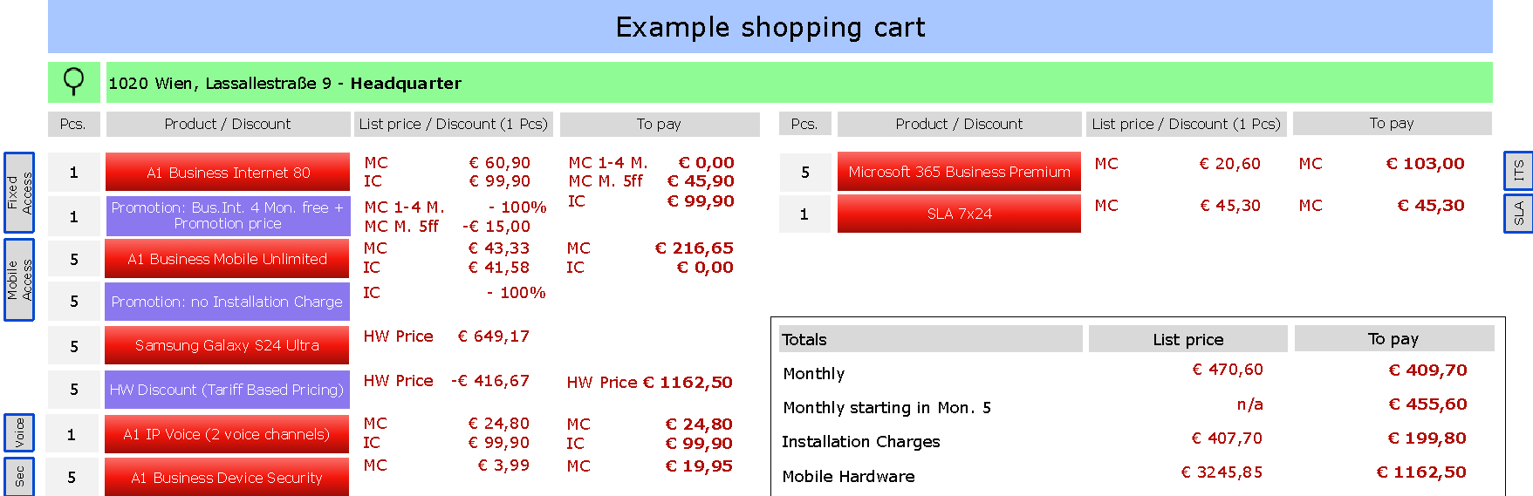

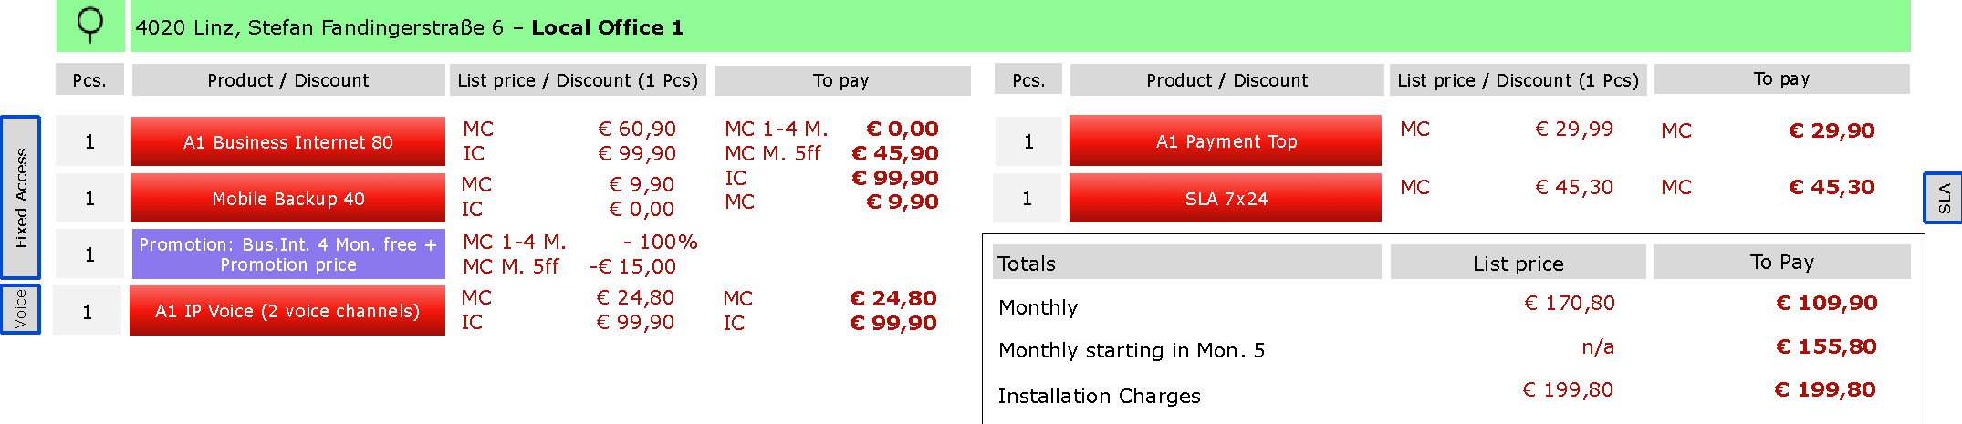

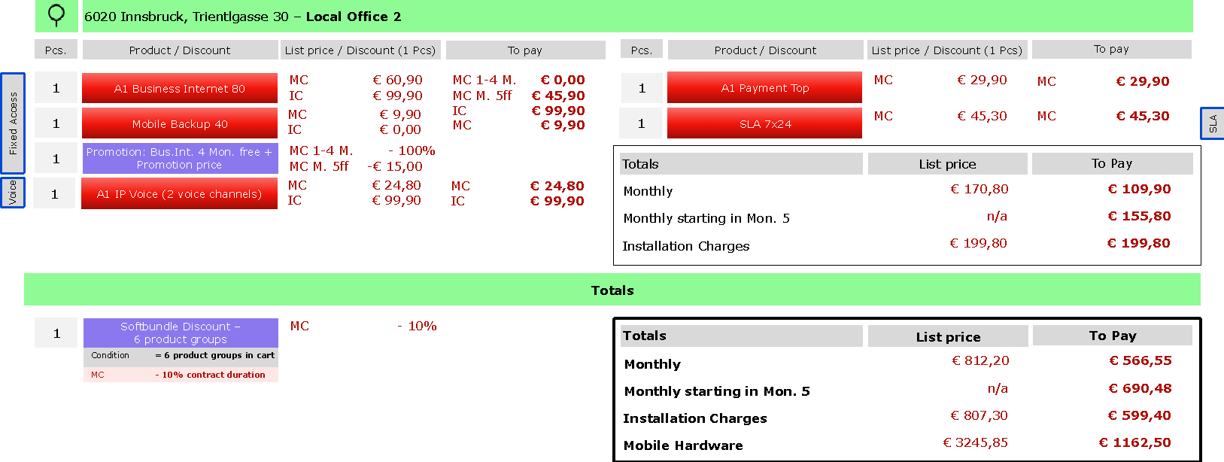

This illustration shows that several discounts are applied to the items in the shopping cart. There are promotions that reduce the monthly charges and/or installation charges. There is also a discount that reduces the HW price based on the selected mobile tariff (A1 Business Mobile Unlimited) in the cart. In addition, another 10% discount is in the cart that is given because products of 6 product groups (Fixed Access, Mobile Access, Voice, Sec(urity), ITS and SLA) are present in the cart.

The list prices and “to pay” prices illustrate who the shopping cart is supposed to behave on a functional level.

**Save and Edit Cart**

The system must allow customers to temporarily save their shopping cart and complete the order at a later time. Additionally, a function should be available for customers to reorder a previously saved cart, with the flexibility to adjust both the product list and location details as necessary.

The duration for which the cart will be stored must be clearly defined, and customers should be notified of any price or product changes when returning to the saved cart. The shopping cart should be intuitive and user-friendly, with easy navigation. Each product in the cart should display essential details, such as the name, image, price, quantity, and total price. Customers should be able to adjust product quantities, remove items, and see a dynamically updated total price. Shipping costs, taxes, and other fees must be clearly displayed. Additionally, the cart should show selected production dates, the validity of the cart, and support both guest and registered users. Cross-selling and upselling features should be implemented to encourage additional purchases, and the cart should be shareable. The transition from cart to checkout must be seamless, and the cart should be compatible across different devices and browsers. The system should also display available payment options, allow the use of vouchers or discounts, track abandoned carts, and support account synchronization across devices.

Key considerations include:

* **Historical Versions**: Allow customers to save and access historical versions of the shopping cart for reference or modifications.
* **Automatic Saving**: Automatically save the shopping cart periodically to prevent data loss and allow for seamless resumption.
* **Custom Naming**: Allow customers to assign custom names to shopping carts for easy identification and management.

**Add-On Recommendations**

The system should provide customers with additional relevant offers or add-ons before completing the shopping cart to boost sales. Only feasible add-ons should be displayed to customers, eliminating the need for additional feasibility checks. These add-ons should be tailored to the customer’s existing cart to enhance relevance and increase potential sales.

**Feasibility Checks on Cart Changes**

The system should automatically check the feasibility of the shopping cart after any changes, such as quantity updates, adding new products, modifying configurations, or removing items. This ensures that the cart is always ready for order placement. Customers or internal users are informed about the technical viability of their orders in the shopping point at the latest. If certain products or services cannot be delivered as requested, alternative solutions or products should be presented and available to replace the previously selected item, along with details of any additional requirements or costs. This process involves checking the availability of infrastructure and resources, and where needed, suggesting mobile alternatives or additional services to meet customer needs.

**Offer Validity Management**

The system must clearly display the validity period of offers to customers to ensure orders are placed within the designated timeframe.

Key features include:

* **Automatic Expiry Management**: Offers should either be blocked upon expiry or updated with current pricing to prevent outdated transactions.
* **Rules and Logic**: Define rules for handling expired or unavailable products within valid offers. Examples include replacement with equivalent services if functionalities are unaffected.
* **Loopback Workflow**: Notify customers if offers are no longer valid and allow them to update or recreate the offer.

**Generate Offer Documents**

Customers should be able to generate, save, and share offer documents in a standardized format. Key features include:

* **Downloadable PDFs**: Customers can download a comprehensive offer document, including all contract components.
* **Email Delivery**: Offers can be sent to customers via email for convenience and record-keeping.
* **Product and Contract Coverage**: The document must cover all product categories (e.g., mobile, fixed network, ICT) and contractual elements.
* **Modular Design**: Optimize document readability by using linked parts for modularity and shorter length.

**Location-Based Order Summary**

The system must allow customers to see a list of all products ordered by location, ensuring that orders across multiple locations are recorded correctly. This breakdown of products by location helps track orders efficiently and ensures all products are accounted for by their respective delivery locations.

**Repeat Previous Orders**

Customers should be able to repeat a previous order with ease, making it simple to equip another company location with the same solution. The system should allow customers to quickly reorder a saved cart and make modifications to the product list and location data. This functionality helps customers efficiently manage their repeat orders without starting from scratch each time.

# Omnichannel Sales Portal

## Overall Description

The platform supports internal departments and external partners through a unified interface, emphasizing seamless collaboration and efficient customer engagement across all phases.

Ein Bild, das Text, Screenshot, Schrift, Design enthält.

## Components of the Platform

The **SME Engagement Platform** integrates several components to streamline business processes across selling, ordering, fulfillment, and service. It begins with **Lead Generation**, which focuses on managing leads and running campaigns to identify and engage potential customers. Additionally, it supports **partner onboarding** for sales, service, and solution partners, fostering seamless collaboration.

The platform includes an **Omnichannel Sales Frontend**, which offers both unassisted and assisted sales channels. The unassisted channel empowers customers with self-service tools for independent interactions, while the assisted channel provides sales representatives with tools for personalized customer engagement and collaboration with service partners.

To ensure transparency, the **Track & Trace of Case** feature allows customers and partners to monitor the status of their orders or cases in real time. Complementing this, the **Ordering & Fulfillment Systems** manage the creation and execution of orders, ensuring a smooth integration between internal teams and external partners during the fulfillment process.

The platform also features **Customer Lifecycle Management & Reporting**, which tracks customer interactions across their lifecycle and generates insightful reports for both internal departments and external stakeholders. Finally, the **Partner Commissioning & Admin Frontend** enables partners to efficiently handle their commissions, administrative tasks, and reporting needs, enhancing collaboration and operational efficiency. Together, these components create a unified, efficient, and customer-focused experience.

The platform is underpinned by a robust **Data Layer**, which includes the **Product Catalog**, housing detailed information about products and services available for sale, and **Customer Data & Inventory**, which ensures that all interactions and transactions are supported by accurate and up-to-date data.

Its **Key Capabilities** cover every aspect of the customer journey. The **Pre-Selling** stage manages lead generation, campaign workflows, and customer engagement content. During the **Selling** stage, the platform provides tools for eligibility checks, product catalog navigation, shopping cart management, contract handling, and customer interaction history. The **Ordering & Fulfillment** stage streamlines order creation, service orchestration, resource allocation, and case management. Finally, the **Service & Incident** management capability handles partner commissions, customer case resolution, loyalty programs, and sales reporting.

The platform also features **Customer Lifecycle Management & Reporting**, which tracks customer interactions throughout their lifecycle and generates insightful reports for both internal departments and external stakeholders. Additionally, the **Partner Commissioning & Admin Frontend** enables partners to efficiently manage their commissions, administrative tasks, and reporting needs, enhancing collaboration and operational efficiency. Together, these components create a unified, efficient, and customer-focused experience backed by data-driven processes.

## End-to-End Salesflow on the Omnichannel Plattform

**LEAD TO ORDER PHASE**

The Lead to Order Phase in the sales flow is designed to effectively guide potential customers from initial interest to a finalized offer.

Key Features and Tools in the Lead to Order Phase:

* Omnichannel Support:
  + Customers can interact across platforms, whether online, in-store, or via direct sales representatives.
  + Shared tools ensure consistency across channels.
* Automation & Personalization:
  + Automated systems for NBA and next-best-offer (NBO) recommendations optimize customer proposals.
  + AI and historical data assist in tailoring configurations and recommendations.
* Touchpoints:
  + Direct sales, point-of-sale systems, service centers, and self-service options ensure a broad reach.
  + Communication via email alerts, live chats, or follow-up calls keeps the customer informed.



**1.1 Inform & Consult:** This stage focuses on identifying and nurturing customer needs through both digital and human touchpoints.

* Information Preparation:
  + Provide accessible product/service details on an omnichannel platform
  + Utilize customer data like click profiles, past interactions, or campaign responses to personalize experiences.
* Lead Management:
  + Leads are created either automatically (via platform interactions) or manually (via sales personnel).
  + Validation ensures that leads are properly segmented and matched with customer-specific needs.
* Customer Engagement:
  + Customers can self-navigate the platform or request assistance through:
    - Guided tools like decision trees or chatbots.
    - Contacting sales representatives for in-depth discussions.
  + Interaction options include:
    - Scheduling consultations.
    - Receiving personalized product recommendations based on cookies, previous activities, or next-best-action (NBA) analytics.

**1.2. Present & Configure**: After identifying customer needs, offers are tailored and formalized.

* Opportunity Qualification:
  + Leads that demonstrate potential are converted into opportunities.
  + The qualification process involves understanding the customer's specific use case, budget, and preferences.
* Offer Design & Configuration: Use tools to configure products/services dynamically, considering:
  + Bundling options for cost efficiency.
  + Eligibility rules and pricing structures.
  + Customer-specific configurations, such as tailoring features for small to large enterprises.
* Commercial Feasibility:
  + Credit checks, payment ability verification, and contract reviews are conducted.
  + Customers not passing initial checks may trigger alternative options, such as deposits or modified payment plans.
* Technical Feasibility:
  + Ensures the requested services or products can be delivered at the customer’s location. Includes:
    - Infrastructure checks for network availability (e.g., fiber optic vs. mobile).
    - Inventory matching for hardware components.
    - Compatibility with existing customer systems.

**1.3. Confirm & Sign**: After the order is configured, it is finalized.

* Offer Finalization (Closing): Present the customer with a comprehensive offer including:
  + Offer configuration
  + Exact pricing
  + Terms and service level agreements (SLAs)
* Order Review:
  + Customers are notified of order details, including expected timelines, pricing, and additional requirements.
  + If adjustments are needed, the process loops back for corrections.
* Customer Communication: Notifications via email, SMS, or the omnichannel platform keep customers updated. Touchpoints include:
  + Estimated delivery or installation dates.
  + Next steps in the process (e.g., site surveys for installations).

**ORDER TO CASH PHASE**

The Order to Cash Phase is the bridge between the Selling Phase and the Fulfillment Phase. It involves verifying and processing the customer’s selected products or services, ensuring all elements are ready for implementation.

Key Tools and Features in the Order to Cash Phase:

* Omnichannel Order Management: Ensures consistency across all omnichannel sales and seamless order tracking.
* Automated Quality Gates: Identify errors or missing data before the order progresses.
* Real-Time Feasibility Systems: Instantly flag and address challenges related to infrastructure, inventory, or customer eligibility.
* Customer-Facing Interfaces: Allow customers to track their order status and make adjustments as needed.



**2.1 Clean & enrich order**: This step is focused on translating the customer’s selections into actionable orders.

* Order Initiation:
  + Orders are created based on the finalized offer from the Selling Phase.
  + This includes transferring customer-selected configurations, bundles, and agreed-upon terms into an order management system.
* Order Completion: Ensure all necessary details are included, such as:
  + Product specifications.
  + Customer information (contact, billing, delivery address).
  + Any additional requirements, like installation or special service needs.
  + Missing data is flagged for resolution to avoid delays downstream.
* Validation:
  + Orders are checked for accuracy and completeness using Clean Order Checks.
  + Automations review orders to confirm compatibility with inventory and pricing policies.

**2.2 Process Order:** Orders are broken down into manageable parts, tailored to the fulfillment process.

* Segmentation: Each order is divided into serviceable components based on:
  + Product type (e.g., hardware vs. software services).
  + Geographical constraints (e.g., location-specific installations).
  + Customer segment (e.g., small business vs. large enterprise).
* Orchestration Assignment: Components are assigned to appropriate teams or systems, such as:
  + Technical provisioning teams.
  + Third-party providers for modular or ecosystem services
* Handoff to technical fulfillment: Orders are marked as ready for delivery and activation for the customer



**Key Tools and Features for fulfillment and activation**: Automated provisioning tools, dynamic order updates, and omnichannel communication ensure accuracy and transparency throughout the process.

**2.3 Technical Fulfillment**

* Availability Checks: Confirm the readiness of network and service components via automated tools.
* Planning & Provisioning: Schedule installations, configure service elements, and run pre-deployment tests.

**2.4 Installation and implementation**

* Installation: Perform on-site or remote installations, addressing infrastructure needs (e.g., equipment setup, network configurations).
* Adjustments: Update orders dynamically to handle unexpected issues or customer requests.

**2.5 Finalize case**

* Verification: Test and confirm service functionality.
* Documentation: Record work performed and finalize configurations.
* Support: Provide ongoing assistance and complete backend tasks like billing updates.

## Customer journey represented on the Omnichannel Platform

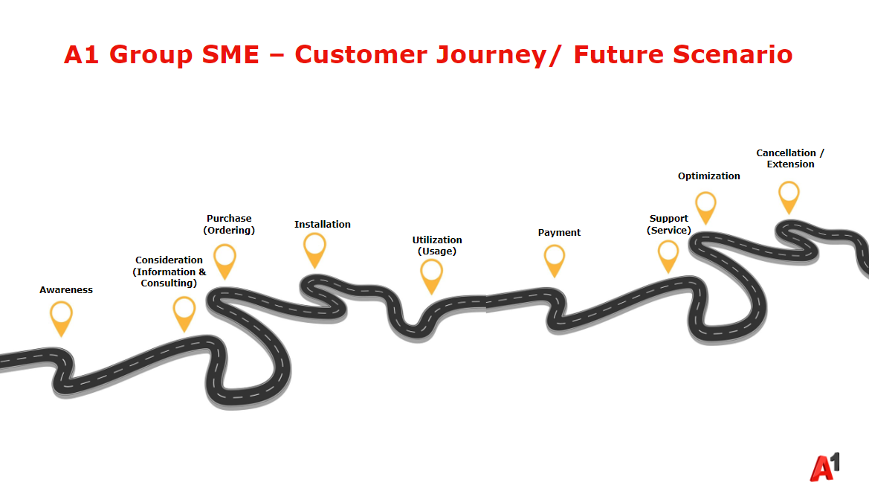

Customers can **view their business case-related data** and change it via an interface on the platform. Customers and A1 internal employees, as well as partners, can also use the platform to **view the communication history**.

The platform should be able to integrate and synchronize customer interactions across different sales channels. This means that customers can switch seamlessly between the touchpoints involved in the sales-to-activation process without losing continuity or context. This requires continuous buffering of the order processing status so that there can be a handover from the customer to A1 and vice versa, as well as the handover within A1 or from A1 to the partner.

The platform should enable customers to log in to all channels with a single login and access personalized services. A comprehensive **360-degree view of the customer and their business cases** should be provided for both the customer and A1 by tracking and consolidating all interactions, transactions and communications across channels. All this data that is stored in the Sales CRM must be viewable on the Omnichannel Platform. This enables sales teams to make better-informed decisions and provide personalized support.

The omnichannel platform should make it possible to administrate customer data securely and comply with the applicable data protection regulations and guidelines. Careful management of customer consent to data use must be ensured.

The platform is to be used as a self-service platform by customers themselves as well as internal and external sales TPs. The platform should make it possible to **switch seamlessly between self-service options and personal customer support**. Customers should be able to carry out simple orders independently, but also be able to quickly access human support when more complex queries arise.

## Use Case: Unified Sales frontend

This comprehensive system ensures a seamless and integrated ordering experience across all touchpoints, whether through direct sales representatives and partners or through self-service e-commerce channels for customers.

**Key Considerations**:

* **Consistent Interface Across Channels**: Implementing a universal front end with a familiar interface across all touchpoints (online, in-store, partner portals, app etc.) allows for smoother transitions, improved efficiency, and higher customer satisfaction.
* **Unified Customer Journey**: The self-service portal integrates with eCommerce, providing a cohesive journey whether the customer is interacting online, in-store, or via another channel. This reduces friction and enhances the user experience.
* **Channel-Spanning Product Portfolio**: The platform should support the entire SME product portfolio, consisting of fixed line, mobile and ICT portfolio, ensuring that users have consistent access and a uniform experience.
* **Differentiated Offering Display**: By implementing business rules to segment offerings and pricing across touchpoints, the system can display tailored product options and pricing by customer segment, product category, or channel.
* **Collaborative Shopping Cart**: A synchronized cart that customers and sales representatives can both access and modify (either sequentially or in parallel) enables fluid, ongoing support across channels. For example, a sales agent can assist a customer who began their order online but needs guidance.
* **Unified Communication Channels**: A transparent view of the case related communication needs to be accessible and editable on the platform. Furthermore, integrating live chat, video calls, or in-store assistance with the shopping platform allows for real-time support that spans the digital and physical sales environments. More on this follows in chapter 6 Sales CRM / Funnel Management
* **Cross-Channel Sales Continuity**: The ability for different sales roles (e.g., shop emplyoees, sales agent, presales) to access, adjust, and return orders to customers ensures that assistance is readily available at any stage, minimizing frustration and improving conversion rates.
* **Role-Based Access Controls**: The omnichannel platform should support role-based views that adjust permissions and data displays to match each role's needs while maintaining a visually consistent interface. This allows employees to work efficiently without retraining when they transition roles.
* **Customizable User Interfaces**: While the platform’s design should be universally recognizable, customization options based on user roles can help deliver information and functionality that align with the specific tasks and objectives of each position (e.g., sales performance metrics for sales agents, inventory for POS associates).

## Use Case: Digital Proposal / Offer creation and acceptance

To simplify the evaluation and approval of offers and reduce manual intervention, the system must provide an automated process for evaluating/approving offers, enabling the efficient release of discounted offers up to defined limits. As part of this process, A1 internal users should be able to define rules for automated releases, allowing offers to be sent to customers without delay as long as they fall within pre-established discount limits. In cases where an automated release is not feasible, A1 users should be able to specify rules for when manual checks are required.

Once a shopping cart with all the necessary configurations has been created on the Sales Plattform the sales representative can create a porposal/offer out of it and send it to the customer for acceptance. This proposal is saved in the CRM and linked to the customer's account.

## Use Case: Display of customer and business transaction data from the Sales CRM (quotes / orders / contracts)

The Sales frontend enables the holistic view and possibilities of administration of customer data such as interaction, personal, contract data, financial data as well as sales and delivery data entities such as existing contracts, proposals (=quotes), orders, leads, opportunities, billing information ongoing and completed orders.

**Additional Integration Points with other Interfaces for a 360° Customer View:**

* **Real-Time Data Synchronization**: The 360° view relies on accurate, up-to-date data from all relevant systems. Real-time synchronization with CRM, ERP, and marketing systems ensures that customer records, contracts, and orders reflect the latest information.
* **Data Privacy Compliance**: Given the sensitive nature of customer and contract data, ensure strict compliance with GDPR and other data privacy regulations. Implement access controls, encryption, and audit logs to secure customer and partner information.
* **Customizable Dashboards**: The 360° view should be adaptable based on user roles, providing each user (customer, sales rep, partner) with the data they need without exposing unnecessary information.
* **Intelligent Analytics for Insights**: A 360° view with analytics capabilities can offer insights into customer behavior, purchasing patterns, and engagement, helping sales teams anticipate customer needs and refine service offerings.

**Key Considerations:**

* **Data Consistency Across Touchpoints**: With shared access to the same up-to-date information across all channels, internal users can engage customers more effectively, reducing miscommunication and improving the accuracy of sales support.
* **Data Synchronization**: Real-time data sharing across all channels ensures that all users — regardless of entry point — have access to the latest product, inventory, and pricing information, reducing errors and improving sales outcomes. Integrate CRM and KUMS systems with the sales platform to allow real-time data transfer. This automation reduces manual entry, minimizes errors, and ensures consistency throughout the sales-to-activation (S2A) process.
* **Editable Customer Data**: While data should be pre-filled for efficiency, customers must have the flexibility to edit details, allowing for last-minute changes (e.g. contact data, location (=address data), billing details) as needed.
* **Secure Data Transfer**: Customer information, especially sensitive data, must be protected during pre-filling and transfer stages with encryption and authentication protocols to ensure compliance with data security standards.

## Guided Sales journey

The platform should provide a personalized and user-friendly shopping experience by utilizing customer data for tailored recommendations. Depending on the case that is relevant to the customer, use case based guided journeys and workflows shall be automatically adapted, e.g. if the case concerns a product replacement or upgrade, an inventory check needs to be involved in the guided sales journey.

# Sales CRM / Funnel Management

## Overall Description

The **Sales CRM** capability focuses on closing deals and managing sales pipelines by tracking leads, opportunities, and customer interactions up until finalization of the order end to end. Its typical outputs include revenue generation, closed deals, and accurate sales forecasts. **Marketing CRM** handles campaign execution and lead nurturing through targeted marketing efforts like email campaigns and automated customer journeys. It delivers outputs such as leads generated, campaign ROI, and engagement metrics. **Service CRM** ensures customer support and satisfaction by managing service requests, troubleshooting issues, and offering omnichannel support. Its key performance indicators include resolved cases and customer satisfaction scores. By integrating these CRMs, a unified view of customer data is provided, enabling personalized experiences, enhanced customer loyalty and growth.

**Unified End-to-End Customer View**

The CRM system must enable a consistent end-to-end (E2E) view of all customers by integrating all involved systems and touchpoints. This includes:

* Products already used by a customer.
* Details of ongoing orders.
* History of past interactions.

This ensures that all departments involved in the Sales-to-Activation (S2A) process access the same consistent information.

**Workflow and Automation Features**

To enhance efficiency, the CRM system must provide workflows and automations, such as:

* Automated notifications for changes in opportunity status.
* Optimization of sales processes through analytics and AI-driven predictions (e.g., probability of deal closure).

**Sales Performance Optimization**

The CRM system offers tools for analyzing and optimizing the sales process, including:

* Sales forecasts based on real-time data.
* Performance reports for individual sales representatives or teams.
* Insights into how actions impact close rates and productivity.

**Transparency and Collaboration**

Opportunity management must foster collaboration between teams and departments. This is achieved through:

* Clear documentation of activities at each sales stage.
* Real-time communication and task tracking within the system.
* Involving all relevant stakeholders to ensure that no information is lost.

**Integration Points with other Interfaces**

The CRM system must integrate seamlessly with other tools and platforms to ensure efficient data flow and usability across the entire sales ecosystem. Key interfaces include:

* **Marketing Automation Tools**: Integration with A1.net and campaigning tools e.g. Bloomreach to track lead generation, manage campaigns, and nurture leads.
* **Customer Service Systems**: Connection to helpdesk tool ServiceNow to ensure that customer service data is linked to sales activities.
* **ERP Systems**: Integration with enterprise resource planning systems like BS Notes, SAP, Business Web, or Microsoft Dynamics to align sales data with inventory, billing, and order management processes.
* **Website and Communication Platforms**: Compatibility with tools such as Microsoft Teams to facilitate communication and collaboration within sales teams.
* **Analytics and Reporting Tools**: Integration with analytics tools such as Tableau or Power BI to create detailed performance dashboards and forecasts.

## Use Case: Data Entity Management

Regarding Customer Data Management we focus on Data that is needed to support the Sales & Fulfillment processes, but also built the base for subsequent Service processes during the usage phase of the customer.

The following Data entities need to be processed in the Sales CRM:

| **Customer Master Data** | * **Name** (Last Name, First Name, Title), Gender, Date of Birth * **Registration Data** (Address, Multiple Addresses) * **Company Data** (Company Name, Company Registration Number, Association Registration Number) * **Customer Number** * **Relationship with A1**: Customer / Strategic Partner / Supplier / Reseller / ISPA / ANB / ... * **Customer Role(s)**: User / Contract Owner / Contact Person by Topic / Invoice Recipient / Community Roles / ... * **Associations**: (Family View, Member, Households, Corporate Organizational Structure, ...) * **Loyalty Information**: (A1TA Points Balance in the Bonus Point System) * **Status Information**: (Insolvent, Deceased, ...) |
| --- | --- |
| **Segmentation Information** | * **Customer Segment / Sales Segment** * **Key Account Manager / Service Advisor** * **Customer Value / Customer Scoring** (including VIP) * **Churn Factor** |
| **Authorization Information** | * **Customer / Personal Password** * **Account Data & Passwords** |
| **User Settings** | * **Configurations per Product** ( e.g. Voicemail Setting) * **Notification Settings & Flags** for e.g. preferred contact channel |
| **Customer Inventory** | * **Contract Inventory**: Framework Agreements, Contract (Contract No., contract owner, contract details, contract duration, discounts, etc.), locations * **Product Inventory:** Existing products and services, options, tariffs, add-ons, duration / commitment, prices, restrictions, licenses * **Equipment Inventory:** Hardware (mobile device, router, payment terminal, etc.) * **Technical Inventory:** Connection information ( technical service and resource specifications e.g. connection ID, type of connection, routing, bandwith, phone numbers, network numbers etc. |
| **Billing information** | * **Outstanding balances** * **Due amounts** * **Invoices** (Invoice no., invoice amounts, etc.) * **Bank accounts & payment methods, Billing agreements** * **Collection status** (incl. blocks / restrictions) * **Vouchers** (Voucher codes, promotion codes) |
| **Track & Trace** | * **Objects:**   + Open (or recently closed) Orders / Contract Documents, Orders (open until fully processed, post-production / acceptance)   + Saved / Abandoned Shopping Carts or Offers   + Ongoing (or recently completed) Opportunities   + Ongoing (or recently completed) Requests / Complaints / Incidents (=Service Cases)   + Ongoing (or recently completed) Leads   + Pending (or recently completed) Terminations   + SLA Information * **Interactions:**    + Customer Interactions (Marketing, Sales or Service) related to ongoing business cases   + Contact Data and communication content |
| **Selling Potentials** | * **Individual Offers** * **Display of CVM Offers** (Next Best Offer, NBO, etc.) * **Display of available Products/Additional** Options (Up-Selling Potential – e.g. second set-top box available) * **Discontinued or abandoned Shopping Carts** * **Expressed Interests** (Lead, Opportunity) * **Click Profiles from Online Portals / eShop / App / etc.** * **Notifications about expiring contract terms** |

| **Historical Data** | * **Contact/Business Case History** (incl. Correspondence and Reports) * **Subscription / Product History** * **Offer & Contract History** * **Campaign History** * **Lead / Opportunity History** * **Order / Transaction History** * **Billing History** * **Loyalty History** * **SLA / Performance History** * **Incident (Disruption) History** * **Complaint History** * **Financial History** (e.g. Payment Behavior) |
| --- | --- |
| **Usage Profiles** | * **Marketing Profile of the customer** (heavy phone user, data only user, etc.) * **Usage behaviour & statistics** (Internet and Telephony Usage, Zone Behaviour, Call Duration Trends) * **Infrastructure Performance Information & Statistics** (Utilization Levels, SLA Levels / Violations, Outages incl. Mass Disruptions, Network Failures, etc.) |
| **Financial Metrics** | * **Revenues** (Total / per SIM / per Location / per Product Group / etc.) * **ARPU, ARPB, ARPE, …** * **Contribution Margins** * **KPI Development** (Time Period x) * **Account Plan** (Revenue Goals, etc.) * **Creditor / Debtor View** (e.g., Siemens as A1 Supplier / A1 Customer) |
| **Administrative Information** | * **Customer Data Quality Notes** (Incorrect, questionable, or missing customer data) * **News Flash** (Important Information) **for the Agent** * **To-Do Tasks** |
| **External Data** | * **Commercial registry data** * **Non-A1 customer infrastructure** |

| **Signed Proposal** | * **Basic Information** (Number, Creation Date, Name, Type) * **Relationships** (Products, Participants, Processing Steps, Location, User, Customer, Offer, Order Items, Reserved Resources, Service Order) * **Production Steps** (Status, Start Date, Type, Detailed Information for Path Establishment (Schaltwegsherstellung), Provisioning, Hardware Delivery, Production Date, …) * **Order Items** (Reference to Products, Actions e.g. New provide, replacement, etc.) * **Order-Related Discounts** * **Product-Independent Cost Blocks** * **Billing Information** (Payment Method, Payment Frequency, Invoice Medium -> Integration with Billing System) |
| --- | --- |
| **Product Offering** | * **Offer Information** (Validity Period, Campaign Name, Pricing Information incl. loyalty discounts, Version, Commercial Owner, Technical Owner, Cluster) * **Specifications** (Version, Name, SID_ID, Brand, Attributes (Fixed Values, Value Range, Complex, Unit of Measure), Relationship to Services, Compatibility Features, …) * **Product Relationships** (Bundle Offering, Offering, Compatibility, Customer Contract, Subscriber) * **Qualification Features** (Customer Segment, Contract Duration, Sales Channels, Technologies, Scoring / Creditworthiness, Allowance, Geographical, Temporal Restrictions) * **Change / Replacement Matrix** * **Terms and Conditions** (Transferability Rules, Cancellation Period, …) * **Grace Period** * **Characteristics** (Bandwidth, QoS, Connection Type, etc.) * **Equipment Specification** (Material Number, Model Name, etc.) * **SLA Parameters** (Service Time, Incident Reporting, Response Time, Resolution Time, Appointment Window, IMAC, Installation, Type) * **Operational Information** * **Payment Information** (Recurring, One-Time, e.g., Setup Fee, Charge) * **Discounts** (Discount Rules, Discounts on Various Product Description Levels, Qualification Features) |
| **Offer / Contract** | * **Basic Information** (Number, Name, Creation Date, Version, Archive Storage, Validity Period) * **Relationships** (Customer, Contact Person, Contract, Products/Product Catalog, Sales Business Case (Opportunity/Lead)) * **Product-Independent Cost Blocks** (Additional Costs, Internal Costs) * **Approval Information** * **Offer Calculation** (Aggregation of Product Relationships, Product-Independent Cost Blocks, Discounts, Version, Contribution Margin) * **Offer Acceptance Information** (Approval, Proof of Authorization) |

## Funnel Management

### Lead Management

Effective lead and contact management form the foundation of efficient sales operations. The CRM system shall serve as a central platform to consolidate leads from various sources, manage them efficiently, and integrate them into the sales process.

**Centralized Lead Collection**

The CRM must be able to centralize leads from a variety of sources, including:

* Marketing campaigns (e.g., online advertising, social media).
* Service touchpoints (e.g., customer service inquiries).
* Partner channels.

This centralized management ensures that no leads are lost and that they are efficiently directed to the appropriate sales channel.

**Automated Lead Assignment**

The system should assign leads to the appropriate sales representatives or teams based on predefined criteria such as:

* Geographic region.
* Workload of the sales representative.
* Competencies or expertise (e.g., technical knowledge).

Smart distribution ensures that leads are handled by the right contact points without delays.

**Lead-to-Opportunity Conversion**

Leads should seamlessly convert into opportunities, supported by automated processes. The system automatically distributes opportunities to the correct touchpoints (e.g., sales, partners, service centers) to accelerate the sales process.

**Standardized Pipeline for New and Existing Customers**

The system must provide a standardized pipeline for processing leads, regardless of whether they pertain to new or existing customers. This ensures that all leads undergo the same quality-assured process, including lead commissioning and follow-up tracking.

**Improved Communication and Follow-ups**

The CRM should actively support sales representatives in communicating with leads by:

* Providing automated reminders for follow-ups.
* Offering a unified communication history for each lead and contact.
* Informing sales representatives of the next required actions to optimize the process.

**Integrated Customer Data Management Approach**

All relevant information, such as contact details, proposals, and customer interaction history, must be centrally stored and easily accessible in the CRM. This creates a consistent 360° customer view for the entire sales team.

### Opportunity Management

Opportunity management ensures a structured and transparent handling of sales opportunities, tracking each opportunity from its starting point (Idea or Lead Generating) to case closure (until the order has been installed and the billing starts) ideally by an E2E ID. A lead is qualified to be converted into an opportunity once the following information can be provided:

* Storage of all relevant information, such as name, position, email, phone number, and company details.
* Documentation of all interactions, including calls, emails, and meetings.
* Capability to link leads to opportunities and existing contracts.

**Centralized Opportunity Management**

The system must manage all opportunities in a standardized pipeline, providing clear visibility into the progress of each sales opportunity. This includes development stages of the opportunity in the pipeline.

#### Opportunity Development Stages

**Idea Generating**

In the "Idea Generating" stage of Opportunity Management, we can lay the groundwork for successful sales by focusing on key activities such as account planning, identifying potential opportunities, and crafting a compelling story tailored to customer needs. This involves researching potential customer challenges through web and social media searches. The expected outcomes include identifying the ideal contact person, scheduling an initial meeting, and clearly defining the potential value for the customer. Additionally, preparing a roadmap for next steps and considering the right team members ensures readiness for further development if feedback is positive.

**Validating**

In the "Validating" stage of Opportunity Management, the focus is on confirming the relevance of the sales idea through direct conversations with key decision-makers. This involves presenting the idea, securing initial approval, and identifying the buying center within the target organization. Defining the opportunity team ensures that the right people are involved moving forward. Successful validation results in the decision-maker acknowledging the idea's value, discussing the next steps, and scheduling a follow-up meeting. Additionally, key discussion points are documented, and adjustments to the idea are made if needed.

**Qualifying**

In the "Qualifying" stage of Opportunity Management, we work closely with potential customers to analyze their needs, clarify project feasibility, and inspire interest. Key tasks include confirming the buying center, discussing potential risks, defining decision-making criteria, and aligning sales team resources. For smaller businesses this stage shall be mostly automized via the platform. A successful outcome includes a jointly developed roadmap, clearly defined deliverables, and a confirmed project start. Responsibilities are assigned, a timeline is documented and shared, and a price estimate is provided. By this stage, customer risks are understood, and the buying criteria are clearly identified, ensuring readiness for the next sales phase.

**Concepting & Offering**

In the "Concepting & Offering" stage of Opportunity Management, the focus is on designing the optimal customer solution and presenting it effectively to the buying center. This includes creating a tailored concept, conducting internal cost calculations, and demonstrating the return on investment (ROI) to establish clear value for the customer. Key outcomes include addressing all customer questions. On top of that for medium to larger businesses a final negotiation meeting with an agreed agenda is scheduled, and a solid negotiation strategy has to be prepared. A well-crafted, inspiring presentation is prepared. Additionally, key discussion points and next steps are documented and shared via email, keeping all stakeholders aligned and ready for the negotiation phase.

**Closing**

In the "Closing" stage of Opportunity Management, the focus is on delivering an inspiring presentation of the final offer, highlighting Proof of Value (POV) and ROI to create a lasting impression on the buying center. This can be presented online for small business or in person for medium to larger business. This phase may involve final negotiations and applying a reciprocal approach to build mutual trust. Introducing the project team ensures readiness for implementation. Successful closure results in an agreement from the customer, followed by contract signing. For larger cases both the customer’s and the company’s project teams are clearly identified, and a project timeline is established. Key discussion points and the final decision are documented and shared via email for clarity and alignment. For smaller businesses the case runs through the process without a dedicated project team.

**Implementing**

In the "Implementing" stage of Opportunity Management, the focus is on ensuring that customer requirements and purchasing criteria are fully met. This includes - especially or larger customers - an escalation matrix and service concept to address potential issues proactively. Exploring and proposing up- and cross-selling opportunities helps identify additional business potential. Successful implementation outcomes include the creation of new opportunities, pricing and executing change requests, and making necessary adjustments to maintain smooth project progress and customer satisfaction.

### Order Tracking

The system must allow customers and sales touchpoints to monitor the progress of orders from order finalization to fulfillment. Key functionalities include real-time status updates, such as order confirmation, processing, shipping, and delivery notifications. Additionally, the system should support automated communication, like email or SMS alerts, to keep customers informed of any delays or changes. Dashboards for sales touchpoints should provide an overview of order statuses, enabling proactive intervention in case of issues. Advanced features like AI-driven predictive insights can forecast delivery times based on historical data. These information needs to be accessible on the omnichannel platform to empower the customer to check order details, manage returns, or request support.

## Use Case: Communication Hub

Seamless email and calendar integration into the CRM system is essential to streamline communication with customers and maintain a clear overview of upcoming tasks and meetings. This helps eliminate duplicate work, optimizes workflows, and creates a unified platform for all activities.

**Email Integration**

The CRM system must be compatible with popular email services such as Microsoft Outlook, Gmail, and other IMAP/SMTP-enabled platforms. Key features include:

* **Centralized email management**: Sales representatives should be able to send, receive, and archive emails directly within the CRM without switching between applications.
* **Automatic email-linking**: Emails should automatically be linked to the corresponding customer, lead, or opportunity based on email addresses and contextual information.
* **Templates and personalization**: Sales representatives should have access to predefined email templates for commonly used communications, such as proposals, follow-ups, or welcome messages. Templates should be customizable to include personal touches and meet specific customer needs.
* **Automated follow-ups**: The system should trigger automatic follow-up emails based on predefined conditions, such as no response within three days.

**Calendar Integration**

Calendar integration helps sales representatives efficiently plan appointments and keep track of meetings, deadlines, and follow-ups:

* **Real-time synchronization**: The CRM system must seamlessly synchronize with calendar applications like Google Calendar, Microsoft Outlook Calendar, and other ICS-compatible platforms. Changes in one application should automatically update the other.
* **Meeting scheduling**: Users should be able to schedule meetings directly in the CRM, with the calendar automatically considering participant availability. Invitations with all relevant details should be generated and sent to attendees.
* **Reminders and notifications**: The CRM must send automated reminders for important meetings, follow-ups, and deadlines, both within the platform and via push notifications on mobile devices.
* **Integration with sales stages**: Calendar entries should be directly linked to opportunities or leads, ensuring that critical milestones and tasks are integrated into the sales process.

## Customer Interaction Management

Objective of the **Communication Hub** is to ensure process that all relevant information within the sales is centrally documented in the CRM and displayed via the omnichannel sales portal. This is true for customers, A1 internal departments and external partners involved in the sales to activation process.

Contact information about the current case is displayed in one place within the Sales CRM system.

Multilingualism is required (A1 group footprint + English).

**Interactions**

* Including main interactions from different channels with a customer in a 360 view
* Starting with information collection from different internal and external sources (based in A1 social media feeds, sales & service touchpoints, back office)
* Including the whole end-to-end journey, from marketing / sales lead to sales process, to ordering and fulfillment as well as service requests

**Process consists of**

* Fully automated messages out of the CRM system
* Manually created artefacts, like eMail messages by back-office employees

**This concerns the following communication Channels / Media**

* Omnichannel Sales Portal
* Integrated eMail option (Outlook) for all activities
* Rich Communications Services messaging
* App
* Messages: SMS, WhatsApp
* Chat
* Chatbot
* Remote hands
* eMail integration of self-service templates and GUIs

**Digital communication includes**

* Interactions around sales activities, from lead, opportunity management, offer management, shopping carts and order acceptance
* Required customer data and actions (obligation to cooperate)
* Order tracking and next steps (track & trace)
* Changes regarding the order / activation from A1 and from customer side
* Case acceptance and closing the case from customer side
* A standardized and automated welcome journey

**Touchpoints**

* Direct Sales: Account Manager, Tele Sales, Field Service Technician (Field Force)
* Online: Website, Online Contact Forms, Chat, Mobile App, Self-Service Portal
* Point of Sale: Company Owned Shops, Franchise Shops, Indirect Sales (Chains, Retailer), Retail Partner, IT Partner
* Field Service: Field Service Technician, Field Service Dispatching (Field Force)
* Service Center

### Use Case: Clarity and Transparency

All parties involved in the sales, ordering and fulfillment process must have clarity about the offering, necessary preliminary work from customers and missing data or data changes. Therefore, the system must have the interactions, next steps and status / track & trace information regarding the current case in place.

For example, a customer needs to be able to understand the offering (like content, price, costs), to know her preliminary work and to know what data is missing to proceed with the order. (Clean Order / Order Management).

Ein Bild, das Text, Screenshot, Schrift, Zahl enthält.

### Use Case: Securing the case closing

Securing the case closing through an acceptance process with customers (feedback process) to know whether the installation of the product was successful, and everything was done to the customer's satisfaction.

If the customer does not set any action, the case is automatically closed after certain period.

After the case is closed, there shall be offered a support via online tools and trainings to ensure the customer’s ability to use the service (welcome journey).

# Authentication & Authorization

## Overall Description

The backend must provide a **digital identification and authorization process** for A1 user, partners and customers, including:

* management of user credentials
* management of user profiles
* support for multi-factor authentication
* Hierarchical and multi-client authorization (authority to sign, power of attorney – link to commercial register)

The integration of logging and auditing is essential to record all relevant actions in connection with logins, authentications and accesses. This contributes to transparency and compliance.

The implementation of single logout functionalities across all used services and devices is important to optimize security and user experience. The backend should be able to log out users and terminate all relevant sessions.

**Hierarchical role concept** must be addressed by the system for the following user groups:

* A1 internal users, like sales or back office
* Partners / external users
* Customers

Different roles can be assigned within the user groups, like

* Admin
* Decision Maker
* User
* Technical Role
* Commercial Role

## Use Case: Hierarchical and multi-client authorization concept ensured by login & dynamic content structure

System needs to be able to identify users by login, including:

* Assigned user groups and roles
* Caring out all/specific functions assigned (see roles above)
* Dynamic content structure

System must support a role & authorization concept with different roles and different data views (depth). Giving different roles a different view on process workflow and data depth.

## Use Case: Online registration of new users & role assignment by administration user

Administration users must be able to register new users and to assign roles to new users – manually or by BULK file upload

New users (of existing and registered customers, A1 departments and external partners) can register online, receive login data and use the platform according to rights assigned.

New customers are automatically checked against the commercial register via a dedicated query during the first order. SOHO customers without commercial registration will be checked in a similar process. Partners will be verified manually and can be checked against the commercial registration– see Partner Onboarding.

## Use Case: Multi-factor authorization and Single Sign-On

A set of login data enables users to access all relevant systems within the assigned role authorization and secured by multi-factor authorization

User login in all relevant sales portals using unified login data at every stage of the selling process.

System must have possibility to integrate existing authorization platforms.

# Commercial Inventory (CPI, EI)

## Overall Description

Establishment and provision of a uniform and consistent e2e customer inventory data based on customer subscriptions integrated into all sales systems across all touchpoints and back office departments involved in the Lead to Order and Order to Cash process.

This customer inventory data includes commercial inventories, and technical inventories. Bases on the focus on BSS transformation and the unification of the product catalogs and offering design a centralization of commercial inventories is required.

**Customer Product Inventory** (CPI): Existing products and services, options, tariffs, add-ons, duration / commitment, prices, restrictions, licenses

**Contract Inventory**: Framework Agreements, structured data of the customer's contractual agreements (Contract No., contract owner, contract details, contract duration, locations, etc.)

**Equipment Inventory**: Hardware owned by A1 specifically for this customer / at the customer location (mobile device, router, payment terminal, etc.)

**Third-party inventory** of the customer regarding infrastructure linked to A1 Portfolio (managed services)

**Technical Inventory:** Connection information (technical service and resource specifications e.g. connection ID, type of connection, routing, bandwidth, phone numbers, network numbers etc.

Technical inventory is related to A1 OSS systems and not in scope of this RFI but has to be integrated in the CRM overall data view.

## Use Case: Building and maintaining CPI and contract data in one central system and ensuring CPI contains all data from A1 and partner products purchased by customers

Changes and adaptions of the customer inventory data must be continuously checked and updated throughout the entire sales process, from lead to order to cash, until fulfillment / activation of the order is finalized. A closed loop of data updates is therefore to be secured.

## Use Case: Providing CPI and contract data to ensure the product compatibility with existing products and services and to reduce fulfillment errors within a new order.

Within the offer creating process the displayed offer modules are checked for compatibility with the customers inventory to the referred product or location so that only compatible products are offered. Furthermore, it is secured that add-ons of replaced products are not canceled automatically and needed changes in technical set ups are monitored. At latest, if the customer is not logged-in, the evaluation is done with the check-out within the shopping card

# Content Management

## Overall Description

The content management capability enables the creation, management, and distribution of digital content across multiple channels. The CMS must provide a unified platform for maintaining consistent messaging, enhancing collaboration, and delivering a superior user experience for both content managers and end-users. A1 currently uses Liferay for their customer and partner facing Frontends. Therefore, an interface with Liferay is a must in terms of e.g. Product and Marketing Content as well as Legal contents and assets.

### Types of Content to be processed in the Platform CMS

**Product Information**

* **Product Listings**: Titles, descriptions, specifications, and categories.
* **Media Assets**: High-resolution images, videos, 360-degree views.
* **Pricing**: Regular price, discounted price, bulk pricing.
* **Variants**: Options for size, color, material, etc.
* **Stock Levels**: Availability and inventory tracking.
* **SEO Metadata**: Keywords, descriptions, tags, and alt text for images.

**Content for Customer Engagement**

* **Blogs and Articles**: Product guides, how-tos, and industry trends.
* **News and Updates**: Announcements of new arrivals, discounts, or events.
* **FAQs**: Addressing common customer questions.
* **Customer Reviews & Ratings**: Moderation and display.
* **Testimonials**: Highlighting customer experiences.

**Marketing Content**

* **Promotional Banners**: Images and messages for homepage and product pages.
* **Campaigns**: Seasonal offers, flash sales, or holiday promotions.
* **Landing Pages**: For specific marketing campaigns.
* **Email Templates**: Newsletters abandoned cart reminders, and promotional emails.
* **Pop-ups**: Announcements for discounts, offers, or sign-ups.

**User-Generated Content**

* **Customer Reviews and Ratings**: Moderation and response options.
* **Community Content**: Forums, Q&A sections.
* **Uploaded Media**: Photos/videos from customers (e.g., contests or testimonials).

**Navigation and UI Content**

* **Menus and Categories**: Dynamic and static navigation elements.
* **Search Engine**: Synonyms, filters, and sorting options.
* **Page Layouts**: Headers, footers, sidebars.
* **Breadcrumbs**: For better navigation.

**Legal and Compliance Content**

* **Privacy Policies**: User data and GDPR compliance.
* **Terms and Conditions**: For purchases, returns, and site use.
* **Accessibility Features**: Content that adheres to accessibility guidelines (e.g., WCAG).

**Customer Support Content**

* **Help Center Articles**: Troubleshooting guides, policies, etc.
* **Contact Information**: Chat, email, or phone support details.
* **Knowledge Base**: Tutorials, best practices, etc.

**Payment and Checkout Content**

* **Payment Options**: Details of supported methods (e.g., PayPal, credit cards).
* **Shipping Options**: Estimated delivery times, costs, and tracking details.
* **Return Policies**: Instructions and timelines for refunds or exchanges.

**Analytics and Reports**

* **Dashboards**: Sales performance, customer behavior, inventory data.
* **Heatmaps**: For understanding user engagement on pages.

**Localization and Multilingual Content**

* **Translation Management**: Product descriptions, categories, and other key areas.
* **Region-Specific Pricing and Offers**: Adjusted for currency and taxes.
* **Cultural Adaptation**: Images and messages tailored to the target market.

**Social Media Integration**

* **Social Sharing Options**: Links to products or blog content.
* **Live Feeds**: Instagram, Facebook, or Twitter integrations.
* **User Activity**: Reviews or testimonials posted on social platforms.

### Integration Points with other Interfaces

**Customer Relationship Management (CRM)**

Integration with existing or already in use CRMs for aligning content with customer data. By connecting the CMS to CRM systems, personalized content can be delivered based on user behavior or CRM insights. Additionally, CMS activity can be synchronized with the CRM for lead scoring and reporting purposes. This two-way integration ensures that content strategies align with customer engagement efforts.

**E-commerce Platforms**

Direct integration with the e-commerce system allows for seamless management of product-related content. Features should include dynamic pricing updates, product inventory management, and real-time updates across product descriptions, images, and promotional content. This integration ensures that both product data and marketing content remain consistent and up-to-date across the CMS and e-commerce platforms.

**Marketing Automation Tools**

The CMS should enable automated content push to marketing platforms, ensuring that content is up-to-date in customer-facing communications. Integration should allow for audience segmentation based on behavior and content engagement, driving more personalized and targeted marketing efforts.

**Analytics Tools**

The CMS should integrate with analytics platforms such as Google Analytics, Tableau, or Power BI to provide detailed performance metrics on how content is performing. These integrations help content managers track user engagement, conversion rates, keyword rankings, and more, allowing for data-driven decisions and optimization strategies. Integration with advanced analytics tools also provides deeper insights into user behavior and content impact across platforms.

**Content Distribution Networks (CDNs)**

Integration with Content Delivery Networks (CDNs) is vital for ensuring fast, reliable, and secure delivery of content to users globally. CDNs help reduce latency and improve load times for media-heavy or dynamic websites, ensuring content is delivered quickly regardless of user location. The CMS should support CDN integration for optimal content distribution.

**Asset Management**

Integration with Legal and Contract Management Systems – already in use - or contract lifecycle management platforms is crucial. This enables seamless contract creation, editing, signing, and storage within the CMS, ensuring that legal workflows are streamlined and all parties have access to the most up-to-date documents. For assets like contracts, NDAs, and other critical documents, the CMS should integrate with document management systems (DMS) that are already in use. These integrations will allow for easy document upload, organization, retrieval, and secure access. The DMS should support version control, metadata tagging, and compliance management to ensure that legal documentation is stored and handled according to organizational and regulatory requirements.

**ERP Systems**

Integration with CRM, Customer Inventory, Product Catalog etc. in order to align their content strategies with overall business operations. Through ERP integration, the CMS can pull data regarding inventory, product offerings, financials, and other key business metrics, ensuring that content related to these areas is automatically updated and aligned with real-time data.

## Use Case: Asset Management

The CMS should include robust asset management capabilities for storing, organizing, and managing documents, particularly those related to legal, contractual, and compliance requirements.

**Document Upload and Storage**

Users should be able to easily upload a variety of document types (PDF, Word, Excel, etc.) into the system, ensuring that files are securely stored and accessible. The CMS should provide versioning for documents, so that every edit is tracked, and older versions can be referenced or restored.

**Document Organization**

A system for categorizing documents by type (e.g., contracts, legal agreements, financial records) and by tags or metadata should be implemented to ensure easy retrieval. Documents should also be organized based on workflow stages (e.g., draft, in review, signed, archived).

**Security and Access Control**

Sensitive documents like contracts and legal paperwork must be securely stored and only accessible by authorized personnel. Role-based access control and encryption should be enforced, with users able to set permissions for viewing, editing, or sharing specific assets.

**Approval and E-signature Integration**

The CMS should support document approval workflows and integrate with e-signature tools (such as DocuSign or Adobe Sign) to enable the seamless signing of contracts and legal documents. Workflow tools should allow for document routing, approvals, and signature collection without leaving the CMS.

**Search and Retrieval**

The CMS should provide advanced search functionality to locate documents based on metadata, keywords, document type, date, or status. Artificial Intelligence: It should also support optical character recognition to index scanned documents, enabling full-text search capabilities.

**Retention and Expiration Policies**

Asset management should include document retention rules to ensure that legal documents are kept for the required duration and archived or destroyed when no longer needed. The CMS should allow automatic archiving of expired contracts and offer alerts for documents that are nearing expiration or renewal deadlines.

**Document Collaboration**

The system should enable collaboration on documents in real time, allowing authorized users to comment, edit, or annotate legal documents directly within the CMS. Notifications for updates, approvals, and changes should be integrated into the workflow to keep all stakeholders informed.

## Use Case: Product / Offer / Solution Overview

### Content Creation and Editing

The CMS must enable users to create and edit content easily with tools that ensure flexibility and productivity.

**Rich Text Editor**: A WYSIWYG (What You See Is What You Get) editor should be provided, allowing users to format text, insert images and videos, add tables, and create links without needing technical knowledge. Advanced features like HTML editing and drag-and-drop functionality should be available for power users.

**Template-Based Content Creation**: The system should offer pre-designed and customizable templates to ensure design consistency across web pages, blog posts, product descriptions, and landing pages. Templates should support branding guidelines, including logos, fonts, and color schemes.

**Version Control**: The CMS must maintain a history of changes to content, enabling users to track modifications, compare different versions, and restore previous versions when necessary.

**Multimedia Management**: Users should be able to upload, organize, and manage multimedia files (images, videos, audio) in a central repository. The system should include image optimization features, video embedding support, and the ability to tag files for easier retrieval.

**Collaboration Tools**: The CMS must support multiple users working on content simultaneously. Real-time editing, comments, and in-line feedback mechanisms should ensure collaboration. Notifications about updates or changes should be sent to relevant team members.

**Scheduled Publishing**: The CMS must include tools for scheduling content to go live at specific dates and times, ensuring timely delivery of campaigns or updates. Additionally, it should support scheduling expiration dates for temporary content.

**Archiving and Retention Policies**: Obsolete content should be archived automatically based on preset rules, such as expiration dates or low engagement rates, while still remaining accessible for future reference.

**Search Functionality**: The CMS must feature a robust search tool capable of locating content based on metadata, keywords, and tags. Advanced filtering options should allow content managers to narrow results further.

### Multichannel Content Delivery

The CMS must provide tools to distribute content effectively across multiple platforms while maintaining consistency.

* **Omnichannel Support**: Content must be adaptable and publishable on various channels, such as websites, mobile apps and email campaigns. The system should ensure a consistent user experience across all touchpoints.
* **Mobile-First Design**: The CMS should support responsive and adaptive design principles, ensuring that all content displays properly on mobile devices. Tools for mobile preview should be included to test content layouts before publishing.

### Workflow and Approval Processes

Streamlined workflows should be a core feature to enhance collaboration and maintain content quality.

* **Role-Based Permissions**: User roles (editor, author, etc.) should be clearly defined, with granular control over access to specific content or features.
* **Approval Workflows**: The system should allow for custom approval processes, such as routing content to specific team members for review before publication.
* **Notifications**: The CMS should send automated notifications to alert users about pending approvals, upcoming deadlines, or changes in content.

### Search Engine Optimization (SEO)

To improve content visibility and engagement, the CMS should include advanced SEO features.

* **Metadata Management**: Users should have fields for entering metadata, such as title tags, meta descriptions, and image alt text. These fields should also provide character counters and guidelines for optimization.
* **URL Customization**: The CMS must allow for customizable URLs that are human-readable and SEO-friendly. Automatic redirects for changed URLs should prevent broken links.
* **Schema Markup**: The CMS should include integrated tools for adding structured data markup, such as schema.org, to improve search engine visibility and rich snippets.
* **SEO Audits**: Built-in tools should analyze content for SEO best practices, including keyword usage, readability, and load times. Suggestions for improvement should be displayed in real-time.
* **Performance Monitoring**: The system should integrate with tools like Google Analytics or Search Console to track traffic, keyword rankings, and user behavior.

# Customer Order Management

## Overall Description

Objectives of capability Customer Order Management are to minimize the throughput time of orders, to improve the customer experience, and to optimize the control and orchestration of fulfilment by A1.

Scope is the

* Standardization and optimization of ordering and fulfilment processes
* Automation and orchestration of ordering and fulfilment processes end2end across all systems

* Customer Order Orchestration & Workflow Management that provides orchestration and detailed status of the order

This includes **Customer Order Establishment & Enrichment** (step guiding, data collection and validation), order publication as well as order orchestration and overall lifecycle management. The customer order can also concern existing products; therefore all order types must be handled:

* Add / provide new product,
* add, change and discontinue existing products
* product replacement
* contract renewal
* cancellation or termination of products

A central tool for **Customer Order Orchestration** must be implemented. The scope extends from the purchase order to completion and includes the orchestration of the customer order, as well as the monitoring of the dependencies between the purchase orders and purchase order items. Customer Order Workflow Management provides automatisms that define the order workflow and the critical path, as it considers the connection and dependencies (f.e. between products, locations) within the order, as well as the prioritization logic for processing and provisioning the customer order.

All requirements also apply to **external partners** if they are required in the ordering and production chain.

**Customer Order Tracking:** A central goal of the implementation is to create transparency in the dependency logics of the order (items). Customers (and A1 employees as well) should be informed easily and at any time about the manufacturing and implementation status of the customer order.

**Manual Interventions, Error Handling & Alarming:** Appropriate tools must provide ample possibilities to edit orders and to solve errors. Alarming and error monitoring of the customer order must be implemented.   
Regarding the planned automation, monitoring is also to be implemented, which triggers and documents self-repair processes. If these repair activities have not been carried out, alarms should be proactively triggered if the order can no longer be provisioned.

## Use Case: Automatic Order Capture and creation of E2E Order-ID

**Automatic Order Creation**

Based on all data collected in Commerce (Clean Order / Customer Order Enrichment), the customer order is automatically captured to establish a valid customer order.

All required data for Order Enrichment has already been collected (through step guiding) and validated:

* Selected products and options that are compatible/feasible at the customer’s location
* Compatibility checks to handle inter product dependencies
* All additional customer and product data needed as part for Order Enrichment, f.e. Porting forms, number plan, etc.

The previous touchpoints deliver all required data for Order Enrichment, so that a valid customer order can be created automatically.

* Product from all product categories and their dependencies on each other are considered

* Products are assigned to the given customer location
* It is possible to enter for each order item a different clearing (billing) account of the customer.

Manual order entry and creation must be possible. All rules of Customer Order Enrichment must also apply here. The User must get step guidance to ensure that he can enter and validate the customer order in an efficient manner.

**Unique E2E Order ID**

A unique Order-ID is created, to identify and trace all components of the customer’s order end-to-end throughout the Lead2Cash process.

The Order-ID is propagated to all fulfillment systems, so that I have end2end traceability from the lead/offering to order to completed fulfillment.

The aim is that a recognizable and usable connection of the products from opportunity and offer across the entire S2A chain to the inventories and invoices can be traced back to the offer.

**Order Bracket:** Within the order there are some different levels that must stay connected with each other to be produced, provisioned or installed correctly, f.e.:

* **E2E Order-ID:** entire order with all ordered products, services, and additional services from A1 and external partners.
* **Customer sites:** all products including their dependencies per location.
* **Product:** for each product, all jobs & tasks that are required to produce the individual product
* **product groups / inter product dependencies:** related products that build on each other, such as add-ons, or f.e.   
  1. Internet line with 2. A1 payment product and 3. additional service SLA agreement
* **Order Type:** such as product change or relocation with/without parallel operation, ...

**Create Order Priority:** Furthermore, the order priority is set so that the order can be processed more quickly in the process according to its priority, so that f.e. critical orders / orders of business customers can be done first. It must be possible to define business rules for prioritization.

## Use Case: Customer Order Orchestration & Order Workflow Management

A Customer Order Orchestration and Order Workflow Management application is needed to provide workflow and end-to-end process orchestration of the customer order.

The orchestration automatically defines the correct order sequence and the critical path for the customer order based on business rules, prioritization logic and dependencies between the ordered products, as well as the customer inventory on the affected customer location.

Essential parameters and requirements:

* the order type (e.g. activation, change, product change with/without parallel operation, ...)
* the specific customer location where the products are to be produced
* determination of the order sequence in compliance with the technical dependencies between order components, services and resources
  + products and inter-dependencies with other products / add-ons (overall and per location)
  + feasibility and technical dependencies between ordered products in the order and the customer’s existing inventory
* contains the production fulfillment flow of the products and can therefore determine the correct order sequence of the ordered components
* decomposition of the order into its items
* automatically reserve / order the required materials and resources
  + Reservation of required hardware (in stock) and tracking of the delivery status and date of required hardware
  + Consider hardware availability (in-stock / and future delivery dates)
  + reservation and availability of resources like ports, network switching paths (GER: Schaltweg), modems, etc.
* End-to-end calculation and scheduling of customer’s installation date(s)
* Derivation of sub-target-dates (deadlines / delivery dates) for required fulfillment partners (internal or external Sales & Service Partners) for their fulfillment work tasks.
* automatically order required external partner services
* Creation of a coordinated rollout plan, when the customer order concerns several locations.

* breakdown by location for orders for multiple sites, so that I can put each site into operation independently and start billing promptly.
* Provide the data for status overview as well as a detailed view of the status of each order item and work task.

**Standardization and Automation:** Customer Order Orchestration and Order Workflow tool must ensure the standardization of the ordering and fulfillment process and also support the automation in the end-to-end process wherever possible and reasonable.

**Integration to OSS Stack**: to ensure an effective orchestration and automation, an integration to the country-specific OSS stack is required, so that

* technical feasibility and dependencies can be considered within the process flow.
* An accurate status of the customer order can be shown for order tracking and to solve exceptions and errors.

**Prompt (manual) order entry** for products on the same site/subscription/last mile/ etc. without waiting time between the order entry of each product, if several products are at the same location. Products that can be processed in parallel at the same location / subscriber / last mile / etc. should also be processed in parallel. The system controls queueing and waiting time of the individual order orders due to the multiple order block (aka “Mehrfachbestellsperre”).

**Bulk order functionalities** are required for larger orders with many product modules on 1 site, and/or multiple locations.

* Possibility to order multiple products on the same site/subscriber/last mile/etc.

* Products that can be processed in parallel at the same location / subscriber / last mile / etc. should also be processed in parallel.
* Success message in the GUI for the A1 (Ordering) employee when the waiting orders have been successfully processed.

**Continuous enrichment of the order** with generated data throughout the order and fulfillment process: Previous workflow tasks generate data that is mandatory in later workflow tasks to fulfill the order and produce the product for the customer. Therefore, a continuous automatic enrichment of the order with the generated data is required.

## Use Case: Manage and coordinate installation date and involved Departments / Service Partners

**Manage end-to-end delivery schedule**

Part of orchestration is to calculate and manage the e2e delivery schedule to ensure that the ordered products are installed on time on the appointed installation date.

* Each required fulfillment partner (internal or external Sales & Service Partner) gets a calculated sub-target date as a deadline for their work task. For example, the sub-target date the logistic department gets for the delivery of the hardware must be sooner than the installation date for the on-site technician.
* When the installation date changes, all due dates are automatically updated in all systems (Amdocs/SNOW/Remedy etc.) that are involved to fulfill the customer order.
* Hardware delivery dates must be considered in calculating and managing the delivery schedule.
* Location based installation dates: If the locations can / must be installed separately, or there is a location-based rollout plan, there must be a separate installation date for each location.

**Workflow Management**

* Work orders are sent automatically to the departments and external partners involved in the fulfillment process.
* Work orders for required fulfilment partners (internal or external Sales & Service Partner) are complete, include all related & dependent products and the correct date (sub-target / installation date).
* Any changes of the order or dates will be transmitted to all order and fulfillment systems and the tickets of the work orders will be updated.
* Integration to Workforce Management systems: Fulfilment partners can see upcoming work orders in their pipeline, so that they can do a forecast and ensure that the work force resources are reserved.

## Use Case: Customer Order Tracking & Management (Track & Trace)

**User-friendly Order Cockpit GUI - Expert View**

To track and manage the status of the customer order, a user-friendly Order Cockpit GUI is needed for the A1 Backoffice Order Manager, other experts and involved fulfilment partners. The purpose of the Order Cockpit GUI is to make it much easier to monitor and control the installation of a customer order, when a lot of fulfilment departments / external partner are involved.

The A1 Backoffice Order Manager has an immediate overview of the status of the customer's order and can immediately intervene and coordinate, as well as fix defects and exceptions. The A1 Backoffice Order Manager can edit (add / change / cancel) the order. If necessary, he can urge or escalate the order-task in the responsible department.

Essential requirements:

* Transparent and intuitive presentation of the entire ordering and fulfillment flow of a customer order, including all the steps for necessary preliminary work from the customer and A1 side, as well as from (external) partners.
* The order is structured according to business rules and prioritization logic for correct delivery sequence of components.
* Transparency of the dependency logics of the orders/order items down to work items in OSS Stack (f.e. CFS – customer facing services, TFS – technical facing services)
* Monitoring of the order and its individual items (components) is carried out and can be viewed centrally (status, workflow: completed tasks, next tasks, missed deadlines).
  + Exact status of the order, for each order item, work task / job can be viewed.
  + It is easy to spot, the ongoing work task and the responsible department / fulfilment partners.
  + Need for manual intervention is signalled (f.e. to urge/ escalate the case / work task)
* Preliminary work and other tasks in the customer’s responsibility are clearly recognizable.
* A user needs to be able to get notifications of order status, milestones, changes, responses and requests or alarming alerts due to delays.
* **Visualization of the order and fulfilment workflow**: All order items, tasks and jobs in the respective delivery lines and their interdependencies are visualized in an intuitively understandable way.
  + Status, alarms, and escalations are visible briefly and A1 Backoffice Order Manager can take immediate action.
  + Orchestration tool provides the data for future management reports.

**Sales & Service Partner**

For efficient customer order tracking, A1 must see the status and progress of the external partners involved in the fulfillment process. A1 Backoffice Ordering must always know the exact status of the customer order and the external work task, to avoid delays and control upcoming issues in a timely manner.

* A1 must provide the partner with all the necessary information about the order and his work task, the deadline and changes.
* The Sales & Service Partner must provide the progress and status of the work task they are responsible for, f.e. the achievement of milestones like excavation work (planning, ongoing, done)
* API-interfaces needed for work tasks, status tracking and communication.

**Simplified Status Overview (Track & Trace)**

Customers and A1 Sales & Service Touchpoints need an (online) status overview of the customer’s order, where the significant milestones and the order status is shown.

* Tasks in the **customer’s responsibility** are presented and clearly recognizable. The customer receives reminders and must be able to set tasks to "Done".

* All A1 Sales & Service Touchpoints can access the status monitoring of the customer order. An authorization concept controls the functions (read / edit / level of detail).
* The customer gets automated notifications of milestones or order status changes.
* After the installation, the customer can sign the acceptance protocol online, regardless if it was an onsite and remote installation.

Ein Bild, das Text, Screenshot, Diagramm, parallel enthält.

## Use Case: Manual Changes and Identified Change Requests

During ordering and fulfillment process the need arises to change, supplement or (partially) cancel the customer's order for as long as possible, if adjustments are necessary due to a customer request, the technical conditions on site, or because of supply or resource bottlenecks.

Essential requirements:

* Possibility to add, edit, expand or change the order, to fix errors, to add an add-on product to that order later, so that both can be installed at the same time.
* On-site technician can add, edit, expand or change the order when the technical conditions onsite require a change, or due to customer’s request.
* The changes must be checked for feasibility and compatibility. Only feasible and compatible changes are allowed.
* Partial cancellation of a product of the order must be possible.
* It must be possible to cancel the entire order.
* Re-orders that have been added to the order-ID/bracket are visible together with the original customer order.
* Location-based rollout plan can be changed or reprioritized due to, for example: hardware delivery problems, resource bottlenecks, necessary preliminary work on the customer side has not yet been completed....
* Re-order / Addition / Changes at the customer's request.
* Reschedule installation date due to customer’s request, or technical issues or delays
* The customer inventory must also be updated, so that the changes result in a complete and correct customer inventory, as well as service, resource, equipment, and third-party inventory, including contract inventory
* Order changes of products must be correctly charged to the customer after installation and case acceptance.
* **Integration with Service Backends:** Commercially relevant customer order requests and change requests for ICS products (f.e. in Service NOW) must also be ordered, so that these changes are correctly fulfilled, stored in the customer inventory and billed to the customer.
* **Multiple orders and re-orders**: There should be the possibility manually combine multiple orders into a single order-ID (bracket) so that they can be ordered, orchestrated, monitored and produced together.
* **Notification**: A1 Backoffice Order Manager gets a notification if mandatory order data is missing. The customer gets a notification and link to add the missing data, if only the customer himself can provide what is missing (f.e. data of customer technical infrastructure, or phone number list with extensions etc.).
* **Synchronization of changes**: when the order data is adjusted, it must be synchronized to integrated systems, so that the On-Site technical or external partner can see the current (=live) order data and can take these changes into account.

The following actions are necessary to resolve bad orders:

* **Edit order** (add / edit / delete)
* **Reorders** can be entered to the order bracket.
* **Urgency / Escalation** in the event of a delay in the deadline (sub target date is overdue)
* **Cancellation:** Partial cancellation or cancellation of the entire order
* **Changes** for various reasons (technical, customer infrastrucure or customer’s request)
* **Time shifts and rescheduling** due to whatever reason – HW availability, delivery date, resource bottleneck at A1 / customer / external partner, etc.

## Use Case: Exception Handling

The A1 Backoffice Order Manager has an immediate overview of the status of the customer's order and can immediately intervene and coordinate, as well as fix defects and exceptions. The A1 Backoffice Order Manager can edit (add / change / cancel) the order. If necessary, he can urge or escalate the order-task in the responsible department.

**Notification if manual intervention is needed:** The A1 Backoffice Order Manager must be notified, as soon as an error or exception occurs, and manual intervention is needed. If manual intervention is necessary, an alarm is sent, and the case is dispatched for manual processing.

**User-friendly GUI:** These faulty orders are shown in a user-friendly Order Cockpit GUI where it is easy to detect the issue, and to have a sufficient toolset the A1 Backoffice Order Manager can use, to efficiently repair errors or solve exceptions in a customer order.

**Automated exception handling:** Wherever reasonable automated error and exception handling processes must handle the bulk of occurring errors and exceptions, to lighten the load of errors / exceptions that must be solved manually. (e.g. abort of automation because system or interface is not available, downtime; runtime error, Failed Flows ...).

**Effective toolset for manual interventions:** The A1 Backoffice Order Manager does the operative status tracking of the order and needs an intuitive overview of the individual order, as well as an effective toolset to edit & change the order in case of customer’s request or exception handling. For example:

* cancellation (of part) of the order,
* an automated way to re-order the products of a cancelled order again with corrections
* an easy way to stop the automated order, make corrections and start automated process again.
* if orders conflict with each other, then put them into the right sequence,
* correct data inconsistences due to bad data quality,
* long hardware delivery time requires alternative hardware,
* etc.

**Automated actions:**

* Automated quality and validation checks check the order at every order & fulfilment process step to detect exceptions fast.
* If necessary, a trigger for communication / notification (to internal departments / partners / customers) is carried out
* **Correct Inventories:** when the exception problem is solved, the changes must be processed in the systems and also stored correctly in the customer inventory (e.g. change to another router model).
* The automated order orchestration process is continued, when the exception / error is resolved.

**Integration to Service Process**: an integration is needed to the systems of remote hands, so that they can fix occurring errors and exceptions.

## Use Case: Error Monitoring and Alarming

Error monitoring is done end-to-end of the entire automated order and fulfillment process of the customer's order. Automated quality and validation checks check the order at every step of the process to quickly detect errors and exceptions.

**Automated error and exception handling:**

* There are already automated error and exception handling processes in place.
* An Alarming is a trigger for action, so that the suitable automated error / exception solving action can be carried out. Examples are: Automation breaks down (system unavailable, downtime; Error, Failed Flows ...)
* After downtimes (planned / unplanned), the failed tasks must be automatically restarted and handled by the system.
* Automatic monitoring of the systems so that a system failure is resolved asap.
* In the event of errors, interface problems, poor performance, unusually long throughput times, the responsible service partners or support units must be alerted to fix the problem asap.

**An alarm is sent if manual intervention is necessary.**

Alerts can be defined in a ruleset, when and who is to be informed.

An alert is sent, for example when

* sub-target dates of work tasks and process steps fail to meet the deadline,
* important milestones on the critical path are on track / are delayed,
* an Internal Fulfillment Partner / external Service Partner have not started with their work / are delayed,
* urgencies and escalations,
* errors and exceptions,
* Requirements have changed, clean order criteria are no longer met, …

An interruption of automation should be able to be evaluated for monitoring, error analysis and further continuous improvement.

# Partner management for Sales, Service and Solution Partner

## Overall Description

In response to the changing business landscape, A1 is pursuing a new business strategy by creating B2B ecosystems. We are creating a partner platform that standardizes the way we onboard partners.

There is currently no standardized and uniform process for integrating partners into our business processes. This leads to inefficient and time-consuming onboarding processes, a confusing partner landscape for Solution Partners and a lack of integration of partner product and services into our existing offerings. And on the other hand, we have missing integration of administration and commissioning processes for our Sales Partners.

Different Types of Partners shall be addressed with this partner platform.

Ein Bild, das Text, Screenshot, Schrift, Zahl enthält.

## Objectives & Scope:

The Scope of the Partner management platform is a standardized system to

* Support a commercial onboarding process to our partners in an automated way, including screening and categorizing processes, availability of commercial models and incentive schemes
* support a simple technical onboarding of our Solution Partners products into the A1 catalogue (i.e. to bundle partner products together with our own portfolio), as well as of Sales/Service Partners regarding their authorization to the Sales Platform and CRM.
* support partner administration functionalities, such as view or administration of partner data, services provided, customer assignments, task assigned, trainings offered and so on
* provide standardized reporting and a dashboard for the partners sales performance, as well as commissions to be paid

The common goal is to achieve further growth and strengthen A1's position as a digital partner. This is to be achieved by promoting our own products, but also by integrating products from partners.

Partner management is an essential part of a platform, as partners expand the product and service portfolio so that A1 can offer its customers a more comprehensive portfolio.

Our streamlined onboarding process saves partners time and resources.

In addition, the business models we offer ensure that success is mutually rewarding and fosters a thriving B2B ecosystem where partners can grow and thrive.

Here is a rough list of the phases the partner will go through in the Partner management platform:

1. **Partner Onboarding:** The onboarding process includes collecting, validating and consolidating data and documents required, to screen and integrate an external partner into a platform, as well as selecting a commercial model and incentive scheme. The technical onboarding secures the integration in the sales process as a sales TP or the integration of products into the central A1 product catalogue.

1. **Partner lifecycle management / Admin:** During an active partnership, changes or adjustments to the contract, services or products applied, customers assigned or other relevant documents/ training materials or to the product (for Solution Partners), partner master data, or documents will be required, and these should be done effectively and traceably via the platform. Trainings are provided and their execution tracked.

1. **Partner lifecycle management / Commissioning and Monitoring**: In addition, it is necessary to enable processes such as payment of commissions and therefore providing reports to partners regarding sales performance or product performance based on targets set, through the platform. Partner evaluation based on the collected data should make it possible to evaluate a partner and optimize performance.

Whether at their own request or at the request of A1, the partner should also be able to be offboarded via the platform.

The partner management platform is connected to the required omnichannel platform for the Lead to order & Order to cash processes via an interface.

Attached is a high-level overview of the partner platform processes:

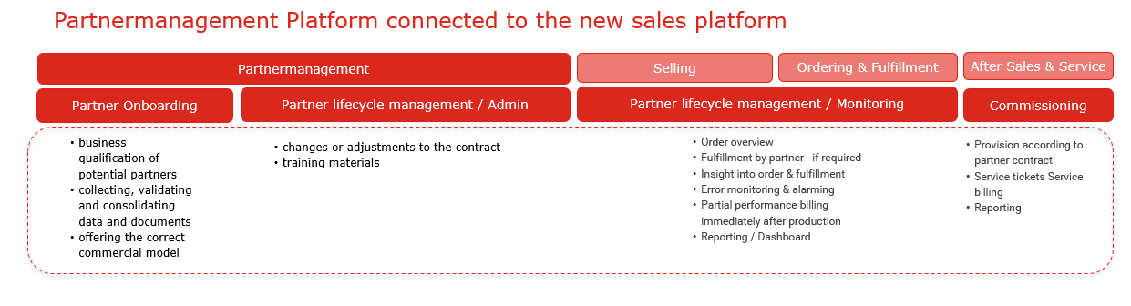

Here you can see an overview of the general high-level stages of the SME Partner Journey for sales partner and which of those belong to the Partner Mgmt Platform.



The Partner management capability does not cover the requirements of partners in lead to order and order to cash process, as this is covered by other capabilities.

Requirements of Solutions Partners concerning the offering of products in the sales process are covered the same way as A1 products in the capabilities Product Catalogue and Product Offering.

Requirements regarding the sales process, order management, delivery and billing are covered in several capabilities of the lead to order, order to cash process.

Below you find an overall picture of the interaction of the different platforms and capabilities in the addressed processes both addressing Partners and A1 Touchpoints.

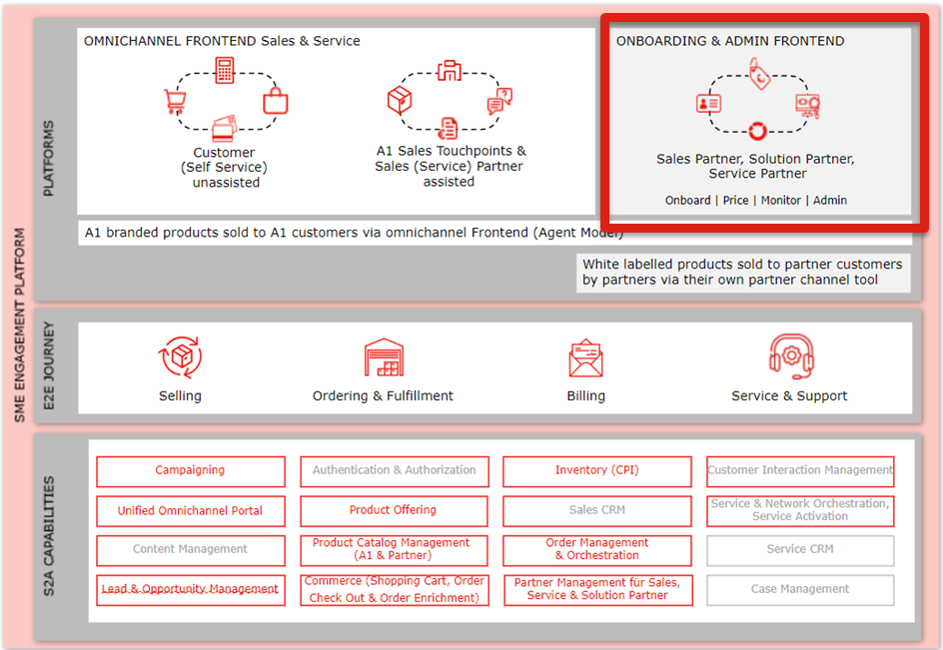

## Use Case: Partner Onboarding

The new partner onboarding process involves collecting, verifying and combining essential data and documentation, with the primary goal of seamlessly integrating an external partner into A1's Partner management platform.

For partners, there must be a simple, standardized, and consistently automated way to register for the partner program and select the available contract options and sales packages.

Relevant for Service, Solution, Sales Partner with each different contract modules.

For Sales and Service Partners, as well as Solution Partners the selection of different commercial models is supported in the onboarding phase.

Here is a short description regarding the **commercial models** of Sales Partners

**Agent Model:**

* A1 is the customer's contractual partner
* A1 sends the invoice to the customer
* The partner acts as an agent and receives a commission for the sale of the product
* The partner therefore sells the product 1:1 under the conditions that we offer as A1
* Advantage for the partner: A1 takes over billing and debt collection

**Reselling Modell / White Labe Model:**

* The partner is A1's contractual partner
* The partner is the customer's contractual partner
* The partner sends the invoice to the customer
* The partner buys the product from us at a discount (e.g. this is done by Exoscale for virtual servers)
* Advantage for the partner: He can put together a product package on his terms, add his own services and offer it to the customer as his own product
* negotiation, purchasing process and contract conclusion

**Tiering of partners based on “service agreement with A1**

Within the models there are defined different levels of partners, depending on their range of support and skilllevel * as a solution or Salespartners.

Below you find the example of partner levels defined for sales partners.

Ein Bild, das Text, Screenshot, Schrift, Zahl enthält.

**Onboarding process:**

After the partner has qualified for the partner program, the commercial contracts with the partner still must be made. In this phase, agreements for commercial and technical conditions are negotiated. A1's purchasing process will not change as part of the implementation of a partner platform. There will be a direct interface from the partner platform to the purchasing portal (RFI/RFP) to have an up-to-date status on progress and to be able to access current documents.

After successfully completing registration on the platform, the partner enters the contract setup phase. The aim of the contract conclusion process is to apply standard contracts and to start the contract signing using a digital signature. Contract documents are stored on the platform and defined data is extracted as basic information and is available on the platform.

For use in A1 processes, contract data is extracted and automatically saved in the platform, so that contracts can be better manage the contract contents via the platform and access information from the contract for the definition of reporting, commissioning and billing information.

For solution partners, standardized technical product onboarding in the A1 product catalogue is also essential for an efficient product design and offering process.

## Use Case: Partner lifecycle management / Admin

Partners have access to their own partner space on the Partner management portal after successfully completing the qualification. On this partner page, the partner can access all information about their partnership with A1. It needs to be structured by different categories of partners and its subtypes (Sales, Service Partners, Solution Partners).

Lifecycle management requires various updates, changes and the rapid exchange of information. Automated interfaces (APIs) enable partners not only to view the documents relevant to them (contracts, etc.) but also to access training materials. The Sales and Service Partners can also offer their own training courses. In the best case, the ability to sell a product is directly linked to the training status for the respective product (no positive training, no access to sales) -> or equivalent proof such as an official certificate that the partner can upload.

**Roles and rights:** Partners can also share access to the Partner management portal with their own employees and assign rights in advance. This functionality must be visible and changeable in the portal. Each partner is assigned rights by the Partner manager. The rights are based on predefined roles in the platform.

**License management:** For uniform and clear license management within A1, it must be possible for the partner manager to store all partner licenses of solution partners for internal use on the partner management platform.

## Use Case: Partner lifecycle management / Commissioning and Monitoring

Sales & Service and Solution partners must be provided with self-admin functions for ongoing self-monitoring of their sales performance as well as a their commisioning status (depending on various types)

The partner management platform enables a seamless flow of information, process flow and billing between A1 and its partners. As a partner platform provider and owner of the partner platform, A1 can also control it.

As a platform provider, A1 sets up new partners, manages access to the functionality and defines the business models and billing agreements for operating as a platform partner.

All business models between partners are supported, including automated revenue allocation, partner billing as well as multi-party commercial agreements and service orchestration.

Here is an actual overview of the commissioning types in A1 regarding the long-term concept. The picture below refers to sales partner.

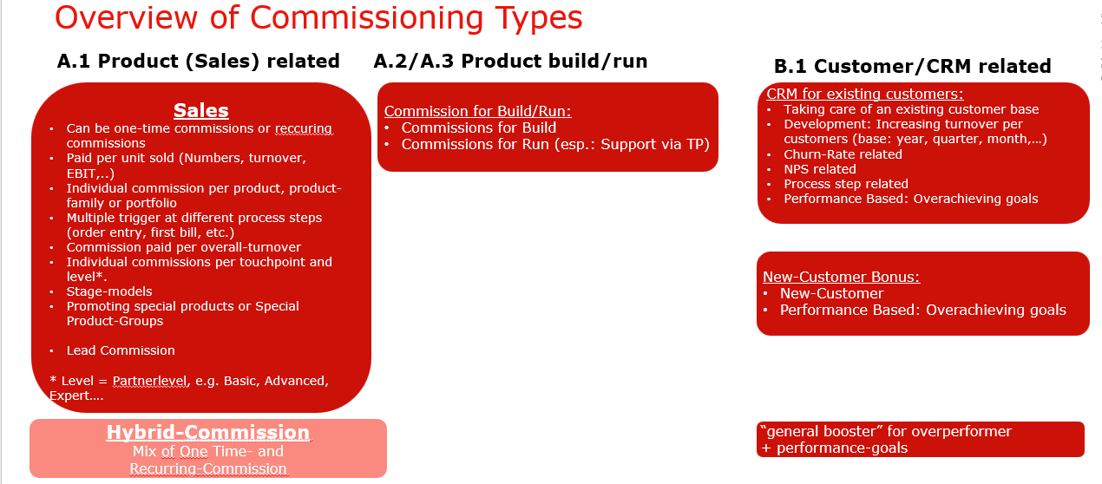

**Commissioning:** The system needs to support specific objectives for selected partners. The targets can be set for a one partner or all partners or specific partner groups

For example, for Sales Partners it must be possible to define temporarily targets on sales promotions. As A1 we want to be able to track the ongoing performance and the number of commissions. The commissions will be paid after a defined period (after one quarter, after one year…)

The platform addresses each partner's revenue sharing model and the automated revenue allocation or billing due to each supplying partner. All partner-to-partner business models are supported, including automated revenue allocation, partner billing, as well as multi-party commercial agreements and service orchestration.

During partner negotiations, KPIs should be agreed with the partner that are to be achieved within a certain period. The achievement of the KPIs should be able to be tracked via the platform.

The Partner management platform should help to simulate and analysis the effect of the provisions. As A1 we want to be able to track the ongoing performance and the number of commissions. The commissions will be paid after a defined period (after one quarter, after one year, aso.)

**Monitoring & Reports:** All reports are accessible via the partner platform for A1 employees with the appropriate rights. For partners, defined reports are automatically available on the partner platform in the monitoring dashboard depending on the contract basis and partner type. Partner managers also have the option of compiling individual reports from the existing data and defined rules and making them available to the respective partner in the monitoring dashboard. As soon as a new report is available, an email message is sent to all authorized persons via the partner platform. Reports should be able to be changed on a time-based/time-controlled basis.

Both the Partner and A1 Partner Managers have access to a Partner Monitoring Dashboard that visualizes relevant partner metrics.

* Relevant metrics include:
* YTD Revenue Budget Revenue
* Marketing Funds

Ein Bild, das Text, Screenshot, Schrift, Zahl enthält.

The partner management portal must support the levelling process and must provide relevant data: e.g. sales performance, employees, training status and help to simulate and analyze the impact of commissions. The commission planning process is an essential part of the partner management platform and must be supported.

Status reports must be available: e.g.

* How much commission is paid for a particular product?
* How does this affect the financial performance of the product?

**Campaigning for Sales Partner:** Product campaigns or "sales push" activities with additional commissions must be supported in the partner management portal to offer our partners additional incentives to increase sales. For partners, the additional commissions are visible in their reporting dashboard and are evident as such in the commissions. Internally, A1 controls the flexible selection of the respective campaigns via the partner management portal.

The partner management portal must provide the ability to support targeted campaigns to drive growth in a specific customer segment, particularly by converting non-customers into customers.

**Partner Offboarding:** The following describes how the offboarding of the partner, i.e. the separation of the partner from the platform, should take place.

There must be appropriate options for all partner types to terminate the partnership via a defined offboarding process via the platform.

For sales and service partners, general partner offboarding is only provided if the partner can be proven to have breached the contract.