Mortality Analysis in a Neural Network
John Koestner, FSA, MAAA, CERA
Life Experience and Assumptions Actuary
Phone: 585-721-7146
Email: john_dnr@outlook.com

Executive Summary
AI is the next frontier of actuarial analyses and being able to use the tools to support the processes will be important to remain efficient and knowledgeable. AI has become integrated in most applications and is multimodal ranging from text prediction, summarization, image creation, voice interaction, coding, idea creation, along with others. Traditionally, actuarial analysis has dealt with probabilities and developing models that optimized loss functions. The depth and breadth of AI models have exploded over the past few years, providing more advanced techniques in data analysis. This paper demonstrates a dual-application of AI in actuarial science:
1) Utilizing a Wide & Deep Neural Network to model mortality on the ILEC dataset
2) Deploying a Large Language Model (Claude) as an automated analyst to review the neural network's performance.
Actuaries have used traditional techniques to explore tabular data for many centuries. New insights coming from this exhausted data may be limited. New data that is less structured may provide more insights and this is where neural networks really excel. This could include things such as zip code data or sleep analytics.
AI is also very good at assisting in building prototypes quickly and helping generate ideas. There is a risk that AI may be used too much and encourage “cognitive offloading”, which could lead to products or models that are largely correct, however subtly wrong. Low risk or idea generation are proposed approaches of using AI to supplement actuarial analysis.

Process
Mortality has been analyzed by actuaries for a very long time which in turn has provided the foundation of projecting life expectancy. Life expectancy has continued to increase over time and as the population grows older, longevity will continue to be an area of increasing focus. There may not be many more insights to gain from the data that is currently available. The insights may come from new unstructured information. Neural Networks are a good model choice to be able to handle this type of data.
The python library used in most of the paper is called Morai (linked GitHub in the Appendix), which is an actuarial toolkit for mortality analysis developed in Python. The Morai package includes a few different functions to analyze mortality including, a dashboard, preprocessing, constraints, graduation, experience, and models. This analysis will mainly use the “models” functions and specifically the neural network model using PyTorch.

Data Preparation
The ILEC dataset (“ILEC_2012_19 - 20240429.txt”) was used as the input source to extract new insights from AI. Domain knowledge was critical in feature selection.
Columns Kept
observation_year | issue_age | attained_age | amount_exposed
sex | duration | soa_post_lvl_ind | policies_exposed
smoker_status | face_amount_band | number_of_pfd_classes | death_claim_amount
insurance_plan | issue_year | preferred_class | death_count

The data was cleaned by removing erroneous data and filtered to a modern mortality dataset removing.
Filters
Filter | Reason
Remove cells where there was no data | If there is no exposure (count and amount) and no claim (count and amount) the cell is removed
Remove cells where there was no exposure (amount since this is going to be our target) | If there is no exposure there should not be a claim.
Filtering the data to remove edge cases  - issue_age>=30  - issue_age<=80  - attained_age>=50  - attained_age<=95  - soa_post_lvl_ind in (‘WLT’, ‘N/A’)  - insurance_plan != ‘Other’  - issue_year>=1980  - smoker_status != ‘U’ | There are some edge cases in the insurance population that could be fine-tuned by a model, however doesn’t represent the majority of the population. These cells were removed to predict on what is more representative of the dataset distribution.

The next enhancement to the dataset was to add features. These features were added to help support the model fit and benchmark against the model.
Feature enhancements
Features | Reason
class_enh | This feature concatenates the preferred underwriting and number of preferred classes together to form an interaction variable.
VBT15 (q_{x}, A/E, expected) | Adding the VBT15 mortality to use as a benchmark in analysis
q_{x} | Adding the q_{x} (capping at 1), which will also be used in training
Attained age splines | Mortality has a general shape of increasing mortality at decreasing rates as age increases (Gompertz function). To help the model find this relationship quicker, attained age was broken into b-splines.
Duration splines | There is a steep underwriting wear-off in the first few durations for insurance policies.

To be able to train the model there were a few more preprocess steps done on the data.
One area where Neural Networks excel compared to other models is embeddings, especially when the feature has many values (e.g. > 50). Embeddings allow a 1-dimensional feature to be split into a k-dimensional field and then be able to have non-linear relationships and group them together.
Neural Networks are sensitive to losses, so it is important that features are standardized so that a given feature doesn’t outweigh the optimization.
The data was sampled because of hardware and processing speed limitations.
Preprocessing
Preprocess | Reason
Ordinal encoding  - sex, smoker_status, observation_year | The following features were ordinal encoded as there were only 2 values, or the feature has natural order.
One hot encoding (OHE)  - class_enh, insurance_plan | The following features were one hot encoded because they do not have an inherent hierarchal nature and are separate entities with a low number of values.
Embeddings  - face_amount_band | There were many values with the face_amount_band, so an embedding was created
Standardizing | It’s important for a neural net to have features standardized so that the loss function isn’t unfairly weighted.
Sampled | Due to constraints on personal computer the data was sampled to 10% of the dataset. This provides quicker processing and modeling time.
Test/Train splitting | The data was split with testing data representing the 2019 observation year and training all other years.

Methodology
A neural network was selected to model the data. A neural network is like other machine learning models in that it takes an input, optimizes a loss function, and predicts an output. The general process is that there is an input, which has a set of weights and a bias term, that then goes through an activation function (e.g. sigmoid, relu, softmax). This process represents “the neuron” in a forward pass. These then have a loss function that is optimizing the loss (e.g. MSE, Poisson, Binomial) with backpropagation. The architecture can be configured depending on how deep (number of layers) and wide (number of neurons) the network should be. A formula for one of the neurons is shown below.
$$\hat{y} = g\left(w_{0}+ \sum_{i=1}^{m}{x_{i}w_{i}}\right)$$
where:
- ŷ = predicted output
- g = non-linear activation function
- w₀ = bias term
- xᵢ = input feature i
- wᵢ = weight of input it
- m = number of input features
There are several types of neural networks and for this example a Feed Forward Neural Network (FFNN) was chosen.
The next step was to define the architecture of the network. One technique chosen to make the model more accurate was to have the model train on a “Wide and Deep Path”. The “wide” path would act like a GLM, which would identify the main effects easier. The “deep” path would learn the intricacies of the data. This approach could be used with other models where for instance a boosted tree could learn the residuals of actuals compared to the VBT15 table.
The goal of this analysis was to demonstrate that neural networks would be able to accurately predict mortality and learn the intricacies of the features. The model was overfit on the training data to show the accuracy on training data; however, it is best practice to regularize the model and validate using the test data.
For the loss function, a Poisson loss was chosen to model mortality, where the exposures are used as an offset. To avoid a neuron from an exploding loss (where the loss is very large and causes a cascade effect) the gradient and loss is clipped.
Model Setup
Model | Reason
Architecture  - Wide path  - Input layer: (1 neuron)  - Deep path  - Input layer: (32 neurons) ReLU  - Hidden layer 1: (32 neurons) ReLU  - Hidden layer 2: (16 neurons) ReLU  - Output: (1 neurons) | Having 2 separate paths allows the model to learn simple relationships quickly and allow the deep path to focus on the intricacies in the data. The number of neurons is a hyperparameter that could be tested.
Learning Rate  - Starting at .01 with gradual reduction  - Adam optimizer | Having the learning rate decrease when the loss plateaus allow the model to find the local minimum and hopefully global minimum
Loss  - Poisson loss function | With a mortality rate a Poisson loss is a natural fit
Other features  - No dropout  - Early stopping on training data  - Initialized on overall mortality rate | The model is initialized on the overall mortality rate, so the model has a good starting point in learning. The model currently does not have regularization, however this will lead to overfitting.

Results

Prediction Analysis
After the neural network ran through 500 epochs, the final model showed the trained predictions compared relatively well to actuals, even fitting closely with the oldest attained ages.
A/E by Attained Age for Actuals, VBT15, and Neural
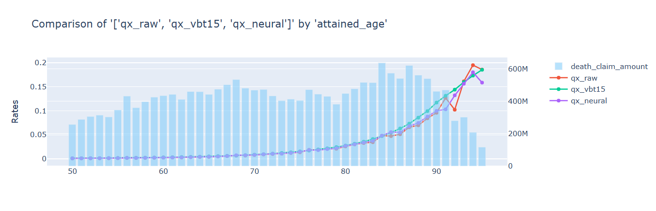
When reviewing the model training, it was observed that the model had a sharp improvement in loss up until epoch 100 (red line) when it started to decrease more slowly. The scheduler decreased the learning rate at around epoch 250 from .01 to .005.
Loss Values by Epoch and Dataset
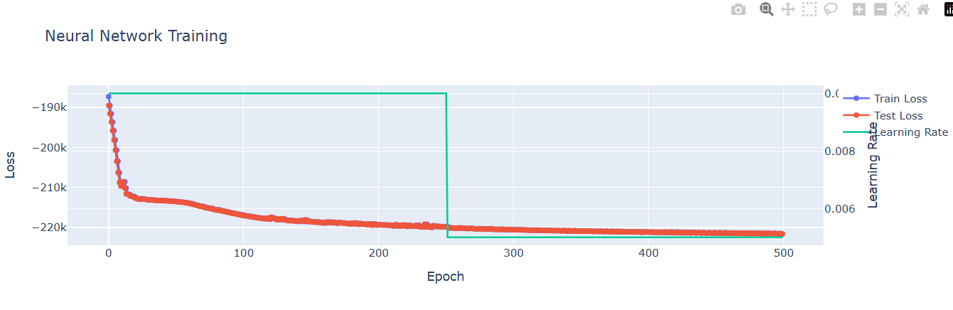
To evaluate the reasonableness of the neural predictions a traditional A/E analysis was performed on the features. The aggregate A/E was 99%, with most features +/- 5%. This shows that the neural network was able to learn the data and performed similar to a boosted tree model (e.g. CatBoost). A boosted tree model would be able to match categorical variables exactly, while the neural network did have some volatility in categorical variables (e.g. class_enh). It also took longer to engineer features for the neural model compared to a boosted tree model. The model architecture may be able to be fine-tuned to be able to get tighter A/E’s.
The training data did have larger variances by feature with an aggregate A/E of 102%.
A/E Neural Network on Train Data by Feature
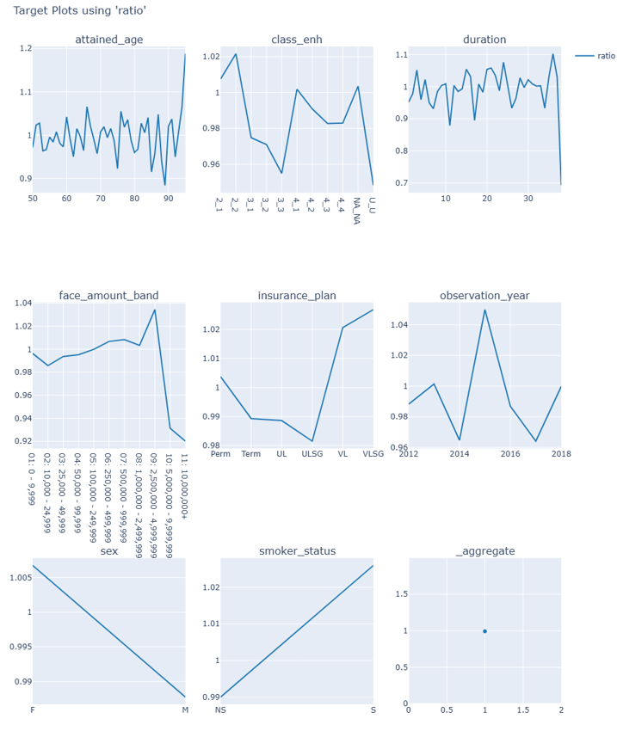
A/E Neural Network on Test Data by Feature
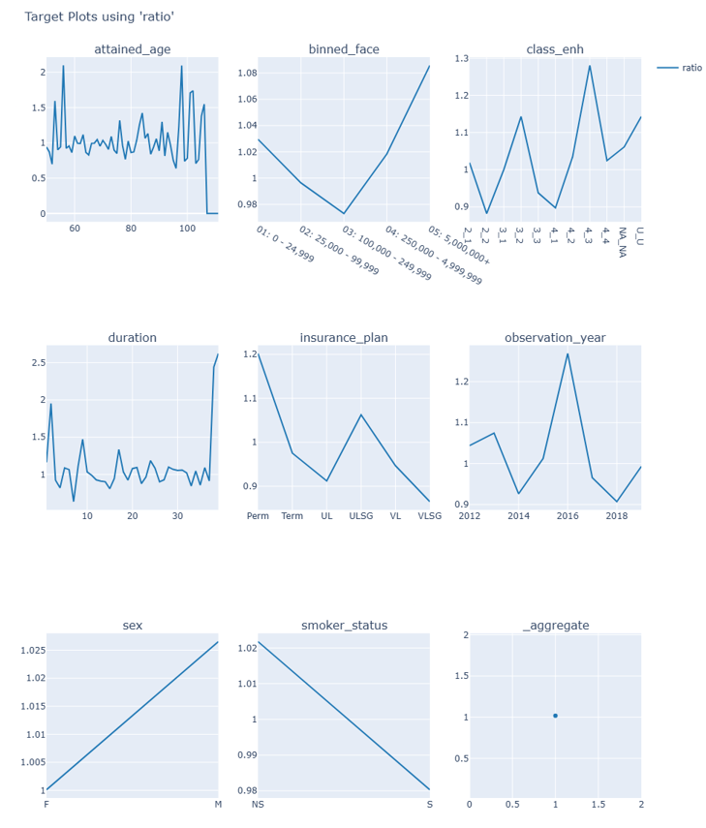

Model Insights
After the model has been trained there are some interesting insights that can be extracted using Partial Dependency Plots (PDP), SHapley Additive exPlanations (SHAP), and Embedding Analysis.
Using PDP analysis, a feature can be isolated and its impact assessed by averaging and marginalizing over all other variables. As an example in life insurance is reviewing mortality by duration. Underwriting of a policy wears-off over duration and may wear-off differently by insurance plan, age, or underwriting class. When reviewing the PDP of duration by insurance plan, the other effects are held constant while only changing the duration and insurance plan to average over the predictions. The durational effect does vary by insurance plan as seen below, where the steepest slope ends by duration 10-15 for most insurance plans.
PDP of Duration by Insurance Plan
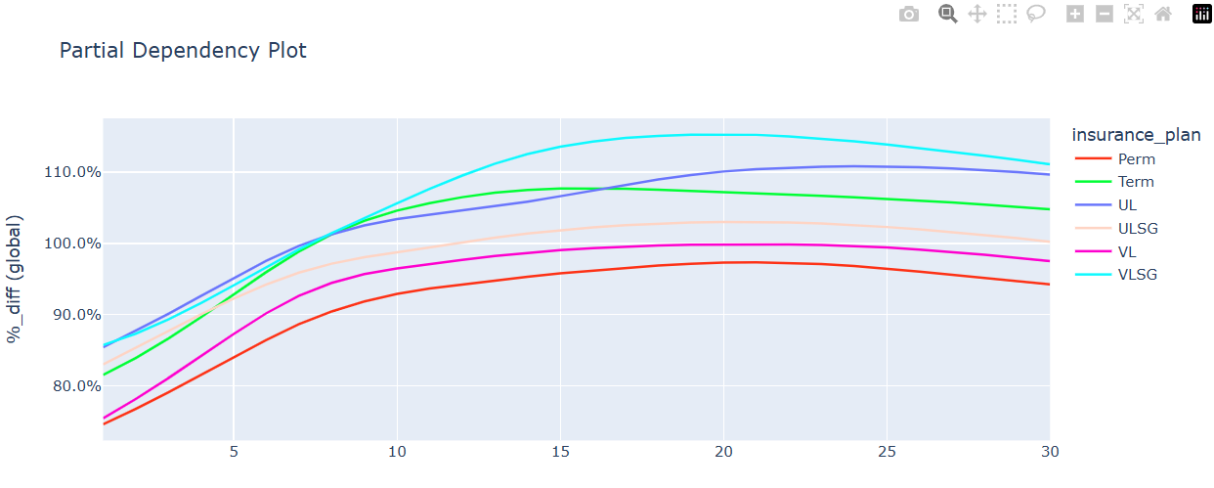

SHAP values allow the model to be interpreted more granularly. For example, the following plot shows which features have the most impact on prediction. As expected, attained_age has the highest impact on the model.
Mean(SHAP value) per Feature
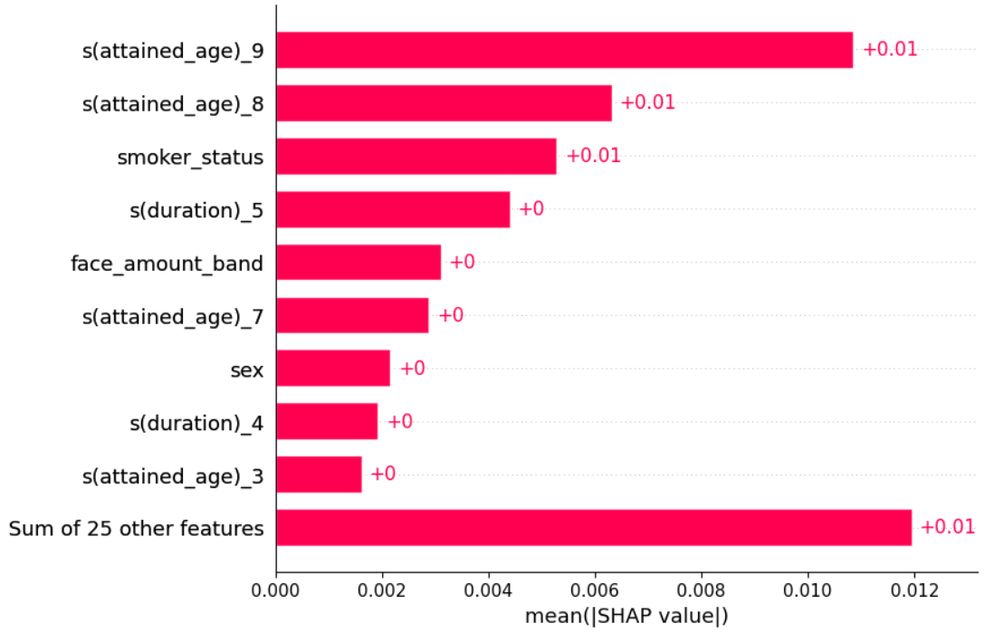

Another example would be to determine how much each feature contributed to a particular prediction. It makes it slightly challenging to interpret the results, due to the model having the features encoded as well as standardized. It was not surprising to see attained age as having the highest contribution to mortality for this cell.
SHAP value contribution by Feature for a single cell
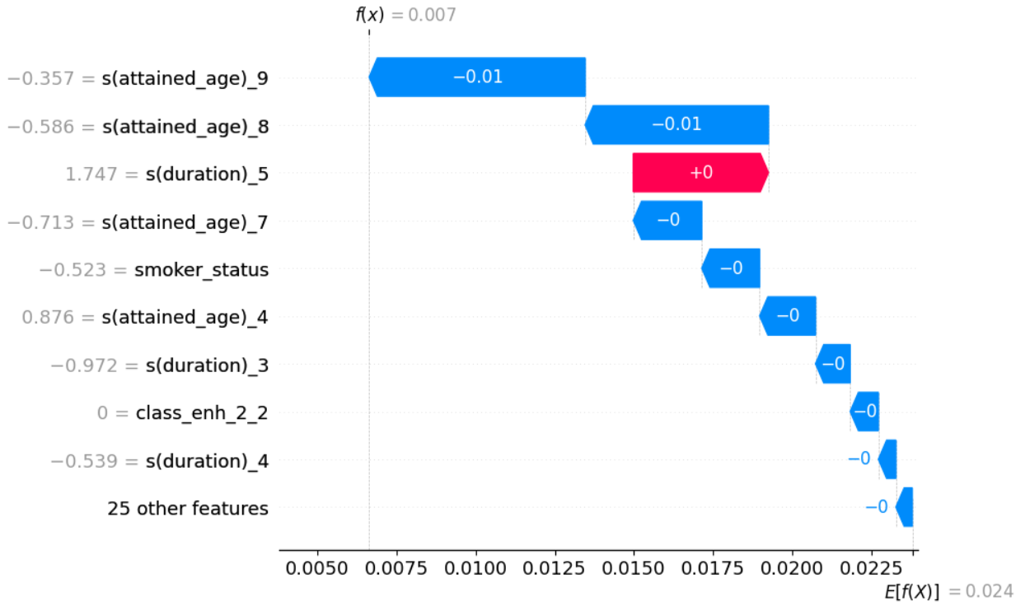

Embedding Analysis
The other type of analysis that can help provide insights from the model is embedding analysis. As mentioned in the 2.1 Data Preparation the “face_amount_band” feature had been encoded with an embedding. This feature had 11 unique values, and it was decided to use 6 dimensions for embedding. For instance, the value “01: 0 - 9,999” may have an embedding value of (0.28, -0.10, 0.09, -0.20, -0.38, -0.15). The embedding dimensions chosen were half the number of values in the feature, in this case 6 rounded up. These weights start at 0 and then the neural network would train the model to optimize the weights to decrease the loss.
There is some art to determine if a feature should be embedded or one-hot-encoded and what the number of embeddings should be. Embeddings are particularly valuable with large feature spaces, such as 50+ values. Embedding when there are fewer than 10 values has less value, as sparsity is minimal and one-hot-encoded may be preferable. A common use-case for embeddings is vocabulary, where a different word with the same meaning would have similar embeddings. As an example, the word “Queen” would be closer in meaning to “Woman” than “Man” in the feature space.
To better understand how data points relate to each other in a 6-dimensional space, several techniques can be used.
- Cosine similarity: measures the angle between vectors to assess how similar they are, making it useful for analyzing relationships between embeddings. Useful only for pairwise interaction.
- PCA (Principal Component Analysis): reduces dimensionality by finding directions that capture the most variance in the data, helping to simplify and interpret complex relationships. Useful for understanding a global perspective.
- t-SNE (t-distributed Stochastic Neighbor Embedding): is a technique designed for visualizing high-dimensional data by mapping it into two or three dimensions, which makes it easier to see clusters and structural patterns. Useful for understanding the local perspective.
Using these methods allows us to analyze relationships, reduce dimensionality, and visualize data, thereby making the complex embedding space more accessible and interpretable.
Embedding is an area that should continue to be tested to get comfortable, however the following were the initial takeaways. The model had higher similarities for facebands that were closer to each other. For instance, 01 was closer in similarity to 02 than it was for 11.
Embedding Cosine Similarity by Faceband
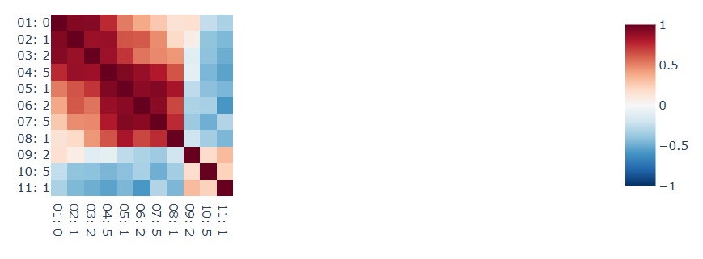

The PCA analysis shows a similar observation to the cosine similarity. The 3 facebands above 2.5M are shown as outliers compared to the other facebands.
Embedding PCA by Faceband
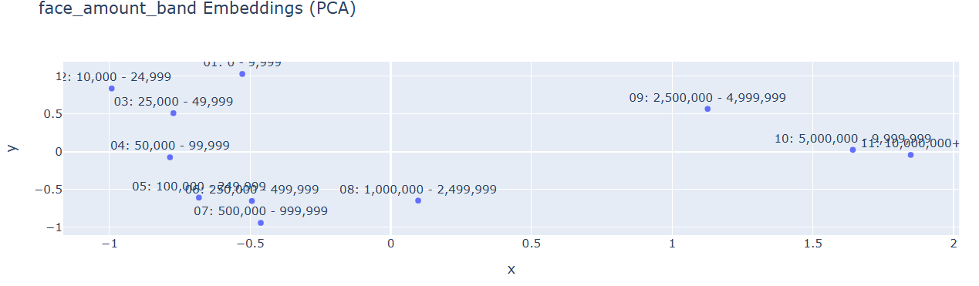
Reviewing the PDP of faceband the expected relationship of faceband mortality was captured by the model without influence from the other effects. Mortality is higher for the lower facebands and decreases as faceband increases. The slope of the decrease is more gradual for facebands 100k and above.
PDP of Faceband
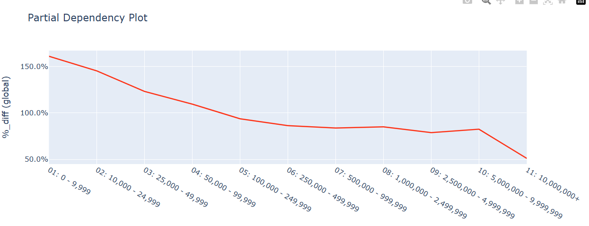

AI Analysis
Once a mortality analysis structure is developed, it can be provided to an AI assistant to uncover additional insights and produce visualizations. Having a foundation for the AI assistant to work with is important as it allows the user to have transparency in the process. If needed the user could replicate the results which provide confidence in the output. There is still a lot of value and efficiency in having an AI assistant be able to create visualizations from natural language instead of having the technical expertise to create the queries.
Claude is a powerful AI assistant, built by Anthropic, that allows a user to interact with a repository with many uses cases such as explain results, add code, review code, and project management to name a few. Anthropic has added another feature (requires a subscription) where a user is able to create a “skill” so that Claude will have the context for the question that is being asked and respond with an appropriate result. This allows Claude to directly use the Neural Network architecture that was created and produce results that are specified. For this project a few files were created for Claude to load into context shown below:
- CLAUDE.md: This provides background knowledge of the repository and key information of the files and code
- skill.md: Provides information on how to review a neural network model as it relates to this repository, which will be the basis of the output
- actuarial-reference.md: Provides some useful context around actuarial analysis
There are other “plugins” that can be enabled in Claude that can help the assistant in interacting with other tools such as databases, GitHub, and dashboard creation.
Input Request
The input request, which is also described in the README.md, will trigger the “nn-review” skill that was created for this project and provide tailored responses evaluating the performance of the neural network.
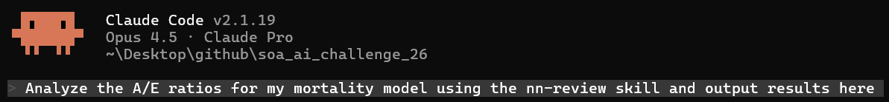

Output Results
It’s impressive seeing the analysis that the AI assistant produces in a short amount of time (2 minutes), and the assistant provided good feedback on the model. The suggestions from the assistant to continue enhancing the model with suggestions for key problem areas are great insights. The analysis could be confirmed by the user to ensure the AI assistant was not hallucinating.
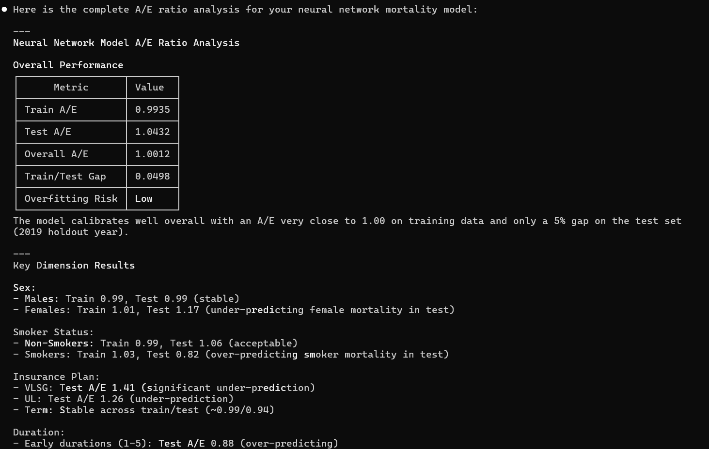
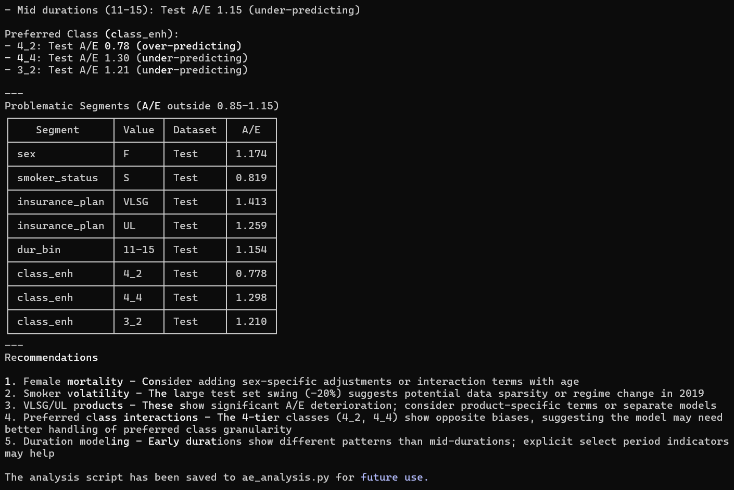

Future Enhancements
There are a few areas that could be further improved in future iterations of the mortality analysis. These include understanding the model better and ensuring the model is not overfit, which are described more below.
- Avoid overfitting by adding penalization –The model may have learned specific patterns in the training data that are not representative of the overall mortality. Another method is to have early stopping on the testing data. The model could also experiment with penalization using a dropout rate, which will help reduce the weight that any one neuron has on the prediction. Weight decay could also be used as an L2 penalization to shrink large weights.
- Model full data – The data used in this analysis was sampled so that the model could be trained and analyzed quickly. A GPU machine could handle this dataset and process easily. Sampling does lead to some of the data being omitted from the analysis, which could be meaningful and have inherent bias in the results.
- Gain a deeper understanding of embeddings – Features like insurance_plan and class_enh could also be explored as experiments with embeddings.
- Adjust hyperparameters – The model can undergo further fine-tuning. Modifying factors such as the number of epochs, weight decay, dropout rate, batch size, loss rate, and feature engineering may lead to improved performance.
- Residual Analysis – Review model residuals for bias or patterns. Fan out or converging patterns may indicate non-constant variance.

Conclusion
AI is evolving fast and it will be important for the actuarial profession to embrace technology. Not every new predictive model or software will be applicable to the industry, however it is important to be able to test the ideas and continue to innovate the profession. Sharing ideas in the community and being open and transparent on the findings will hopefully continue to inspire and progress the efforts. Previous key insights can serve as the basis for analysis, with further discoveries still possible.
This paper has shown how a neural network could be used to model mortality and provided some of the benefits and limitations. Mortality insights could be enhanced by incorporating new data sources to lead to new discoveries. AI can also support analysis by providing new ideas and efficiently analyzing data. There should be some caution when using AI to handle the end-to-end process, as AI assistants are prone to error, so there is some volatility in the answers provided and they are sometimes subtly wrong. The way that an AI assistant can understand human language and interact on a technical level across different domains is impressive and will allow more efficient processes with deeper insights.

Appendix

Links
- Github repository for challenge – using the soa_neural.ipynb notebook
  - https://github.com/jkoestner/soa_ai_challenge_26
- AI Life Insurance Challenge
  - https://www.soa.org/research/opportunities/2025/ai-life-ins-challenge/
- ILEC 2012-2019 dataset and data dictionary 20240429
  - https://cdn-files.soa.org/research/ilec/ilec-mort-text-data-dict-2012-2019.zip
- Github repository for Morai
  - https://github.com/jkoestner/morai

https://www.gapminder.org/fw/world-health-chart/
https://en.wikipedia.org/wiki/Gompertz_function
https://scikit-learn.org/stable/modules/partial_dependence.html
https://shap.readthedocs.io/en/latest/index.html

