Login into your Google account and go to the page

<https://www.google.com/recaptcha/admin>

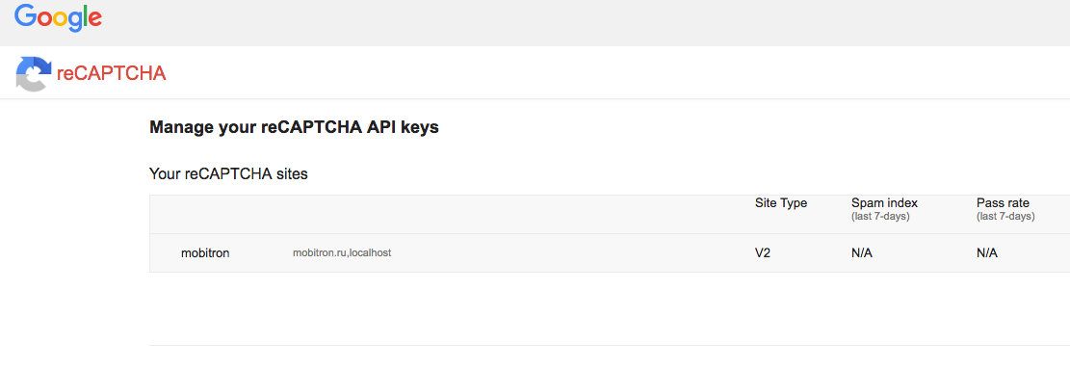

Fill in label field and choose reCAPTCHA2 V2 radio button:

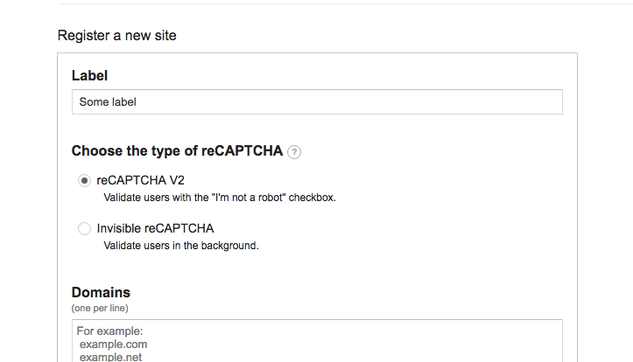

Define domains on which recaptcha2 will work:

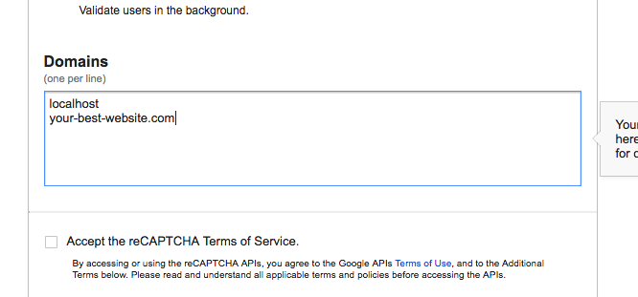

Accept the terms of service and push the register button:

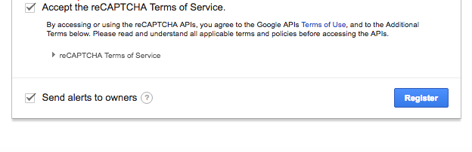

Get public and private keys:

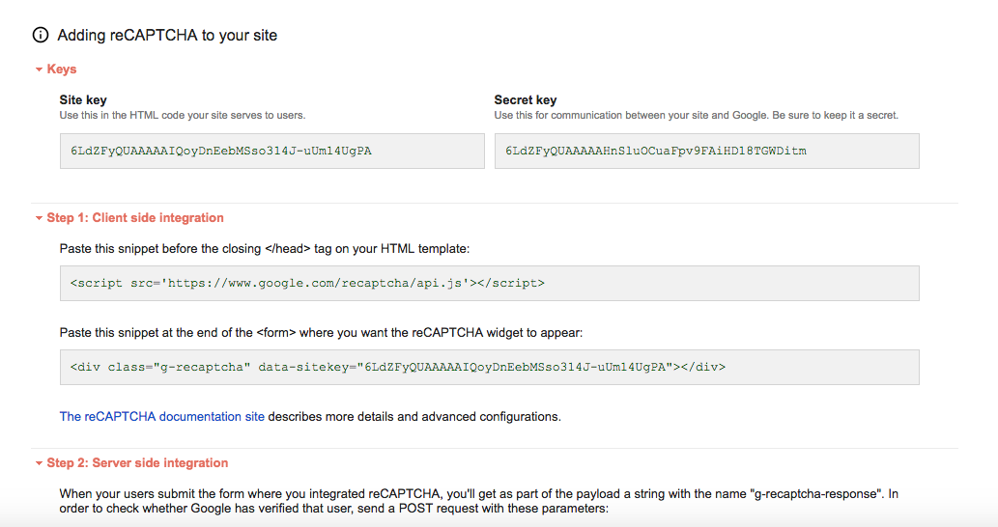

Look into the sample app for more details how to use public and private keys