Unscented Kalman Filter Project

1. Introduction
In this project, we estimate the position of an object by means of an unscented Kalman filter (UKF) and sensor fusion. In particular, we combine (noisy) measurements from laser and radar sensors in order to estimate the object position.

2. Implementation
This projects builds upon the previous one (extended Kalman filter, EKF) and in this document we will focus on the differences between the two projects. First of all, in the EKF project we have assumed a constant velocity (CV) model which assumes a linear motion (with constant velocity) when performing the prediction step. This means that, for non linear motion, this type of filter carries some amount of inertia when the orientation of the actual velocity varies. In the UKF project we assume a constant turn rate and velocity (CTRV) magnitude model which better (but not perfectly) reflects the actual motion of a car in traffic.

Since UKF is in fact a Kalman filter, it consists of 3 basic steps (as EKF does) that are performed iteratively:
- Initialization - his step consists of setting up the filter variables when the first measurement arrives.
- Prediction – predict the position and velocity of the object based on the motion model and the elapsed time from the last measurement.
- Update – update the prediction by correcting it by the actual measurement that arrives from the sensor.

2.1. UKF vs EKF
The main difference between UKF and EKF is how they deal with non-linearities. The first source of non-linearity is the radar sensor itself which sense the world in polar coordinates while the target space is Cartesian. The mapping between the two spaces is non-linear. The second source of non-linearity is introduced by the CRVT motion model. The fundamentals of Kalman filtering require that motion model and measurement model are both linear. Since, in this case, they are not, EKF “linearizes” the model by (first order) Taylor expansion. On the other hand, UKF uses the so called sigma points that aim at approximating the probability distribution in the transformed space by a (best fitting) normal distribution and both prediction and update steps make use of the aforementioned sigma points.

3. Results
One of the challenges of this project is to set up appropriate values for the process noise variances. After some experimentation and educated guesses, we have set the process noise standard deviation for longitudinal acceleration to approximately 1m/s². This that means in 95% of cases the acceleration will fall within the interval of ±2m/s² which seems reasonable for recreational biking. On the other hand, the standard deviation for yaw acceleration is set to around 0.5rad/s². This means that for the 95% interval we will consider a maximum turn rate of 0.5rad/s² which is slightly more than a 90 degree turn in 2 seconds (which we can consider a reasonable choice as well). To assess the validity of our choices we have performed the chi-squared test on normalized innovation squared (NIS) which for Χ²0.050 yields 5,6% for radar (3 dimensions of freedom) and 4,4% for laser (2 dimensions of freedom).

We have evaluated the implemented Kalman filter on Dataset 1. The evolution of RMSE for both position and speed is shown in Fig. 1. The final RMSE values are (0.066, 0.083) for (x, y) and (0.33, 0.22) for (v_{x}, v_{y}).
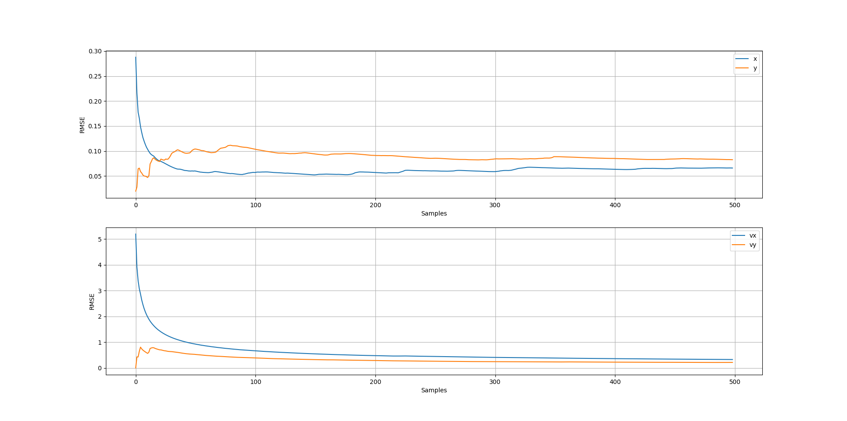
Figure 1: Evolution of RMSE for position and velocity using sensor fusion with unscented Kalman filter.

It can be observed that for both position and velocity the error is decreasing and then stabilizes around the values reported above. The error cannot be reduced to zero since measurement errors are always present (even though their influence is minimized by Kalman filter). It is also observed that the first measurement in y-axis has been much more accurate that in the x-axis. However, this is just a coincidence as also demonstrated by the later evolution of RMSE in both axis.

We have also performed the tests using laser/radar data only. In the case of laser, the resulting RMSE values are (0.17, 0.15) for (x, y) and (0.61, 0.25) for (v_{x}, v_{y}). For radar data only, the resulting RMSE values are (0.21, 0.25) for (x, y) and (0.36, 0.27) for (v_{x}, v_{y}). As expected, laser data yield lower position RMSE than radar since the measurements are more accurate. On the other hand, Kalman filtering of radar data yield much better velocity estimates (even though radar measurements are less reliable than laser). This (relatively) good performance of radar data on velocity RMSE is due to the much accurate motion model selection (which is why we did not observe such a behaviour in the EKF project). Finally, both simulations lead to higher RMSE than the fusion of the two sensors. This is due to two main reasons:
- When using one of the sensors only, the time difference between two measurements is higher so the prediction step is more noisy.
- Using two sources of noisy information yields measurements whose noise is always lower than the noise of any of the two sources separately.

The comparison of the results obtained by fusing laser and radar data, by using laser data only and by using radar data only is shown in Fig. 2.
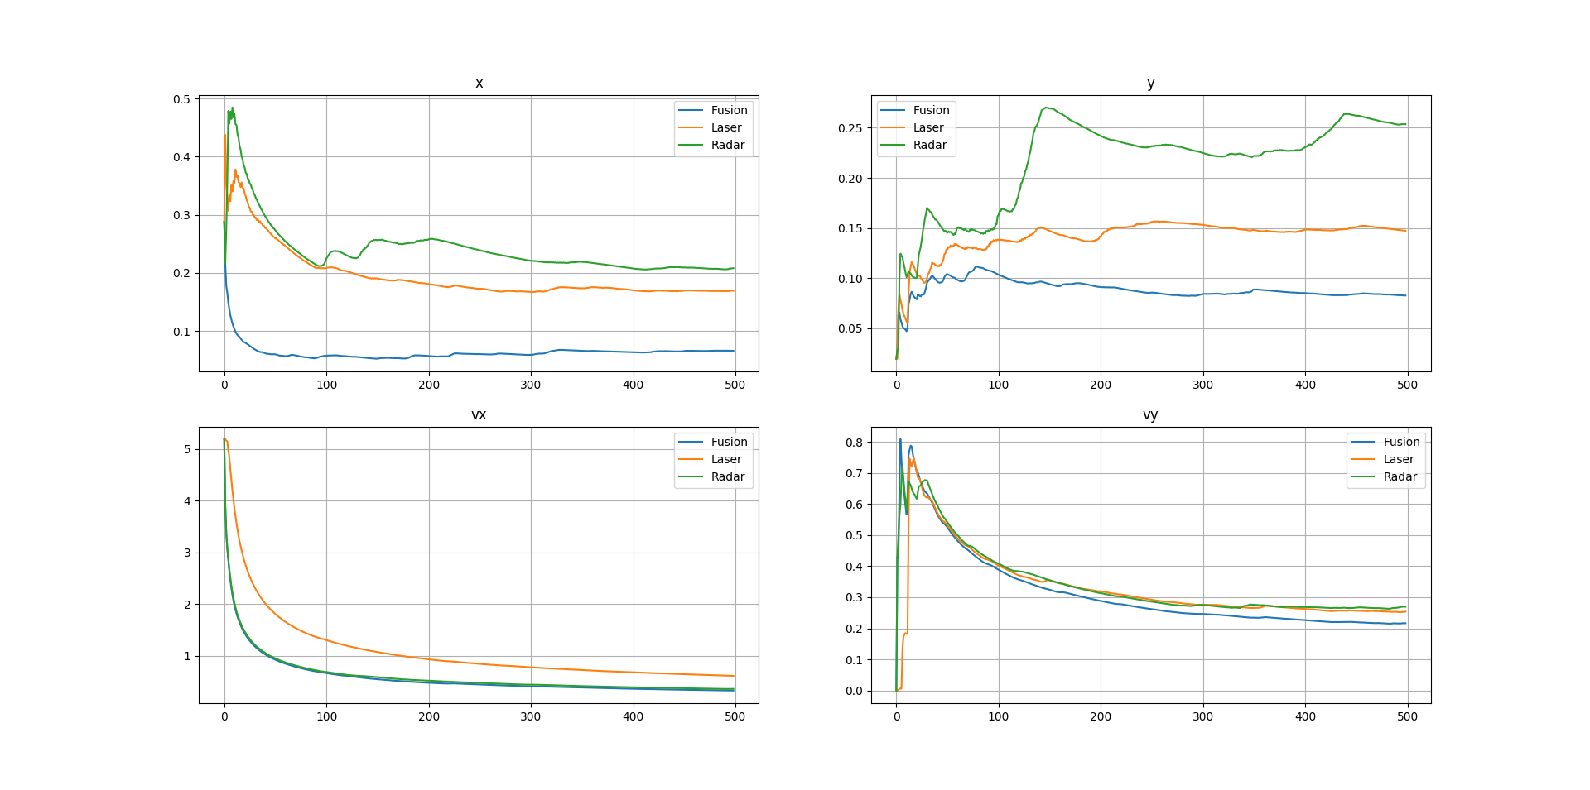
Figure 2: Comparison of RMSE obtained by sensor fusion and by using each sensor separately.

Finally, Fig. 3 shows the performance comparison of UKF and EKF. As already indicated by the RMSE values reported above, UKF (with CTRV motion model) yields more accurate estimations than EKF.
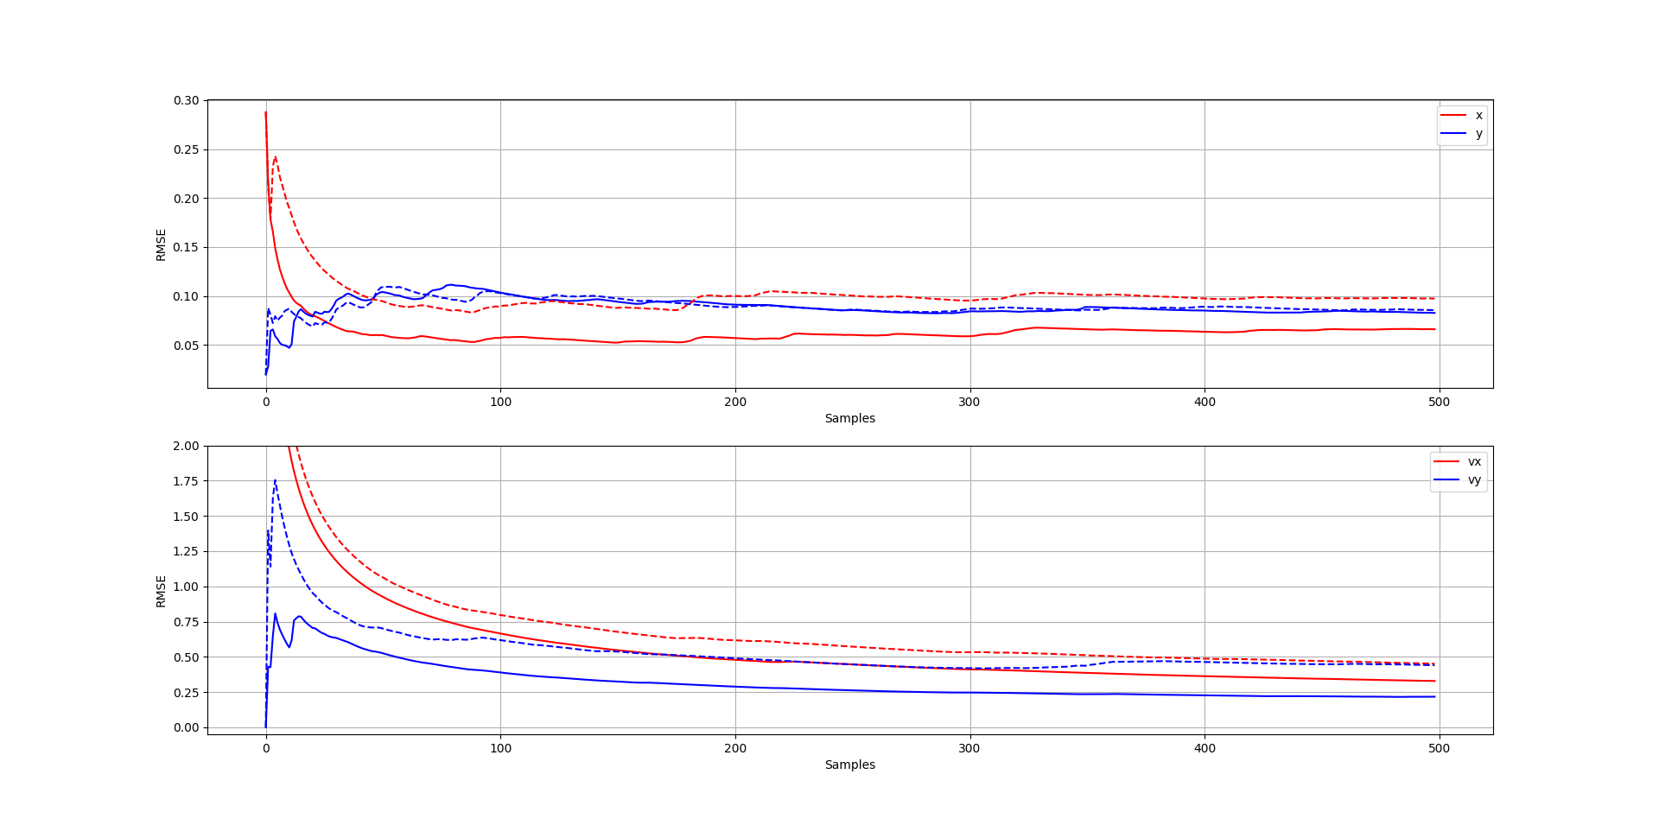
Figure 3: Performance comparison for UKF (continuous) and EKF (dashed) for position and velocity.

