Stage A – Analysis

A1 – Analysing the Problem

At time of writing, the interviews have not been completed. This should not be the final version turned in to IB.
Introduction:

At Canada/USA Mathcamp last summer, I and many others played a card game called Mao. On the penultimate day of camp, many of my friends lamented being able to play no longer, and discussed potentially creating a way to play online. I have taken up the challenge, and have contacted many of them as end-users for feedback.

Brief Description of Mao

In the games of Uno and Crazy Eights, players sit holding hands around a playpile. They take turns either playing a card of the same suit or rank as the card on top, or, if they cannot do so, drawing, with the ultimate goal being to run out of cards. Some cards have special effects such as reversing the direction of play or skipping the next player’s turn. Mao is similar, except that players do not know the rules (beyond that “play proceeds like Uno”), with the point being to figure them out. Players who run out of cards are dealt a new hand, and may create a new rule and insert it into the game for other players to figure out. If you believe a rule has been violated, you may punish the offending player with a penalty card accompanied by a call such as “Out of turn,” “Bad play,” “Failure to either play another seven and say ‘Have a very nice day!’ or draw two cards and say ‘Thank you,’” or “Failure to move the banana away from the deck” (incorrect calls are themselves punished with “Bad Call”). Players create rules with all kinds of crazy effects such as having a banana that must sometimes be moved around or turning the playpile upside down, or even using a card to flip another into the air, so creating a system in which any desired effect can be faithfully implemented is especially difficult.

Methodology

An E-mail was sent to nine Mathcampers interested in playing Mao online, requesting they provide feedback throughout this project. Four responded in the affirmative; interviews were then arranged over instant messenging. One other responded arguing the futility of a specialized program in favor of his own system, described below.
To limit biasing interviewees’ thoughts towards existing, interviews were conducted in a two-phased fashion. The first phase consisted of open-ended questions of their image of the ideal Mao-playing system; questions were often directed at specific aspects and areas of consideration, but with as little leading-on as possible. The second phase consists of interviewees commenting on the ideas of others (including myself). While the first interviewee was told whose thoughts those were, subsequent interviewees were presented the ideas only, with me sharing my thoughts only at the very end.
I typically asked the following questions in the interview, but with modification depending on the interviewee’s previous response (i.e.: asking additional questions for elaboration, not asking a question if the interviewee touched it sufficiently) in a previous response:

- Picture the perfect Mao system. How do you communicate? How do you see players and the playpiles? How do you make plays, calls, and odd effects such as making alternate playpiles?
- How do you handle props (e.g.: the aforementioned banana) and really odd effects such as building a card-tower?
- If there was a perfect automated rules enforcement system that could read your mind to enforce your rule, would you play with it?
- How should rule conflict disputes be resolved? Needs there be vote-kicking of some sort?

Proposed systems:

Everyone asked agreed that rule enforcement should be purely informal and in the hands of the players, handled over the medium of communication. This is to be assumed

Proposal 1: Webcam System
As mentioned above, one friend opposed the notion of a specialized Mao system altogether, and instead heavily advocated for using a webcam chat, with one player serving as the dealer, who would maintain the playpile and keep it in view of the webcam at all times. Players would draw from their own deck, and would show the group the card they wanted to play. If there were no objections, the dealer would update the playpile accordingly.
This has the major problem of requiring a webcam, and would be inconvenient to play (especially for the dealer, who would have to constantly hunt down copies of the cards played). A more primitive version of this would be to use voice or text chat, and state actions. While this lacks the webcam barrier (though the voice-chat merely replaces it with a microphone barrier), the inconvenience persists. Additionally, in both, even among the most virtuous players, the intense frustration that can be experienced against difficult-to-figure-out rules combined with the ease of cheating (namely via misrepresenting one’s hand) could cause many to succumb to the urge to cheat. Furthermore, the limited “bandwidth” of information communicated between players in the voice or text chat medium – only auditory information is conveyed, whether via literal sound or subvocalization (the universal process of reading text aloud in one’s head) – would likely greatly limit the fun factor. Even the webcam system runs into bandwidth limits, as one of the best-designed rules subtly depends on card-placement; this would be difficult to implement given the decentralized overview of a game of Mao played via webcam chat (namely, the players see the game as a disjoint collection of players sitting at terminals, rather than all in one virtual place). Even if players could imagine themselves sitting around the playpile, it would still “spoil” the rule if the dealer had not yet figured out that the rule involved card placement, and a player had to instruct him to place a card facing a certain direction, thus tipping him off that the rule involves that. Finally, the lack of a formal system for organizing Mao games, in addition to the inconvenience of the dealer needing to find a copy of the card played makes this a system unlikely to maintain popularity.
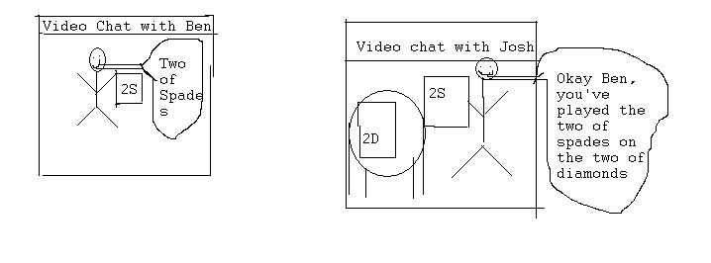
Figure 1 -- Very rough visualization of webcam-chat system

Proposal 2: Scripted system
I came up with a system in which players play online via a client (likely with an associated website where players could create accounts and join games) and are shown as sitting around a table, holding hands, with text chat (potentially voice chat as well) communication. The table would have objects such as the standard playpile and drawpile with associated actions such as “play card” and “draw” associated, and would merely provide a framework for these objects and actions to live, along with a loose notion of a space to put them. However, there would be a library of a variety of other objects and actions such as “additional cardpile,” which would support the actions of moving it and putting cards on and taking them off; “moveable prop,” which users could set an image for so that it could be a range of things such as a banana or a poker chip and would simply have a “move” action; and “placement-sensitive playpile,” which players could replace the standard playpile with and would have actions allowing players to specify playing cards at an angle (and some associated code to display them correctly). These additional objects and actions would be used to implement a wide variety of rules. Most importantly, there would be a system that would take advantage of the scripting-engine support in Java 1.6 to allow players who know some programming to create their own objects and actions to implement other odd effects and add them to the library for (if they mark it as “public”) all to use. See Figures 2, 3, 4, and 5 for a visual demonstration of this system.
This system has several problems. The rigidity of the play system (i.e.: only having a small set of pre-defined actions) would create a mental barrier between players’ desires and ability to carry them out, and would likely fail to carry over the informal, just-for-fun feel of a face-to-face Mao game and create a focus on pure game mechanics which would highly disrupt the fun factor. Additionally, the object-verb model play is based on would likely feel highly unintuitive to those without a programmer’s mindset. More concretely, the need to script effects in advance would likely create a substantial barrier (and, for non-programmers, insurmountable without extreme effort) for creating new effects, which would prevent many from creating effects for rules they aren’t sure is worth it and greatly limit rules created on the spot, and would thus stifle creativity, and ruin a good deal of the experience. Additionally, as in the above, a rule that subtly depends on card placement or the like would be “spoiled” for the players when they see the creator of the rule replacing the playpile with a placement-sensitive playpile.

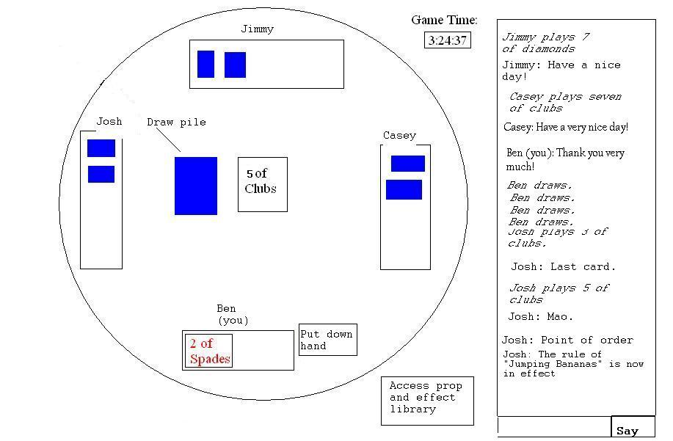
Figure 2 -- Visualization of scripted system, image of player Ben's client
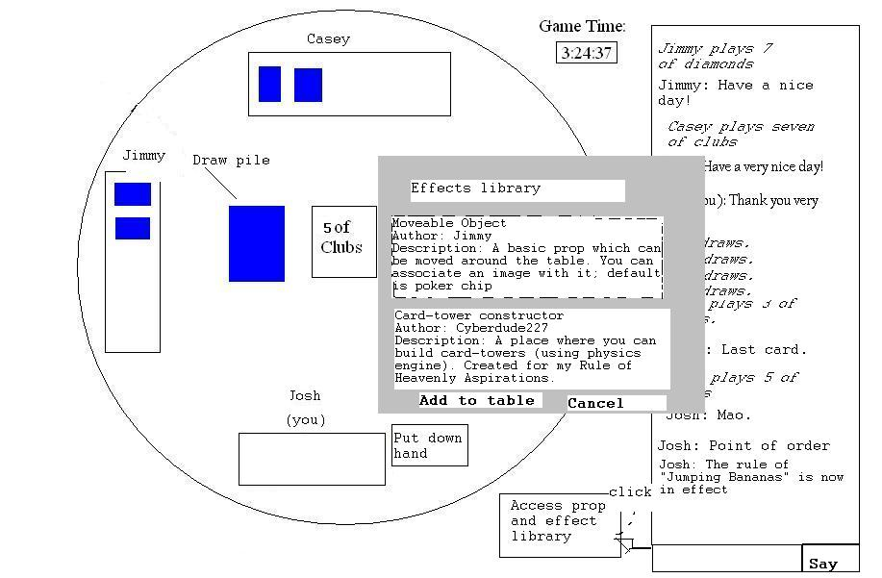
Figure 3 -- Image of player Josh's client. Josh is busy adding a banana for his new rule.
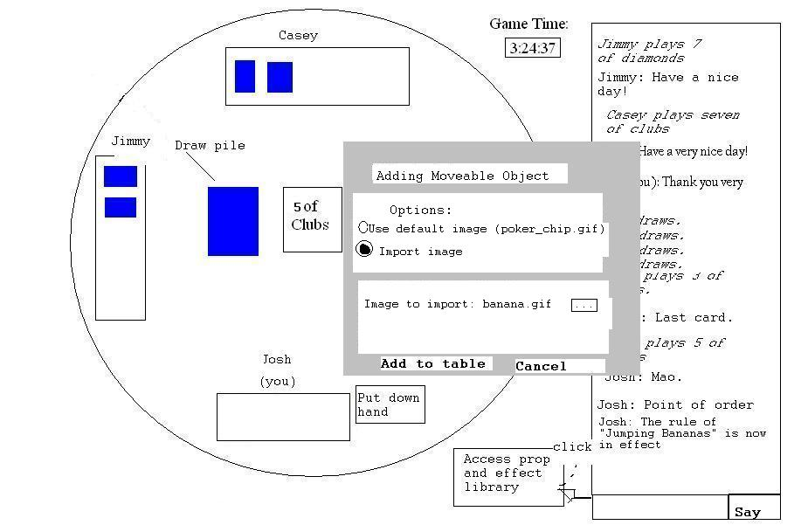
Figure 4 -- Continuation of Josh adding his banana
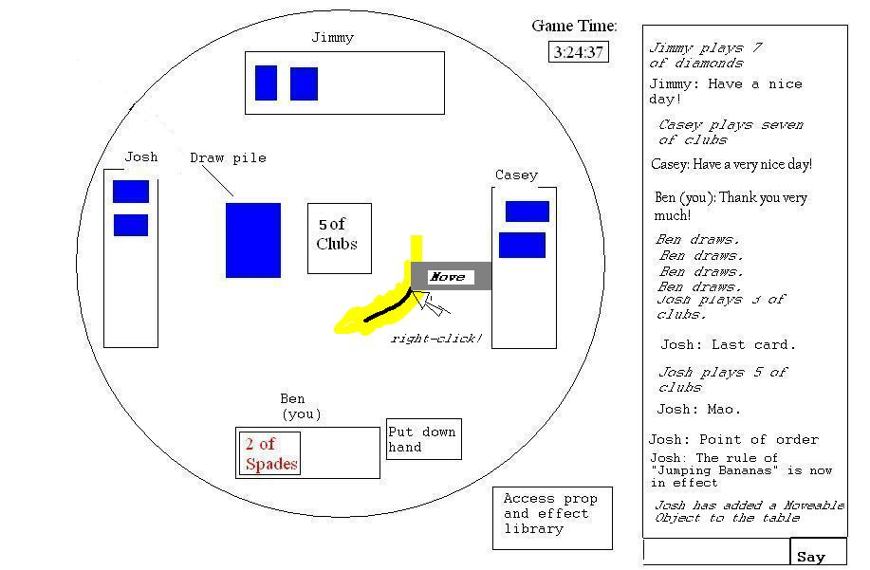
Figure 5 -- Josh has added his banana, which is now visible from Ben's client. Right-clicking reveals it has the "Move" action

Proposal 3: Table System

All of my interviewees independently came up with a virtually identical system. Like the above scripted system, this one would be played via a client, with players displayed around a table holding hands, with primarily text-chat communication and potentially voice chat; however, rather than depending on a scripting system to create functionality, this system would attempt to mimic the table environment of a card game as closely as possible by providing mechanisms for moving around cards. Instead of a rigid concept of a pile, there is a concept of a bunch of cards roughly on top of each other; instead of a rigid concept of playing, there is a concept of moving a card onto a pile denoted as the playpile. Under this system, effects that required scripting under proposal two such as creating new piles, placing cards a certain way, and flipping the playpile upside-down would be easily possible under the general mechanics of moving, rotating, and changing cards between face-up and face-down in a manner that more naturally corresponds to the way these actions are implemented in real-life. (Of course, in order to make things such as flipping a pile upside-down or moving a pile, there would have to be a concept of performing a transformation on every card in a pile). When asked how to handle basic props such as a poker chip (used in a certain rule to track which players can use a certain ability), all interviewees responded with something along the lines of needing to add a basic moveable prop (which one described as a “custom card”). (One suggested also making available a few other simple props such as dice.) Beyond these basic table, prop, and communication mechanics, little would be necessary to play other than an innate concept of hands (i.e.: cards that act face-up only to a single player).
In order to more fully convey the real-life table experience, players would need to be able to see what each other was doing. To that end, after the first interview, I created the idea of a unique cursor in the shape of a hand for each player that would be used to carry out the various actions, with each player able to see the smooth movement of other players’ cursors to the maximum extent possible without lag issues. The second interviewee agreed this was a good idea, and the third independently came up with it. The hand-cursor would increase immersion, and carry over aspects of the informal, fun nature such as jokingly handing the creator of a difficult rule a penalty card for “being evil.”
This system has many advantages. In addition to being highly flexible in what it can do, it carries over the intuitive real-life notions of how things are done, and thus can implement a very lifelike Mao experience. Additionally, it is easily flexible enough to play virtually any card game, opening a wide-array of potential opportunities for expanding the userbase to significant levels. However, it has the disadvantages of requiring a highly fine-tuned user-interface to maintain levels of friction low enough to make use of the system fun, could be prone to lag due to the cursor system, would still need to add a scripting system a la proposal two in addition to the table environment for very odd effects such as building card-towers, and would still have no chance of being able to fully mimic the full physical environment of Mao in which effects such as stroking another player’s hair are possible. Nevertheless, the difficulties are likely surmountable and the limitations minor or inevitable enough that I feel this system is far superior to the others, and thus plan on building it.

