A3 – Prototype Solution

This system can be split into two parts – the online interactivity capabilities, and the table environment and the way of interacting with it. The online features are fairly generic, and, while certainly necessary for smooth play, it’s not the defining feature that makes this application unique. It is of the essence that the table environment and its controls be fluid in order to facilitate a fun Mao experience, and thus I have chosen the mouse controls as the target of my prototype.

Design

I wrote a document containing my thoughts on control schemes for my end-users to respond to when I sent them the prototype. In it, I outlined what I thought the final control system would have to be able to do:

- The ability to pick up and drop multiple cards (plus a good way to see what you've picked up). Dropping a card will, by default, drop the last card picked up; a way to drop an arbitrary card being held is not necessary.
- Dragging a card should allow one to move it without picking it up (is often more convenient than pick-up and drop -- Java requires the mouse to be held still during a click, as it will not register as a click).
- Rotating cards is a must, especially if the table is implemented as I visualized -- like in real-life Mao, everyone will be sitting in a circle and placing their cards facing away from them (the view of the table is rotated for each person so that "away from them" appears to be straight up-and-down).
- There should be a convenient way to pick up several cards from a pile or the entire pile, and to drop all cards
- There needs to be a way to turn cards face-up, or face down, and to turn an entire pile upside-down.
- There needs to be a way to put cards in your hand. Face up-cards should be placed in the hand facing away from the player (everyone but player can see it); face-down cards should be placed in hands facing toward player. There should be a way to place face-down cards into the hand face-up (as I mentioned in some of the interviews, may be necessary for an interaction between the rule of Yuri's Revenge I've been thinking of and Witchhunts).
- There needs to be a way to pick-up and drag cards from your hand.
- There needs to be a way to turn your hand either toward you or away from you.
- There needs to be a mechanism to put down the hand. Putting down the hand face up is not necessary.

For the prototype, my goal is to implement a simple system demonstrating points (1) and (2) minus the display of picked-up cards. Cards will be represented by randomly colored rectangles; I will create a sandbox in which they can be carried and dragged around, along with a button to add more rectangles to the sandbox.
The control scheme for the prototype will be as follows: Left click picks up a card, right click drops the last picked-up card, any click drags.

Screenshots Demonstrating Prototype

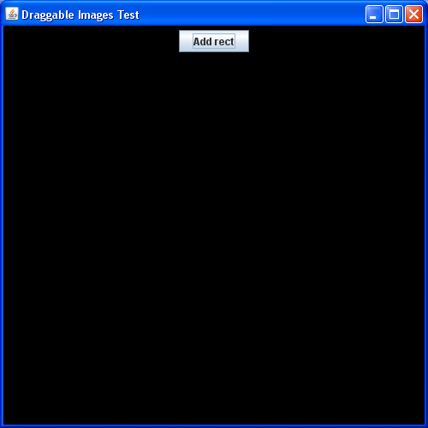

When the program loads, there is a blank black canvas save for the “Add rect” button.

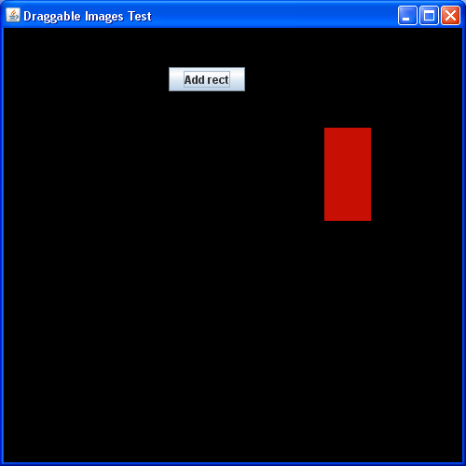

Clicking the button adds a randomly-colored rectangle to its immediate right. Although not visible in this screenshot, after having clicked it, it will move so that its center is at my mouse – I have “picked it up.”

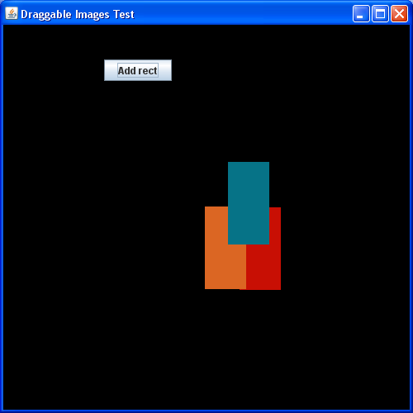

I added two more rectangles and dropped them using right-click into this configuration.

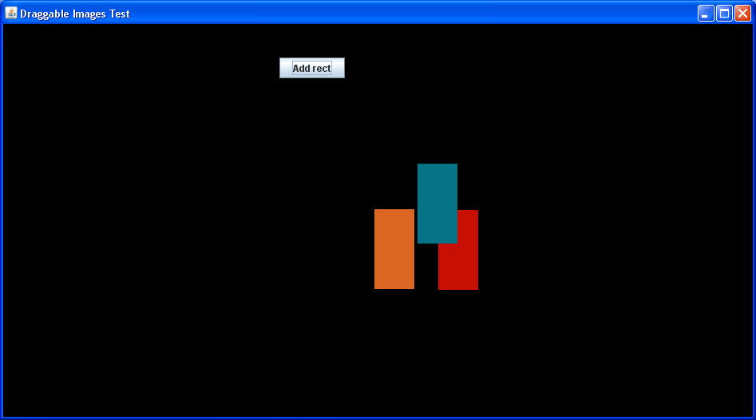

Normally, locations are represented as the number of pixels from the top left of the screen to the top left of the widget. However, because it’s important the table act the same for people playing with different window sizes, I tried out representing it as the percentage across the screen the top left corner is, so they move proportionally with resizing. However, notice how that can cause overlapping (i.e.: in the same pile) cards to cease to overlap. If I use this system in the future, I will have the size of the cards change with resizing as well so that this does not occur.

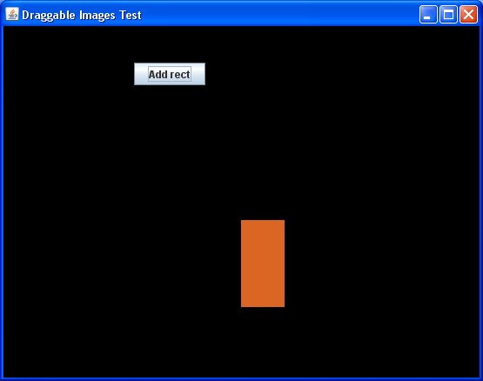

I de-resized the window and clicked on each card to pick them up. Note how only one is visible – in the prototype, picked-up cards overlap perfectly.

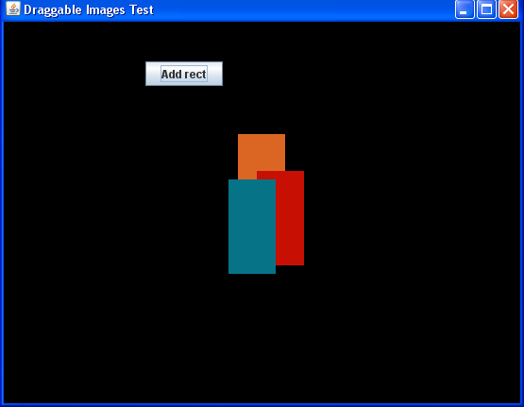

Nevertheless, while only one was visible, they were still all there, as I was able to drop them back. Notice how the card on the top in the previous image is on the bottom in this one. That’s because the most recently picked up card is displayed on top of the picked up cards, and is the first to be dropped.

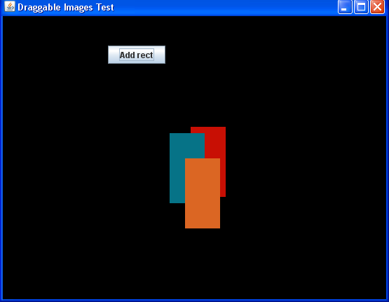

Nonetheless, although it was on the bottom, I was able to drag the orange one on top (take my word I was able to move it with click+drag rather than picking it up and dropping it). This is consistent with the ability in real life to pick up an exposed card even if it’s not on top of the pile. However, note that this prototype has no concept of piles as a unit other than some cards need to be displayed as being on top of others.

End-user Feedback

The prototype was sent to my end-users along with the short instructions for it and my control scheme proposal document, which began with the goals quoted above and continues as follows:

Actions on "piles" will refer to one of the following rigorous ways of saying that cards are in a pile:

Rigorous definition of pile #1 (recursive definition):
1)A card is in the pile if it overlaps with any other card in the pile
2)The card directly below the mouse is in the pile

So, e.g.: if you arrange cards in a fan in front of you, all those cards are in the same pile. Even if you arrange them in a triskelion or some other branching structure.

Rigorous definition of pile #2:
A card is in the pile if its boundary overlaps with the card directly beneath the mouse

So if you have a really messy pile that wavers left and right a little and has one card sticking out a fair bit to the right and the top card sticking out a fair bit to the left, the former card will not be in the pile.

Perhaps there's some other definition so that a triskelion is not a pile but an ultra-messy one is, though IMHO the firstr definition is sufficient for normal play (Metaprime is the only rule I've seen that involves laying cards in a fan, though they were still treated as a pile)

Here are two complete control schemes. Each is an assortment of thoughts I've had on the best ways to do each action, so the absolute best will likely mix-and-match the two (as well as outside suggestions)

Proposal #1:

Left-click to pick up a card; right-click to drop
Left-click+drag to drag
Double-click flips everything picked up over
Click+hold to continuosly pick up cards at an ever accelerating frequency (thus quickly picks up piles)
Right-click+hold to drop cards at an ever accelerating frequency
Mouse wheel rotates cards
Your hand is displayed in a separate section at the bottom of the screen; drag cards into that section to place them in your hand, and out of that section to take them out of your hand
There are buttons to show your hand and put it down; there are also buttons to perform many of the above actions (so you don't have to memorize this). Unlike below, there cannot be right-click menus for obvious reasons.
For Mac users, arrow keys function like mouse wheel. (Macs naturally have Command+click as a simulation of right-click.)

Proposal #2:

Click on a card to pick it up; click again to drop.
Shift+click to pick up a second card; ctrl+click to drop the last card picked up (yes, redundant with normal clicking)
(Potentially, left-clicking over a pile picks up unless Ctrl is held, left-clicking over space puts a card)
Left-click+drag to drag a card
Right-click to flip a card over
Cards should naturally wobble a little in the hand; shift+mouse wheel rotates
Your hand is displayed in a separate section at the bottom of the screen; drag cards into that section to place them in your hand, and out of that section to take them out of your hand

Turning the mouse wheel (without pressing shift) opens up a little overlay that shows everything you're carrying on one side and the pile on the other.
Turning the mouse wheel in one direction transfers cards from the pile to the hand; the other direction does the opposite.
While in this mode, normal commands perform that command on a pile -- shift+click picks everything up, ctrl+click puts everything down, right-clicking flips the pile over, et
There are buttons to show your hand and put it down; there are also buttons and/or right-click menu options to perform many of the above actions (so you don't have to memorize this)
For Mac users, arrow keys function like mouse wheel. (Macs naturally have Command+click as a simulation of right-click.)

My users unanimously agreed Proposal #1 was superior as was pile definition #1. On the prototype, one suggested the cursor be aligned with the top left of held cards instead of the middle and the ability to drag a card while holding others be removed. With that removed, now holding the left mouse button could be made into a “suction function” which picks up cards faster and faster as suggested in the proposal, but could now be done while moving. Meanwhile, holding the right-mouse button could drop cards while moving. He also suggested using middle-click to flip a card and simultaneous right+left click to pick up a whole pile. I had forgotten about middle click and like that suggestion; however, I find simultaneous click unintuitive and awkward, not to mention potentially impossible for Mac users with single-button mice.
Another end-user suggested using modifier keys as part of the controls. She suggested having ctrl make an operation act on a pile or everything you’re carrying as relevant, and shift flip a card over before performing that action. So, for example, Ctrl+Right-click would place everything you’re holding face up on the table, while Ctrl+Shift+Right-click would place everything you’re holding face down on the table. I think there’s lots of merit in that; however, I have a fair bit of animosity towards a keyboard+mouse control combination, as I personally know that something about that posture makes me tense and, if shared in any sizable fraction of the population, would subtly hamper the casual feel of the game.

