D1 – Annotated Hard Copy Output

Notes:

As an online program for which many of the requirements involve smoothness of rendering, capturing the requirements in still screenshots can be very difficult. Furthermore, one of the most important requirements is consistency – the tables across different clients should act as if they were a single table, displaying the same except for a rotation. However, since the rotated perspective was not fully implemented, that means that the goal of having the program work correctly necessitates the different windows looking indistinguishable, meaning taking screenshots from different computers running the program would prove nothing.

Thus, instead of running this test on multiple computers, I will run three separate instances of the program simultaneously, and have the latter two connect to the first. (This is frequently done in the testing of web programs – in fact, there exists a special IP address “127.0.0.1” which creates a standard mechanism for a computer to connect to itself over the Internet.) Though each instance is meant to take up the entire screen, I will do my best do have the relevant portions of each client running in each screenshot.

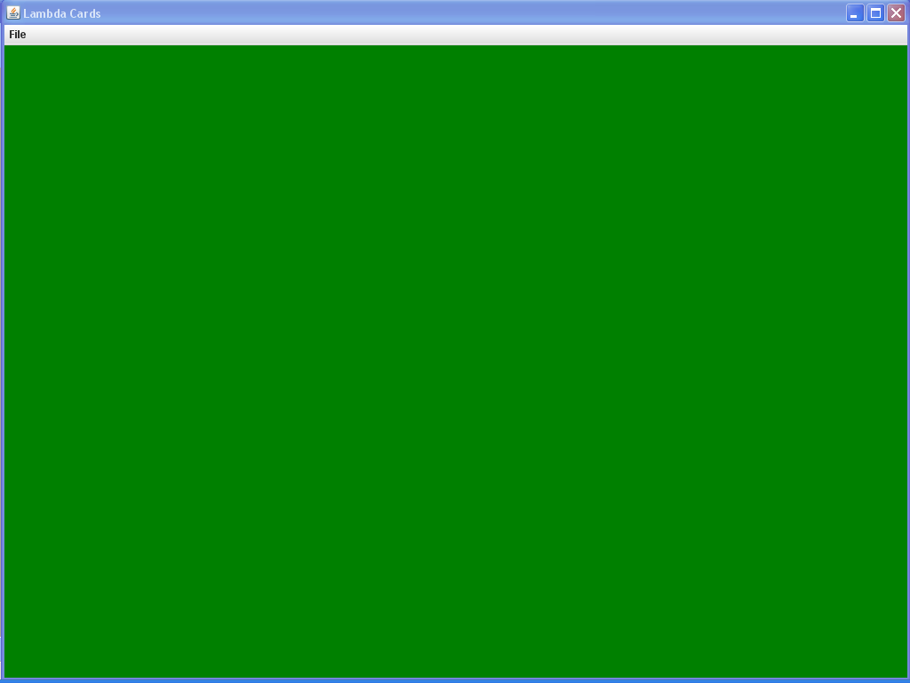

Screenshot 1: One instance of the program on startup
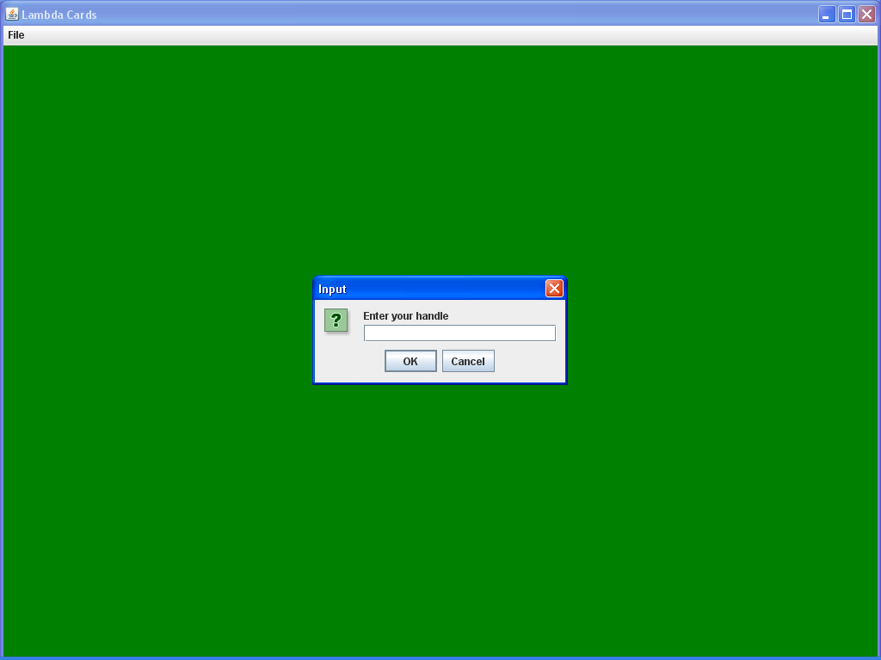

Screenshot 2: The dialog opened by the File->Host a Game menu.

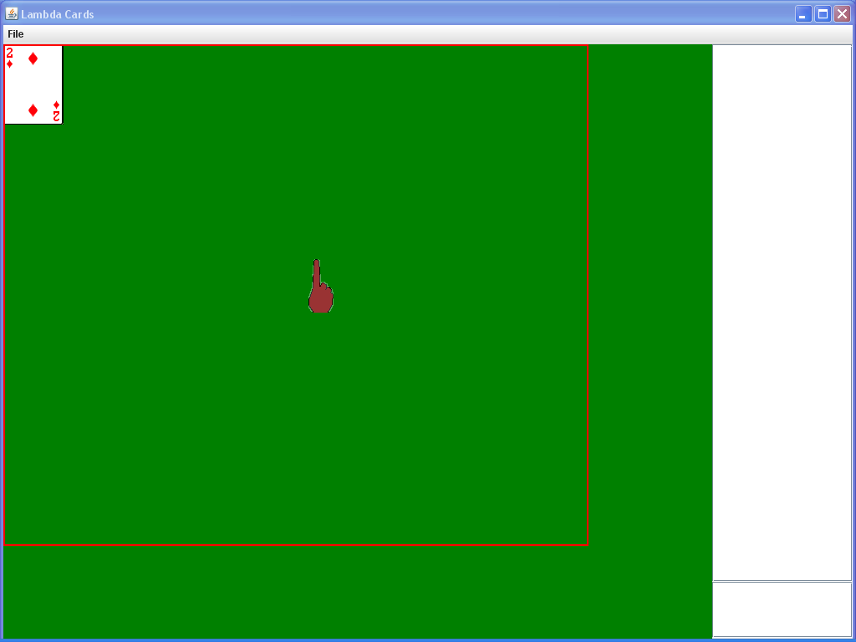
Screenshot 3: The first instance has begun hosting a game using the name “Alice.” When a game is created, a chat box (right) is created, as well as a table object (marked by the red border), and the player is given a red manipulator (hand-shaped cursor). The current version begins with a shuffled deck of 52 cards face-up in the top-left corner.

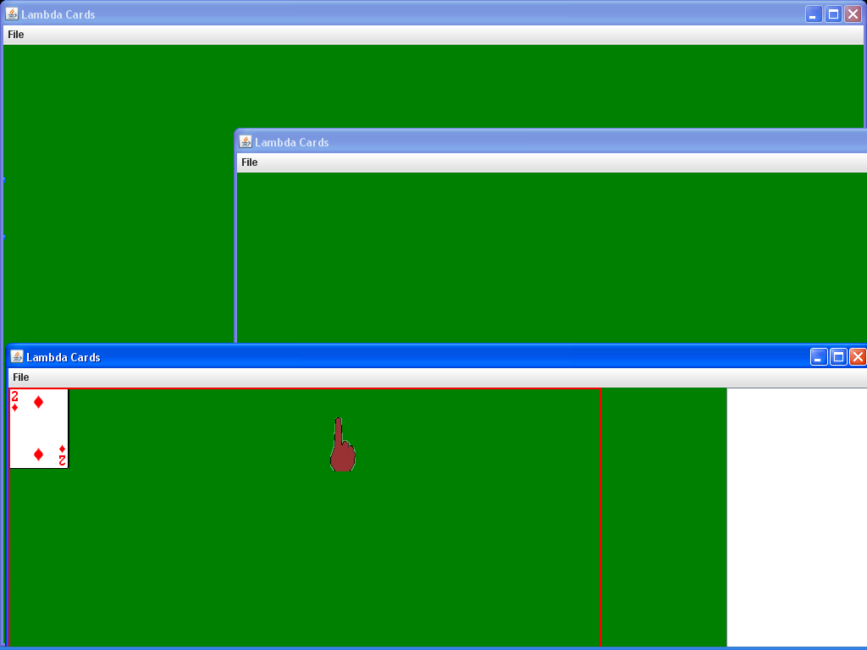
Screenshot 4: Opening two more instances of the card-game player.

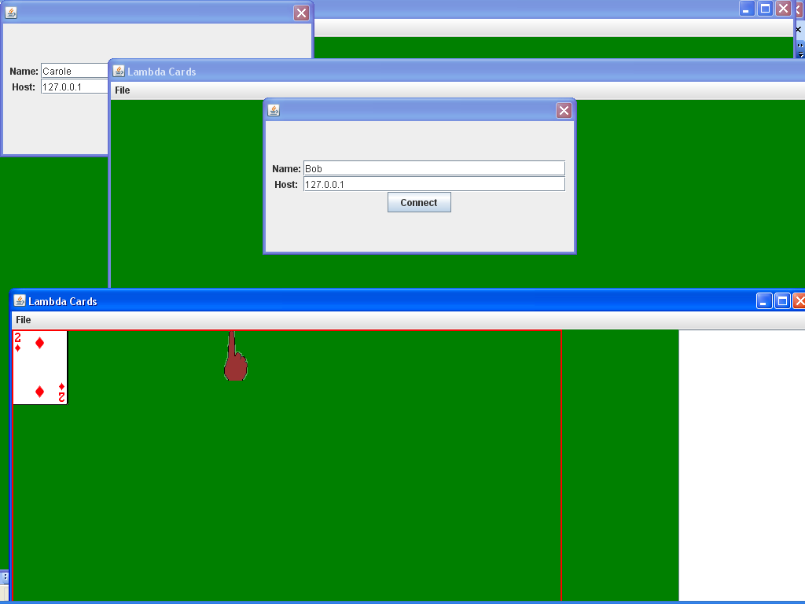
Screenshot 5: Both other instances have gone to the File->Connect to a Game menu, and have entered in their handles and IPs.

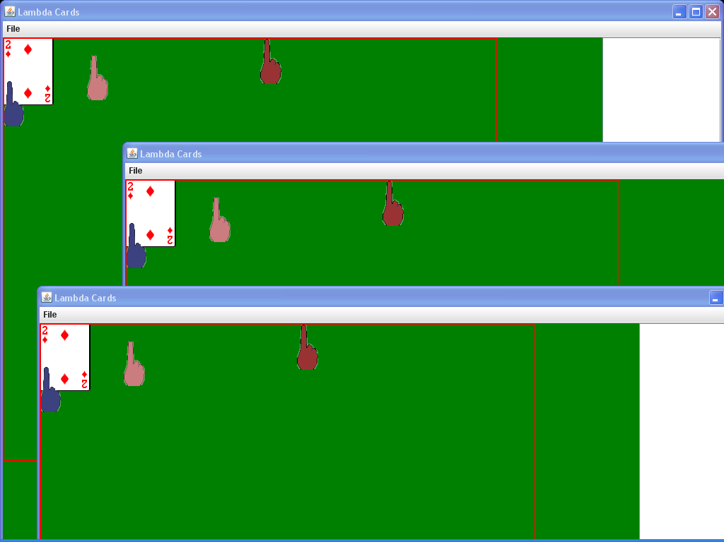
Screenshot 6: Both other instances have connected, and now all three instances are constantly communicating actions so that the table will look the same across all three. The pink manipulator belongs to Bob, and the blue Carole.

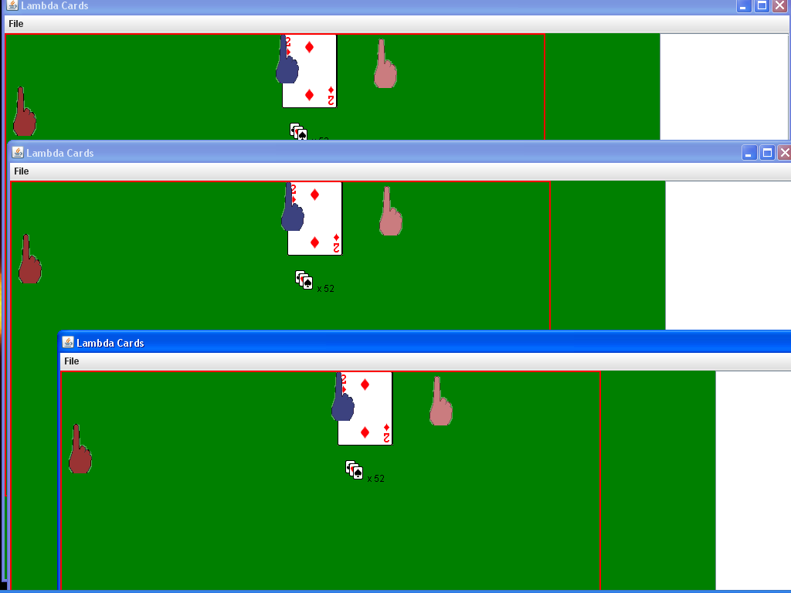
Screenshot 7: Carole has used Ctrl+Left click to pick up the entire pile of 52 cards. Notice how the icon below denotes that he is holding 52 cards. Since one cannot see the cards move along with Carole’s manipulator in a screenshot, the icon is the only indication that Carole is carrying those cards (as opposed to merely resting her mouse over them).

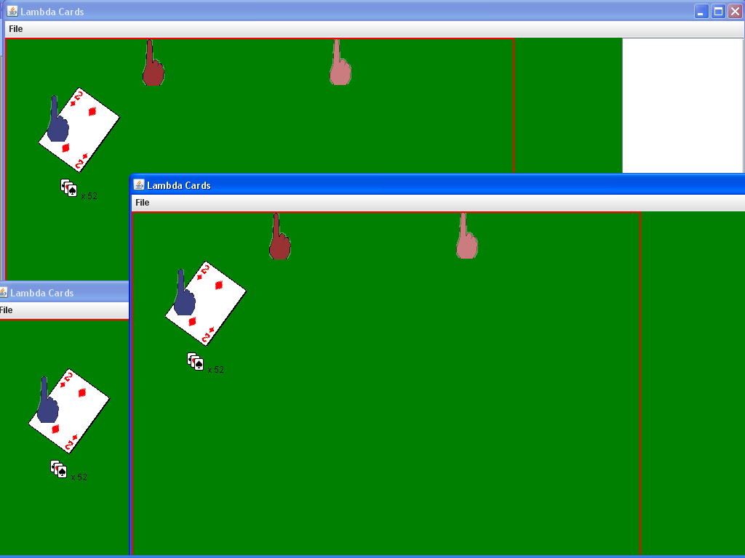

Screenshot 8: Carole demonstrates the ability to rotate carried cards using the mouse wheel.

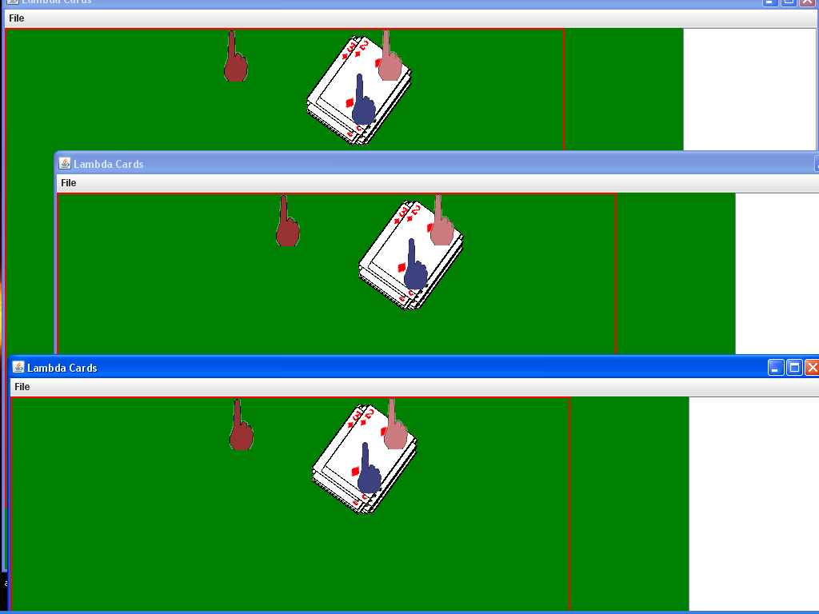
Screenshot 9: Carole has performed the standard pile-drop using Ctrl+right-click. Note how each dropped card has moved randomly a small amount as if the pile were dropped from 6 inches above the table, making it visually apparent that this is a pile of cards, whereas before they overlapped perfectly.

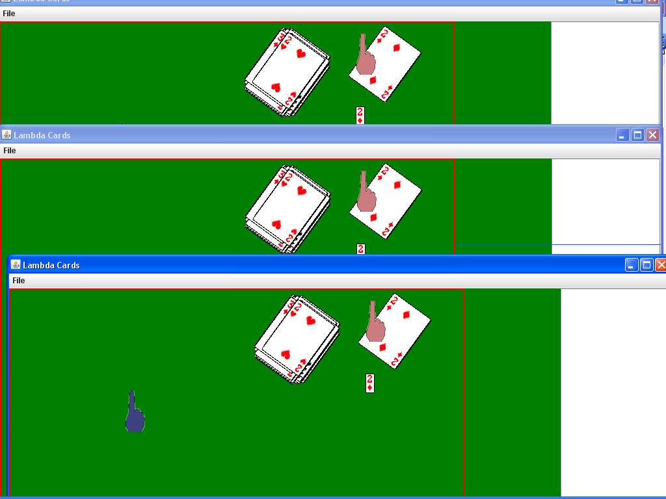

Screenshot 10: Bob demonstrates the ability to pick up a single card using Left-click. Notice how the icon below his manipulator depicts what he is holding.

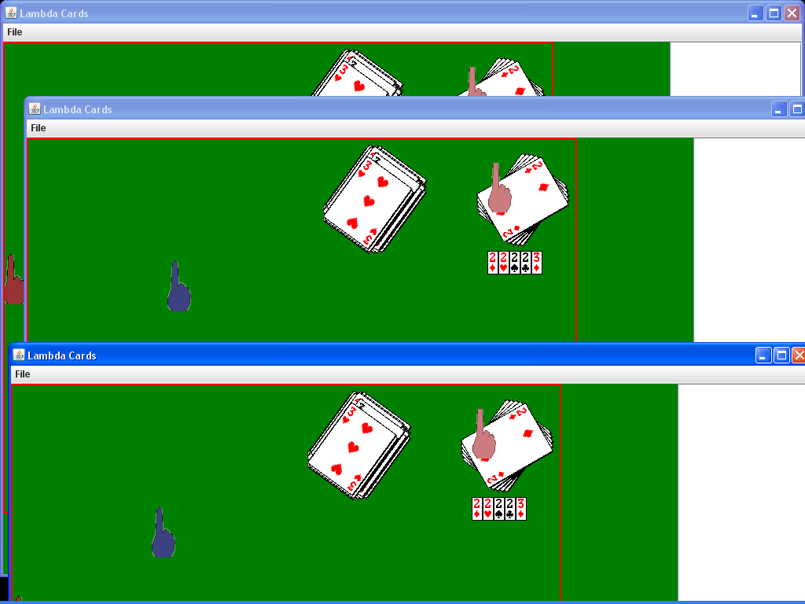
Screenshot 11: Bob has picked up four more cards, rotating what he was carrying a little before picking up each one so as to make it visually apparent he is carrying five cards. Note that the order of the icons below his manipulator correspond to the order he picked up the cards.

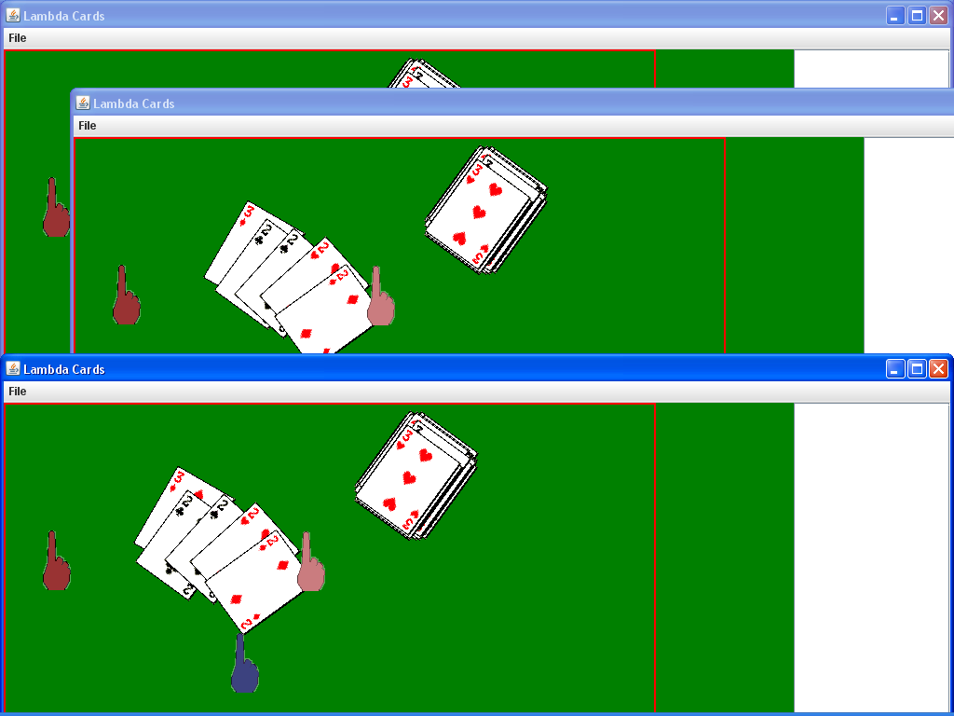
Screenshot 12: Bob demonstrates the single card put-down via right-click.

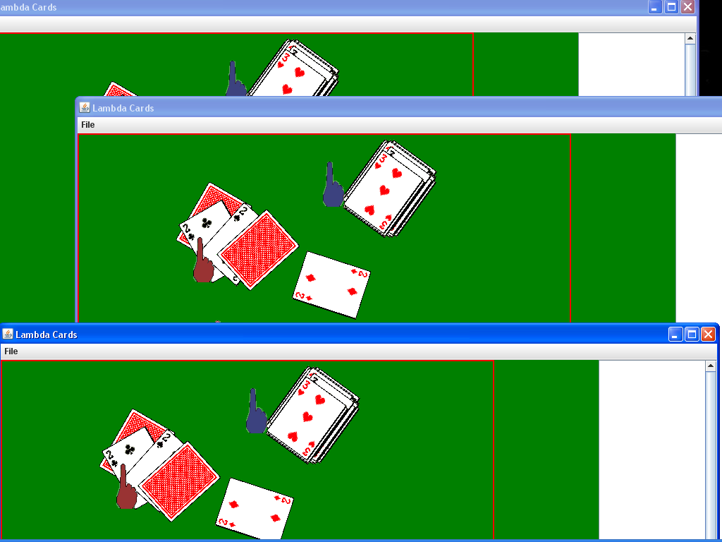
Screenshot 13: Alice has demonstrated the ability to flip and rotate single cards on the table.

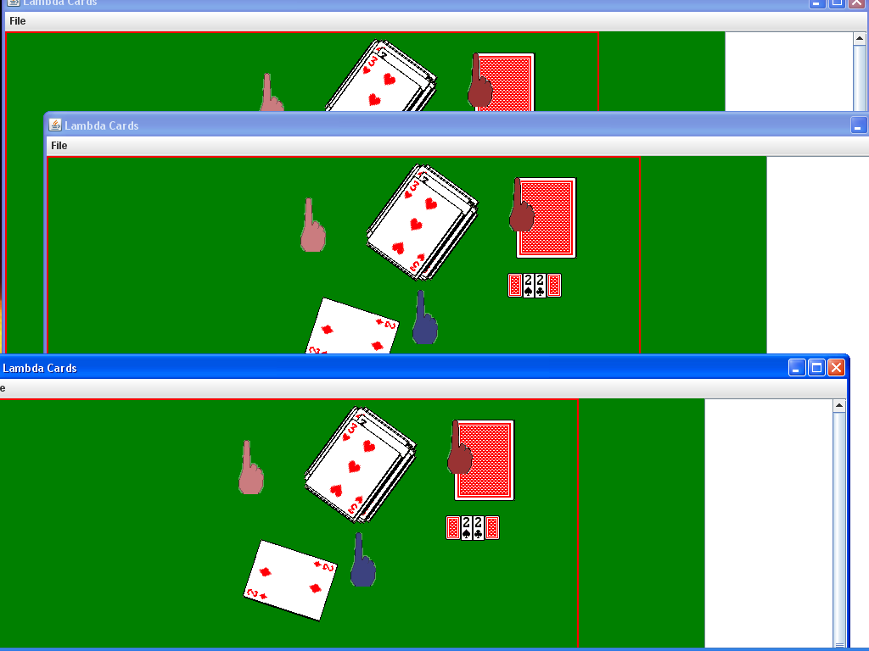

Screenshot 14: Alice has demonstrated the “straightening pile-pickup” – that via Ctrl+Alt+Right-click one can straighten a pile of cards as one picks it up – as well as how pile-pickup works even when piles are oddly shaped, as the were above. Notice also how the icons correspond to the order the cards were in the pile, and how face-down cards are given face-down icons.

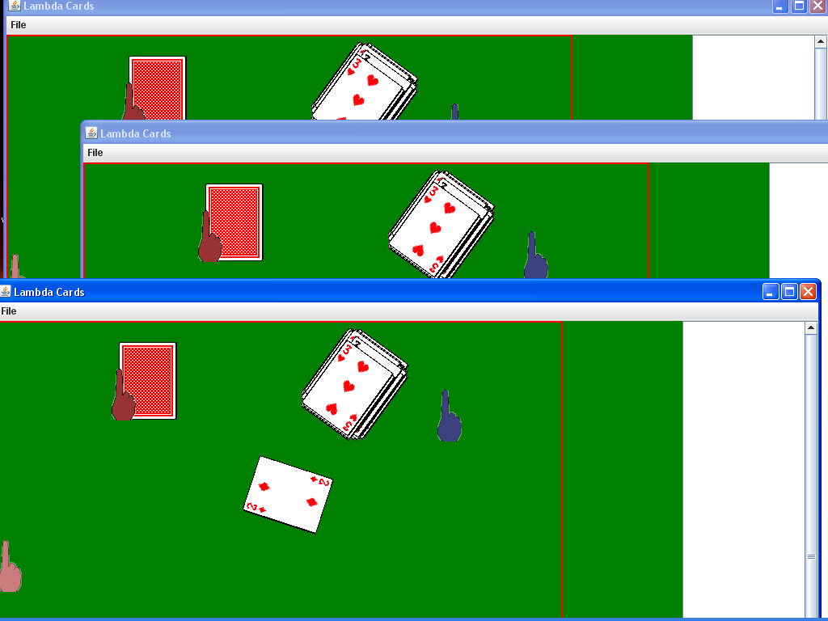

Screenshot 15: Alice has demonstrated the “careful” pile put-down – by holding Alt in addition to Ctrl during her right-click, she was able to put down all the cards she was carrying without the small random movement seen in the first example.

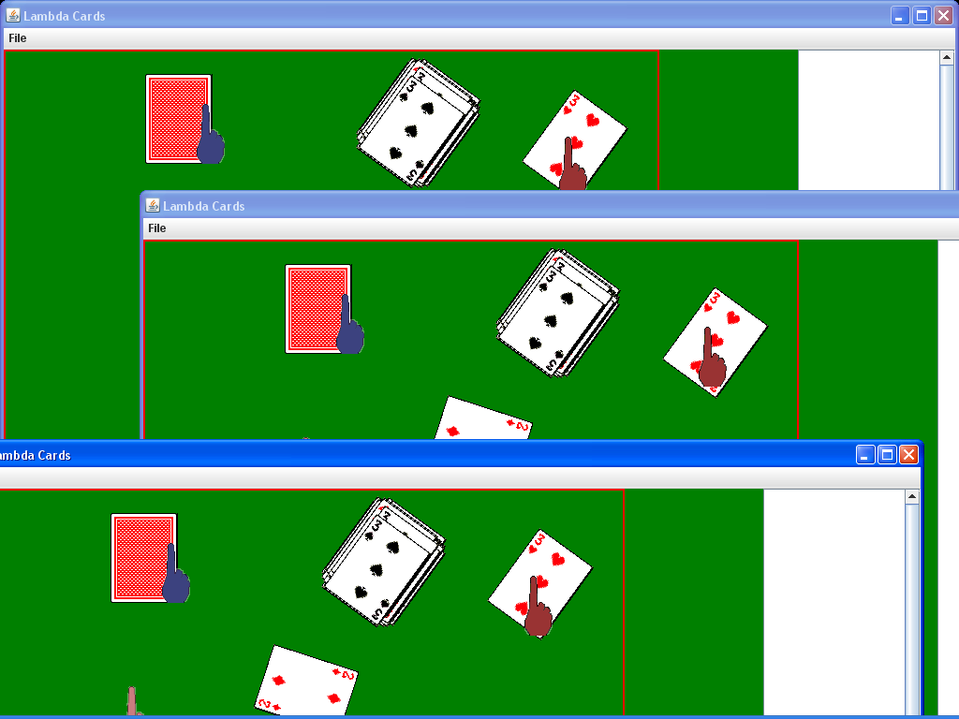

Screenshot 16: Though it may not be apparent in a static screenshot, Alice is currently dragging the 3 of Hearts.

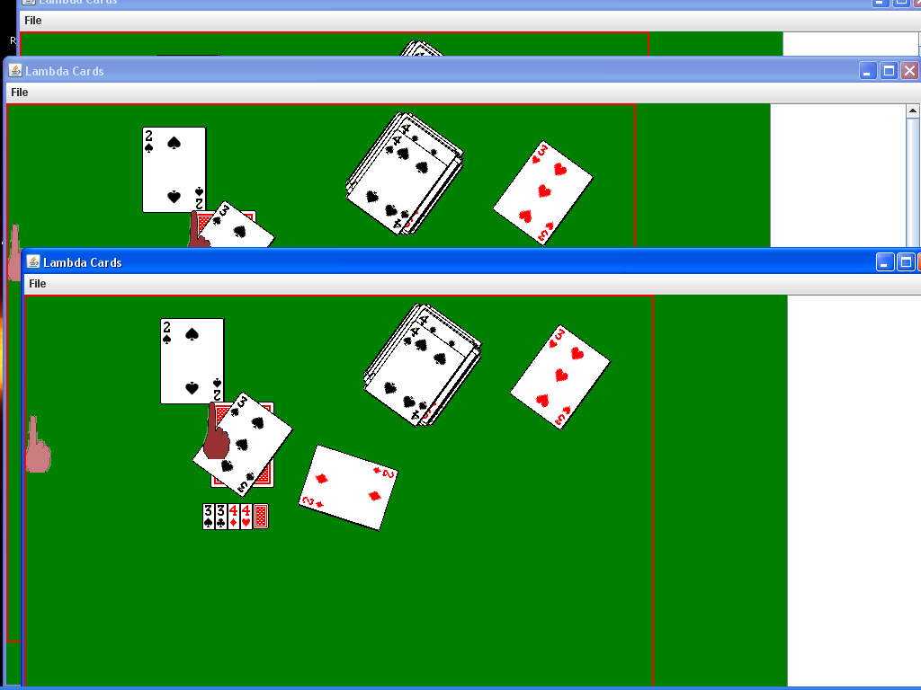
Screenshot 17: This screenshot and the next demonstrate it is possible to flip cards being carried via middle-click.

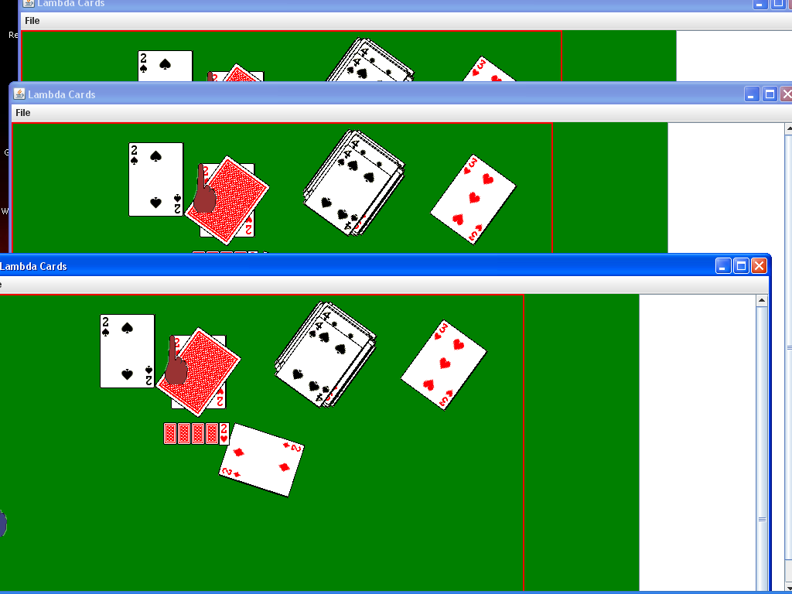
Screenshot 18: This screenshot and the previous demonstrate it is possible to flip cards being carried via middle-click.

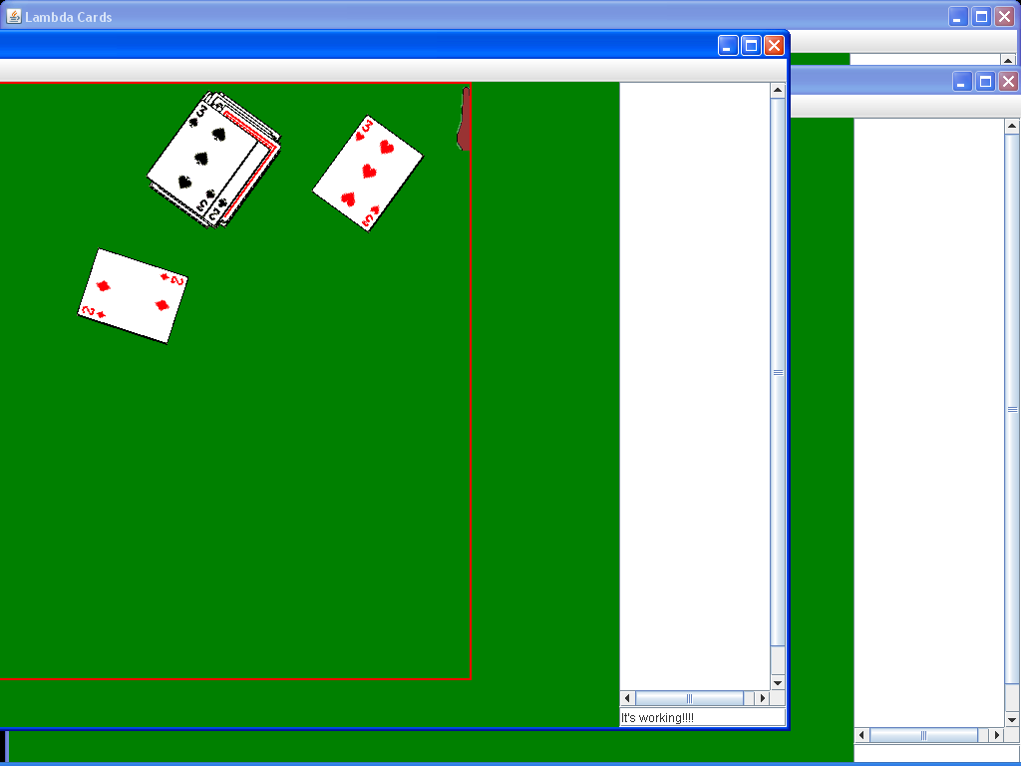
Screenshot 19: Alice is typing a message in the chat window.

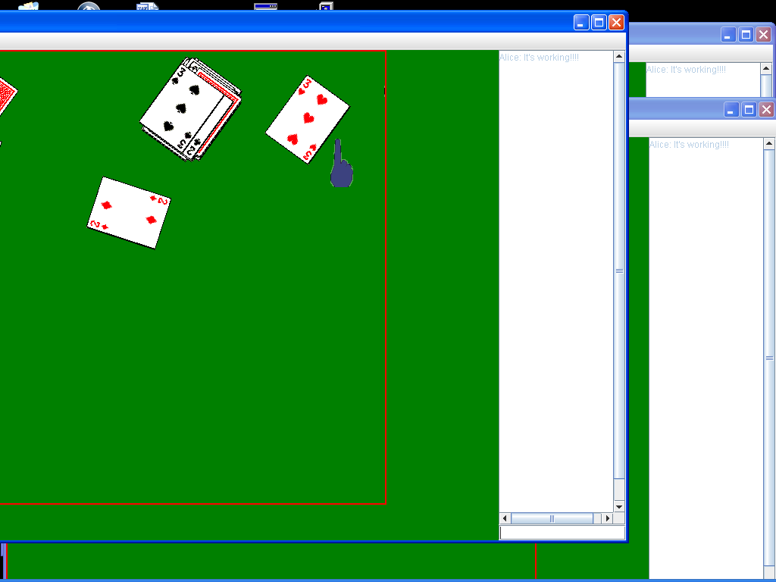
Screenshot 20: Alice has sent her message by striking “Enter.” Alice’s message is now displaying in all three chat windows.

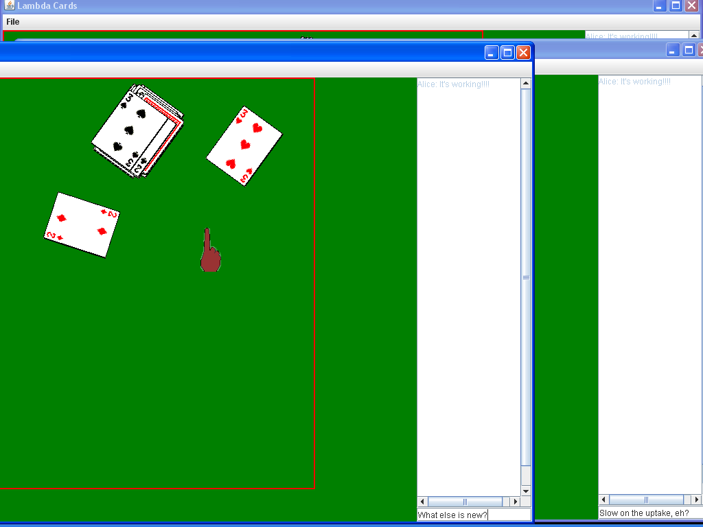

Screenshot 21: Bob and Carole are typing responses into their chat windows.

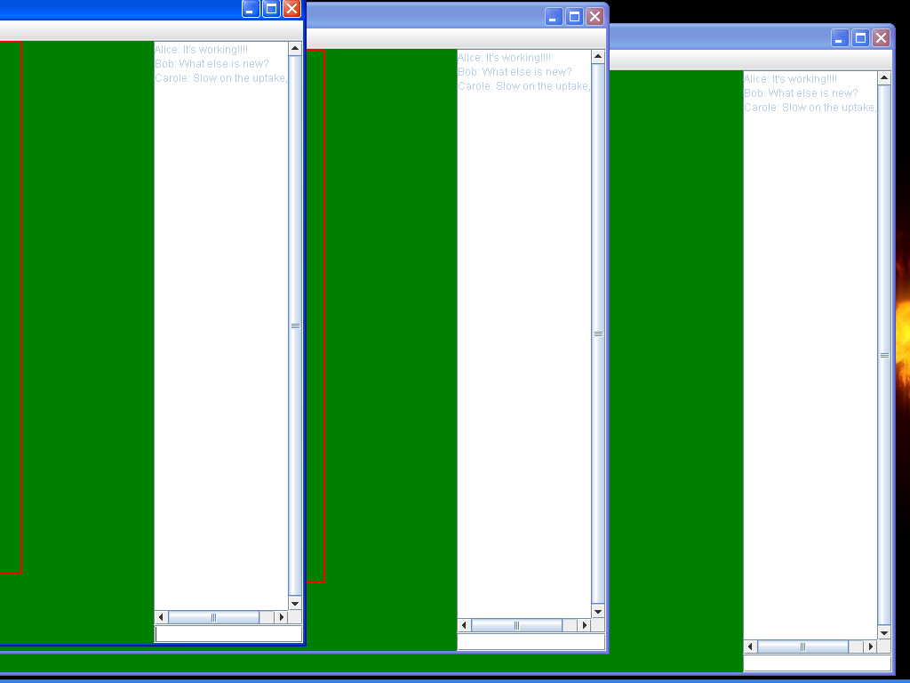
Screenshot 22: Bob and Carole have sent their messages. All three messages are now displaying in the same order in each chat window.

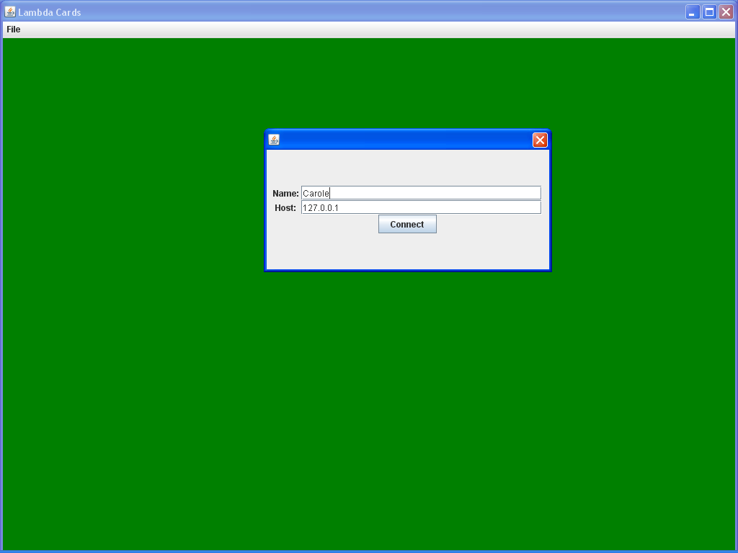
Screenshot 23: All three instances have been closed, and a new instance opened. Visiting the “Connect” dialog shows that both the last name used and IP connected to have been saved in the preferences file and loaded.

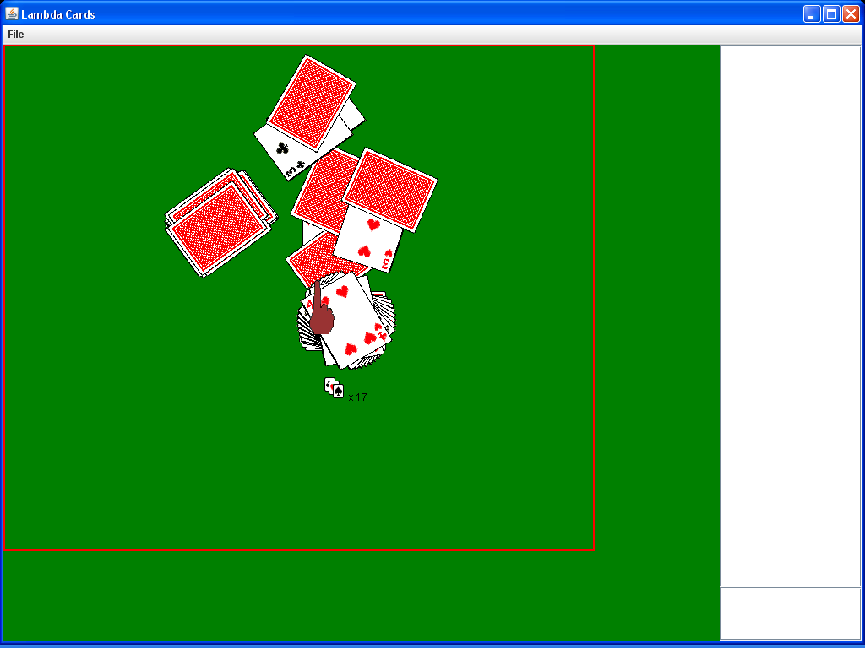
Screenshot 24: The previous instance has been closed, and a new one opened, in which a the program is hosting a game which no-one else is connected to. This is a demonstration that all manipulations of cards can be performed alone, fulfilling the “Sandbox” requirement.

