D3 – Manual

Requirements:

There are several requirements to run Lambda Cards:

- The latest version of the Java Runtime Environment, downloadable by going to http://java.sun.com and following the link to Java Se.
- A keyboard and a mouse with or other pointing device. Mice need a mouse wheel for maximal enjoyment, and other pointing devices (e.g.: trackball) should be able to simulate a mouse wheel and middle clicks.
- In order to play with others, a network connection is required. If playing over the Internet (as opposed to a local-area network), a minimum of a DSL/cable connection is recommended.

Unzipping and Running

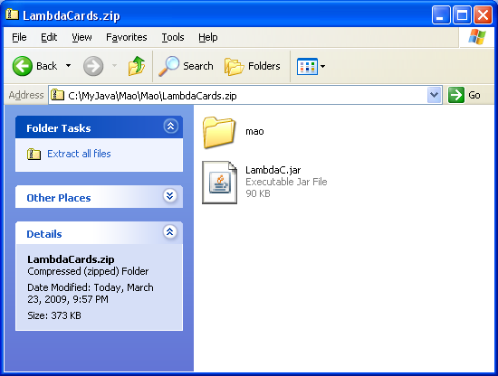

Lambda cards is distributed as a ZIP file consisting of a JAR containing of the program and a folder labeled “mao” containing another folder labeled “images” containing the images necessary to run the program. Unzipping both to the same folder then double-clicking the JAR should cause the program to run. If it does not, then open your operating system’s command prompt (in windows, this can be done by going to Start->Run and typing “cmd” or by going to File->Programs->Accessories->Command Prompt) or terminal and navigate to the folder containing the files using the cd command. Then enter the command “java –jar LambdaC.jar”.

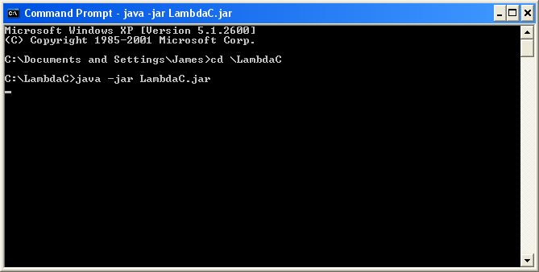

Hosting and Connecting to Games

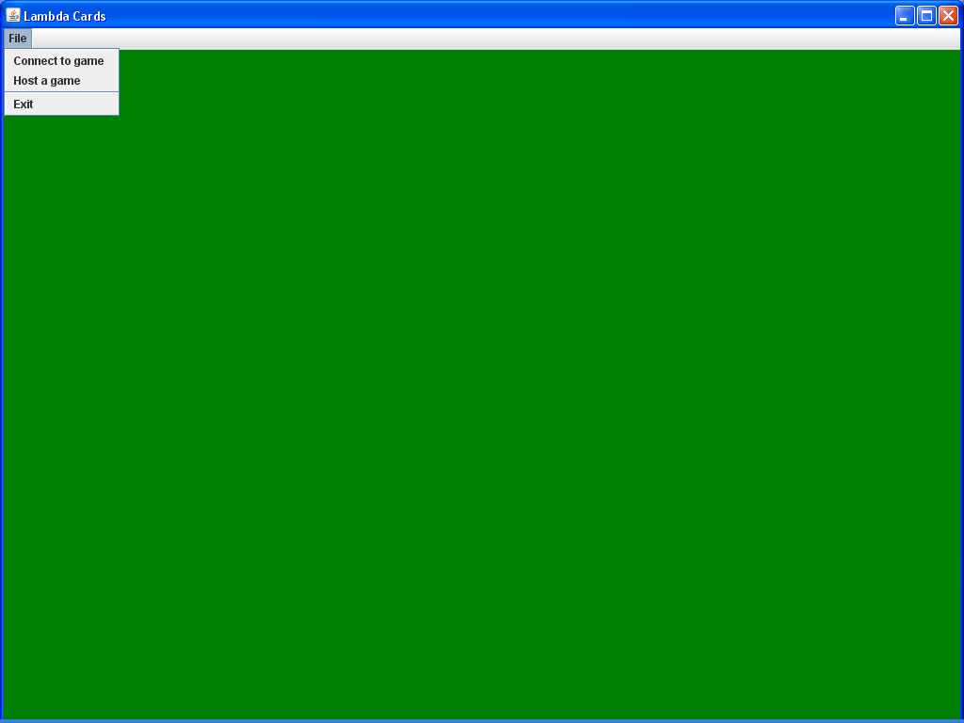
When Lambda Cards starts, you will see an empty green screen, with a single menu, File, containing the options “Connect to game”, “Host a game”, and “Exit”. To host a new game of cards, choose the “Host a game” option, then enter a handle to go by, then hit the “Okay” button. You will see a table initialize, filled with cards, and a chat-box initialize. To let other players connect to your game, you must give them your IP address (which you can find by going to http://www.whatismyip.com if playing over the Internet, or by entering the command prompt/terminal [see above] and entering the command “ipconfig” if playing on a local network). To connect to your game, they choose the “Connect to game” option from the File menu, enter a handle to go by and your IP address, and then hit “Connect”.

All handles must be 30 characters or below. The last IP connected to and last handle used will be stored in a preferences file. The values in the preferences file will appear pre-filled-in next time you host or connect, to make repeat play, or at least using the same name repeatedly, more convenient.

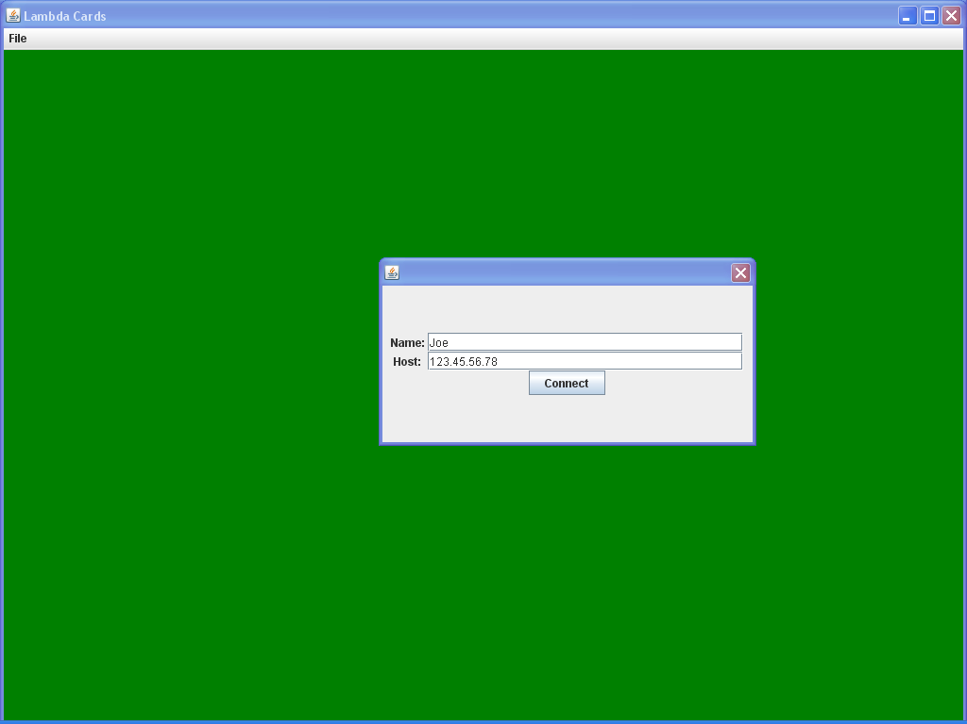

Playing

When the game loads, you’ll see either a deck of cards in the top left if hosting, or whatever state the game is in on the host’s comp if connecting. You are now in a sandbox, and can move the cards around to play any card game.

All players will have a hand-shaped mouse cursor called a “manipulator.” Just as other players in real-life card games can see what you’re doing with you hands, other players will be able to see your manipulator as you move it around with the mouse cursor.

To play games using the cards, you can perform five actions on them: pick them up, put them down, drag them, rotate them, and flip them over. Other players will be able to see you do these actions.

You can carry cards around using your manipulator. They will display beneath your manipulator, and below it will display a small icon representation of what you are currently carrying in the order they were picked up, or, if you’re carrying more than five cards, the number of cards being carried. You pick up cards by clicking on them with the left mouse button, and put them down by clicking with the right mouse button.

You can also hold down one or more modifier keys while picking up or putting down cards:

Ctrl (Pile mode modifier): If you hold down Ctrl, then, instead of just picking up or putting down the card clicked on, you will put down everything you’re holding, or pick up an entire pile of cards (loosely define to include any conglomeration of touching cards). If you pick up a pile, then Lambda Cards will place them in a linear order corresponding the how they were layed out.

Shift (Flip modifier): Hold down Shift while picking up and putting down cards, and you’ll flip them over as you do so.

Alt (Neatness modifier): Because Lambda Cards is two-dimensional, if two or twenty cards are exactly on top of each other, you’ll have no idea there’s more than one. Real life is not like that, however. To convey the sense that piles have depth, every time you put down a card, it moves a small amount, as if you had dropped it from a few inches above the table. Thus, when moving a pile of cards, it will be visually apparent you just put down a pile of cards. However, if it is important that this “drop chaos” not occur and cards are placed exactly where you want them, hold down Alt while dropping. Meanwhile, holding down Alt while picking up cards straightens them to their upright position as you do so, negating the effects of any rotations as you do so.

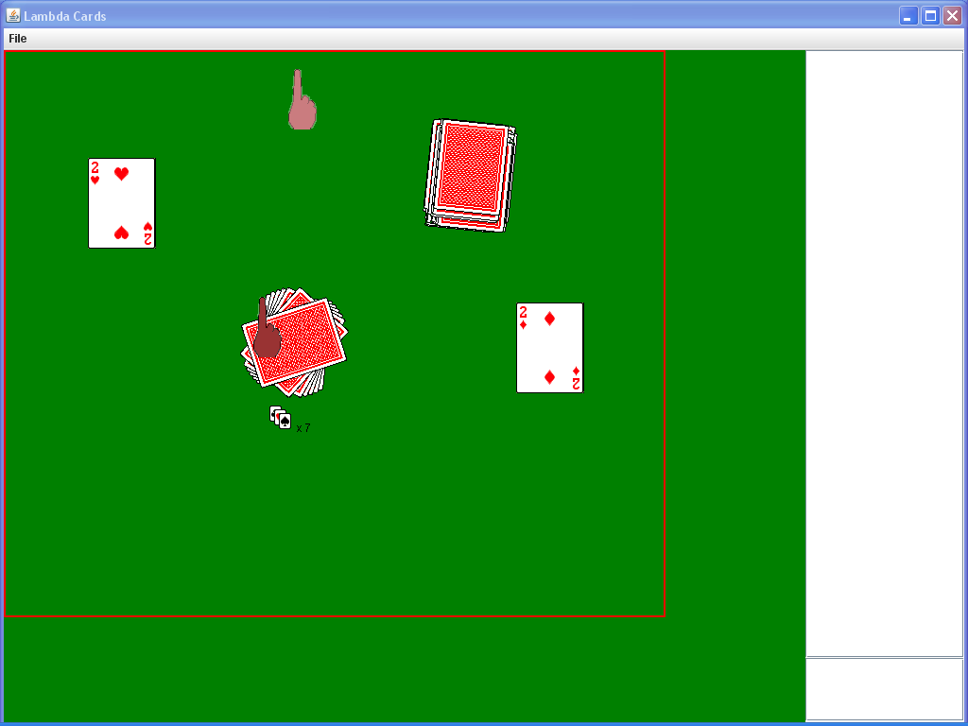

Dragging: Dragging is often a far faster and easier way to move cards around the table than picking them up and putting them down. If you are not holding any cards, then holding down the left mouse button and dragging will cause you to begin dragging any card the mouse comes into contact with. Note that you needn’t have the mouse cursor over cards when you begin dragging the mouse to drag them – by holding it down and then mousing-over cards, you can “push” and “pull” them with ease.

Flipping: Real-life playing cards can be both face-up and face-down. Middle-clicking (pressing down on the mouse wheel) flips over everything you’re carrying, or the card below the mouse if you’re carrying nothing. Holding Ctrl and middle-clicking enters pile mode – every card in the pile below the mouse is then flipped.

Rotations: You can turn cards using the mouse wheel. This rotates everything you’re carrying, or the card below the mouse if you’re carrying nothing.

Using these actions, one can play a wide variety of card games. For example, to play War, players split the deck into two piles of 26 cards, move them to opposite corners, and then sequentially move cards to the center, and flip them. The winning player then moves both cards to the side. Once the entire piles are gone through, both players take their won cards, mix them around, and the cycle repeats.

Communication

Lambda Cards has a simple built in chat feature. There is constantly a chat box to the right. Simply type in your message in the text box below, strike “Enter,” and your message will be sent to all other players.

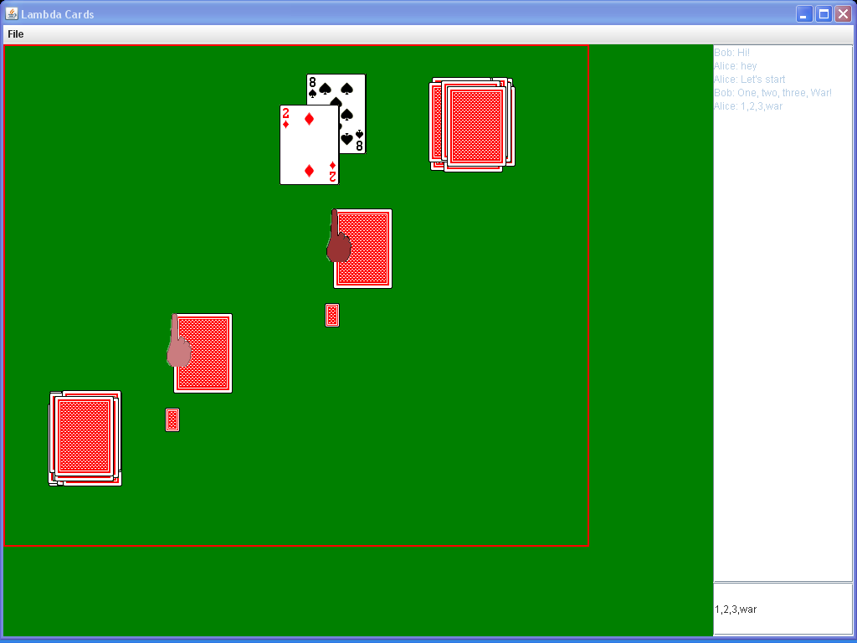

Troubleshooting

When I try to host or join a game, I get “There was trouble loading the images.”

Double-check you have the images set-up correctly. Make sure that, in the same folder containing LambdaC.jar, there is a folder labeled “mao”, containing a folder labeled “images”, containing the images.

When I try to host or join a game, I get “Error reading from or writing to the preferences file.”

If there already is a file labeled “pref.dat” in the same folder as LambdaC.jar, make sure it is the pref.dat created by this program and has not been altered by any other programs. Also make sure no other programs are using it – if you open it in a word-processor while trying to use Lambda Cards, the word processor will stop Lambda Cards from being able to read it. If there is not already a pref.dat file, make sure the folder LambdaC is in is not write-restricted. For example, at least in Windows Vista, if you have LambdaC.jar in the C:\ directory, it will be blocked from creating C:\pref.dat by the operating system. Try moving both LambdaC.jar and the images folder to another directory.

When I try to host a game, I get “Error creating server.”

This often occurs if previous instances of Lambda Cards failed to close properly. This can occur if you close it via the X-button in the top right or if it crashes – you should always close Lambda Cards by going to File->Exit. The previous instance will have already created a server program listening for connections on port 7777; this will stop new instances from creating a server. To fix this, open up the Task Manager by pressing Ctrl+Alt+Delete. Then switch to the Processes tab, and find and end any remaining processes labeled “javaw.exe.”

When I try to connect to a game, I get “Trouble connecting to server.”

There are several reasons this can occur. The simplest reason is that the computer on the other end is not hosting – make sure you have the right IP address and that the computer you are trying to connect to is currently hosting a game and its server has not crashed.

Another common reason is firewalls. Make sure neither party’s firewall is blocking Lambda Cards. Disable them if necessary.

A third reason is if the host is playing behind a router. He will need to forward the port 7777 to his computer on the local network. For details on how to do this, visit http://www.portforward.com.

