**Figures**

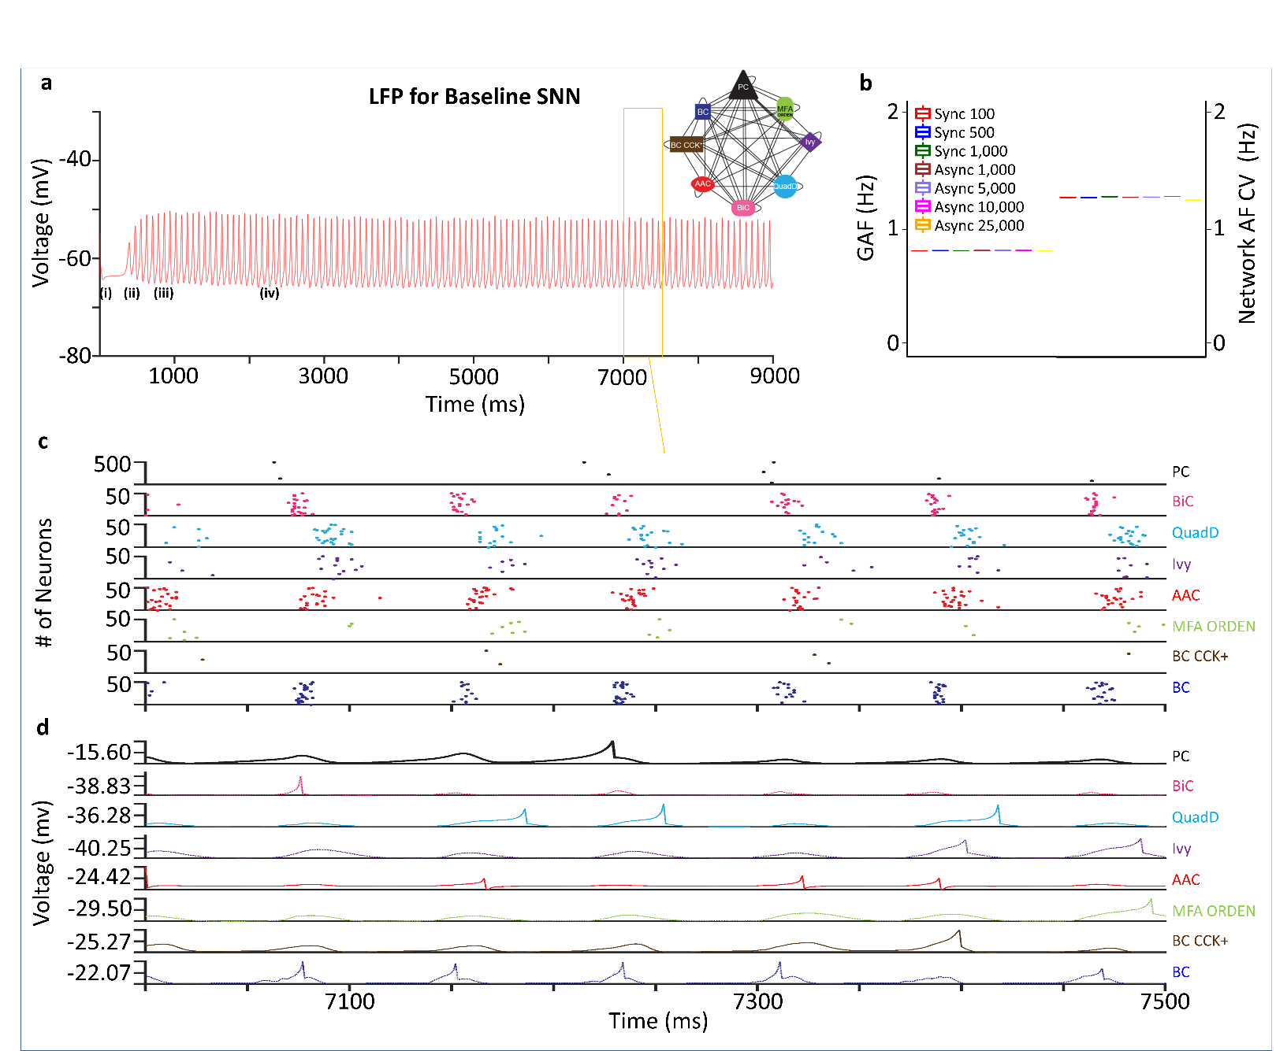**Fig. 3**

Population activity for CA3 spiking neural network. **a** First approximation LFP activity. Synchronous stimulation leads to transient network depolarization (i), followed by integration of currents propagating throughout the network for the next 500 ms (ii). With a large number of pyramidal cells above firing threshold, the network experiences a population burst (iii), before settling into a steady rhythm that will persist for the duration of the recording (iv). Inset: Connectivity schematic for the baseline network. **b** Summary plots for both synchronous and asynchronous stimulation detail low firing rate variability (< 0.1 Hz), and low network CV (< 1.5), indicative of a stable and robust network. **c** Raster plot of 500 ms activity from **a** (yellow frame) of 500 Pyramidal cells and 50 interneurons of each type. **d** Representative voltage trace for each neuron type during 500 ms activity from **a**.

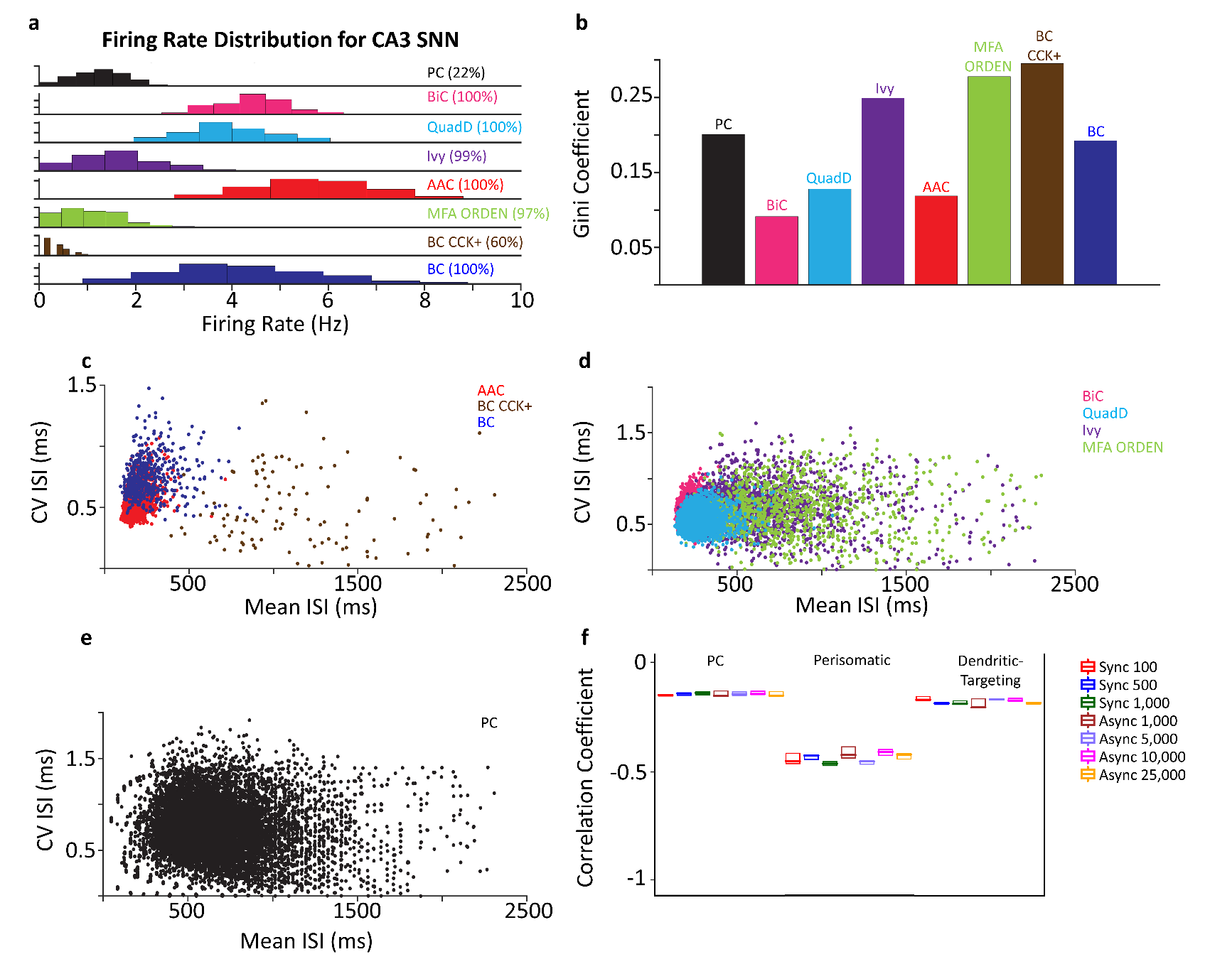**Fig. 4**

CA3 spiking neural network firing characteristics. **a** Mean firing rate distributions of the neurons active during the recording window in each type. Percentages in parentheses indicate active fraction. **b** The Gini coefficient shows how unevenly individual neurons contribute to the overall firing rate of their respective type. **c-e** Scatter plots of the coefficient of variation (CV) of the ISI of every neuron in each type as a function of its mean ISI displayed for perisomatic (**c**), dendritic-targeting (**d**), and Pyramidal cell types (**e**). **f** Box plot of correlation coefficients for perisomatic, dendritic-targeting, and Pyramidal cell types with varying levels of synchronous and asynchronous network activation.

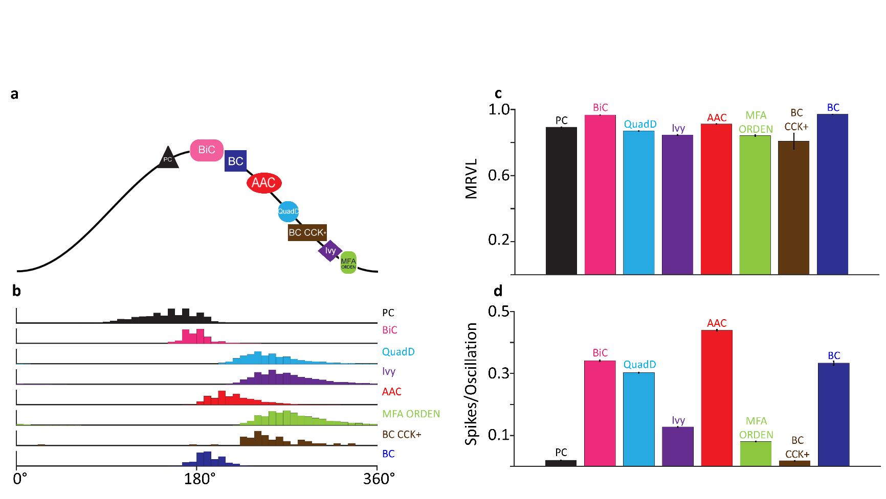**Fig. 5**

Intrinsic beta rhythms of the baseline CA3 SNN. **a** Preferred firing phases of each neuron type. **b** Firing phase histograms for each neuron type relative to the network’s beta rhythm. **c** Mean resultant vector length (MRVL) for each neuron type exhibit strong phase-locking to the beta rhythm. **d** Mean spikes per oscillation for each neuron type.

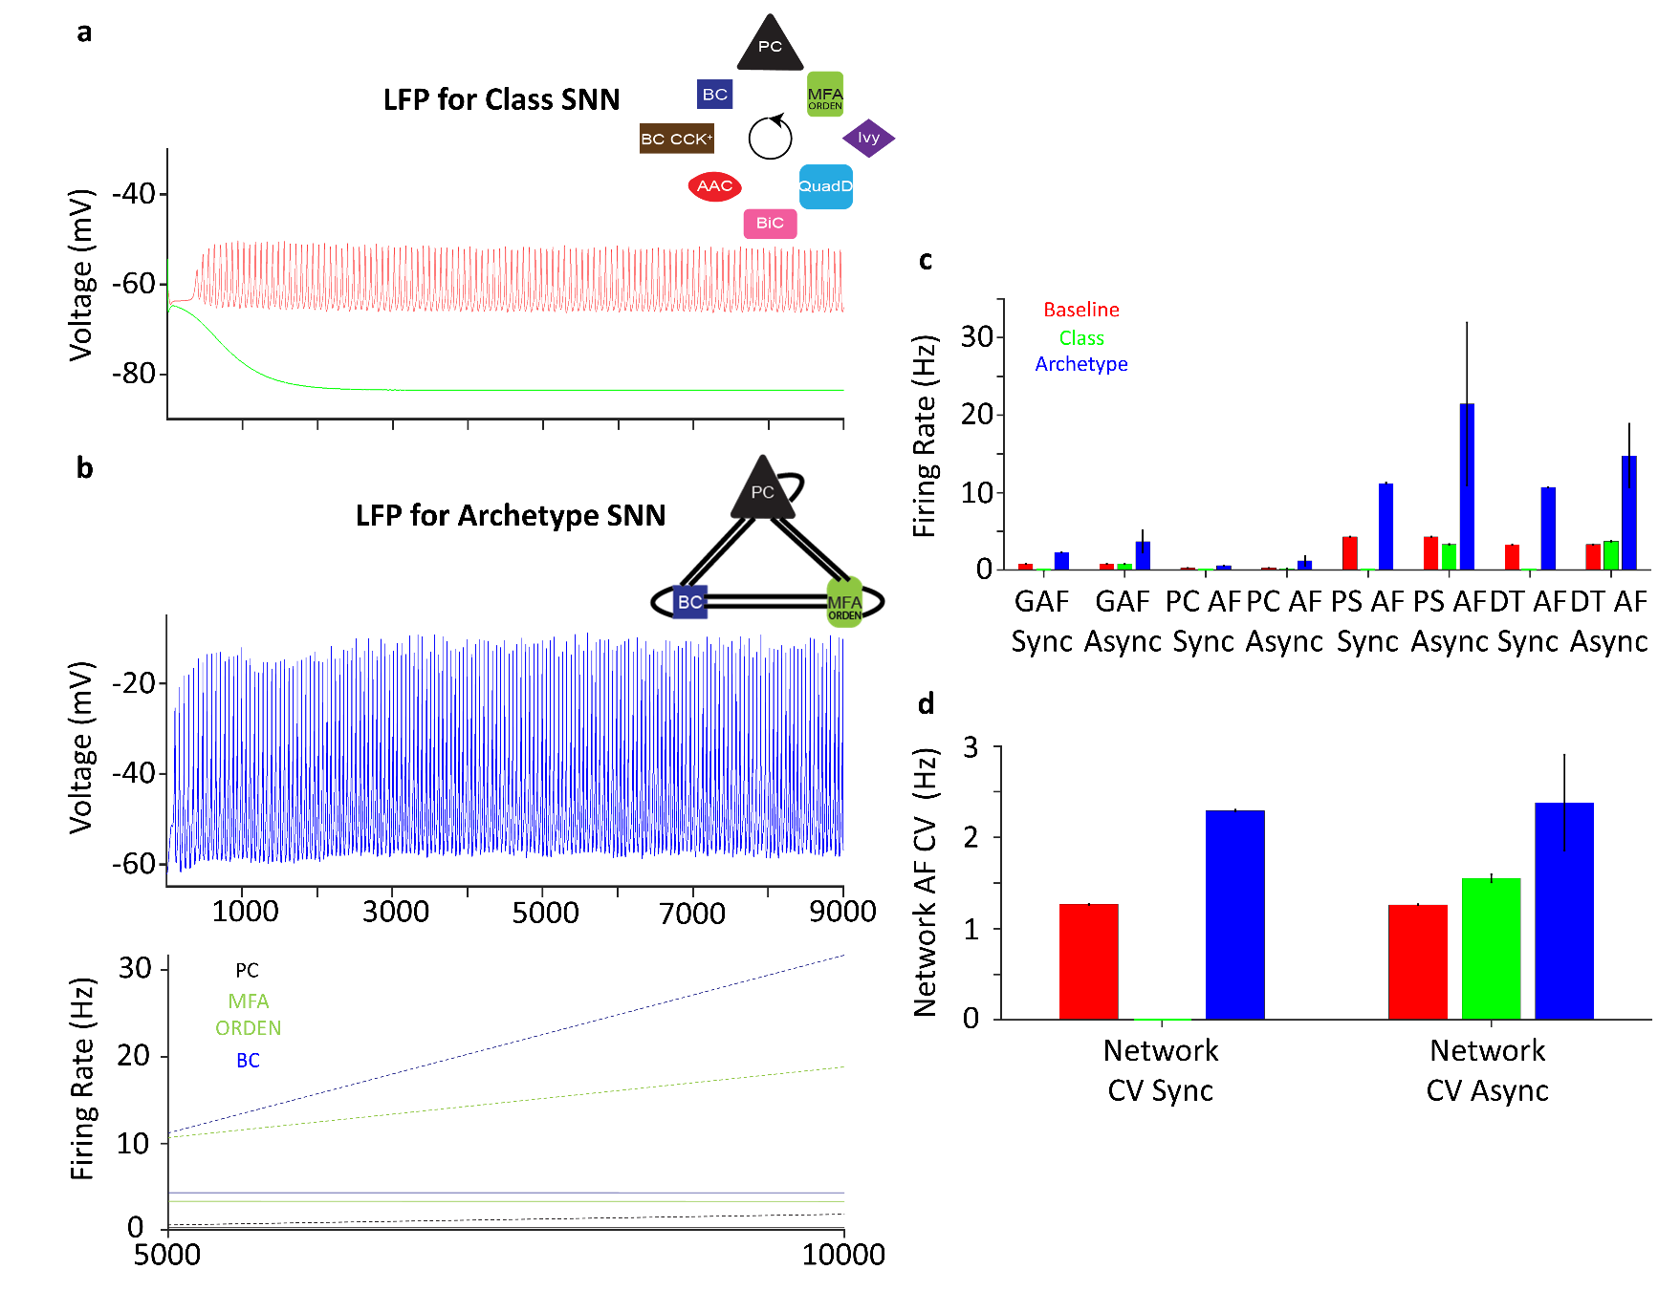**Fig. 6**

Alternate networks highlight the importance of both neuron and connection type specificity. **a** The *class* network LFP is strongly hyperpolarized (green), leading to network silence. Baseline network LFP (faded red) shown for comparison. Inset: Connectivity schematic for the *class* network, with a circular arrow indicative of shuffled connectivity among each connection class. **b** Top: The archetype network LFP (blue) exhibits a beta band oscillation, similar to the baseline. Inset: Connectivity schematic for the archetype network. Bottom: Population firing rates for the archetype (dashed lines) network’s Pyramidal (black), MFA-ORDEN (green), and Basket cells (blue) increase more than 2-fold as asynchronous activation increases from 5,000 to 10,000 PCs, indicative of non-robustness, while the baseline (solid lines) firing rates do not significantly change. **c** Average firing rate frequencies (AF) of the whole network, Pyramidal, perisomatic, and dendritic-targeting interneuron types for the baseline (red), class (green), and archetype (blue) network configurations. AFs are robust under synchronous and asynchronous activation for the baseline network, while AFs are not robust for the class and archetype networks. **d** The network AF CV highlights the stability and instability of the baseline and archetype networks, respectively. GAF = grand average frequency; PC = Pyramidal cell; PS = perisomatic; DT = dendritic-targeting; CV = coefficient of variation.

**Fig. 7**

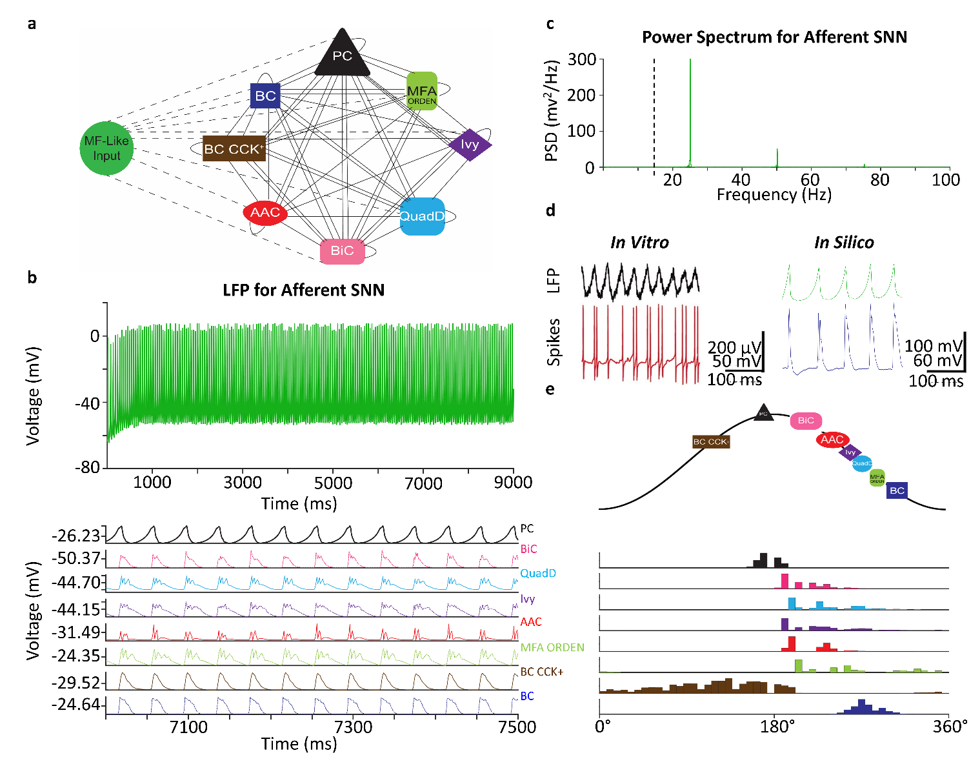

Addition of Mossy Fiber-Like (MF) input generates gamma oscillations. **a** Connectivity schematic for the network including noisy input current applied to each neuron type from MFs (dashed lines). **b** Top: The MF-CA3 network LFP (green) exhibits oscillations in the slow gamma frequency band. Bottom: LFPs for each neuron type. **c** The power spectrum of the MF-CA3 SNN contains a pronounced peak at 25 Hz, indicative of the network’s slow gamma frequency as mediated by the mossy fiber input. Dashed line indicates the spectral peak in the baseline network. **d** Basket cells fire in spike doublets during gamma oscillations *in vitro* (left), a behavior also exhibited by Basket cells in our simulations (right). **e** Top: Preferred firing phases of each neuron type. Bottom: Firing phase histograms for each neuron type relative to the network’s gamma rhythm.