WordCounter Doc 1.0

1. Installation:
   1. Dependencies:
      1. Yt-dlp
      2. SpeechRecognition
      3. Fmmpeg
2. Usage:
   1. To run a script using your own source you need to change the youtube video hash value in a *video_url* variable.



* 1. Later on you need to change the word that is requied to be counted in a *word_count* variable. As an example used in a code we have a word “odkurzacza” that is clearly hearable in video linked to the project.



* 1. (Additional) In case of a need to chagne file name from mysong to any other you have to change the *outtmpl* in *ytdlp_options* section (marked in yellow field).

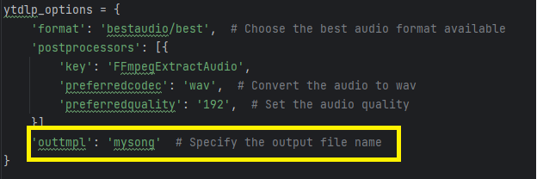

Follow this step with changing the *audio_file* variable to a correct path with new filename



* 1. Run a script using *python path/to/file/main.py* in command line.