Made my own document since packet tracer has 3 different layouts for this activity and the pdf they gave us did not correspond to my activity.

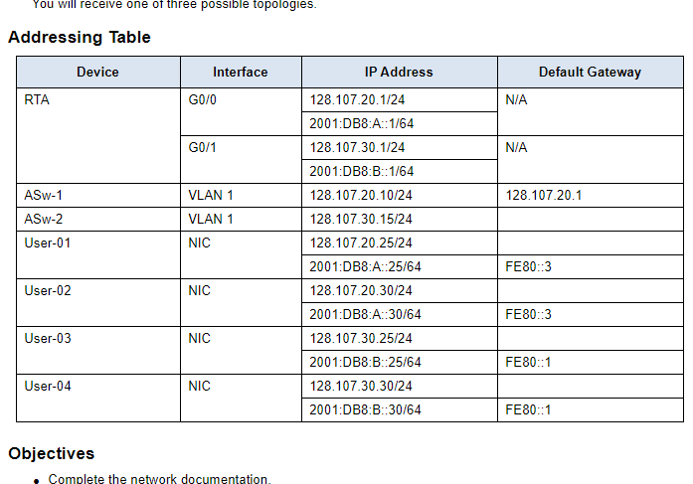
128.107.30.1

