possible_figures

Jessica E. Kosie

5/1/2020

# Figure Option 1

plot.data <- pdr_data %>%   
 group_by(region_1s, partner, reg_num) %>%   
 summarise(mean = mean(pdr_z_filtered, na.rm = TRUE),  
 sd = sd(pdr_z_filtered, na.rm=TRUE),  
 n = n(),  
 se=sd/sqrt(n),  
 ci = qt(0.975,df=n-1)*se)

## `summarise()` regrouping output by 'region_1s', 'partner' (override with `.groups` argument)

rects <- data.frame(xstart = c(-30, 0, 29), xend = c(0, 29, 59), Region = c("pre-boundary", "boundary", "post-boundary"))  
  
rects <- rects %>%   
 mutate(Region = factor(Region, levels = c("pre-boundary", "boundary", "post-boundary")))  
  
plot.data$partner <- factor(plot.data$partner, levels = c("Infant", "Adult"), labels = c("Motionese", "Adult-Directed"))  
  
#without any lines  
ggplot(plot.data, aes(x = reg_num, y = mean, linetype = partner)) +  
 geom_rect(data = rects, aes(xmin = xstart, xmax = xend, ymin = -Inf, ymax = Inf, fill = Region), alpha = 0.4, inherit.aes = FALSE) +  
 ylim(-0.2, 0.15) +  
 theme_linedraw() +  
 scale_fill_viridis(discrete = TRUE, option = "D") +  
 geom_vline(xintercept = 0, color = "darkcyan", linetype = "dashed", size = 1.5) +  
 theme(plot.title = element_text(hjust = 0.5), legend.position = "none") +  
 labs(y = "Average Z-Scored and Filtered Pupil Size", x = "Frame Number (Boundary at 0)", linetype = "Demonstration Type")

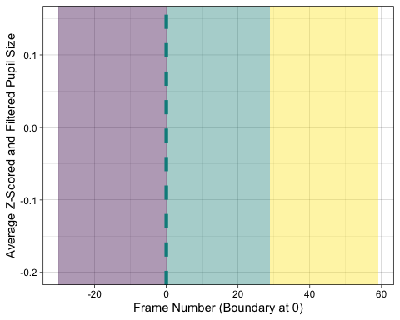

#only adult-directed  
ggplot(filter(plot.data, partner == "Adult-Directed"), aes(x = reg_num, y = mean)) +  
 geom_rect(data = rects, aes(xmin = xstart, xmax = xend, ymin = -Inf, ymax = Inf, fill = Region), alpha = 0.4, inherit.aes = FALSE) +  
 geom_line(size = 1, linetype = "dashed") +  
 geom_ribbon(aes(ymin=mean-se, ymax=mean+se), alpha=0.2) +  
 ylim(-0.2, 0.15) +  
 theme_linedraw() +  
 scale_fill_viridis(discrete = TRUE, option = "D") +  
 geom_vline(xintercept = 0, color = "darkcyan", linetype = "dashed", size = 1.5) +  
 theme(plot.title = element_text(hjust = 0.5), legend.position = "none") +  
 labs(y = "Average Z-Scored and Filtered Pupil Size", x = "Frame Number (Boundary at 0)", linetype = "Demonstration Type")

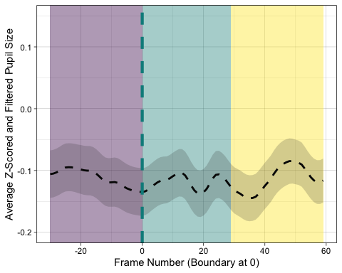

#motionse and adult-directed  
ggplot(plot.data, aes(x = reg_num, y = mean, linetype = partner)) +  
 geom_rect(data = rects, aes(xmin = xstart, xmax = xend, ymin = -Inf, ymax = Inf, fill = Region), alpha = 0.4, inherit.aes = FALSE) +  
 geom_line(size = 1) +  
 geom_ribbon(aes(ymin=mean-se, ymax=mean+se), alpha=0.2) +  
 ylim(-0.2, 0.15) +  
 theme_linedraw() +  
 scale_fill_viridis(discrete = TRUE, option = "D") +  
 geom_vline(xintercept = 0, color = "darkcyan", linetype = "dashed", size = 1.5) +  
 scale_linetype_manual(values=c("solid", "dashed")) +  
 theme(plot.title = element_text(hjust = 0.5), legend.position = "none") +  
 labs(y = "Average Z-Scored and Filtered Pupil Size", x = "Frame Number (Boundary at 0)", linetype = "Demonstration Type")

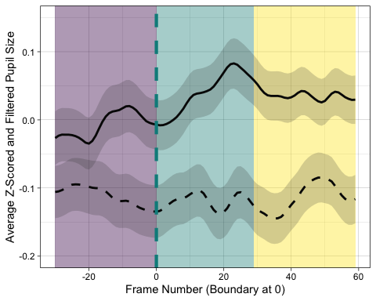

#with legend  
ggplot(plot.data, aes(x = reg_num, y = mean, linetype = partner)) +  
 geom_rect(data = rects, aes(xmin = xstart, xmax = xend, ymin = -Inf, ymax = Inf, fill = Region), alpha = 0.4, inherit.aes = FALSE) +  
 geom_line(size = 1) +  
 geom_ribbon(aes(ymin=mean-se, ymax=mean+se), alpha=0.2) +  
 ylim(-0.2, 0.15) +  
 theme_linedraw() +  
 scale_fill_viridis(discrete = TRUE, option = "D") +  
 geom_vline(xintercept = 0, color = "darkcyan", linetype = "dashed", size = 1.5) +  
 scale_linetype_manual(values=c("solid", "dashed")) +  
 theme(plot.title = element_text(hjust = 0.5)) +  
 labs(y = "Average Z-Scored and Filtered Pupil Size", x = "Frame Number (Boundary at 0)", linetype = "Demonstration Type")

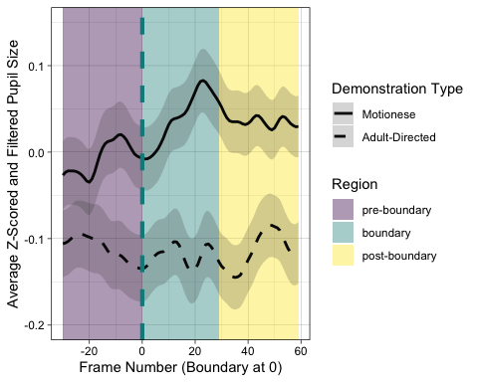 # Figure Option 2

ggplot(plot.data, aes(x = reg_num, y = mean, linetype = partner)) +  
 geom_rect(data = rects, aes(xmin = xstart, xmax = xend, ymin = -Inf, ymax = Inf, fill = Region), alpha = 0.4, inherit.aes = FALSE) +  
 geom_line(size = 1) +  
 geom_ribbon(aes(ymin=mean-se, ymax=mean+se), alpha=0.4) +  
 ylim(-0.2, 0.15) +  
 theme_linedraw() +  
 scale_fill_manual(values = c("grey88", "grey62", "grey8")) +  
 geom_vline(xintercept = 0, color = "grey62", linetype = "dashed", size = 1) +  
 theme(plot.title = element_text(hjust = 0.5)) +  
 labs(y = "Average Z-Scored and Filtered Pupil Size", x = "Frame Number (Boundary at 0)", linetype = "Demonstration Type")

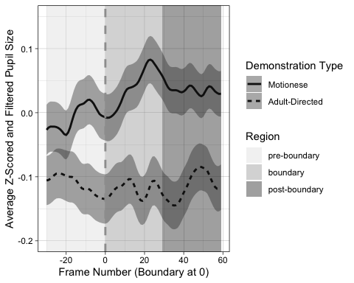 #Figure Option 3

ggplot(plot.data) +  
 geom_rect(data = rects, aes(xmin = xstart, xmax = xend, ymin = -Inf, ymax = Inf, fill = Region), alpha = 0.4, inherit.aes = FALSE) + scale_fill_manual(values = c("grey88", "grey62", "grey8")) +  
 new_scale_fill() +  
 geom_line(aes(x = reg_num, y = mean, linetype = partner, colour = partner), size = 1) +  
 geom_ribbon(aes(x = reg_num, ymin=mean-se, ymax=mean+se), alpha=0.4) +  
 scale_fill_viridis(discrete = TRUE, option = "D") +  
 ylim(-0.2, 0.15) +  
 theme_linedraw() +  
 geom_vline(xintercept = 0, color = "darkcyan", linetype = "dashed", size = 1) +  
 theme(plot.title = element_text(hjust = 0.5)) +  
 labs(y = "Average Z-Scored and Filtered Pupil Size", x = "Frame Number (Boundary at 0)", linetype = "Demonstration Type")

