kg-age-analyses-supplementary

Jessica E. Kosie

10/6/2020

# Boundary Advantage and Pixel Change Analysis, including age as a predictor

In the manuscript (for the model without age) we reported that - replicating previous analyses with preschoolers and adults - slide type was a significant predictor of dwell time such that preschoolers’ dwell times were significantly longer to boundary (*M* = 2.89, *SD* = 0.21) over non-boundary slides (*M* = 2.85, *SD* = 0.2), $β=0.03$ ($SE=0.01$), $p=<.001$. However, pixel change was not a significant predictor, $β=0.01$ ($SE=0.01$), $p=.470$, nor did it interact with slide type, $β=0.01$ ($SE=0.01$), $p=.349$.

We then added age and all interactions with age to the model. Again, slide type was a significant predictor of dwell time, $β=0.08$ ($SE=0.03$), $p=.015$. Age was also a significant predictor, such that younger children’s dwell times were longer than older children’s (see Figure 1), $β=−0.005$ ($SE=0.002$), $p=.013$. Pixel change was not a significant predictor of dwell times, $β=0.04$ ($SE=0.04$), $p=.311$ and none of the interactions between any of the variables were significant, $ps>.085$. Thus, while age was correlated with overall dwell times, including age in the model did not interact with or affect any of our conclusions.

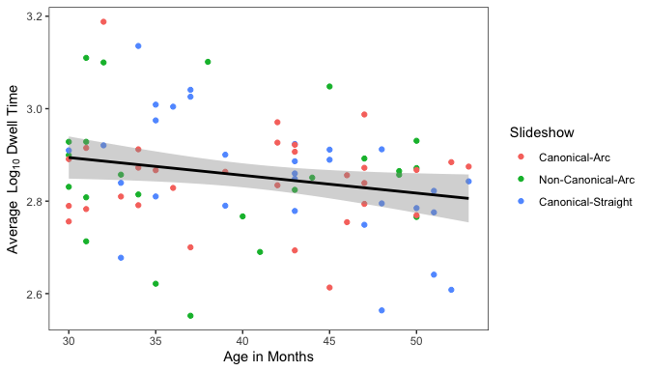

Relation between participant age and overall average dwell time.

# Causal Violation Analysis, including age as a predictor

In the analysis without age, outlined in the manuscript, we reported that numerically, mean dwell times were greater to the region of causal violation in the *non-canonical-arc* slideshow (*M* = 2.87, *SD* = 0.25) than in the *canonical-arc* (*M* = 2.79, *SD* = 0.16) slideshows. However, a linear mixed effects model (including a fixed effect of condition and random intercepts for subjects) did not reach statistical significance, $β=−0.04$ ($SE=0.03$), $p=.105$.

In a model including age and all interactions with age, none of the indivdual predictors nor interactions were significant, $ps>.364$.