## TABLE OF CONTENTS

**AWS Cloud Setup Guide**

Amazon Web Services (AWS)

* How to create a free AWS Cloud Account
* How to create an Ubuntu VM machine
* Open Port from VPC Networks
* Run commands on the Ubuntu VM

**Summary**

Topics covered

* Road ahead

**AMAZON WEB SERVICES (AWS)**

**What is AWS?**

Amazon Web Services (AWS) is a comprehensive, evolving cloud computing platform provided by Amazon. AWS can be defined as a huge set of on-demand services provided to the customers on cloud with pay-as-you-go pricing model. The technology allows subscribers to have, at their disposal, a virtual cluster of computers, available all the time, through the Internet. Whether it is about configuring a server or running an application, AWS lets you execute your operations on cloud in a similar manner as you would do on a physical computer.

AWS is the pioneer of the cloud computing technology. Way back in 2006, it first offered its cloud solutions and today is way ahead of its competitors. AWS competes primarily with Microsoft Azure, Google and IBM in the public IaaS market*.* Amazon's internal IT resource management built AWS, which expanded and grew into an innovative and cost-effective cloud solution provider.

Back in 2006, cloud might still have been a relatively new phenomenon, but today it is critical to the survival of any business enterprise. Cloud is offering some incredible advantages that on-premise technology just cannot compete with. With this cloud, we need not plan for servers and other IT infrastructure which consumes lot of time in advance. Instead, these services can instantly spin up hundreds or thousands of servers in minutes and deliver results faster. We pay only for what we use with no up-front investment and no long-term commitments, which makes AWS cost efficient.

Today, AWS powers multitude of businesses in 190 countries around the world. AWS offers flexible, reliable, scalable, easy-to-use, and cost-effective solutions and allows enterprises to focus on their core competencies while Amazon takes care of the IT and cloud related issues. Let us understand the impact through an example - Netflix is a popular video streaming service which the whole world uses today. Back in 2008, Netflix suffered a major database corruption, and for three days their operations were halted. The problem was scaling, that is when they realized the need for a highly reliable, horizontally scalable, distributed system in the cloud. They started using AWS, and since then their growth has been off the charts.

AWS provides a mix of infrastructure as a service (IaaS), platform as a service (PaaS) and packaged software as a service (SaaS) offerings. More than 100 services comprise the Amazon Web Services portfolio, including those for compute, databases, infrastructure management, application development and security.

* 1. **What are the top AWS products?**
  2. Amazon **EC2** and Amazon **S3** are the two core Infrastructure as a Service (IaaS) services,

**EC2 :** An EC2 instance is nothing but a virtual server in Amazon Web services terminology. It stands for Elastic Compute Cloud. It is a web service where an AWS subscriber can request and provision a compute server in AWS cloud. EC2 provides you configuration capacity in a seamless manner. With EC2 you have complete control of your computing environment along with high availability, scalability, and cost-effectiveness.

An on-demand EC2 instance is an offering from AWS where the subscriber/user can rent the virtual server per hour and use it to deploy his/her own applications. The instance will be charged per hour with different rates based on the type of the instance chosen. AWS provides multiple instance types for the respective business needs of the user. Thus, you can rent an instance based on your own CPU and memory requirements and use it as long as you want. You can terminate the instance when it’s no more used and save on costs. This is the most striking advantage of an on-demand instance.

**S3 :** This is the Amazon Simple Storage. AWS S3 lets you seamlessly store and retrieve huge amounts of data anytime, anywhere through the web interface. It allows software developers to have access to the data quickly in an inexpensive, reliable and highly scalable manner. You can store all sorts of folders, files, and documents on the AWS S3.

**RDS :** This is the Amazon Relational Database Service. The Amazon RDS is a highly scalable relational database service. It offers a simple, cost-efficient database in the cloud that also automatically does database setup, hardware provisioning, backup and patching. Its advantages include high availability, fast performance, security and compatibility.

**DynamoDB** : This is the Amazon NoSQL database in the cloud that provides extremely high latency at

any scale. It offers highly reliable service that is fully managed, has built-in security, in-memory caching, backup and restoration.

**VPC :** This is the Amazon Virtual Private Cloud which can be thought of as a cloud data center for deploying all your resources. VPC lets you isolate all your resources on the Amazon cloud and thus offer very high security. It gives you complete freedom to work within your virtual networking environment, along with selection of IP addresses, creating subnets, configuring route tables and network gateways. AWS VPC offers logically isolated provisioning on the cloud wherein you can launch your AWS resources.

**Why should you learn AWS?**

Some of the top reasons why you should learn AWS are as follows:

* AWS is an amazing standard of cloud computing and is slowly becoming synonymous with the cloud itself.
* The salaries of AWS professionals are among the best in the IT industry.
* Getting AWS certified is not a big deal; all you need is the right training in AWS.
* There is a huge shortage of certified AWS professionals - thanks to the rapid deployment of AWS.
* There are no prerequisites to learn AWS as anybody can master this top technology.
* AWS is a very vast domain, and anybody can find their niche and excel in their careers.

**How to create a free AWS cloud account?**

**Step 1**: Navigate to ***https://aws.amazon.com/.*** The first screen you will view:

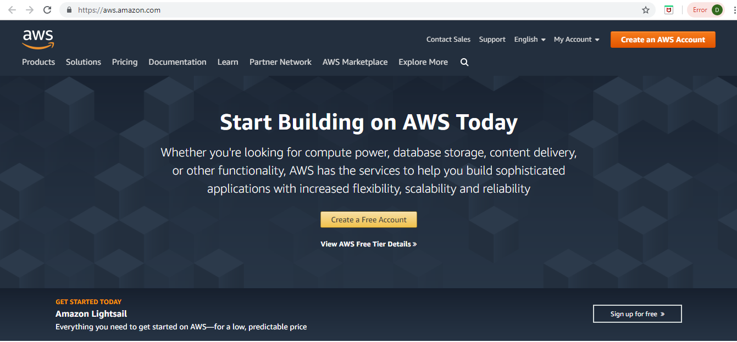

**Step 2**: Go to MyAccount dropdown and click on AWS Management Console.

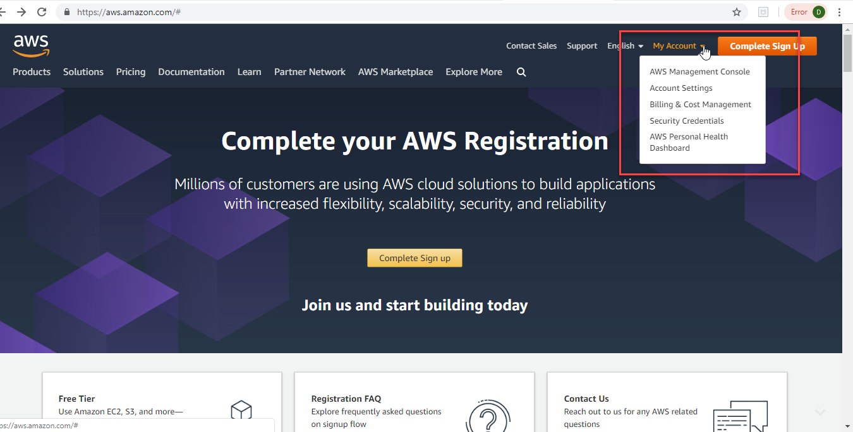

**Step 3:** You landup on this screen to sign in. Click on Create a new AWS account.

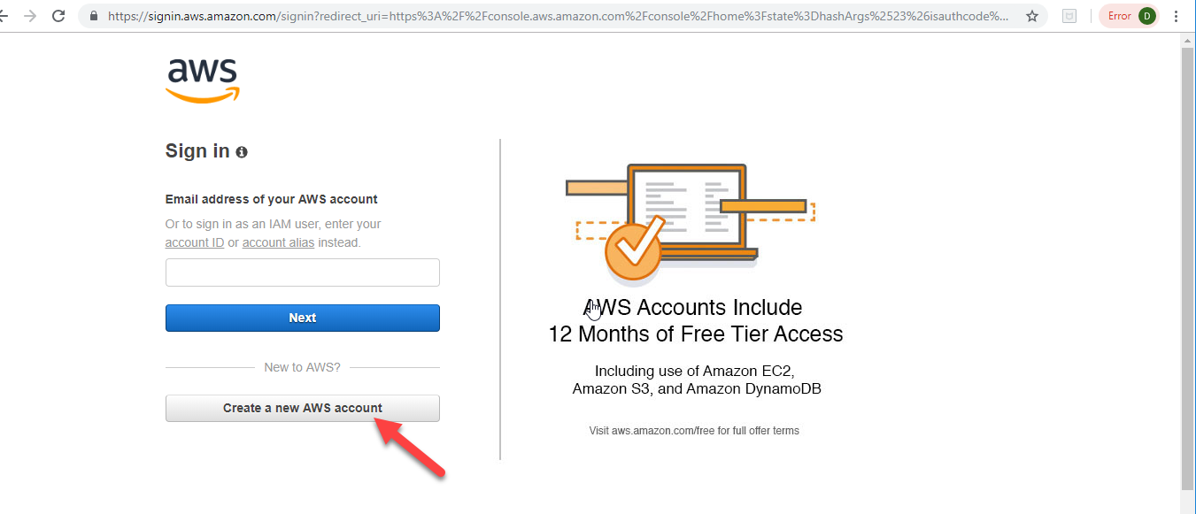

**Step 4:** Enter the details below and click Continue.

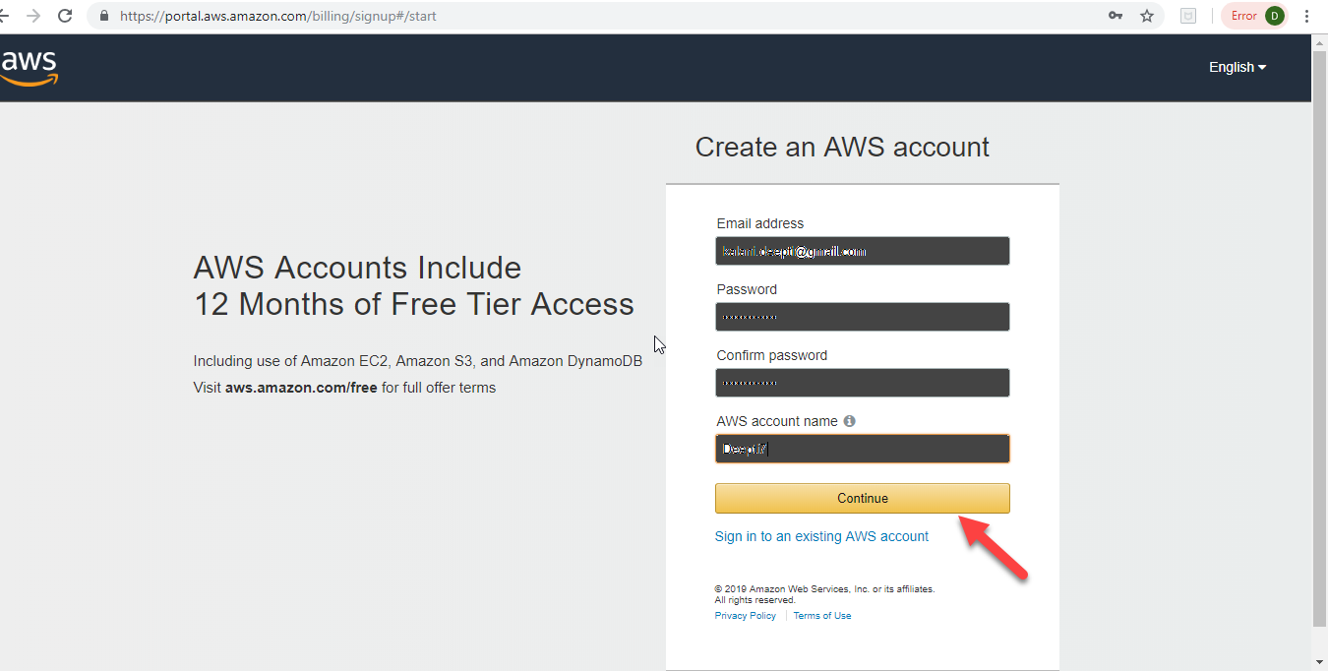

**Step 5:** Select the Account type as Personal and enter the details. Select your Country from the dropdown.

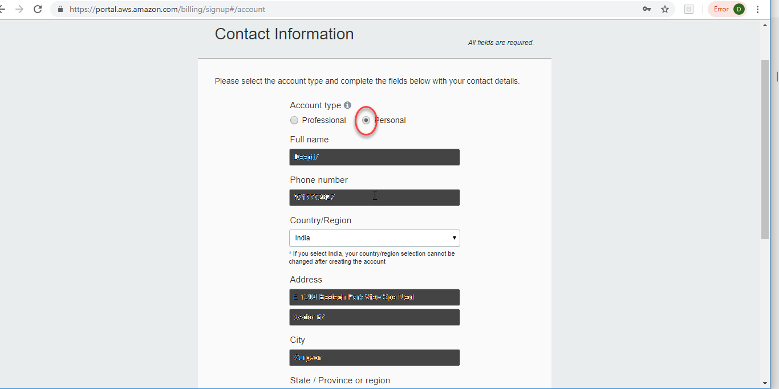

**Step 6:** Enter the details and click the check here checkbox and Create Account and Continue.

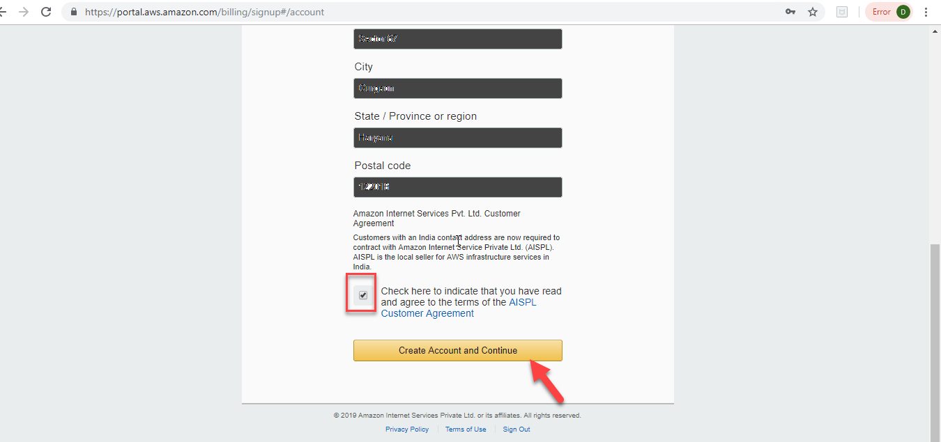

**Step 7:** Complete the Payment Information. Though, it is a free trial account, you need to enter a card details for identification/verification purpose.

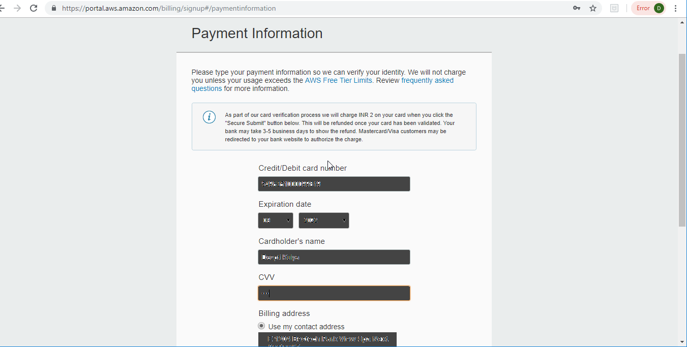

**Step 8:** Fill the required information and click Secure Submit.

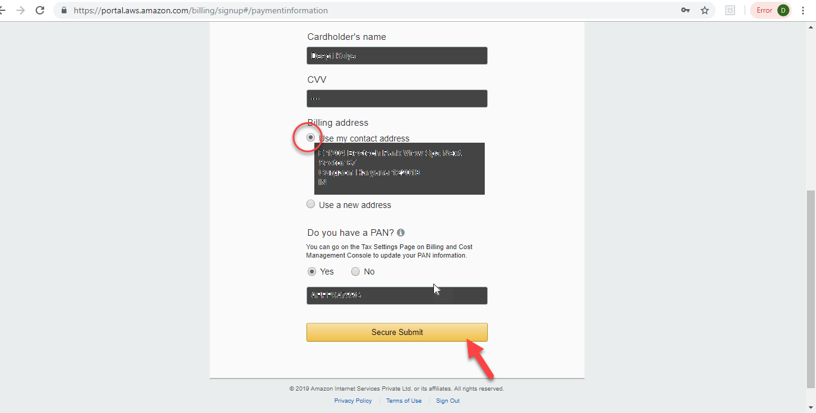

**Step 9:** Once the payment process is completed, you will view this screen. Fill in the appropriate details and click Contact me.

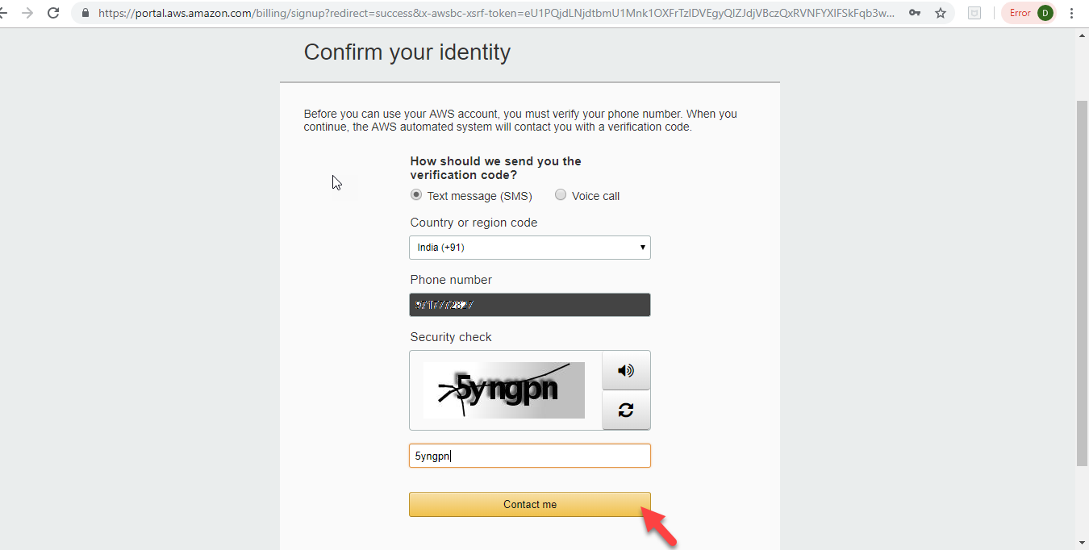

**Step 10:** Enter the verification code as received on the given mobile number and click Verify code.

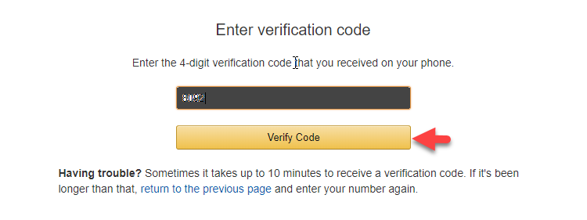

**Step 11:** You will view the below screen.

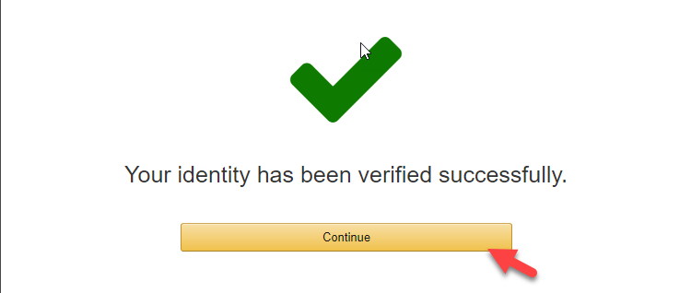

**Step 12**: Choose the Basic Plan by clicking Free button on the screen as below.

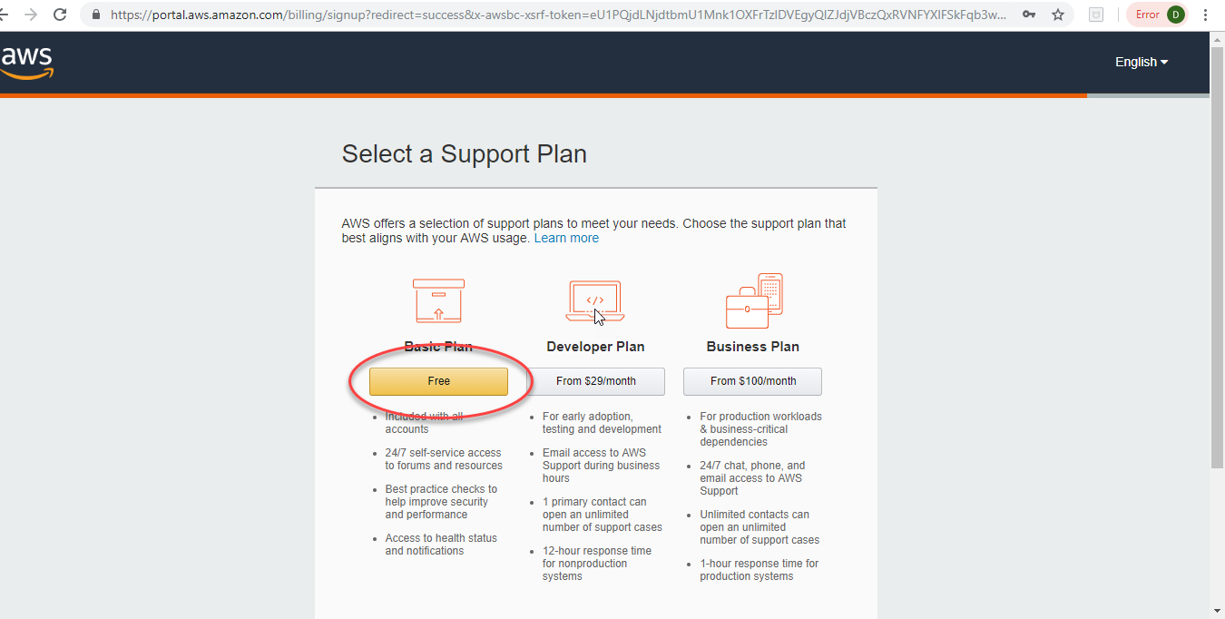

**Step 13:** You have successfully created your AWS free account. You should see this welcome screen.

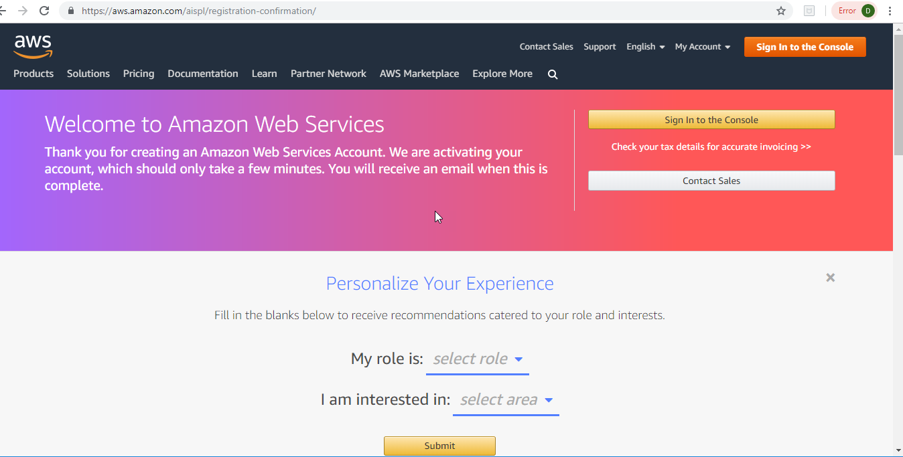

**How to create a new Ubuntu Virtual Machine**

Now, let's create a new VM instance on AWS.

**Step 1:** Once you login to the console clicking the *Sign in to the console* button on the welcome screen above using your credentials, you view the AWS console.

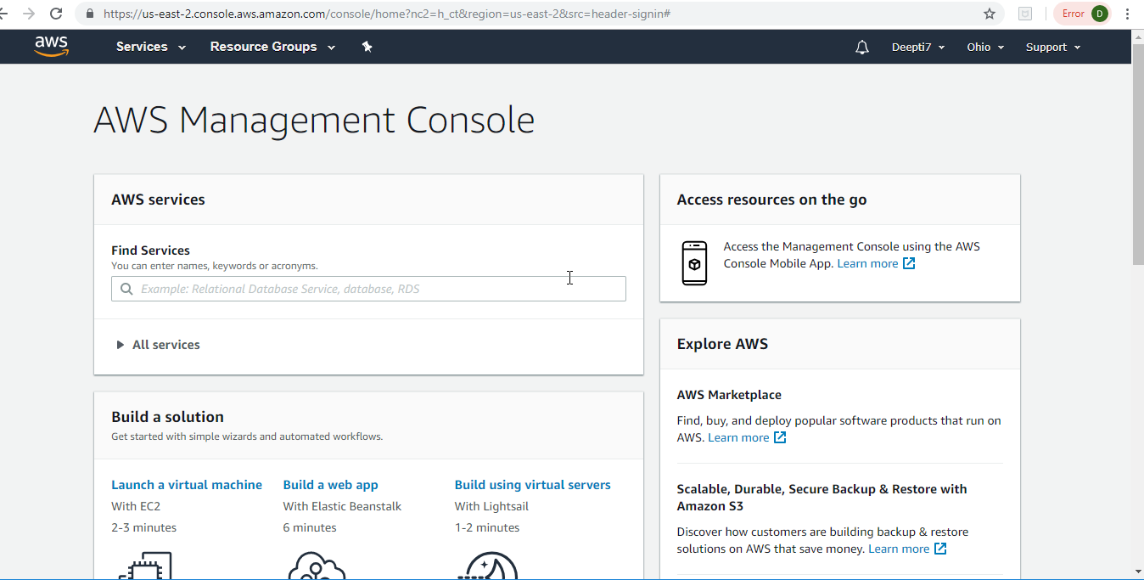

**Step 2:** Click on Launch a virtual machine.

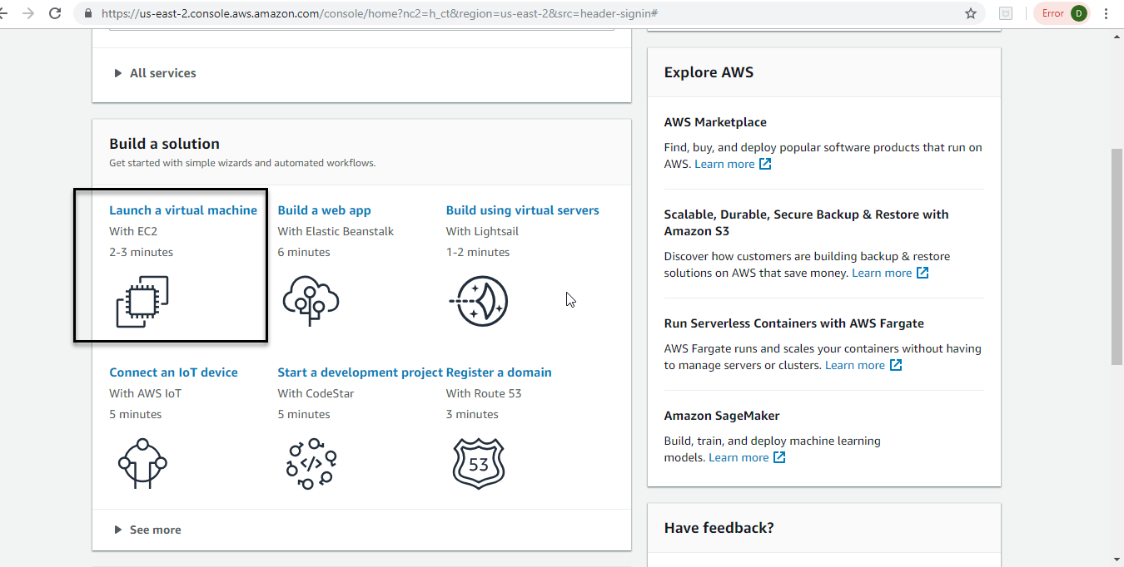

**Step 3**: Once you click on Launch a VM machine, you will view this screen.

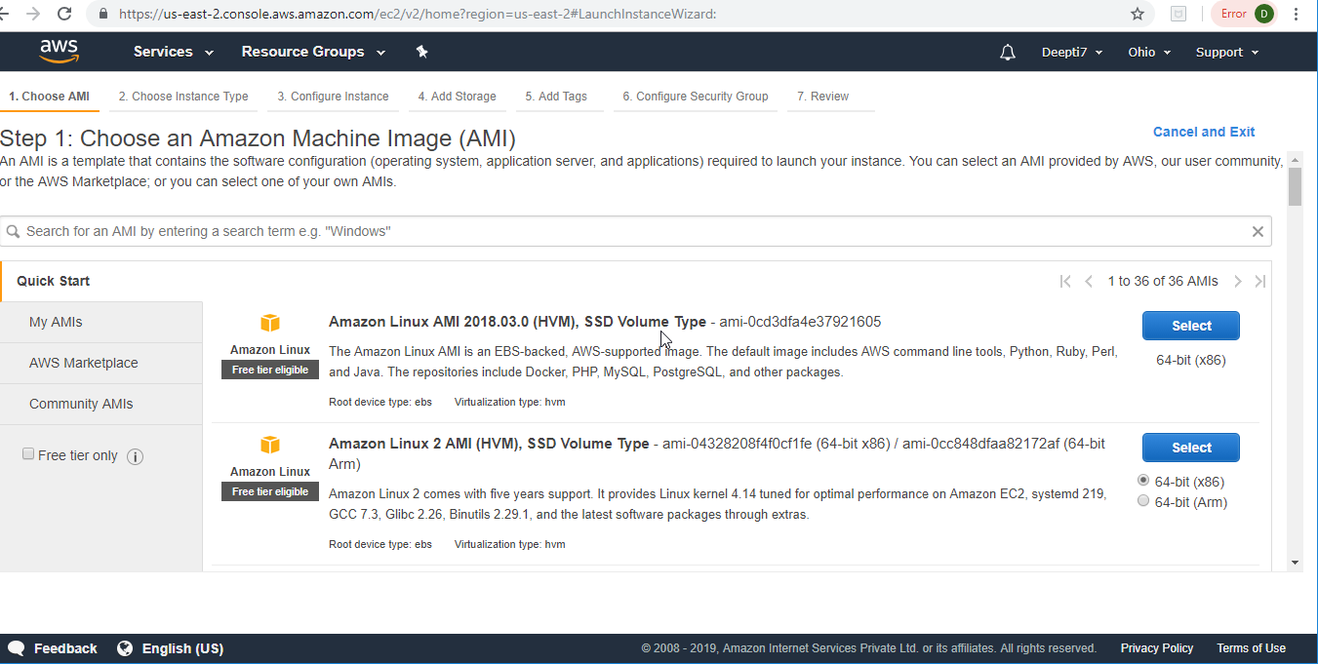

**Step 4:** Scroll down and Select Ubuntu Server 16.04 LTS.

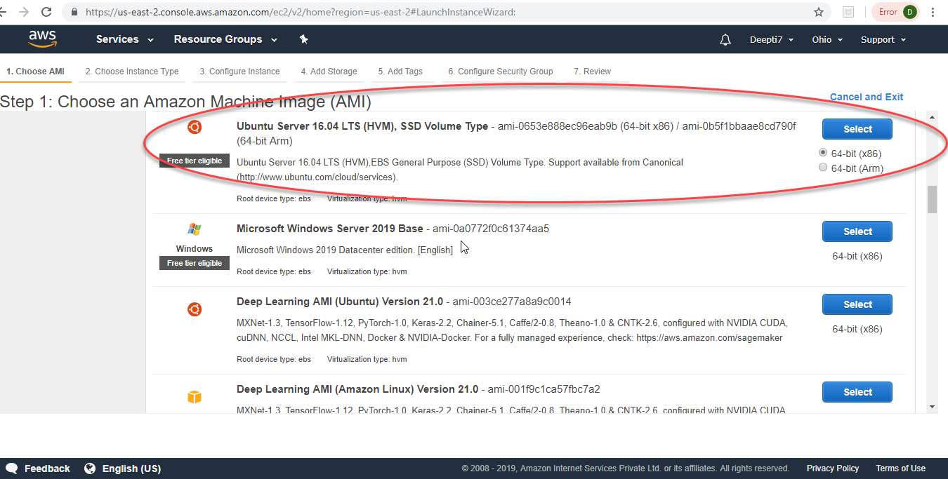

**Step 5:** Choose an Instance type. Le t the default selection remain and click Review and Launch button.

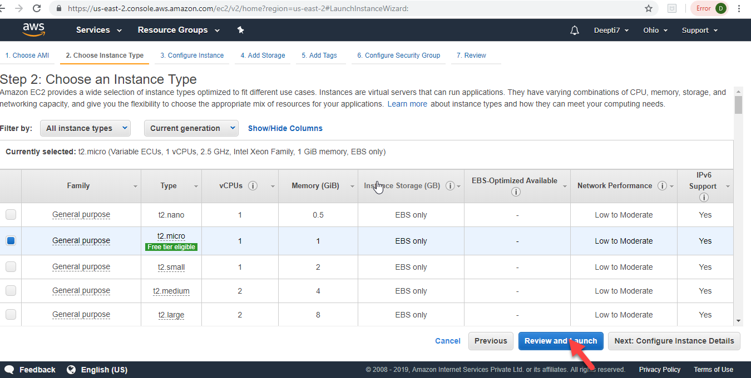

**Step 6:** Review Instance Launch screen. Click the Launch button.

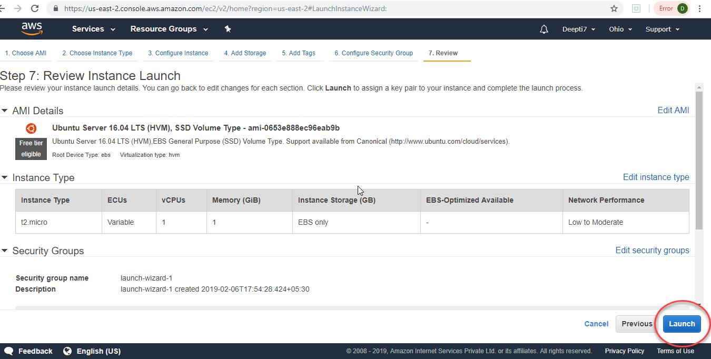

**Step 7:** You will see the below popup to select or create a new key pair. Select the create a new key pair from the dropdown and click Download Key Pair.

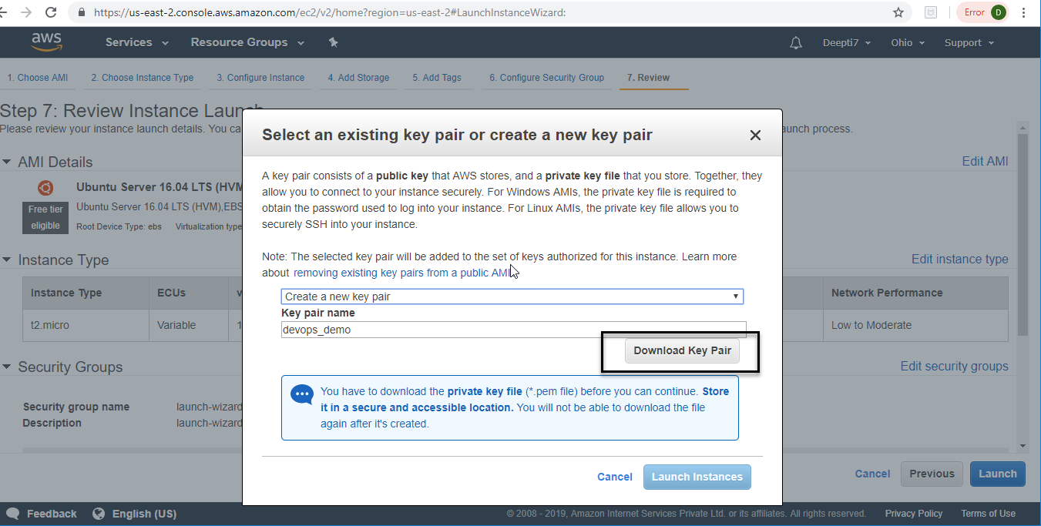

**Step 8**: Save the downloaded .pem file to a safe location on your computer. Then, click Launch Instances.

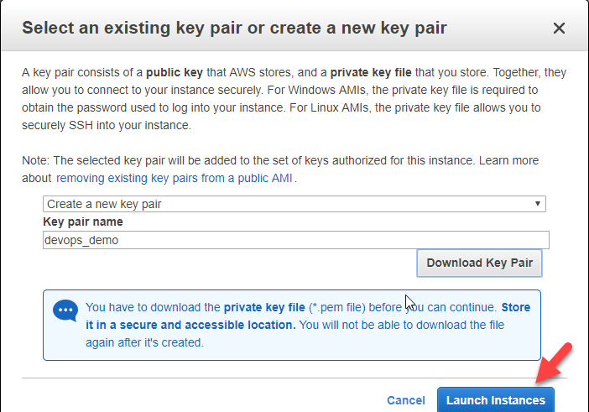

**Step 9** : You will view the below screen.

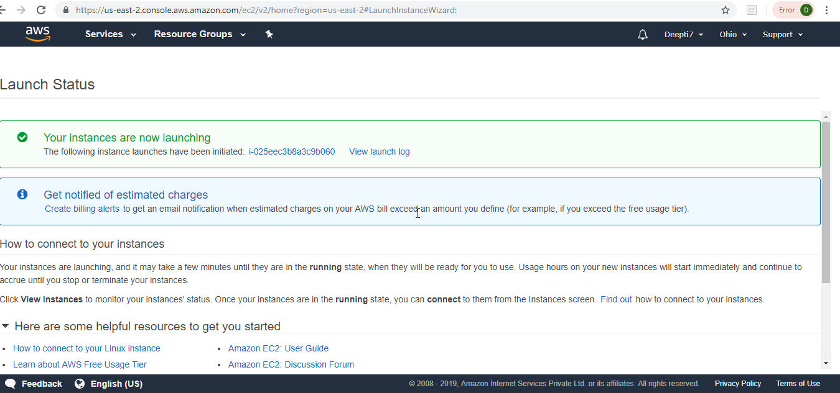

**Step 10**: Once the instance is launched, you will view the below screen. Click on View Instances.

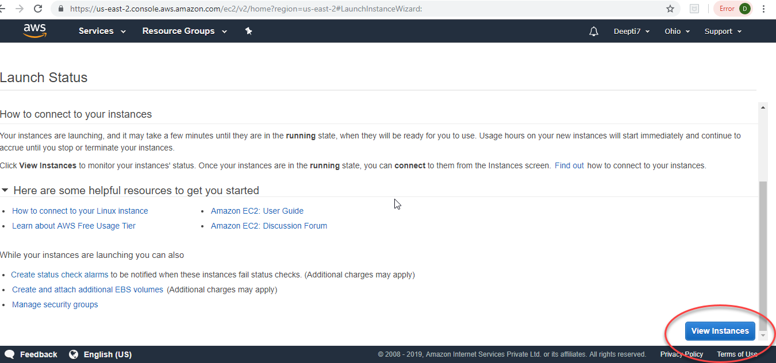

**Step 11**: Click on Connect on the screen below.

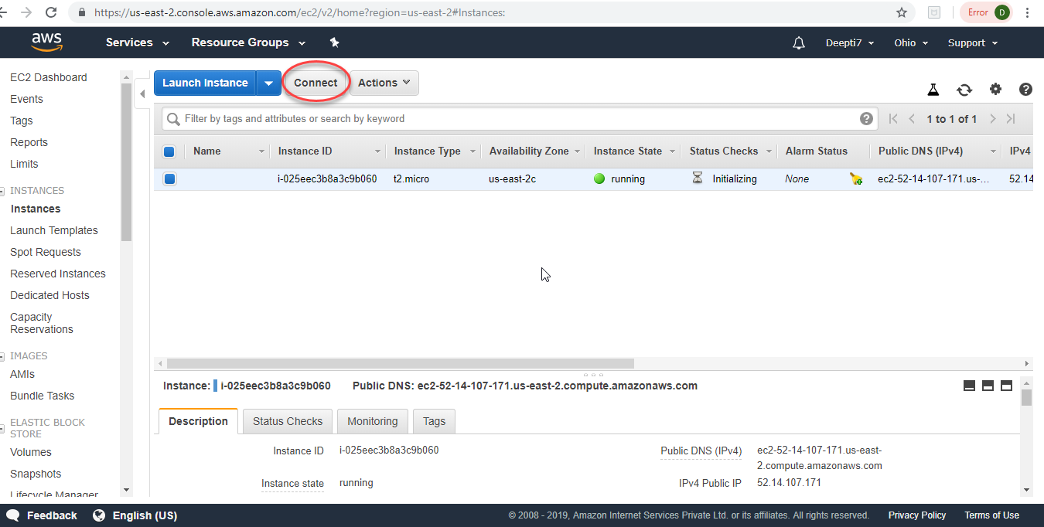

**Step 12**: You will view this popup – Connect to your instance.

To connect to the VM, follow the instructions and click Close button.

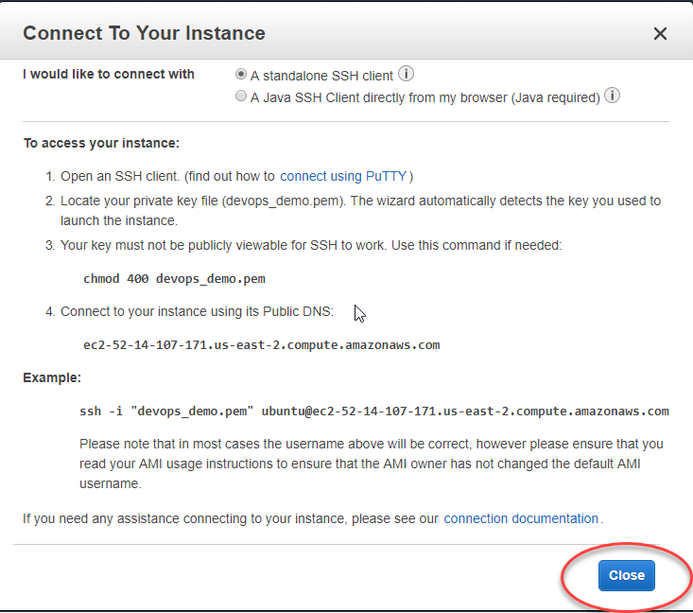

**Step 13:** Go to the folder where you saved the .pem file and do richt click and run GitBash Here.

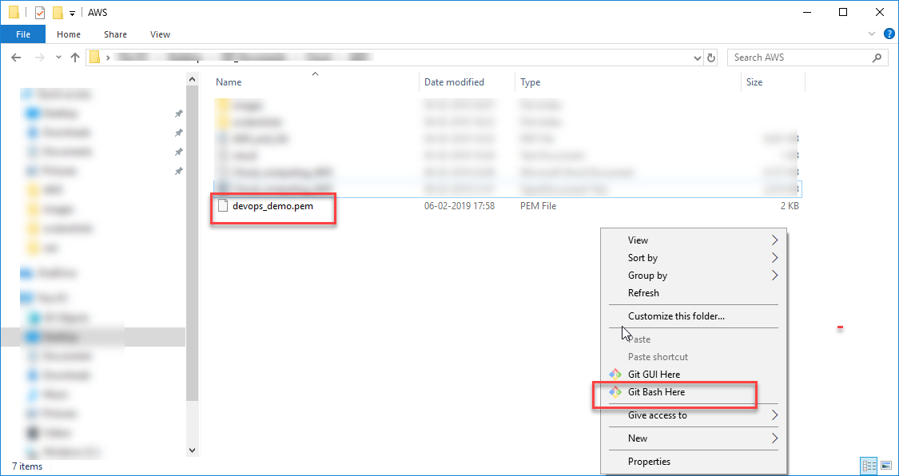

**Step 14:** Once GitBash opens, run the following command to the public VM instance you created.

***ssh -i "devops_demo.pem" ubuntu@ec2-18-221-249-158.us-east-2.compute.amazonaws.com***

***The connection is established.***

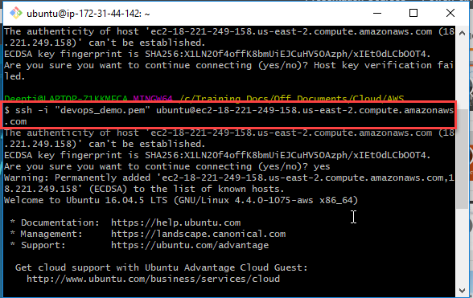

**Open port from VPC networks**

**Step 1:** From the left navigation menu, go to Network & Security->Security Groups. Then, click Create Security Group.

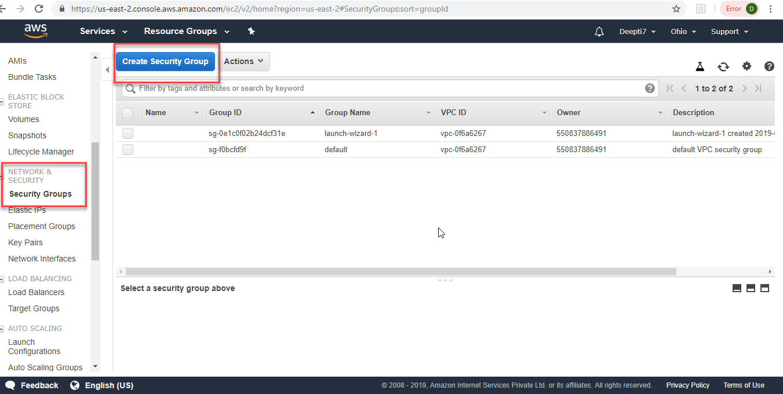

**Step 2:** The below screen opens.

Select All Traffic from the Type dropdown (you can choose to select a particular protocol also, here we have allowed connections using all protocols).

Select Anywhere from the Source dropdown. (allowing connection from anywhere). Click Create

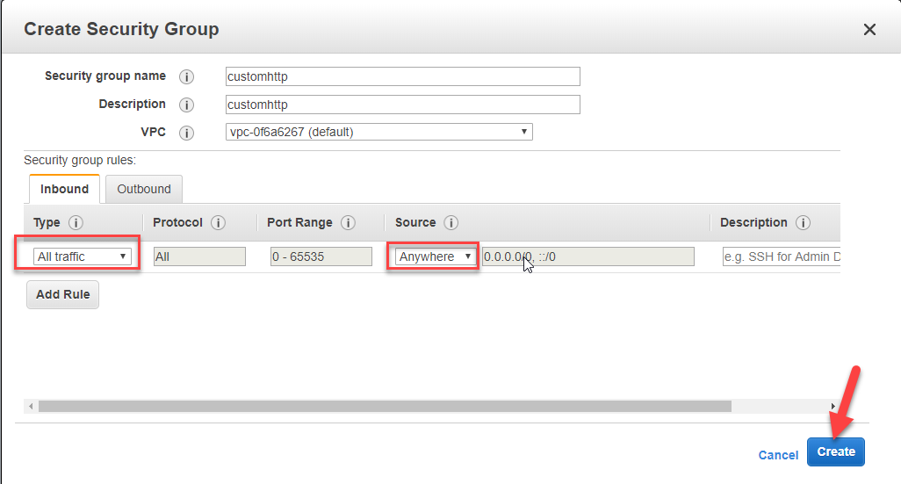

**Step 3:** Once the new security group is created, you will see it in the list of Security groups as below.

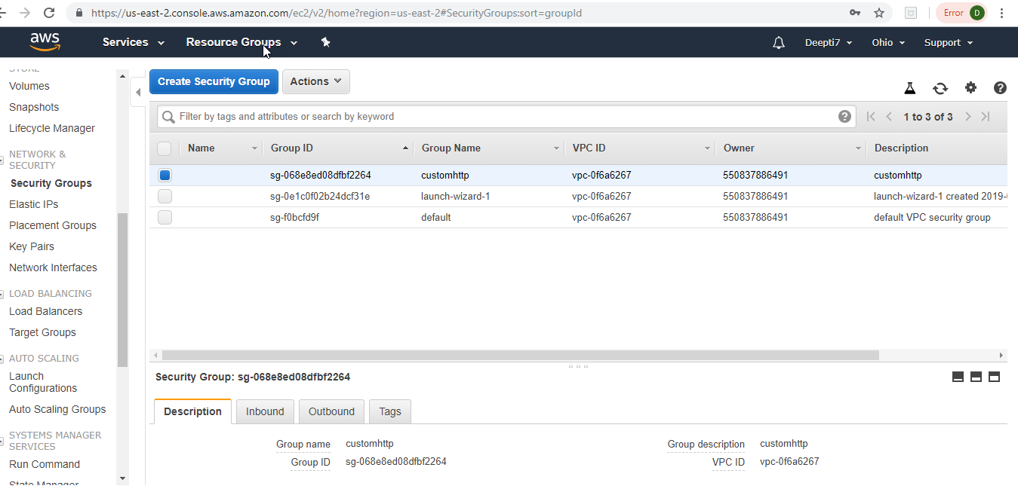

**Run Commands on the Ubuntu VM**

**Step 1:** Once the connection is made to the VM through GitBash, we will run the following command:

**sudo apt-get update.**

Sudo is the command to get admin rights temporarily on the VM. We will get the software package update by executing the above command.

Once the command is executed and update completes, you should view the below screen.

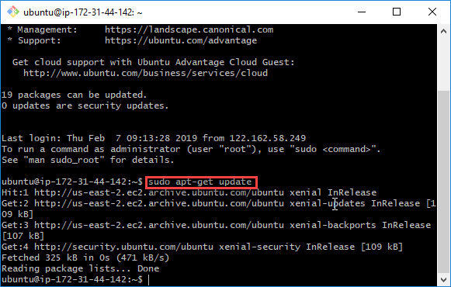

**Step 2:** Now, we will install JDK 8 on the VM with the command:

**sudo apt-get install software-properties-common && \**

**sudo add-apt-repository ppa:webupd8team/java -y && \**

**sudo apt-get update && \**

**sudo apt-get install oracle-java8-installer -y && \**

**sudo apt-get install oracle-java8-set-default**

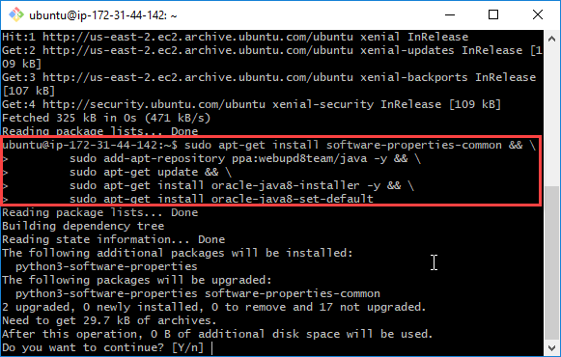

**Step 3:** Click Y for continuing the installation and press enter.

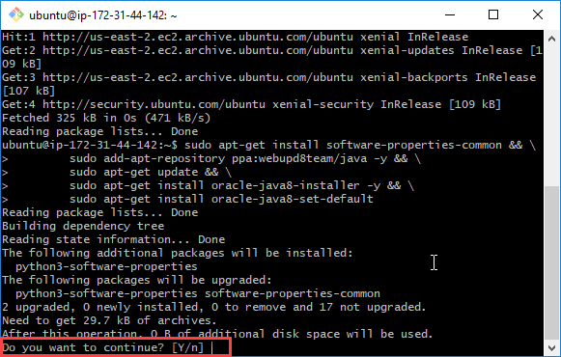

**Step 4:** Click Ok on the below popup.

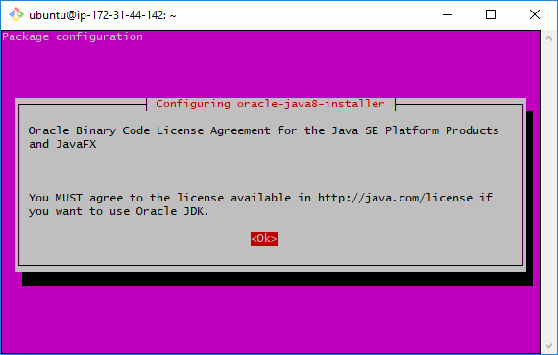

**Step 5:** Click Yes on the below screen.

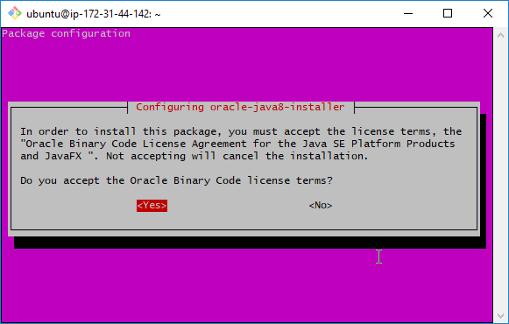

**Step 6:** Once jdk is installed, you will see the below screen.

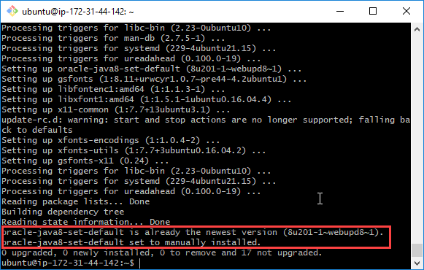

**Step 7:** Clear the screen by clear command, then, run ***java -version*** command to check the jdk version installed.

**JDK is successfully installed.**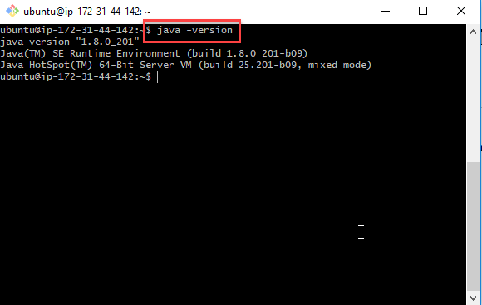

**Step 8:** Now, we will install Maven on the VM with the following command:

**sudo apt-add-repository ppa:andrei-pozolotin/maven3 && \**

**sudo apt-get update && \**

**sudo apt-get install maven**

**Press Enter to continue.**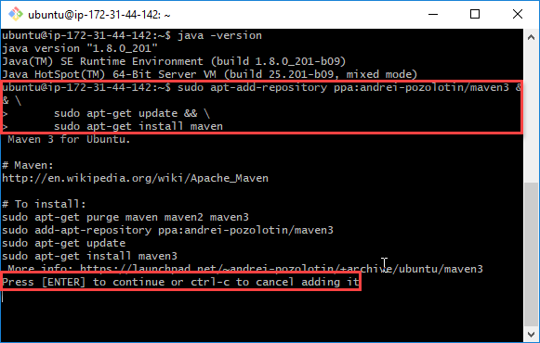

**Step 9:** You will see the below screen. Now, the VM on AWS is ready with JDK and Maven installed.

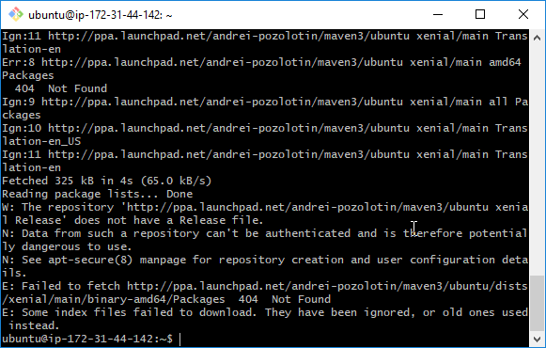

**Summary**

**Topics Covered**

In this tutorial, we tried to decode the term – AWS.

We discussed the major products AWS offers and why we should learn AWS.

We learnt the steps to sign up for a free AWS account, how to create a VM instance and connect to it.

**Road ahead**

I hope you enjoyed reading this document.This basic tutorial on AWS will help all the professionals in their career paths to gain expertise on AWS by further exploration. AWS is a huge topic with so much to offer– one should definitely deep dive into it to understand it in more detail. This document will act as the first step in this insightful journey.