The Northern Alberta Institute of Technology  
Edmonton, Alberta

TROUBLESHOOTING AND DIAGNOSTIC ANALYSIS OF EARTH-MOVER SCRAPER CAT 637G

Prepared for

Lisa Slywka, Instructor

English and Communications

School of Applied Sciences and Technology

Prepared by

Tai Tran, 200222333

Industrial Heavy Equipment Technician Program

School of Applied Trades

November 23, 2016

12025 - 105 Street  
Edmonton, AB T5G 2N6  
  
November 23, 2016  
  
Ms. Lisa Slywka, Instructor, English and Communications  
School of Applied Sciences of Technology  
Northern Alberta Institute of Technology  
11762 - 106 Street  
Edmonton, AB T5G 2R1  
  
Dear Ms. Slywka:  
  
I am writing regard to a diagnosis and troubleshooting report for the Caterpillar 637G. The report collects reliable sources about common troubleshooting instructions for the scraper. This report will help HET technicians and students familiarize themselves with fixing common cushion-hitch hydraulic and torque converter problems. Thus, they can use these knowledge in their future jobs.  
  
The objective of the report is to provide basic troubleshooting skills for cushion-hitch and torque converter in the CAT 637G. In order to make it easy to comprehend the fixing procedures, the report also gives a quick explanation of the components and their functions. The report goes through following major sections:  
  ●  Equipment description  
  ●  Diagnostic and troubleshooting analysis  
     ○  Generic troubleshooting process  
     ○  Cushion-hitch hydraulic system and services  
     ○  Torque converter fundamentals and services  
  
Citations from many reliable sources, such as the SIS web portal, articles, modules, and books are incorporated into the report. Basically, the paper utilizes information from the SIS portal as its first priority because it is more specific to my equipment. On the other hand, books, such as Heavy Equipment Systems are reliable sources for researching generic troubleshooting procedures.  
  
Thank you for creating an opportunity to research a diagnosis and troubleshooting report on the CAT 637G. If you have any further questions, please do not hesitate to contact me via email tai.t@hotmail.com.  
  
Your sincerely,  
  
  
Tai Tran, 200222333

Table of Contents

LIST OF FIGURES 4

INTRODUCTION 5

Purpose 5

Background 5

Scope 6

EQUIPMENT DESCRIPTION 6

History Background 7

Components 8

DIAGNOSTIC AND TROUBLESHOOTING ANALYSIS 9

Generic Troubleshooting Process 9

Cushion-hitch Hydraulic System and Service 11

Cushion-hitch Hydraulic System 11

Cushion-hitch Fault Diagnosis 15

Torque Converter Fundamentals and Service 16

Torque Converter Fundamentals 16

Torque Converter Fault Diagnosis 18

CONCLUSION 21

REFERENCES 22

# LIST OF FIGURES

1. Mountain Mover with a telescoping bowl was invented in June, 1922. (Orlemann, 2000) .
2. A modern tractor earthmoving scraper Caterpillar 637G (Thompson Agriculture, n.d.); an illustration of scraper’s components
3. Cushion-hitch hydraulic components. (GOA, 2016)
4. Cushion-hitch hydraulic system. (Caterpillar, 2014)
5. A stator located between two components can redirect fluid back to impeller (Angelo Spano & Bennett, 2013)
6. Pressure tap for the torque converter output (Caterpillar, 2014)

# INTRODUCTION

“With today’s highly sophisticated machinery and with the advent of mass production, industry can no longer afford a failure, as the cost of downtime is prohibitive.” (Doddannavar & Barnard, 2005, p. 190). To avoid these unexpected failures, technicians should recognize common equipment’s symptoms and fix them before equipment breaks down. By doing this, technicians help organizations save time and money that they can use to invest on other things. This paper introduces typical troubleshooting practices on

## Purpose

The goal of this report is to provide essential hydraulic and powertrain troubleshooting skills on the Caterpillar scraper 637G. This research is significant due to the popularity of utilizing hydraulics in heavy equipment. As the vast majority of equipment heavily depends on hydraulics to do the job, including powertrain, technicians or students with troubleshooting skills in this field can consolidate their positions or increase the chances of getting a good job. In order to provide an in-depth analysis of the hydraulics and powertrain system, this report will not examine entire the 637G’s hydraulic systems, which is not timely feasible.

## Background

Just like a human body, if the owners and technicians neglect minor problems of equipment, things will get worse. Companies can have a comprehensive preventative maintenance strategy for their fleet; nevertheless, equipment still can fail at any time between service intervals because equipment health heavily relies on working environments. Hydraulic systems are susceptible to contamination since components, such as cylinder seals are exposed to dusty environments. On the other hand, the powertrain might be less prone to contamination as its components are less exposed. Therefore, their service life may be longer than other hydraulic systems, but their failures, such as clutch slipping can cause longer downtime because technicians have to remove the whole transmission to fix the torque converter located between the engine and transmission.

## Scope

The 637G scraper uses hydraulics in many places: the bowl, apron, ejector, cushion-hitch, auger, steering, and powertrain. Because of the large amount of hydraulic implementation used in the 637G, this paper will merely concentrate on the 637G’s cushion-hitch, auger, and torque converter. Typically, the report will cover the purposes, locations, and basic diagnostics and troubleshooting instructions for cushion-hitch hydraulics and torque converter. Besides, the paper also incorporates safety procedures along with technical troubleshooting measures.

# EQUIPMENT DESCRIPTION

This section gives basic knowledge about earthmoving scrapers, such as the history, basic operations, and major components. Hopefully, this section assists technicians who are not familiar with scrapers can have a quick view of scrapers before starting to dig into cushion-hitch hydraulic systems and torque converter.

## History Background

“The invention of the scraper, as we know it today, is credited to Robert Gilmour LeTourneau, who had established his own earthmoving business in 1922.” (Haddock, 1988, p. 59) Robert and his brother-in-law Ray Peterson built the first earthmoving scraper in June, 1922 in Stockton, California. After the first scraper was built by Letourneau in 1922 (Figure 1), the author created a second version of earthmoving scraper, nicknamed the Gondola. Later, the third edition Mountain Mover was created in 1923. The self-propelled scraper was the fourth built. Letourneau continuously dedicated his life to improve his creations (Orlemann, 2000).

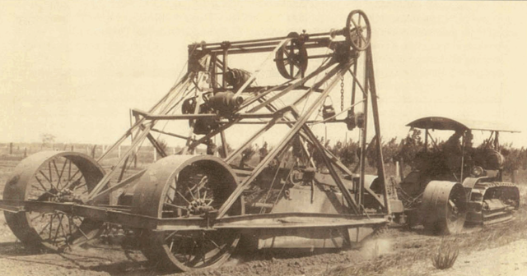

**Figure 1**: Mountain Mover with a telescoping bowl was invented in June, 1922. (Orlemann, 2000)

## Components

The CAT 637G is a typical earthmoving scraper, designed for quick loading, hauling, dumping, and spreading of loose material. The scraper has a excellent self-loading capability in a wide range of material. It is designed to load material with auger mechanism which allows material distributed throughout the bowl. Typically, an earthmoving scraper has two parts: tractor and scraper. Some scrapers, such as the CAT 621K, have only one engine on the tractor; however, for heavy duty applications, the CAT 637G have two engines located front and back of the bowl.

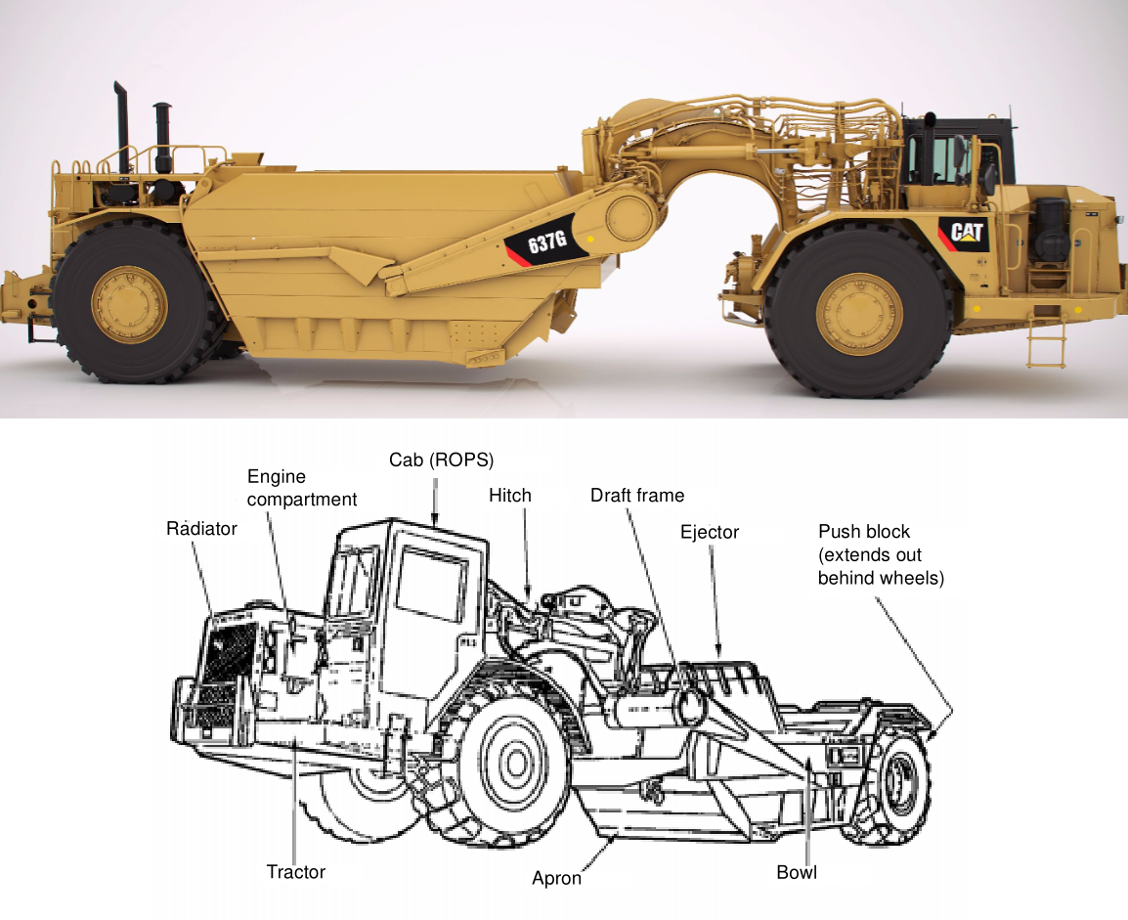

**Figure 2**: A modern tractor earthmoving scraper Caterpillar 637G (Thompson Agriculture, n.d.); an illustration of scraper’s components (“Earthmoving operations,” 2000)

* A bowl is responsible for loading and carrying material with the help of cutting edge and auger mechanism.
* An auger in front of the bowl lifts material off of the cutting edge. It also helps to distribute material evenly throughout the bowl
* An apron mounted in font of the auger retains material upon hauling.
* An ejector internally mounted in the end of the bowl helps to discharge material during spreading.

# DIAGNOSTIC AND TROUBLESHOOTING ANALYSIS

## Generic Troubleshooting Process

Sometimes, it is hard to find a root cause of certain equipment problems. Incompetence technicians may go straight to replace the broken components. This approach is not brilliant. For example, if a filter is clogged, oil will become hot. If a technician just replaces the filter without digging why the filter is plugged, he or she will replace that filter second time. There are various reasons causing oil filter clogged, such as incorrect oil viscosity, contamination, or metal-to-metal contacts. Thus, big companies always have a good finding process chart for technicians’ references.

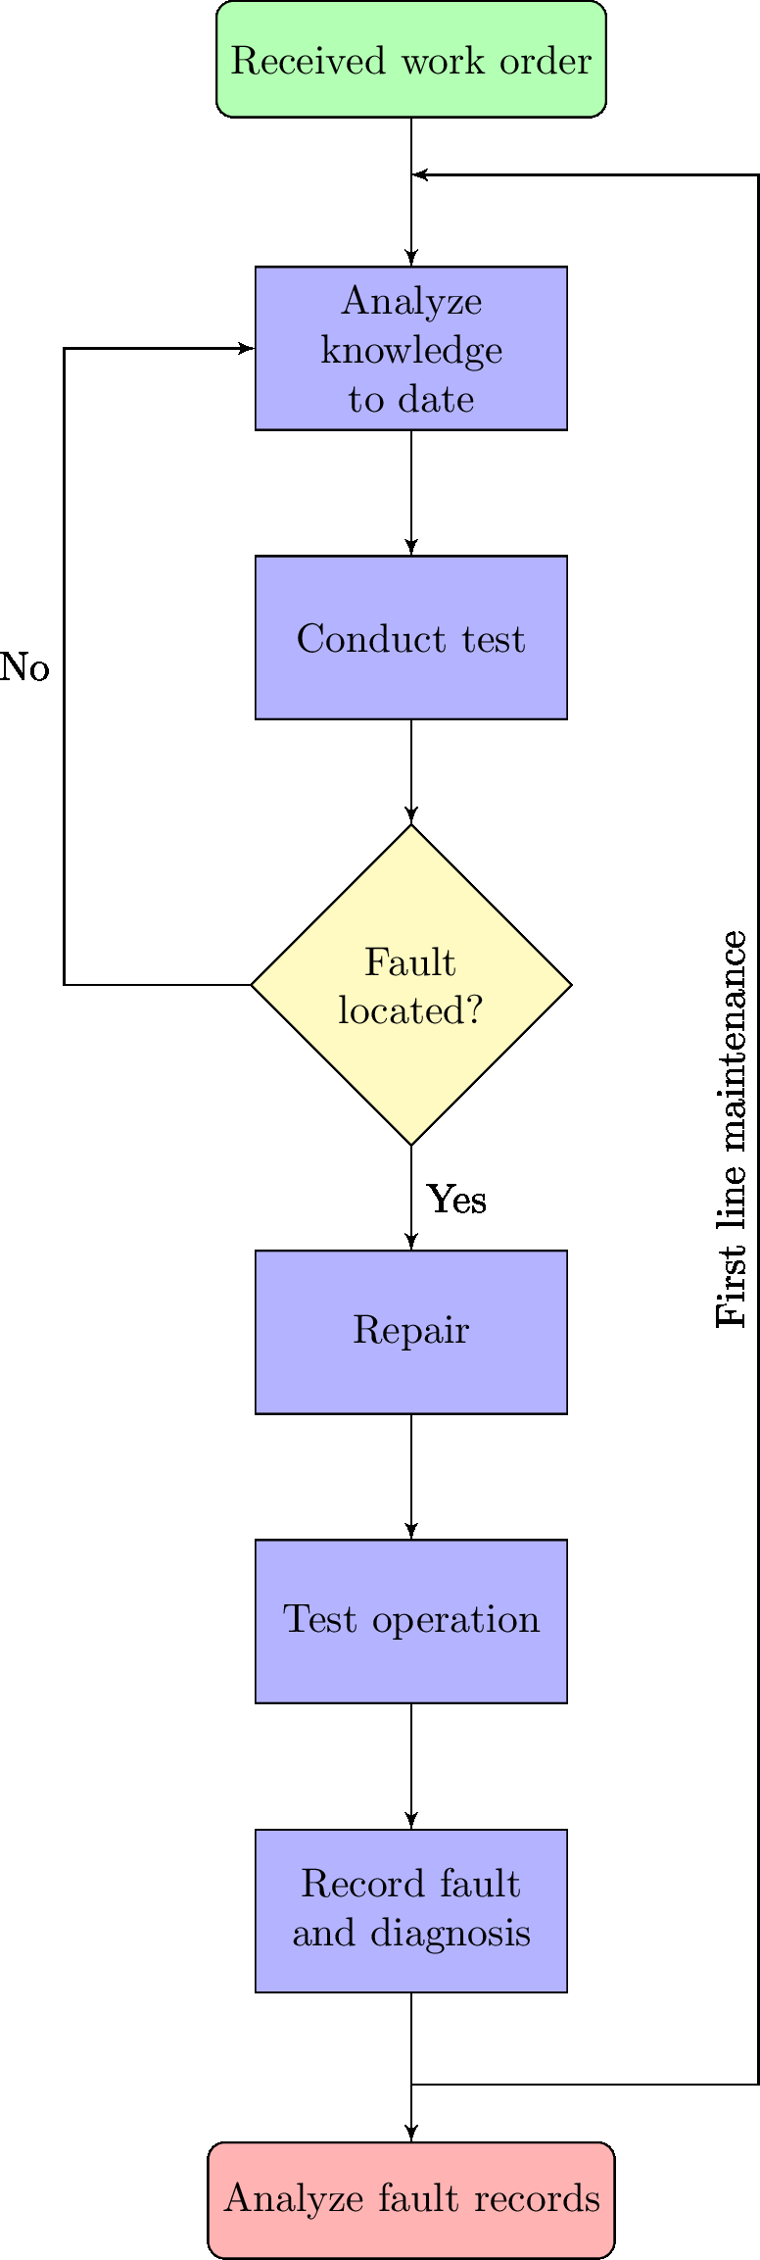

**Figure 3**: Flow chart illustrates the process of fault finding

## Cushion-hitch Hydraulic System and Service

The 637G uses hydraulics in various places: steering, cushion-hitch, bowl, apron, ejector, auger, and bail. As mentioned in the previous section, only cushion-hitch hydraulic system will be examined.

### Cushion-hitch Hydraulic System

“The function of a cushion hitch system,…, is to act as a connection device when it is mounted between the scraper and tractor” (GOA, 2016). The cushion-hitch is belong to the suspension system which helps equipment to maintain traction, transfer load during breaking and accelerating, provides an articulation point for steering and provide a comfort ride for drivers. The cushion hitch maintains a certain height for scrapers by continuously adding and removing from the load cylinder. In the next page, the pictures taken from HeavyEquipment.org shows the left and right side of scraper gooseneck, cushion-hitch pump, and its control system.

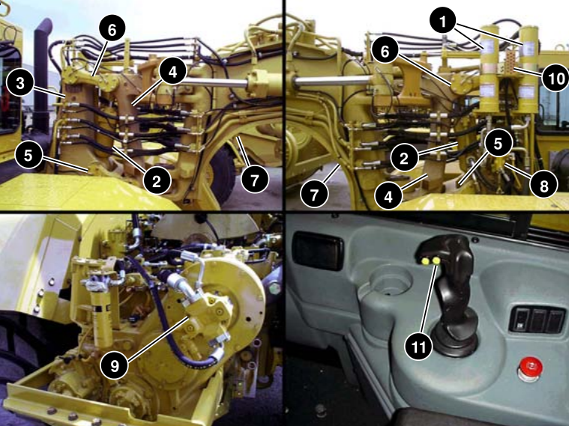

**Figure 3**: Cushion-hitch hydraulic components. (GOA, 2016)**Table 2**: Cushion-hitch components

|  |  |
| --- | --- |
| 1. Accumulators 2. Load cylinders 3. Tractor bracket assembly 4. Scraper hitch assembly 5. Lower link | 1. Upper link 2. Gooseneck 3. Leveling valve 4. Cushion-hitch pump 5. Lubrication points 6. Cushion-hitch button. |

Two nitrogen accumulators help to dampen vertical movement by compressing nitrogen gas, and constantly providing oil back and forth to the load cylinder to stabilize the equipment. The load cylinder lifts the hitch assembly off the tractor bracket in cushion ride mode so that the equipment can easily move to other working sites. In lockdown mode, load cylinder is bottomed, providing a rigid connection between the scraper and tractor. In CAT 637G, operators can also control the height of cutting edge by varying the oil flow to the load cylinder. As shown in the next page, the schematic taken from SIS portal, the 637G cushion-hitch features a load-sensing pump working with two accumulators.

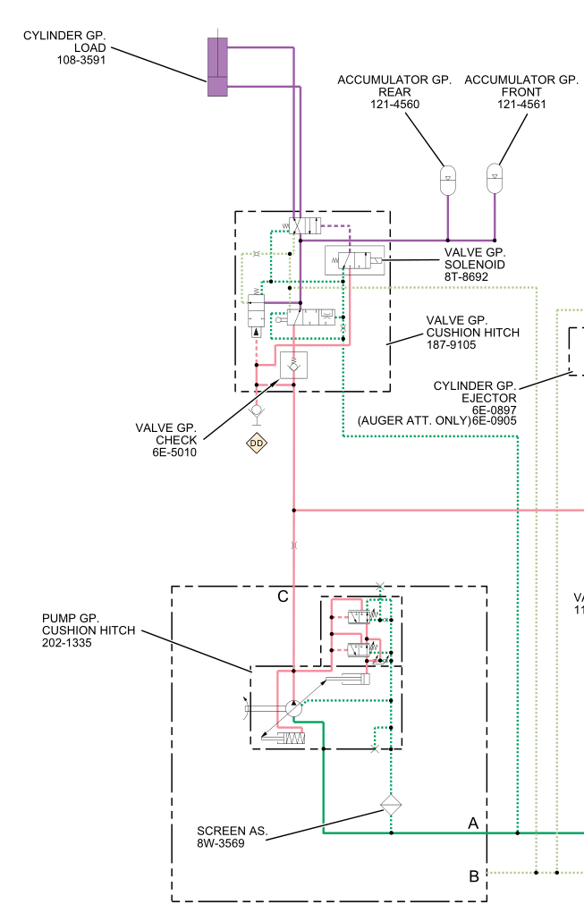

**Figure 4**: Cushion-hitch hydraulic system. (Caterpillar, 2014)

### Cushion-hitch Fault Diagnosis

“When working on suspension systems that use gas/suspension cylinders, be sure that all the nitrogen in the suspension cylinder has been released before checking the oil level.” (Angelo Spano & Bennett, 2013, p. 550). Indeed, this is true for the 637G as well. Although the engine is off, hydraulic oil is still under high pressure because of the nitrogen accumulators. Thus, technicians must make sure that all the nitrogen pressure is dissipated before overhauling cushion-hitch hydraulic system.

According to Caterpillar, as a rule of thumb, the first step of servicing any hydraulic systems, such as a cushion-hitch, is to perform a visual inspection, which will help to identify any leakage, component damage, loose or missing components. After that, operation tests can be done to find leakage in the system, a failed valve or a failed pump. The hydraulic oil should be warmed up to 115 to 125F before performing do any test (Caterpillar, 2014). In order to reach normal operating temperature, operators have to run the engine at high idle for at least five minutes (Caterpillar, 2014). Below table shows common hydraulic faults and possible causes.

**Table 1**: Common cushion-hitch problems and possible causes

|  |  |
| --- | --- |
| Faults | Possible Causes |
| Temperature of the hydraulic oil is excessively high | * The viscosity of the hydraulic oil is incorrect * The cushion-hitch piston pump is excessively worn * A restriction exists in a hydraulic oil passage * An air restriction exists at the hydraulic oil cooler |
| There is a large amount of air in the oil | * There is a leak in the oil line between the tank and hydraulic pump * The return baffle in the tank is loose or broken. * There is leakage around the cylinder seals. |
| The hydraulic and steering pump has no pressure | * Oil level is low * The hydraulic pump or pump drive shaft has malfunctioned. * A relief valve has malfunctioned |
| The cushion-hitch pump makes noises | * The viscosity of the oil is wrong. * Loose connection of the oil line on the inlet side of the pump. * The pump has too much wear. |
| Selector valve does not automatically go to lockdown position when engine is stopped | * Piston in selector valve does not move * Dirt in the orifice in the body of the selector valve. |

## Torque Converter Fundamentals and Service

### Torque Converter Fundamentals

The torque converter is the first part of powershift transmission which responsible for transferring and multiplying engine torque. The basic working principle of torque converter is just like taking a fan which is plugged into the wall and blowing another unplugged fan. However, instead of air, the torque converter uses fluid as its medium. “Torque converters and other types of fluid couplings utilize a hydrodynamic principal to transfer engine torque to the transmission, without a direct mechanical link between two components” (Angelo Spano & Bennett, 2013) . Engine torque is transferred to transmission by moving fluid at high velocity at low pressure (p. 296).

When the engine first starts, torque is transferred from the engine to the impeller. The impeller rotates causing the turbine rotates. The torque is now transfer from the turbine to the transmission. Initially, when the impeller rotates and the turbine is stationary, the fluid in torque converter can be turbulent. Therefore, a stator added in the middle of turbine and impeller, smoothly redirecting fluid from turbine back to impeller; thus, multiplying engine torque. The following illustration shows basic components of a torque converter.

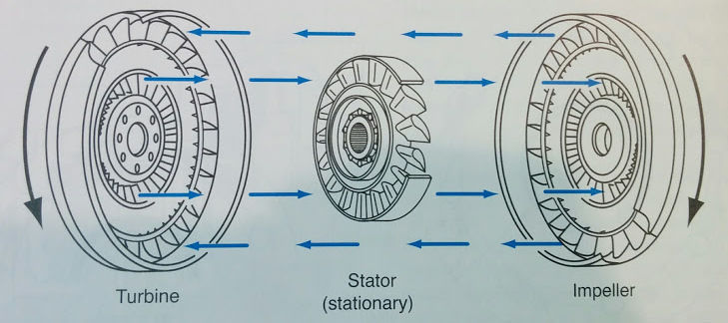

**Figure 5**: A stator located between two components can redirect fluid back to impeller (Angelo Spano & Bennett, 2013)

### Torque Converter Fault Diagnosis

Although the absence of mechanical coupling minimizes wear, a torque converter has to deal with overheating and pressure issues. A plugged oil cooler or a faulty charge pump can also cause increase in operating temperature of torque converter. Temperature can increase significantly if oil level is low because of leakage.

Air entering torque converter can also cause overheating. Typically, air could penetrate loose pipe connections, or it can just because of system is not properly vented. In order to determine the nature of the torque converter problems, the first step is to installing one or more pressure and temperature gauges at the torque converter and/or transmission. (GOA, 2016) Below image shows location of pressure tap for the 637G torque converter.

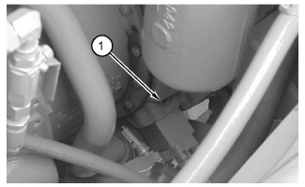

**Figure 6**: Pressure tap for the torque converter output (Caterpillar, 2014)

To check for pressure of torque converter, technicians have to do following steps:

1. Connect a digital pressure indicator at pressure tap (1).
2. Start and run the tractor and scraper engine at low rpm in neutral
3. The drive wheels must not turn during a stall test. Lower the bowl into the ground or put the tractor against a solid object that will not move.
4. Make sure that air pressure is at the normal pressure for operation. Push the brake pedal and hold the brake pedal down. Make sure that the parking brake and the secondary brake are released.
5. Move the transmission shift lever to SECOND speed position and keep the tractor engine at low rpm.
6. Slowly increase the scraper engine rpm to the maximum governor setting. The machine will try to move.
7. The scraper engine rpm must be 1920 to 2060 rpm with the torque converter in a stall condition.
8. The pressure on the digital pressure indicator at pressure tap (1) must be 430 ± 85 kPa (62 ± 12 psi).
9. Run the machine at low rpm in order to allow power train oil to cool.

**Table 2**: Common torque converter problems and possible causes

|  |  |
| --- | --- |
| Faults | Possible Causes |
| The torque converter outlet pressure is correct, but transmission lubrication pressure is too low. | * Too much leakage in the transmission lubrication circuit (bad seals, etc.). |
| The torque converter outlet pressure is too high, and transmission lubrication pressure is too low. | * There is excessive restriction in the oil cooler. |
| Torque converter outlet pressure is too low. | * The inlet relief valve is open. * There is excessive leakage in the torque converter. |
| The oil gets too hot during normal operation. | * There is a bad temperature gauge. Make a replacement of the gauge and the sending unit. * There is not enough oil in the torque converter because the torque converter inlet relief valve is open. * There is excessive oil in transmission case because of excessive leakage in the torque converter. * There is an excessive restriction in the oil lines or the oil cooler. |
| Low stall speed | * Engine performance is not correct * The oil is cold |
| High stall speed in both direction | * The oil level is low * Clutches are slipping |
| High stall speed in one direction | * There is a leak in the clutch circuit. * There is a clutch failure in the gear that has a high stall speed. |

# CONCLUSION

In the heavy equipment world, a small mistake can lead to catastrophic equipment break down, such as incorrectly back off system pressure upon replacing a new pump. Nevertheless, if technicians are skillful, they can easily prevent these types of mistake; thus saving companies time and money. Preventative maintenance is a good practice, yet there is always a chance equipment breaking down on duty. In fact, This phenomenon happens quite often, and the CAT 637G faces the same problem. Hopefully, findings in this paper give our technicians some basic diagnosis and troubleshooting instructions on cushion-hitch and torque converter of the CAT 637G. As the researched equipment is a typical scraper, technicians can apply these instruction to fix most scrapers in market.

# REFERENCES

Angelo Spano, Robert Huzij, & Bennett, S. (2013). *Modern diesel technology. heavy equipment systems*. Clifton Park, NY: Delmar/Cengage Learning.

Caterpillar. (2014). *Service information system: 637G wheel scraper awe*. Retrieved from https://sis.cat.com/sisweb/servlet/cat.cis.sis.Pcontroller.CSSISConfigServlet

Doddannavar, R., & Barnard, A. (2005). *Practical hydraulic systems: Operation and troubleshooting for engineers and technicians*. Boston, USA: Oxford.

*Earthmoving operations*. (2000). Retrieved from http://www.google.ca/url?q=http://www.globalsecurity.org/military/library/policy/army/fm/5-434/fm5-434.pdf

Government of Alberta [GOA]. Suspension system fundamentals and service (190302b) [individual learning modules] (2016). Edmonton, Canada: Queen’s printer.

Government of Alberta [GOA]*.* Torque converter fundamentals and services (190303b) [individual learning modules]. (2016). Edmonton, Canada: Queen’s printer.

Haddock, K. (1988). *Giant earth movers: An illustrated history*. Osceola, WI: MBI.

Orlemann, E. C. (2000). *Building giant earthmovers*. Osceola, WI: MBI.

Thompson Agriculture (n.d.). *Caterpillar 637G scraper [photograph]*. Retrieved from http://www.thompsonagriculture.com/new/cat-products/wheel-tractor-scrapers/637g-wheel-tractor-scraper