Joseph Kramer

CS 375 Into To Computer Networks

06-27-15

Lab 1

#1.

TCP, HTTP, QUIC, SSDP, DNS

#2.

Start Time: 17:37:22.429433000

End Time: 17:37:22.539245000

Difference = 00:00:00.109812000

#3

gaia.cs.umass.edu IP = 128.119.245.12

Joseph Kramer IP = 10.211.55.3

#4 (I had to print and then scan the printed document. Screen shots also included)

**Scanned Get Message**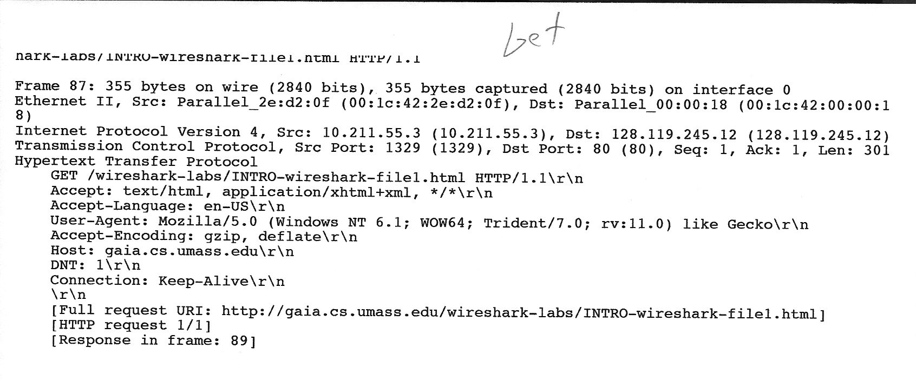

**Screen Shot Get Message**

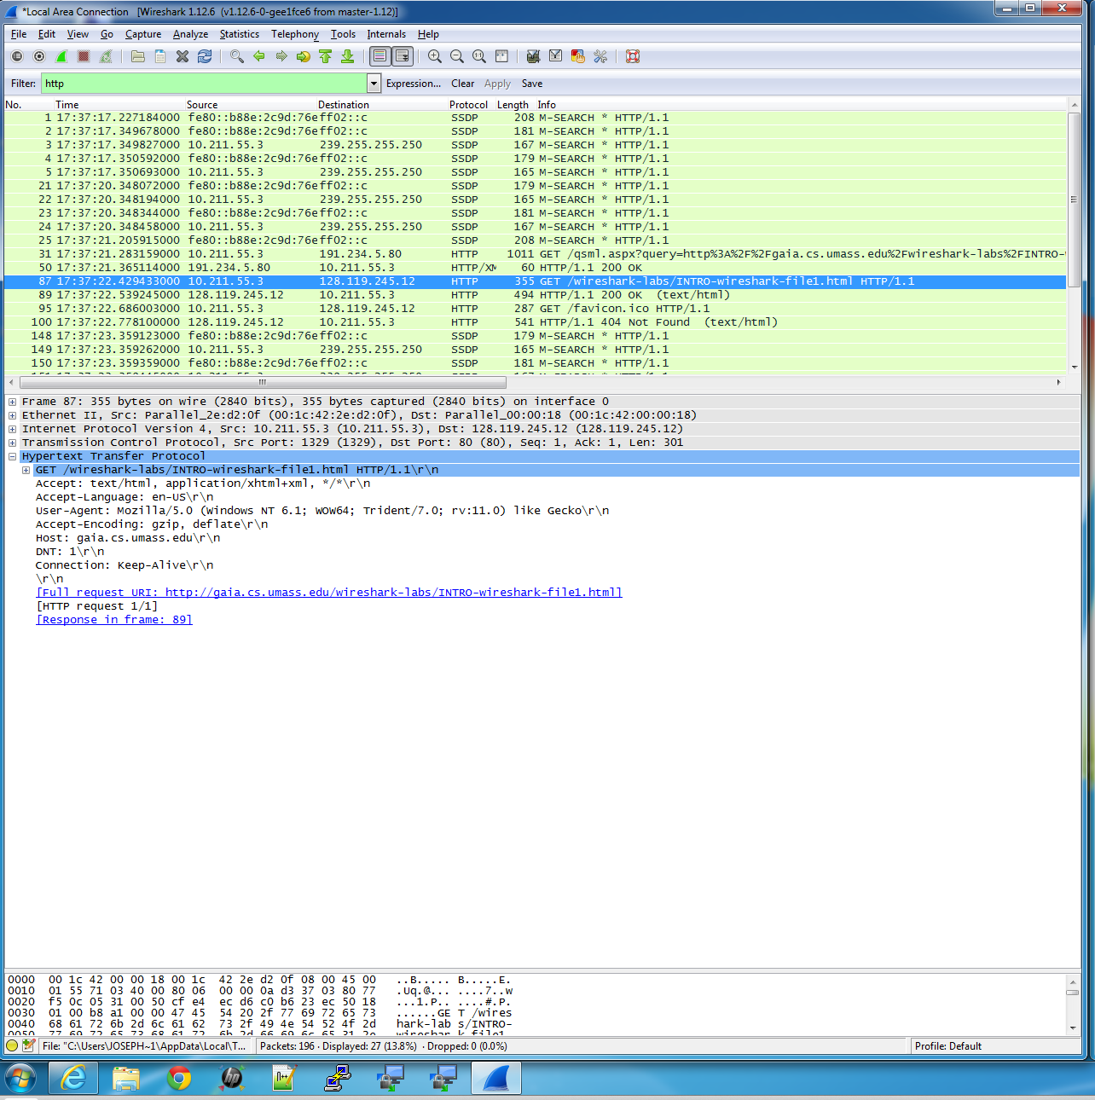

**Scanned OK Message**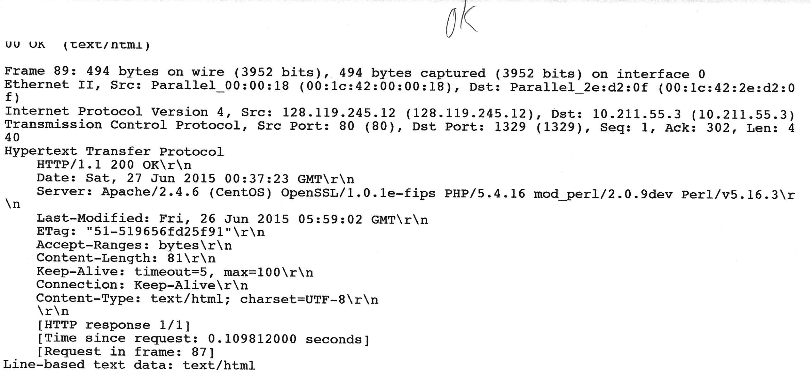

**Screen Shot OK Message**