**1. IP Address**

- 192.168.1.102

**2. Within the IP packet header, what is the value in the upper layer protocol field?**

The value is 768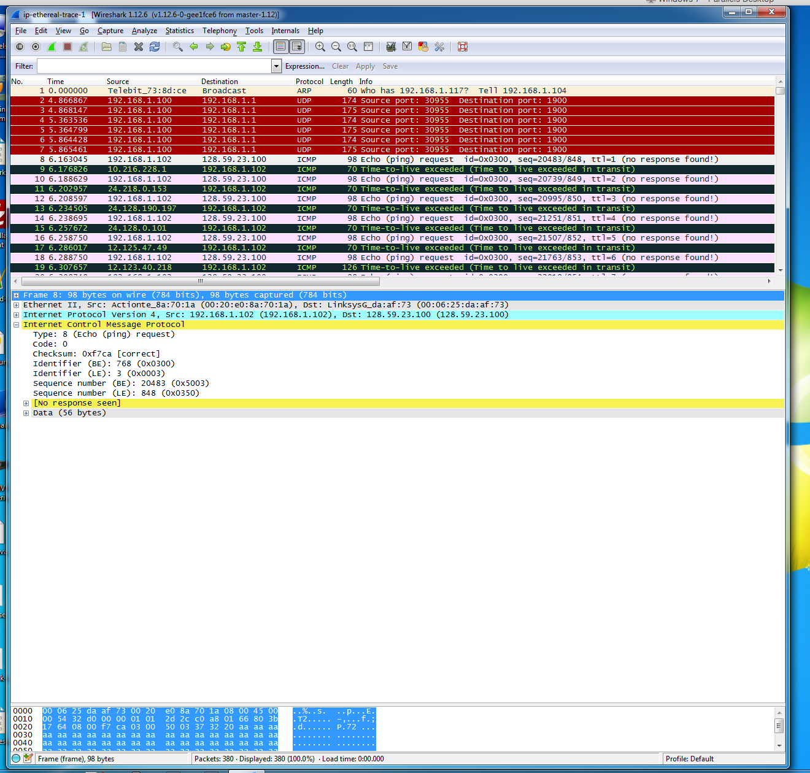

**3. How many bytes are in the IP header? How many bytes are in the payload of the IP datagram? Explain how you determined the number of payload bytes.**

There are 20 bytes in the IP header.

There are 36 bytes in the payload.

There were 56 bytes sent, and 56-20=36

**4. Has this IP datagram been fragmented? Explain how you determined whether or not the datagram has been fragmented.**

The fragment offset is set to 0. This indicates that the packet is no fragmented. 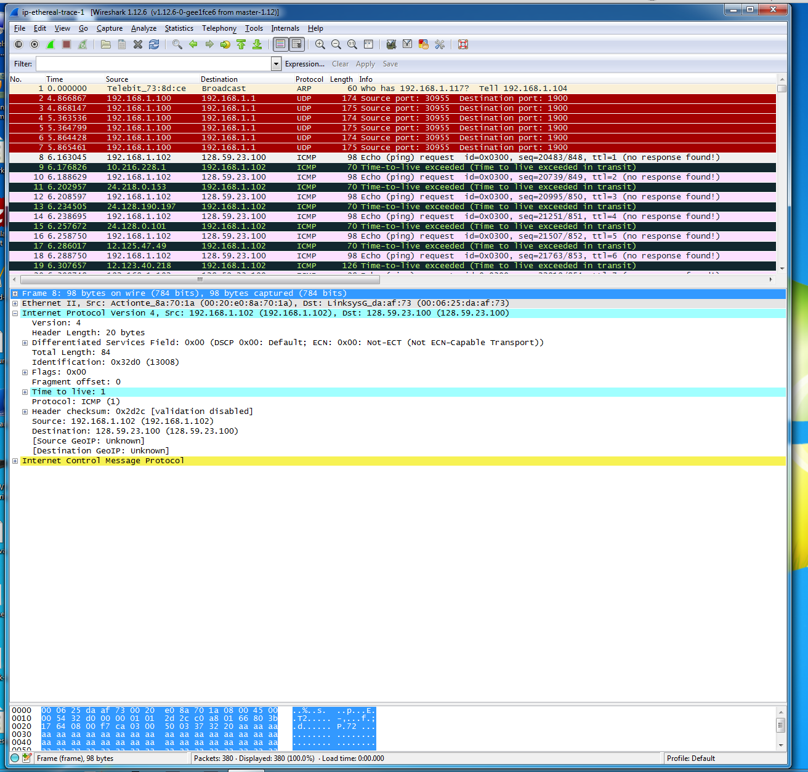

**5. Which fields in the IP datagram always change from one datagram to the next within this series of ICMP messages sent by your computer?**

Identification, Checksum, Time To Live

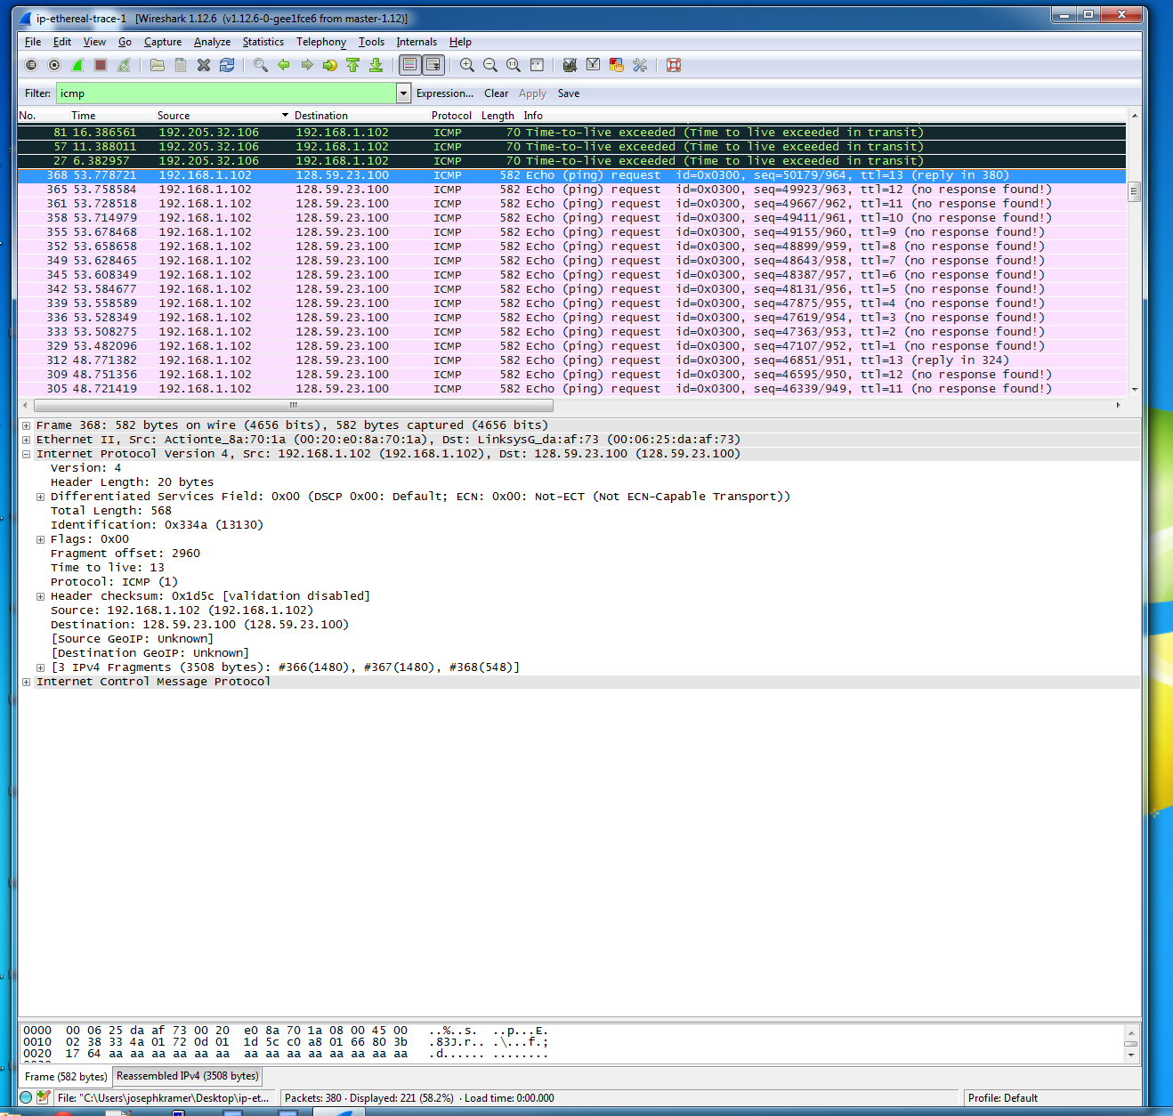

**6. Which fields stay constant? Which of the fields must stay constant? Which fields must change? Why?**

**Constant:**

Version – because IPv4 is used for the packets

Header Length – because of ICMP packets

Source IP – always sending from the same source.

Destination IP – always sending to the same destination.

Differentiated Services Filed – All packets are ICMP, therefore they use the same type of service class.

Upper Layer Protocol – Because these are ICMP packets

**Fields That Must State Constant:**

** Same As Above **

**Fields That Must Change:**

Time to live – The IP packets must have different ID’s

Header checksum – When the header changes, so does the checksum

Identification – The IP packets must have different ID’s

**7. Describe the pattern you see in the values in the Identification field of the IP datagram**

The IP header ID fields’ increment with each ICMP echo

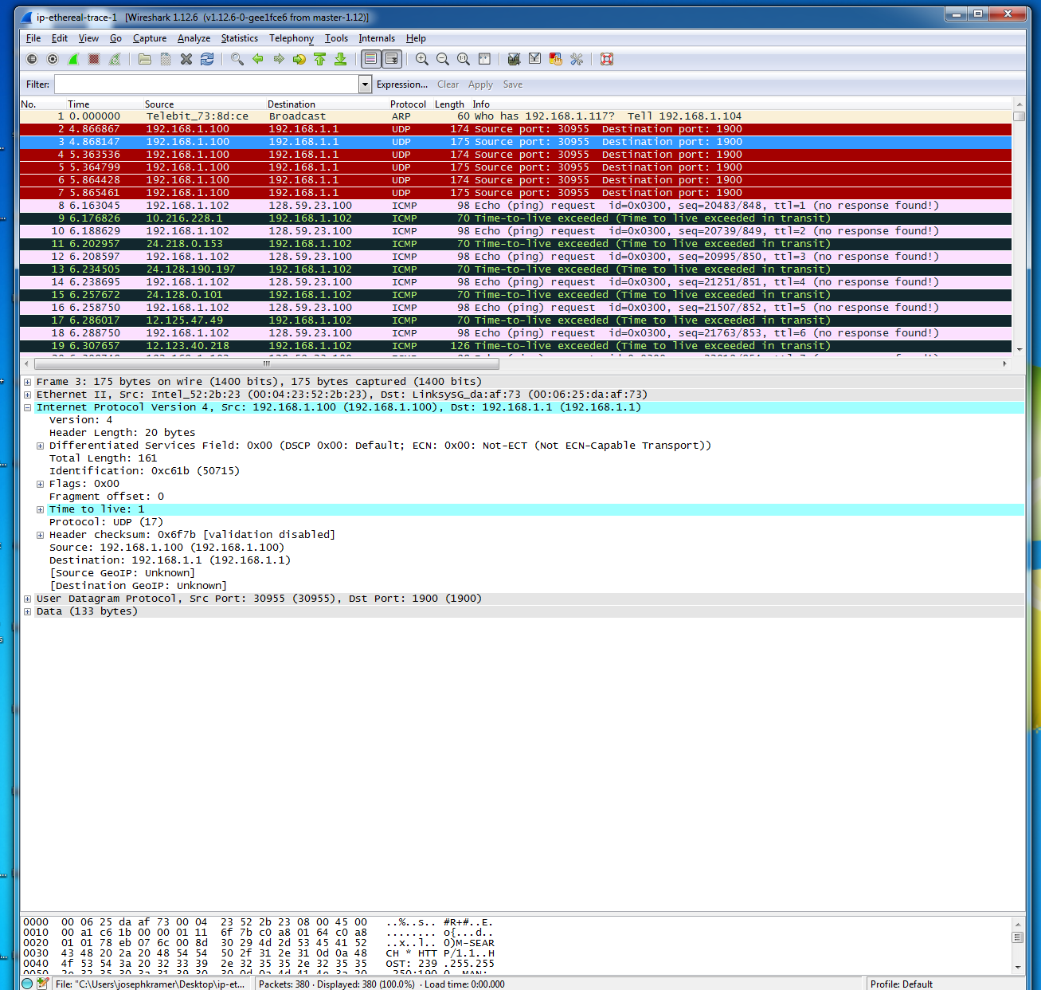

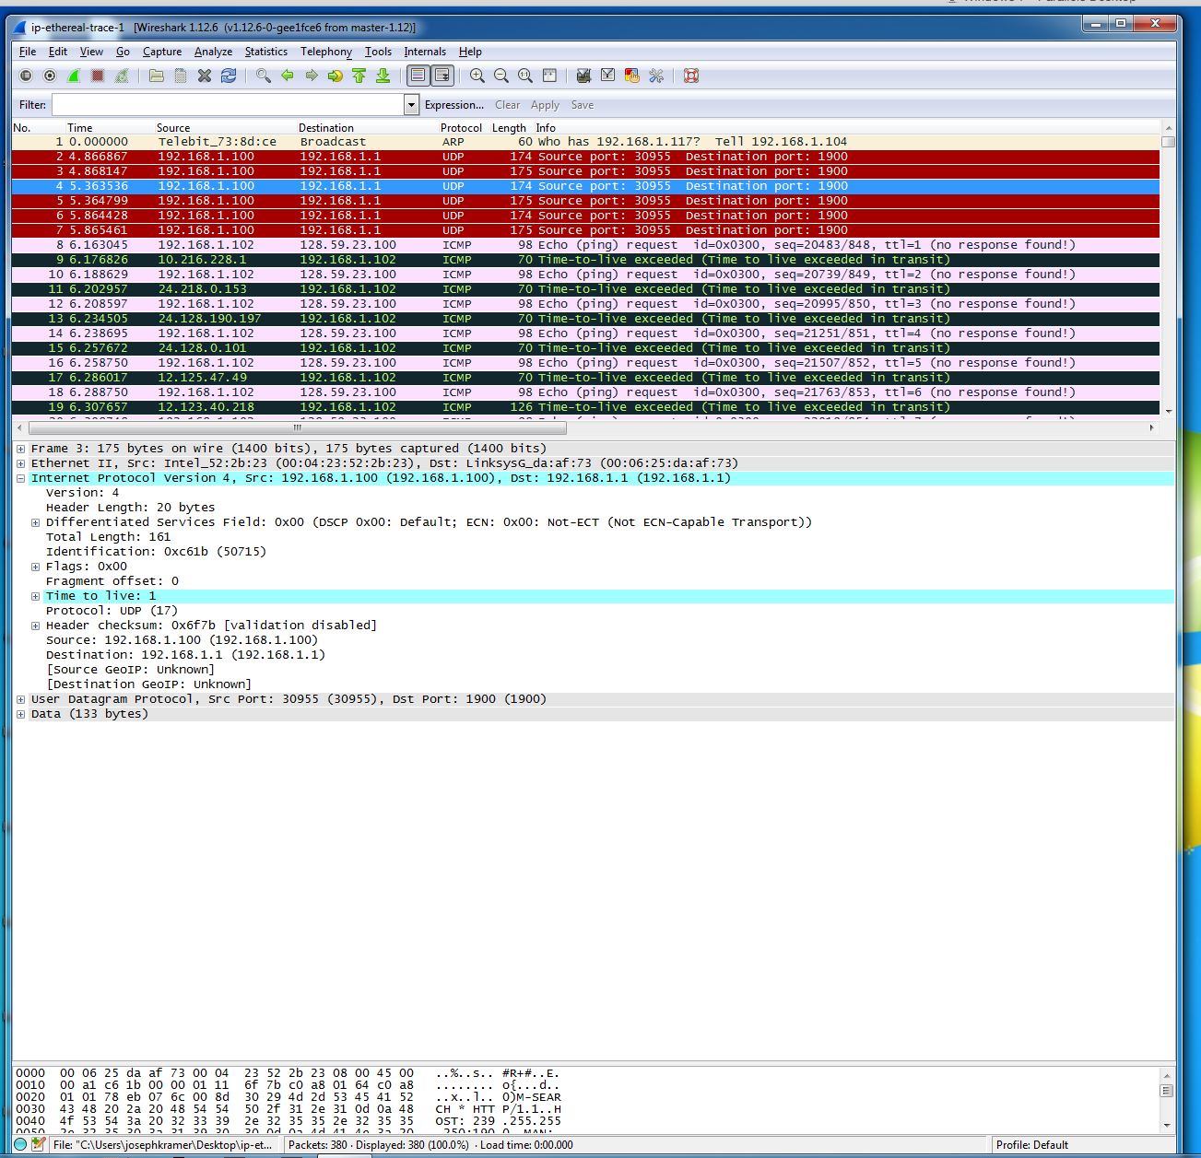

**8. What is the value in the Identification field and the TTL field?**

Identification: 0x4fcd (20429)

Time to live: 243

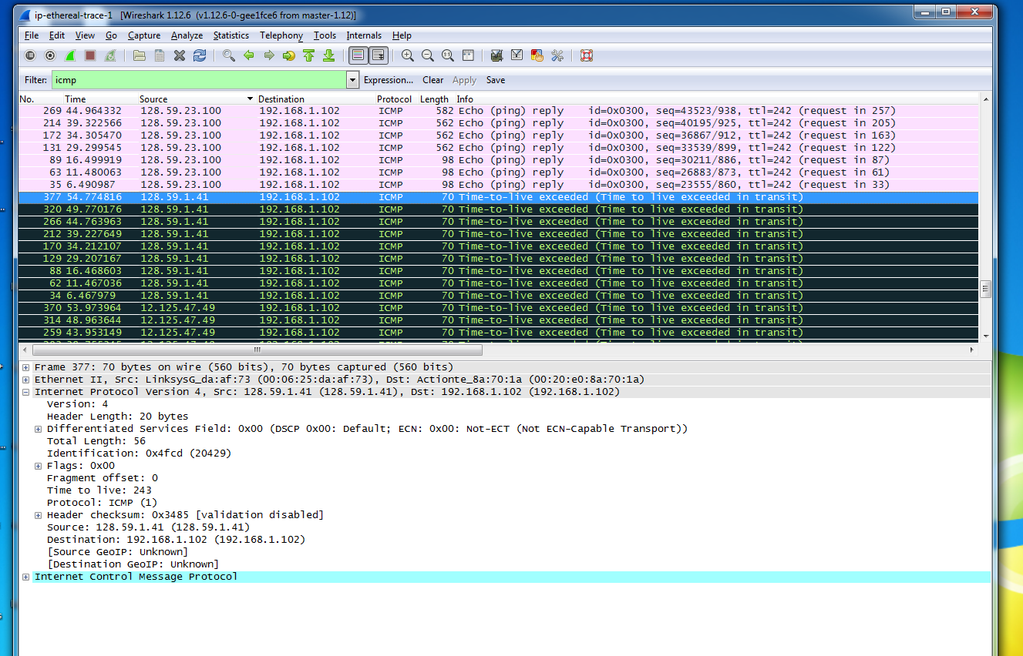

**9. Do these values remain unchanged for all of the ICMP TTL-exceeded replies sent to your computer by the nearest (first hop) router? Why?**

The identification field changes from every reply, because the field must remain unique. If the ID fields have the same value then the replies are fragments of a bigger packet.

The time to live field is unchanged, because the time to live for the first hop router is always the same.

**10. Find the first ICMP Echo Request message that was sent by your computer after you changed the Packet Size in pingplotter to be 2000. Has that message been fragmented across more than one IP datagram?**

Yes the message has been fragmented across more than one IP Datagram.

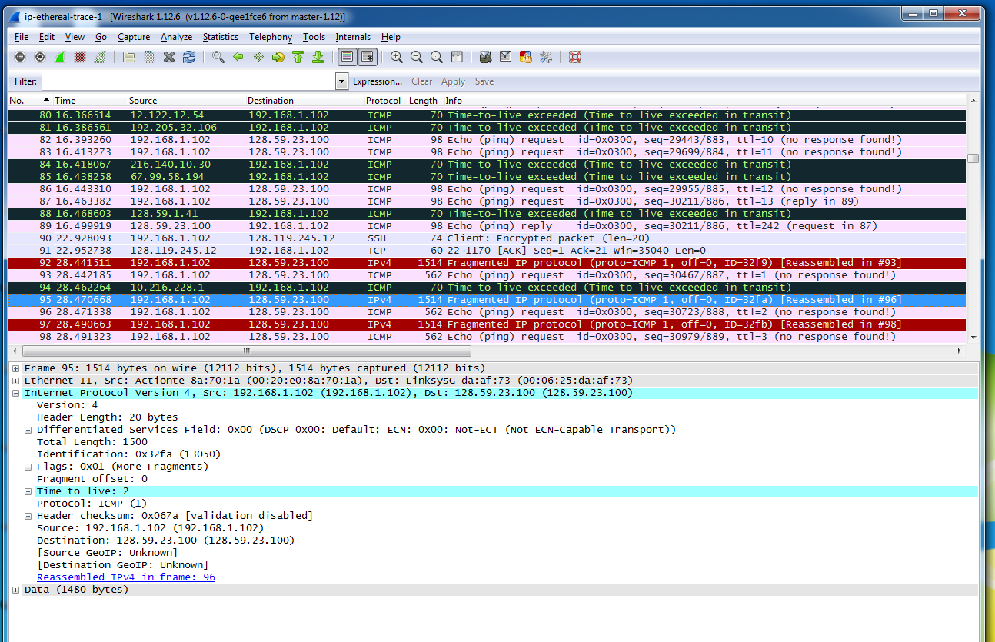

**11. Print out the first fragment of the fragmented IP datagram. What information in the IP header indicates that the datagram been fragmented? What information in the IP header indicates whether this is the first fragment versus a latter fragment? How long is this IP datagram?**

The flag bit is set, which indicates that the datagram is fragmented. The fragment offset is 0, therefore this is the first fragment. The length is a total of 1500, header + offset.



**12. Print out the second fragment of the fragmented IP datagram. What information in the IP header indicates that this is not the first datagram fragment? Are the more fragments? How can you tell?**

The fragment offset is 1480 and that is what indicates this is not the first datagram fragment. There are no more fragments, because the flag is not set

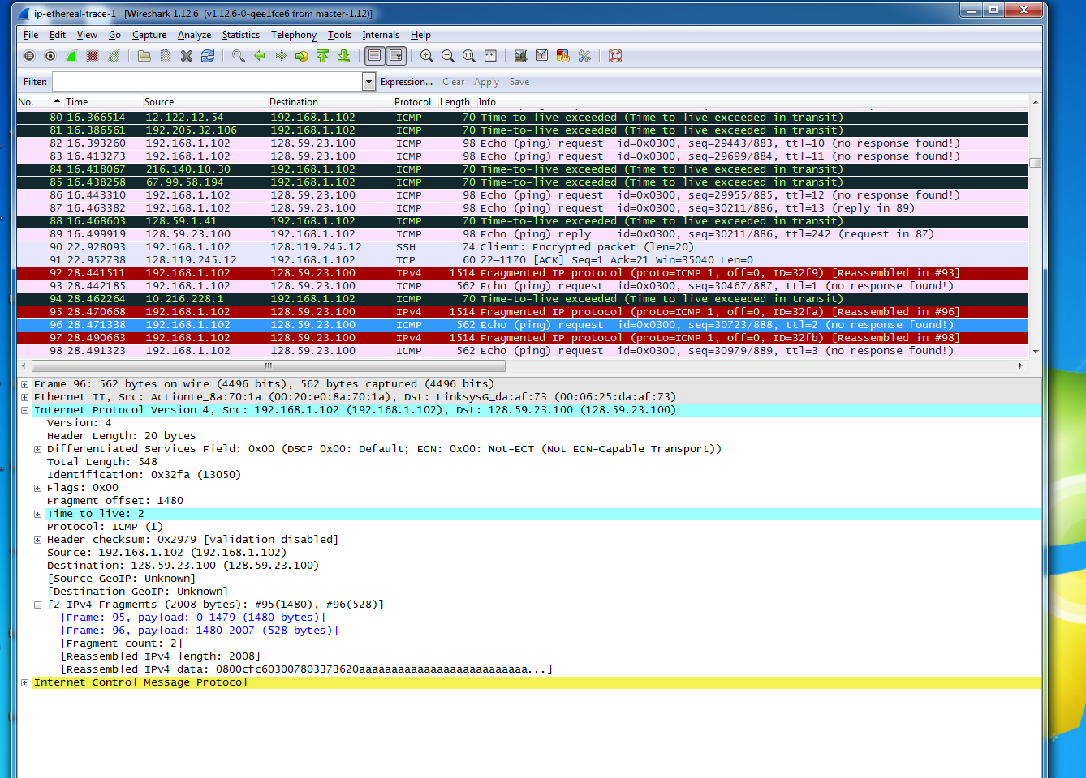

**13. What fields change in the IP header between the first and second fragment?**

Length, Flag Set, Fragment Offset, Header Checksum

**14. How many fragments were created from the original datagram?**

There are 3 packets crated after switching to 3500.



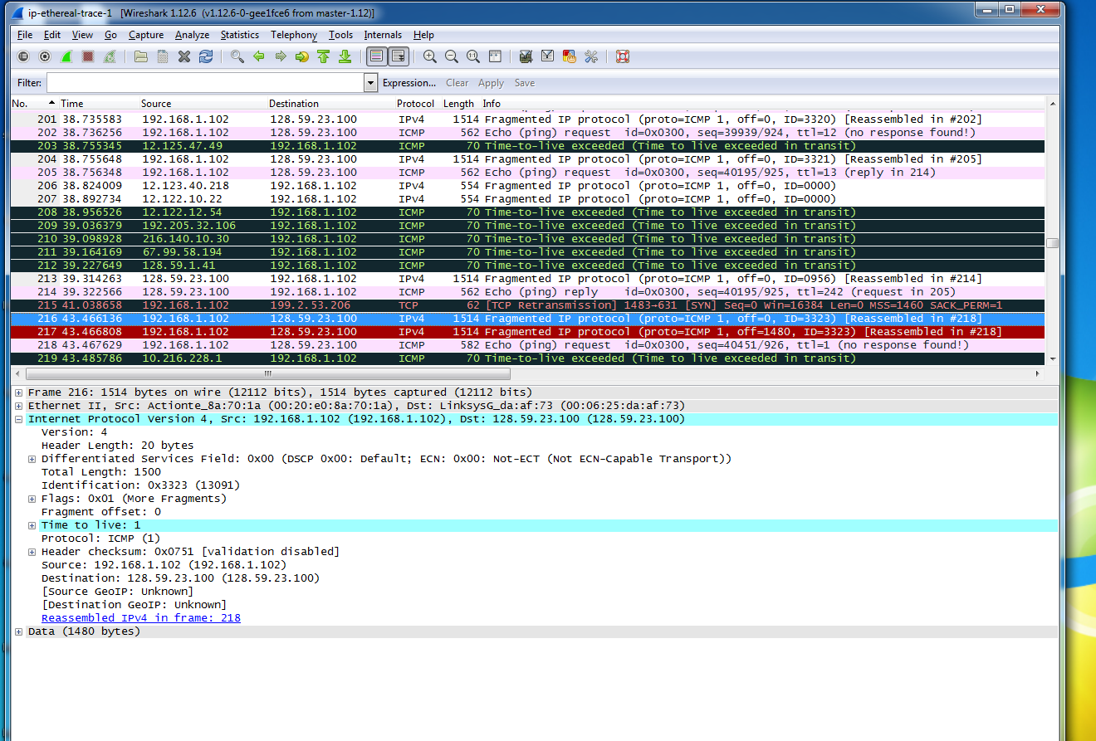

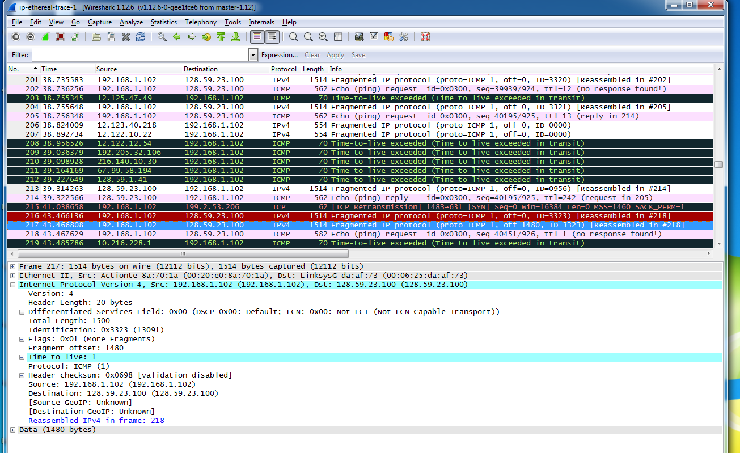

**15. What fields change in the IP header among the fragments?**

Between all packets the IP header fields that changed are checksum and fragment offset. For all three packets there is a change in the total length. There is a change in the flag for the 3rd packet from 1 to 0. The first two packets have a length of 1500, while the 3rd packet has a length of 568.





