1.

00:d0:59:a9:3d:68 🡪 AmbitMic

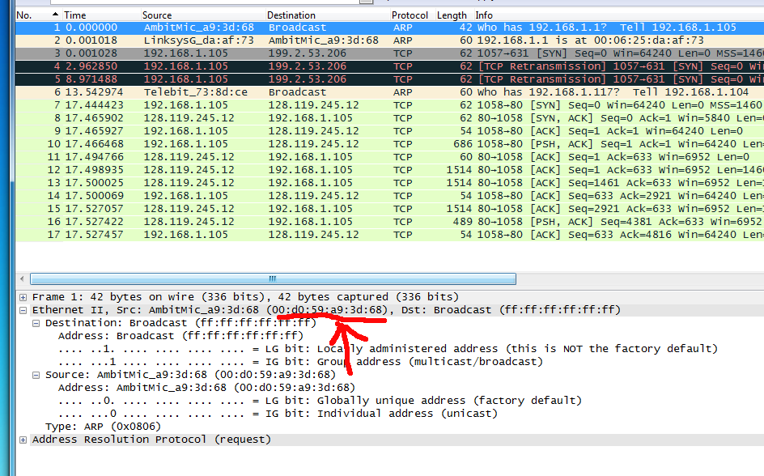

2. 00:06:25:da:af:73 🡪 The Linksys Router

3. 0x800

4. 686 – 632 = 54

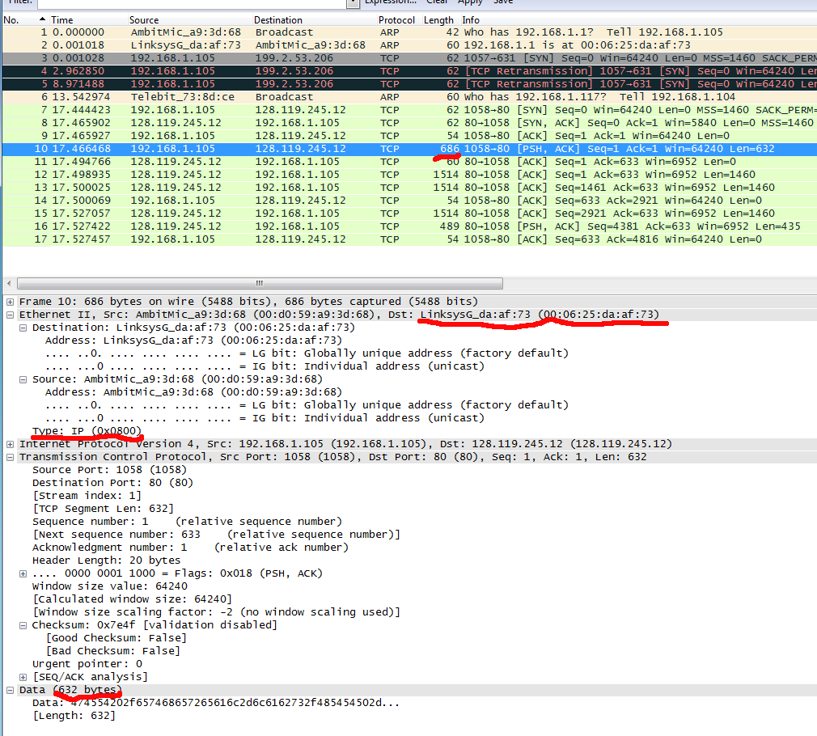

5. 00:06:25:da:af:73 🡪 The Linksys Router

6. 00:d0:59:a9:3d:68 🡪 AmbitMic

7. 0x800, it corresponds to the IP

8. It appears at 66 bytes

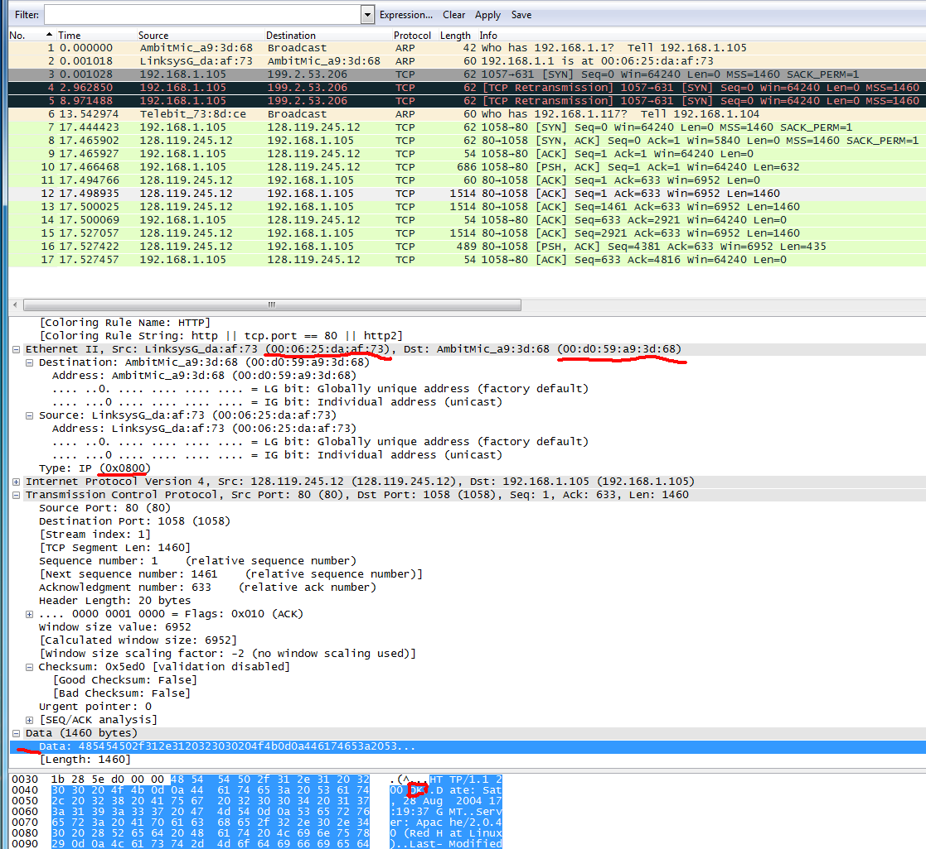

9.

The left:

Header: Internet Address

Contains: IP Address

The Middle:

Header: Physical Address

Contains: MAC Address

The Right:

Header: Type

Contains: Protocol Type

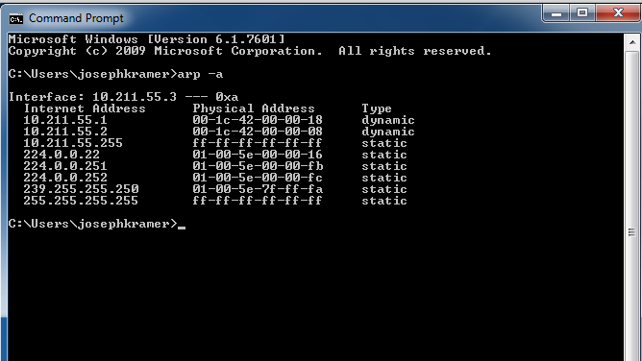

10.

Source 🡪 00:d0:59:a9:3d:68

Destination 🡪 ff:ff:ff:ff:ff:ff

11.0x0806. This is the ARP state.

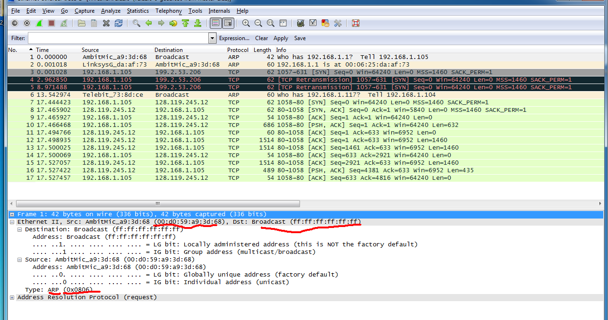

12.

a. 20 bytes from the very beginning

b. 1

c. Yes, 192.168.1.105

d. The target MAC address field is 00:00:00:00:00:00 and once the MAC address is resolved, it will

change to the finished MAC address of the router / server.

13.

a. 20

b. 2

c. It appears in the previously blank target MAC address field. This is the senders MAC address,

because this is a reply to the broadcast request. . That is the router MAC address of

00:06:25:da:af:73

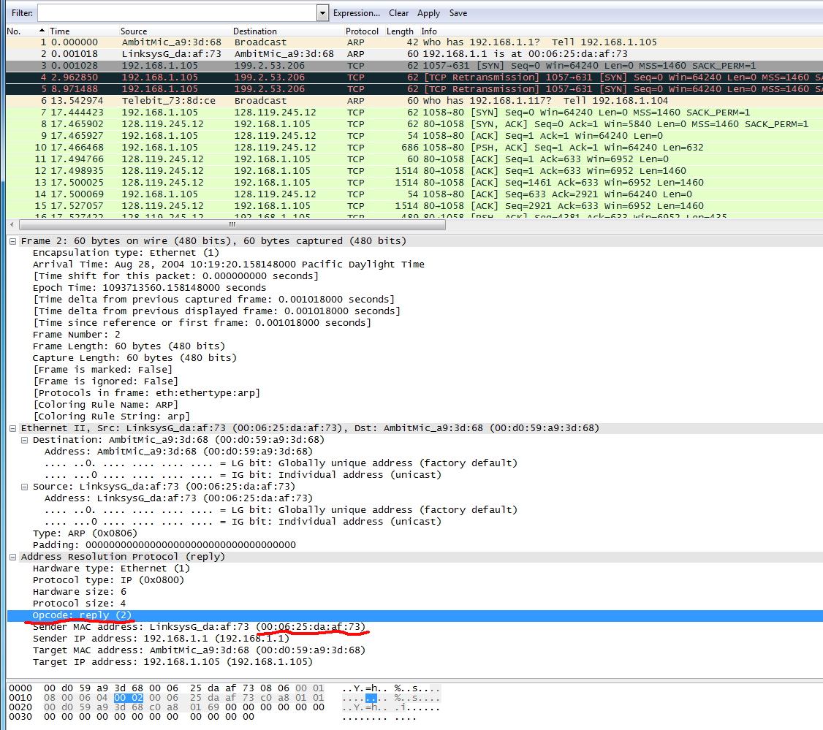

14.

Source: 00:06:25:da:af:73 🡪 The Linksys Router

Dest: 00:d0:59:a9:3d:68 🡪 AmbitMic

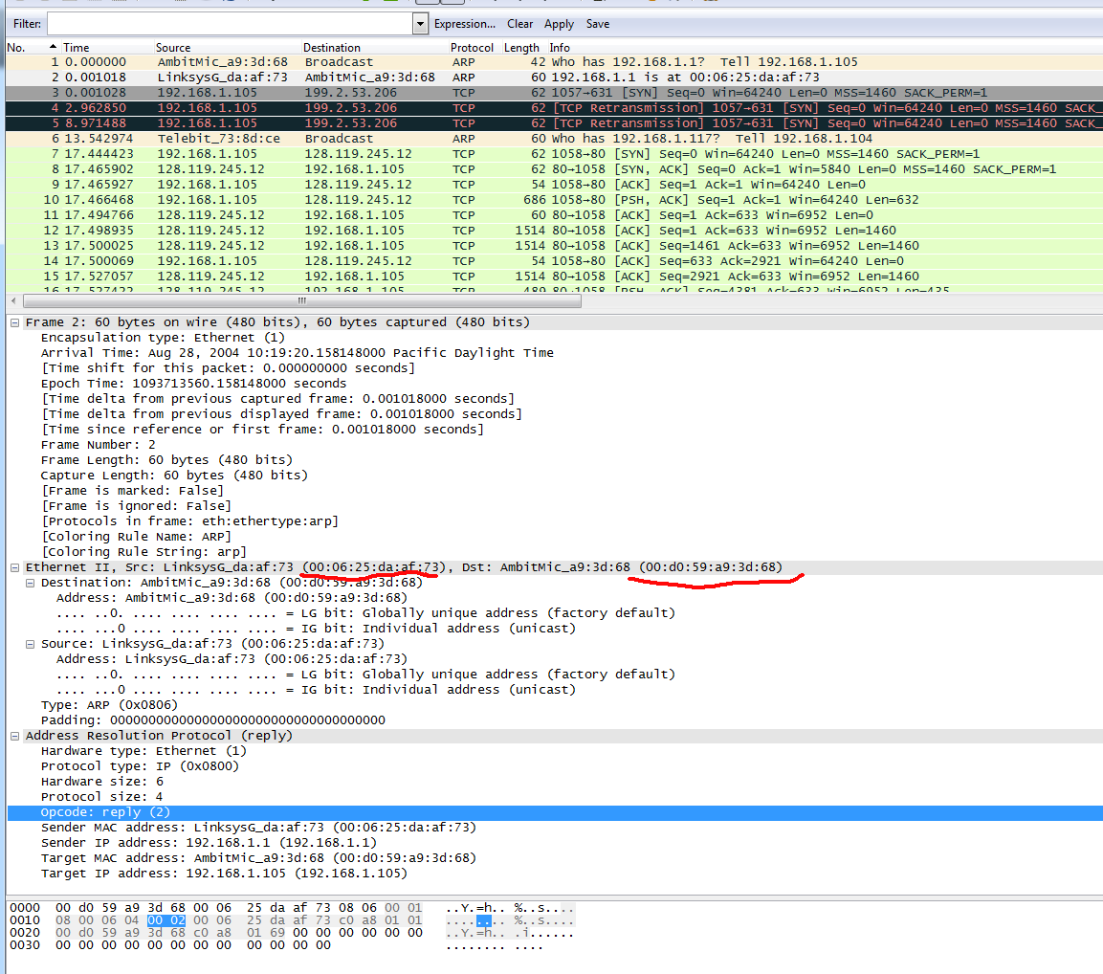

15.

This does not need to be rediscovered, because it is an IP address in the same subnet as the router,

which has already been mapped in the ARP table.

