PlanningPhase-DRD&ERD
Bicol University Polangui Campus

Web System and Technology
Data Flow Diagram (DFD)

BSIT Animation 3
GroupName: SiniGang
Members:
Nicole Anne Cabrera
Jean Ashley Cabria
Jeniela Kate Cidro
John Michael Orcio
Arabella Faye Marilejos

Data Flow Diagram (DFD)

Context Diagram/Level 0 (Highest Level)

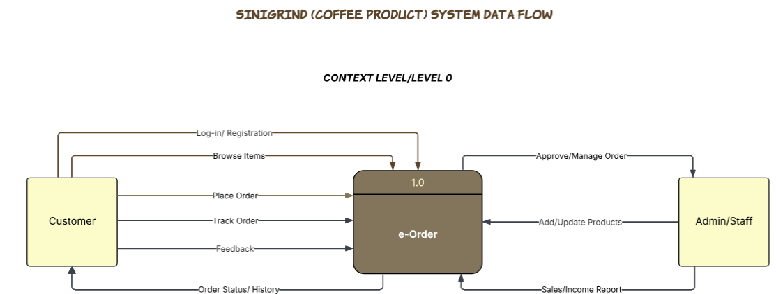

Overall SiniGrind Web System as a single process. It connects external entities such as Customer and Admin/Staff.

Level 1 (More Detailed Breakdown)

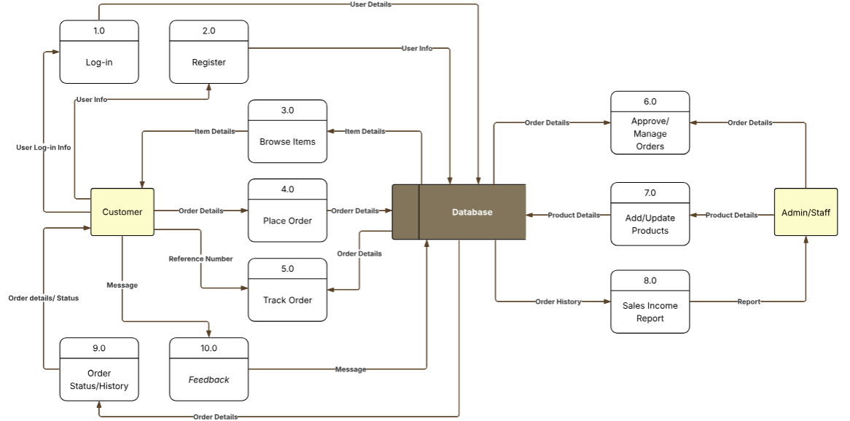
Expands the system into 10 major processes: Log-in, Register, Browse Products, Place Order, Track Order, Approve/Manage Orders, Add/Update Products, Sales Income Report, Order Status/History, and Feedback.

Level 2 (Even More Detail, if Needed)

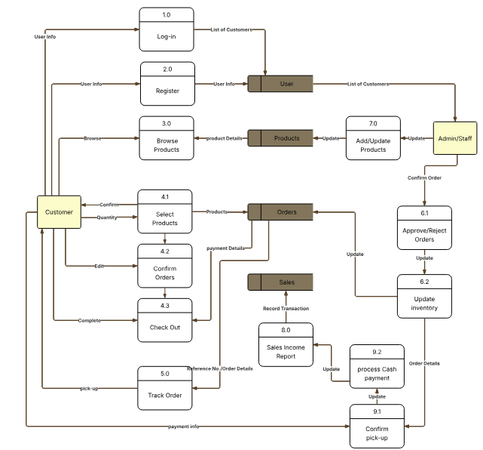
Sub-Processors such as selecting products, confirming orders, checking out, approving/rejecting orders, updating inventory, confirming pick-up, processing cash payments, and updating sales income reports. This connects to Customers, Products, Orders, Sales databases.

