Lappeenrannan teknillinen yliopisto

School of Business and Management

Sofware Development Skills

József Krizsán, <x150256 >

LEARNING DIARY, Software Development Skills: Full-Stack MODULE

**LEARNING DIARY**

**15-30.9.2024**  
  
I setup the environment what the course details recommended (VS Code). Checked the additional videos and materials for the course.

**1-15.10.2024**

Checked the MERN-stack videos. Checked out the project in my local environment. Installed the recommended tools (Postman, MongoDB Compass). Based on the videos setup a free online MongoDB database, which one I can access from web, MongoDB Compass and from the application as well. I had some issues with the URL which one required to use from the application because the URL pattern was updated since the video was captured. Finally solved it and I was able to run locally the Goal application and also be able to test the backend APIs with Postman. Noticed the architecture seems very similar like the Asp.Net MVC has. Both solution has 3 well separated layers.

**16.10.2024-05.11.2024**

In order to get some experience and feelings how the application is actually working, extended the goal data model with a new field (deadline)

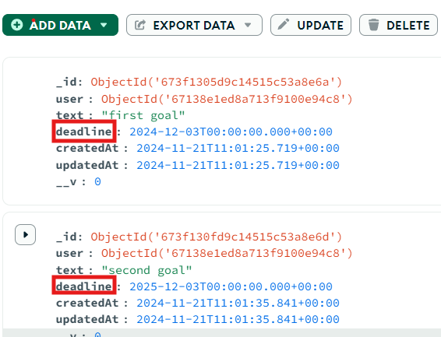

and extended with it the backend part:

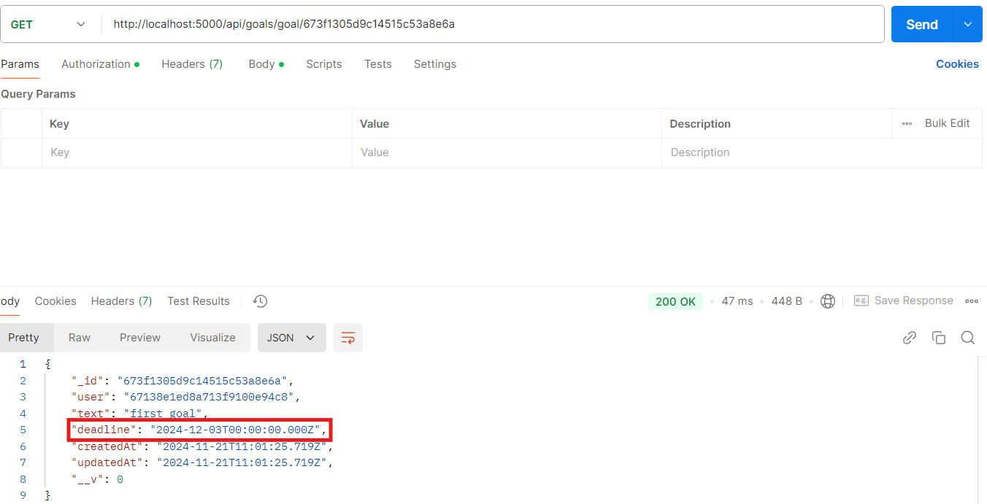

and the frontend one as well:

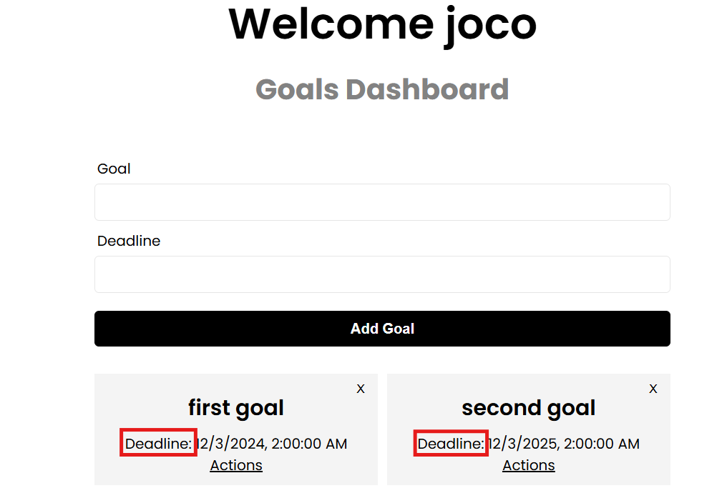

**06.11.2024-10.11.2024**

Added the Action data model to the database with a reference to the Goal model. Extended the backend with the necessary logic to be able to manage the new resource. Also extended the delete goal API with a solution which one will delete the Goals Actions before it will delete the goal itself.

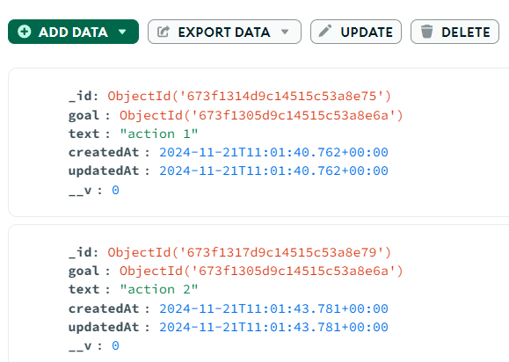

**11.11.2024-21.11.2024**

I worked on the fronted side for the Actions page, which one is available from Goal Dashboard with the Actions link. This page is able to manage the Actions for a goal. Tested the solution with Chrome and Edge browsers.

