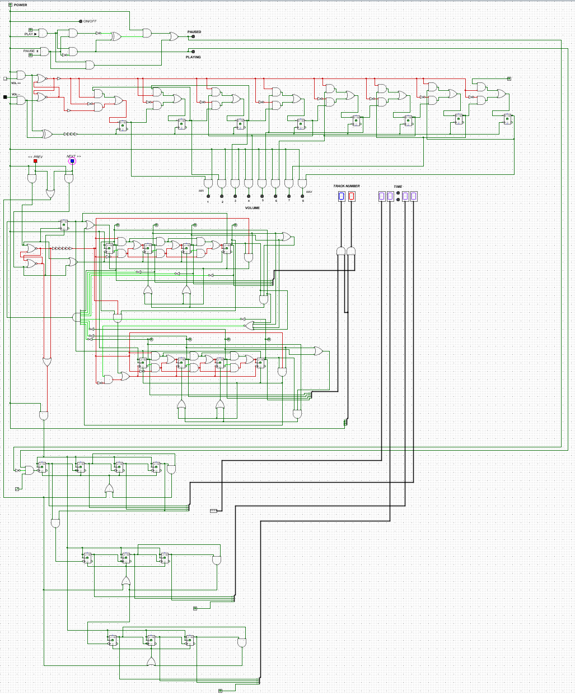
More progress on the assignment:
Remove “00” state when prev/next
Add a simple time counter for track playing

