HP 5370 Processor Board – Test Procedure
2013-12-07
Use with PCB V3.1 10/25/2013

Summary:

Each trace on the board will be tested for opens and shorts with errors displayed using four LEDs on the attached BeagleBone single-board-computer (top component in Figure 1 below). The BeagleBone runs the Linux operating system and it is important to let the test finish, and Linux shutdown, before removing power. This is described in the steps below.

Procedure:

- Figure 1 shows the BeagleBone and the two blue edge connectors that will attach to the board-under-test. The right edge connector carries +5V DC from an AC power module that should be compatible with China AC power outlets.

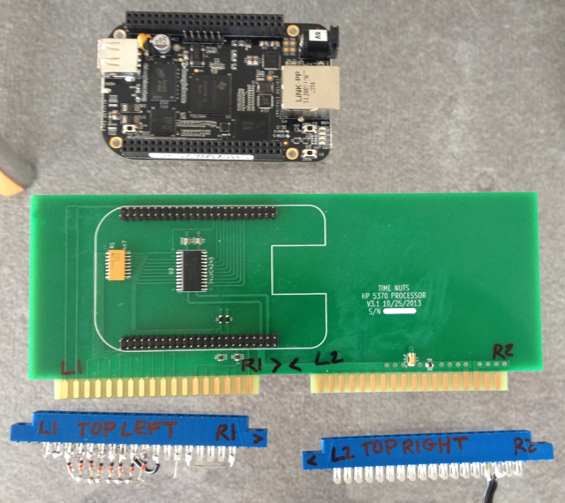Figure 1: Test fixture components

- Attach the BeagleBone and the two blue edge connector to the board-under-test as shown in Figure two. It is very important to attach the BeagleBone and the blue edge connectors with the proper orientation as the connectors are not polarized.
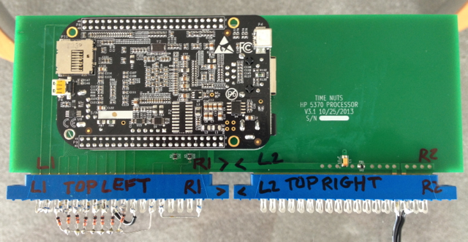Figure 2: Assembled test fixture

- Apply AC power. As shown in Figure 3 below the power LED will light. The status LEDs will then light and flash as Linux boots on the BeagleBone.

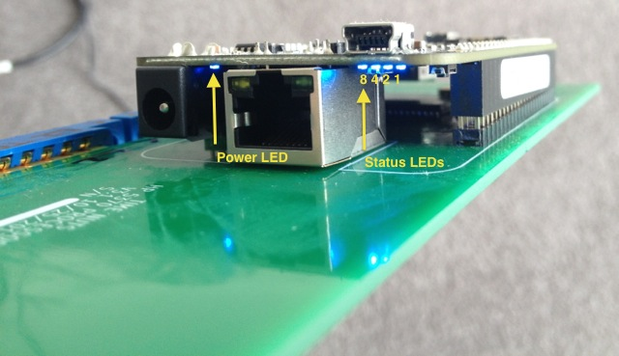Figure 3: LED locations

- After about 30 seconds the “testing” LED pattern shown in Figure 4 will begin. If there are no errors found the LEDs will light in this back-and-forth pattern ten times. After the LEDs have turned off wait 15 seconds. Then it is safe to remove AC power and disconnect. The board has passed testing.

- If there is an error one of the patterns in Figure 5 will flash ten times. After that the LEDs are turned off and it is safe to disconnect after 15 seconds. Note that the 8-4-2-1 orientation of the LEDs matches what is shown in Figure 3.

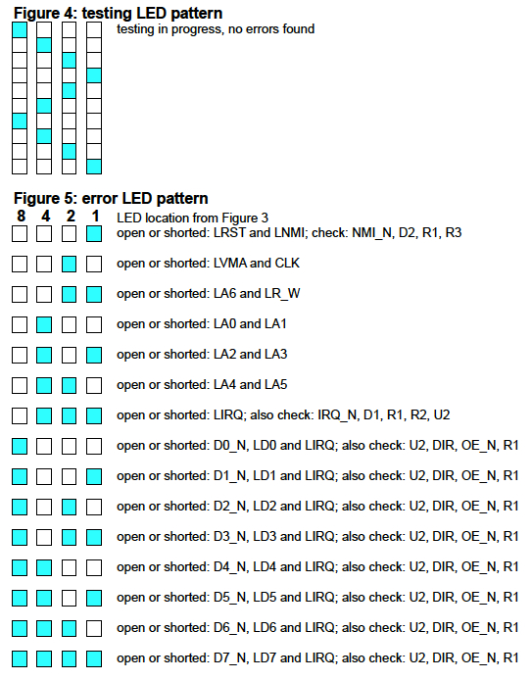

- In Figure 5 the signal names shown (e.g. LIRQ) are the same as in the schematic. Figure 6 below shows how the edge connectors are wired. For example LA0 and LA1 are wired together so LA0 can be set to a one or zero and the value read back on LA1 to test that those two traces are connected together and not shorted to +5V or ground. Also the other traces are checked to see if LA0 or LA1 are shorted to them.

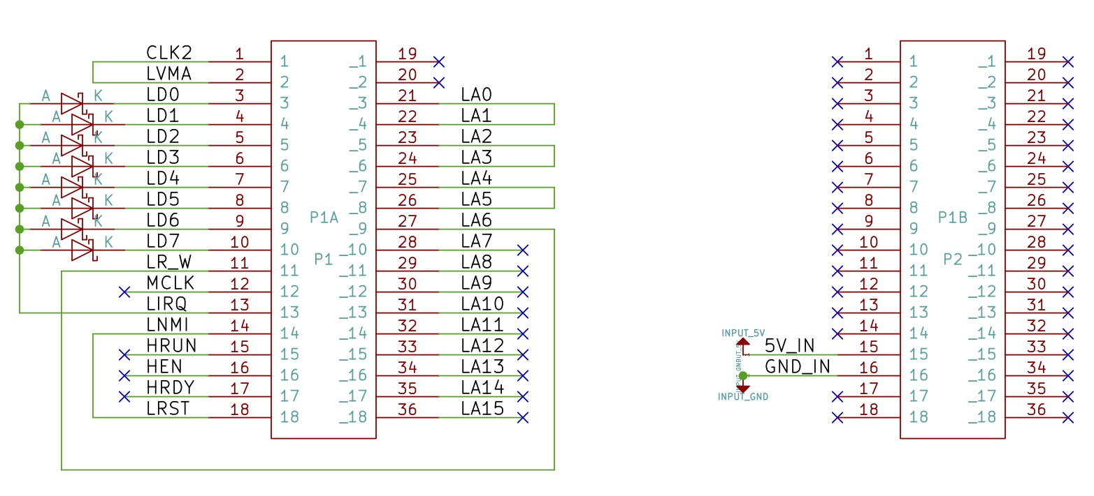Figure 6: Edge connector schematic

(end of document)

