**NAME: KSHITIJA SHAMRAO JADHAV**

**PRN:2019BTECS00053**

**ASS 3: PlayFair Cipher**

Playfair cipher is an**encryption algorithm** to encrypt or encode a message. It is the same as a traditional cipher. The only difference is that it encrypts a digraph (a pair of two letters) instead of a single letter. It initially creates a key-table of 5*5 matrix. The matrix contains alphabets that act as the key for encryption of the plaintext.

**Encryption:**

#include <bits/stdc++.h>

using namespace std;

#define SIZE 30

// Function to convert the string to lowercase

void toLowerCase(char plain[], int ps)

{

    int i;

    for (i = 0; i < ps; i++) {

        if (plain[i] > 64 && plain[i] < 91)

            plain[i] += 32;

    }

}

// Function to remove all spaces in a string

int removeSpaces(char* plain, int ps)

{

    int i, count = 0;

    for (i = 0; i < ps; i++)

        if (plain[i] != ' ')

            plain[count++] = plain[i];

    plain[count] = '\0';

    return count;

}

// Function to generate the 5x5 key square

void generateKeyTable(char key[], int ks, char keyT[5][5])

{

    int i, j, k, flag = 0;

    // a 26 character hashmap

    // to store count of the alphabet

    int dicty[26] = { 0 };

    for (i = 0; i < ks; i++) {

        if (key[i] != 'j')

            dicty[key[i] - 97] = 2;

    }

    dicty['j' - 97] = 1;

    i = 0;

    j = 0;

    for (k = 0; k < ks; k++) {

        if (dicty[key[k] - 97] == 2) {

            dicty[key[k] - 97] -= 1;

            keyT[i][j] = key[k];

            j++;

            if (j == 5) {

                i++;

                j = 0;

            }

        }

    }

    for (k = 0; k < 26; k++) {

        if (dicty[k] == 0) {

            keyT[i][j] = (char)(k + 97);

            j++;

            if (j == 5) {

                i++;

                j = 0;

            }

        }

    }

}

// Function to search for the characters of a digraph

// in the key square and return their position

void search(char keyT[5][5], char a, char b, int arr[])

{

    int i, j;

    if (a == 'j')

        a = 'i';

    else if (b == 'j')

        b = 'i';

    for (i = 0; i < 5; i++) {

        for (j = 0; j < 5; j++) {

            if (keyT[i][j] == a) {

                arr[0] = i;

                arr[1] = j;

            }

            else if (keyT[i][j] == b) {

                arr[2] = i;

                arr[3] = j;

            }

        }

    }

}

// Function to find the modulus with 5

int mod5(int a) { return (a % 5); }

// Function to make the plain text length to be even

int prepare(char str[], int ptrs)

{

    if (ptrs % 2 != 0) {

        str[ptrs++] = 'z';

        str[ptrs] = '\0';

    }

    return ptrs;

}

// Function for performing the encryption

void encrypt(char str[], char keyT[5][5], int ps)

{

    int i, a[4];

    for (i = 0; i < ps; i += 2) {

        search(keyT, str[i], str[i + 1], a);

        if (a[0] == a[2]) {

            str[i] = keyT[a[0]][mod5(a[1] + 1)];

            str[i + 1] = keyT[a[0]][mod5(a[3] + 1)];

        }

        else if (a[1] == a[3]) {

            str[i] = keyT[mod5(a[0] + 1)][a[1]];

            str[i + 1] = keyT[mod5(a[2] + 1)][a[1]];

        }

        else {

            str[i] = keyT[a[0]][a[3]];

            str[i + 1] = keyT[a[2]][a[1]];

        }

    }

}

// Function to encrypt using Playfair Cipher

void encryptByPlayfairCipher(char str[], char key[])

{

    char ps, ks, keyT[5][5];

    // Key

    ks = strlen(key);

    ks = removeSpaces(key, ks);

    toLowerCase(key, ks);

    // Plaintext

    ps = strlen(str);

    toLowerCase(str, ps);

    ps = removeSpaces(str, ps);

    ps = prepare(str, ps);

    generateKeyTable(key, ks, keyT);

    encrypt(str, keyT, ps);

}

// Driver code

int main()

{

    char str[SIZE], key[SIZE];

    // Key to be encrypted

    strcpy(key, "Monarchy");

    cout << "Key text: " << key << "\n";

    // Plaintext to be encrypted

    strcpy(str, "instruments");

    cout << "Plain text: " << str << "\n";

    // encrypt using Playfair Cipher

    encryptByPlayfairCipher(str, key);

    cout << "Cipher text: " << str << "\n";

    return 0;

}

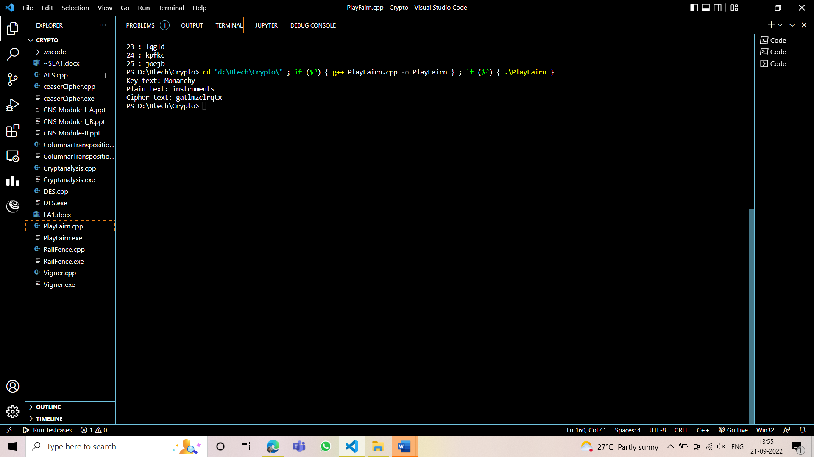**OUTPUT:**

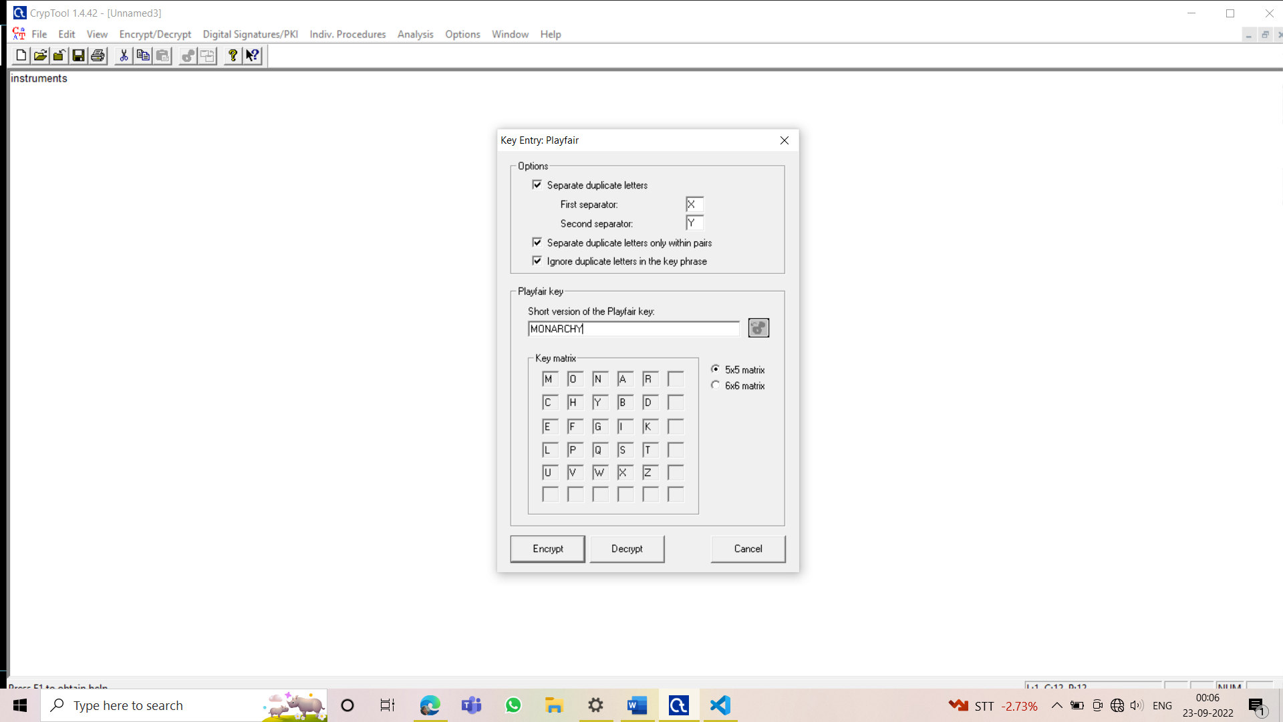



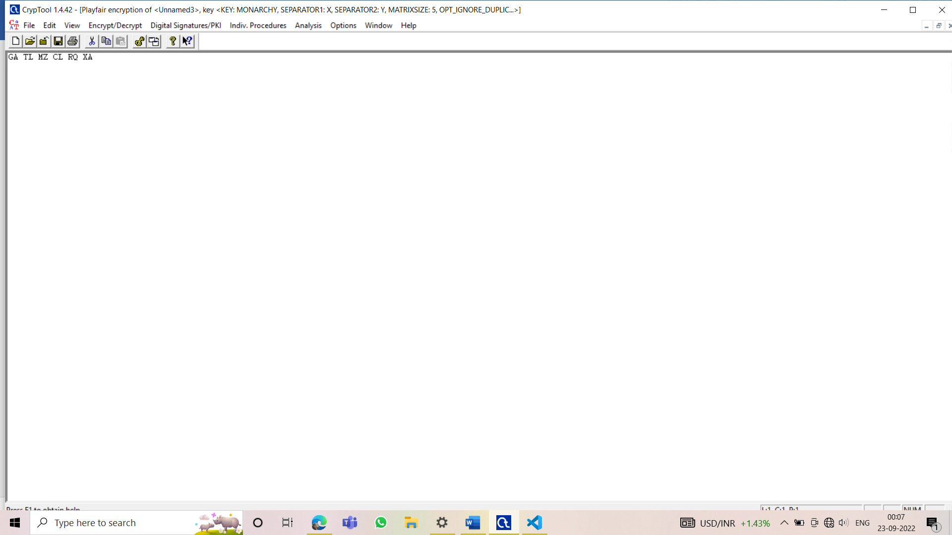

**DECRYPTION:**

#include <stdio.h>

#include <stdlib.h>

#include <string.h>

#define SIZE 30

// Convert all the characters

// of a string to lowercase

void toLowerCase(char plain[], int ps)

{

 int i;

 for (i = 0; i < ps; i++) {

  if (plain[i] > 64 && plain[i] < 91)

   plain[i] += 32;

 }

}

// Remove all spaces in a string

// can be extended to remove punctuation

int removeSpaces(char* plain, int ps)

{

 int i, count = 0;

 for (i = 0; i < ps; i++)

  if (plain[i] != ' ')

   plain[count++] = plain[i];

 plain[count] = '\0';

 return count;

}

// generates the 5x5 key square

void generateKeyTable(char key[], int ks, char keyT[5][5])

{

 int i, j, k, flag = 0, *dicty;

 // a 26 character hashmap

 // to store count of the alphabet

 dicty = (int*)calloc(26, sizeof(int));

 for (i = 0; i < ks; i++) {

  if (key[i] != 'j')

   dicty[key[i] - 97] = 2;

 }

 dicty['j' - 97] = 1;

 i = 0;

 j = 0;

 for (k = 0; k < ks; k++) {

  if (dicty[key[k] - 97] == 2) {

   dicty[key[k] - 97] -= 1;

   keyT[i][j] = key[k];

   j++;

   if (j == 5) {

    i++;

    j = 0;

   }

  }

 }

 for (k = 0; k < 26; k++) {

  if (dicty[k] == 0) {

   keyT[i][j] = (char)(k + 97);

   j++;

   if (j == 5) {

    i++;

    j = 0;

   }

  }

 }

}

// Search for the characters of a digraph

// in the key square and return their position

void search(char keyT[5][5], char a, char b, int arr[])

{

 int i, j;

 if (a == 'j')

  a = 'i';

 else if (b == 'j')

  b = 'i';

 for (i = 0; i < 5; i++) {

  for (j = 0; j < 5; j++) {

   if (keyT[i][j] == a) {

    arr[0] = i;

    arr[1] = j;

   }

   else if (keyT[i][j] == b) {

    arr[2] = i;

    arr[3] = j;

   }

  }

 }

}

// Function to find the modulus with 5

int mod5(int a)

{

 if (a < 0)

  a += 5;

 return (a % 5);

}

// Function to decrypt

void decrypt(char str[], char keyT[5][5], int ps)

{

 int i, a[4];

 for (i = 0; i < ps; i += 2) {

  search(keyT, str[i], str[i + 1], a);

  if (a[0] == a[2]) {

   str[i] = keyT[a[0]][mod5(a[1] - 1)];

   str[i + 1] = keyT[a[0]][mod5(a[3] - 1)];

  }

  else if (a[1] == a[3]) {

   str[i] = keyT[mod5(a[0] - 1)][a[1]];

   str[i + 1] = keyT[mod5(a[2] - 1)][a[1]];

  }

  else {

   str[i] = keyT[a[0]][a[3]];

   str[i + 1] = keyT[a[2]][a[1]];

  }

 }

}

// Function to call decrypt

void decryptByPlayfairCipher(char str[], char key[])

{

 char ps, ks, keyT[5][5];

 // Key

 ks = strlen(key);

 ks = removeSpaces(key, ks);

 toLowerCase(key, ks);

 // ciphertext

 ps = strlen(str);

 toLowerCase(str, ps);

 ps = removeSpaces(str, ps);

 generateKeyTable(key, ks, keyT);

 decrypt(str, keyT, ps);

}

// Driver code

int main()

{

 char str[SIZE], key[SIZE];

 // Key to be encrypted

 strcpy(key, "Monarchy");

 printf("Key text: %s\n", key);

 // Ciphertext to be decrypted

 strcpy(str, "gatlmzclrqtx");

 printf("Plain text: %s\n", str);

 // encrypt using Playfair Cipher

 decryptByPlayfairCipher(str, key);

 printf("Deciphered text: %s\n", str);

 return 0;

}

OUTPUT:

