**NAME: KSHITIJA SHAMRAO JADHAV**

**PRN:2019BTECS00053**

**ASS 5: Rail Fence And Columnar Transposition**

**Rail Fence:**

Given a plain-text message and a numeric key, cipher/de-cipher the given text using Rail Fence algorithm.

The rail fence cipher (also called a zigzag cipher) is a form of transposition cipher. It derives its name from the way in which it is encoded.

#include<iostream>

#include<string.h>

using namespace std;

void encryptMsg(char msg[], int key){

    int msgLen = strlen(msg), i, j, k = -1, row = 0, col = 0;

    char railMatrix[key][msgLen];

    for(i = 0; i < key; ++i)

        for(j = 0; j < msgLen; ++j)

            railMatrix[i][j] = '\n';

    for(i = 0; i < msgLen; ++i){

        railMatrix[row][col++] = msg[i];

        if(row == 0 || row == key-1)

            k= k * (-1);

        row = row + k;

    }

    cout<<"\nEncrypted Message: ";

    for(i = 0; i < key; ++i)

        for(j = 0; j < msgLen; ++j)

            if(railMatrix[i][j] != '\n')

                cout<<railMatrix[i][j];

}

void decryptMsg(char enMsg[], int key){

    int msgLen = strlen(enMsg), i, j, k = -1, row = 0, col = 0, m = 0;

    char railMatrix[key][msgLen];

    for(i = 0; i < key; ++i)

        for(j = 0; j < msgLen; ++j)

            railMatrix[i][j] = '\n';

    for(i = 0; i < msgLen; ++i){

        railMatrix[row][col++] = '*';

        if(row == 0 || row == key-1)

            k= k * (-1);

        row = row + k;

    }

    for(i = 0; i < key; ++i)

        for(j = 0; j < msgLen; ++j)

            if(railMatrix[i][j] == '*')

                railMatrix[i][j] = enMsg[m++];

    row = col = 0;

    k = -1;

    cout<<"\nDecrypted Message: ";

    for(i = 0; i < msgLen; ++i){

        cout<<railMatrix[row][col++];

        if(row == 0 || row == key-1)

            k= k * (-1);

        row = row + k;

    }

}

int main(){

    char msg[] = "Hello World";

    char enMsg[] = "Horel ollWd";

    int key = 3;

    cout<<"Original Message: "<<msg;

    encryptMsg(msg, key);

    decryptMsg(enMsg, key);

    return 0;

}

**OUTPUT:**

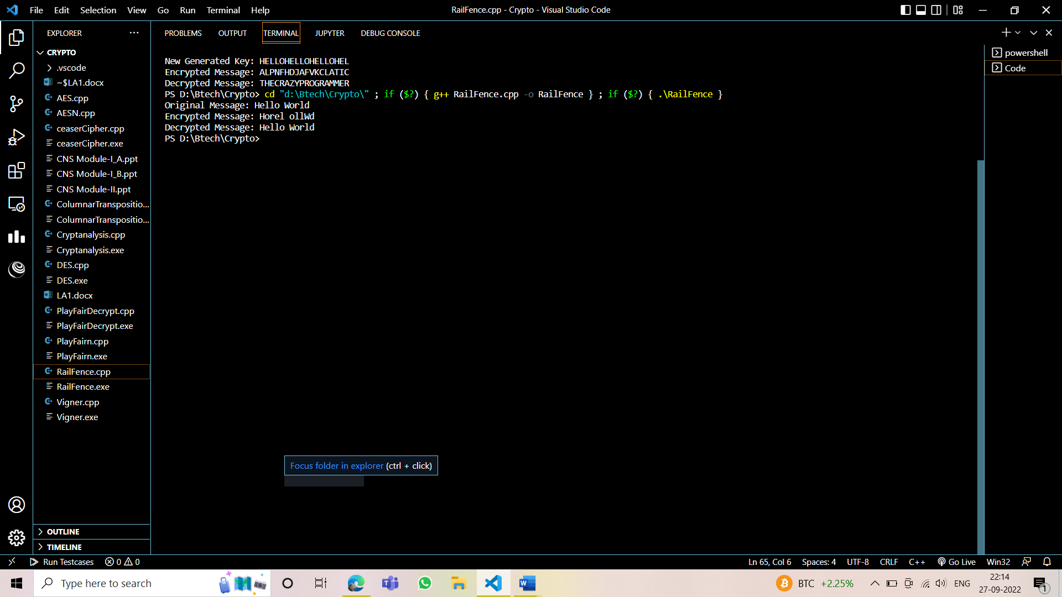

**Columnar Transposition:**

The Columnar Transposition is a simple transposition cipher that can be performed manually, without the need of using additional equipment. It was very popular throughout centuries, and it was used in various situations by diplomats, soldiers, and spies.

The encryption and decryption can be performed by hand, using a piece of paper and a simple matrix, into which the user enters the letters of the message.

// Columnar Transposition Cipher

#include<bits/stdc++.h>

using namespace std;

// Key for Columnar Transposition

string const key = "HACK";

map<int,int> keyMap;

void setPermutationOrder()

{

    // Add the permutation order into map

    for(int i=0; i < key.length(); i++)

    {

        keyMap[key[i]] = i;

    }

}

// Encryption

string encryptMessage(string msg)

{

    int row,col,j;

    string cipher = "";

    /* calculate column of the matrix*/

    col = key.length();

    /* calculate Maximum row of the matrix*/

    row = msg.length()/col;

    if (msg.length() % col)

        row += 1;

    char matrix[row][col];

    for (int i=0,k=0; i < row; i++)

    {

        for (int j=0; j<col; )

        {

            if(msg[k] == '\0')

            {

                /* Adding the padding character '_' */

                matrix[i][j] = '_';

                j++;

            }

            if( isalpha(msg[k]) || msg[k]==' ')

            {

                /* Adding only space and alphabet into matrix*/

                matrix[i][j] = msg[k];

                j++;

            }

            k++;

        }

    }

    for (map<int,int>::iterator ii = keyMap.begin(); ii!=keyMap.end(); ++ii)

    {

        j=ii->second;

        // getting cipher text from matrix column wise using permuted key

        for (int i=0; i<row; i++)

        {

            if( isalpha(matrix[i][j]) || matrix[i][j]==' ' || matrix[i][j]=='_')

                cipher += matrix[i][j];

        }

    }

    return cipher;

}

// Decryption

string decryptMessage(string cipher)

{

    /* calculate row and column for cipher Matrix */

    int col = key.length();

    int row = cipher.length()/col;

    char cipherMat[row][col];

    /* add character into matrix column wise */

    for (int j=0,k=0; j<col; j++)

        for (int i=0; i<row; i++)

            cipherMat[i][j] = cipher[k++];

    /* update the order of key for decryption */

    int index = 0;

    for( map<int,int>::iterator ii=keyMap.begin(); ii!=keyMap.end(); ++ii)

        ii->second = index++;

    /* Arrange the matrix column wise according

    to permutation order by adding into new matrix */

    char decCipher[row][col];

    map<int,int>::iterator ii=keyMap.begin();

    int k = 0;

    for (int l=0,j; key[l]!='\0'; k++)

    {

        j = keyMap[key[l++]];

        for (int i=0; i<row; i++)

        {

            decCipher[i][k]=cipherMat[i][j];

        }

    }

    /* getting Message using matrix */

    string msg = "";

    for (int i=0; i<row; i++)

    {

        for(int j=0; j<col; j++)

        {

            if(decCipher[i][j] != '_')

                msg += decCipher[i][j];

        }

    }

    return msg;

}

// Driver Program

int main(void)

{

    /* message */

    string msg ;

    cout<<"Enter The msg to Encrypt : "<<endl;

    cin>>msg;

    setPermutationOrder();

    // Calling encryption function

    string cipher = encryptMessage(msg);

    cout << "Encrypted Message: " << cipher << endl;

    // Calling Decryption function

    cout << "Decrypted Message: " << decryptMessage(cipher) << endl;

    return 0;

}

**OUTPUT:**

